Truenat™ Tests for the Detection of TB and Rifampicin Resistance Central-Level Training
Facilitator’s Guide

Table of Contents

Table of Contents 2
Introduction 6
Training Schedule 6
Customizing this Training 6
Training Format 7
Facilitator Preparation 7
Course Introduction 8
Module 1: Introduction to Truenat 9
Target Audience 9
Learning Objectives 9
Materials 9
Advance Preparation 9
Lesson Plans 10
Introduction 10
TB Context 11
Plenary Session 14
TB Laboratory Tests 14
Placement of Truenat in Diagnostic Networks 16
Diagnostic Accuracy of Truenat 18
Activity: Which Test Should I Use 21
Summary 22
Module 2: Diagnostic Algorithm and Results Interpretation 26
Target Audience 26
Learning Objectives 26
Materials 26
Advance Preparation 26
Lesson Plans 26
Introduction 27
WHO Recommendations 28
Truenat Algorithm 30
Activity: Truenat Algorithm 36
Patient Flow 36
Summary 40
Knowledge Check 41
Module 3: Operational Aspects 43
Target Audience 43
Learning Objectives 43
Materials 43
Advance Preparation 43
Lesson Plans 44
Introduction 44
Introduction 45
Equipment and Supplies 46
Truenat Test Procedures – Prepare Samples and Extract DNA 50
Truenat Test Procedures – Run a PCR TB Test 52
Truenat Test Procedures – Run a RIF Resistance Test 55
Class Activity 56
Waste Management 56
Errors and Troubleshooting 58
Class Activity 60
Infrastructure Requirements 62
Class Activity 66
Recording Testing Activities 67
Warranty 67
Summary 71
Knowledge Check 71
Module 4: Order Planning and Quality Assurance (QA) and Control 74
Target Audience 74
Learning Objectives 74
Materials 74
Advance Preparation 74
Lesson Plans 75
Introduction 75
Forecasting and Quantification 76
Activity: Regular Forecasting 79
Stock Management 81
Quality Assurance and Control 84
Monitoring Quality 90
Summary 92
Knowledge Check 93
Module 5: Monitoring & Evaluation (M&E) 95
Target Audience 95
Learning Objectives 95
Advance Preparation 95
Lesson Plans 96
Introduction 96
M&E for Truenat 97
Indicators 98
Summary 100
Knowledge Check 100
Module 6: Biosafety and Specimen Collection and Referral 103
Target Audience 103
Learning Objectives 103
Advance Preparation 103
Lesson Plans 104
Introduction 104
Biosafety Measures and Risk 105
Assessing Risk 107
Laboratory Infrastructure 109
Personal Protective Equipment 109
Biosafety Cabinets 112
Generation and Prevention of Aerosols 113
Managing Spills 115
Waste Disposal 116
Specimen Collection Procedures 118
Specimen Referral 119
Summary 121
Knowledge Check 122

Introduction
The Truenat™ Tests for the Detection of TB and Rifampicin Resistance Central-Level Training was developed to provide countries with a tool to introduce Truenat to key stakeholders in their country. This training is intended to be delivered at central or national level, with additional hands-on onsite training from Molbio, the manufacturer of Truenat, for lab technicians. The training is divided into six modules:
- Introduction to Truenat
- Diagnostic Algorithm and Results Interpretation
- Operational Aspects
- Order Planning and Quality Assurance (QA) and Control
- Monitoring and Evaluation (M&E)
- Specimen Collection and Referral

This training is based on and intended to serve as a complement to the Practical Guide to Implementation of TruenatTM Tests for the Detection of TB and Rifampicin Resistance developed by the United States Agency for International Development (USAID), Stop TB Partnership, and the Global Laboratory Initiative (GLI).

Training Schedule
 | Estimated Instructional Time | Participants
Module 1 | 2 hours | Lab technicians; Lab and program managers; clinicians
Module 2 | 2 hours | Lab technicians; Lab and program managers; clinicians
Module 3 | 9 hours | Lab technicians; Lab and program managers
Module 4 | 2 hours | Lab and program managers
Module 5 | 1 hour | Lab and program managers
Module 6 | 2 hours | Lab technicians; clinicians

Customizing this Training
This training is designed to be customized by countries to meet their individual needs. In the PowerPoint slides, text that is highlighted in yellow is intended to be replaced with information pertinent to the country. All other text should also be reviewed by national program managers and may also need to be customized.
Countries should also develop a Truenat implementation plan that identifies items such as where in the diagnostic network Truenat instruments will be placed, who will be trained to use Truenat, which forms and reporting tools need to be developed, and how specimens, patients, and results will flow through the diagnostic network. This training can be delivered before the implementation plan is developed to prompt conversation and development of action items for developing an implementation plan or can be delivered after the implementation plan has been developed – which may require customization of much of the material in this training.
The PowerPoint slides use a basic template that was designed to convey information visually and be easy to understand. Countries might consider uploading their logo to the existing template using the Slide Master. They can also change the template to a national one using these instructions from Microsoft. The slides use the Montserrat font – if this font is not installed on training facilitators’ computers, it can either be downloaded or installed or the font can be changed in the slide master. Similarly, colors can also be changed in the slide master and then using the “reset function” on each slide.
Please note that any customization to the training may require changes to the participant guide, facilitator guide, and PowerPoint slides.

Training Format
This training is designed to be delivered in person but can be slightly modified to be delivered virtually if preferred. The main changes that need to be considered will be to the activities and discussion questions. Instructors should consider using features such as breakout rooms, poll questions, and the chat function. Participants should be encouraged to participate as much as possible, preferably by coming off mute in a small group, or through the chat if in a large group.

Facilitator Preparation
Instructors can use the checklist below to help successfully plan and deliver each training module.
SESSION PREPARATION
Customize PowerPoint slides, facilitator guide, and participant guide as needed
Familiarize yourself with the facilitator guide
Familiarize yourself with the participant guide
Review and test materials requiring technology (website links, video links, etc.)
Confirm meeting room and technology equipment for date and time of session (if needed)
Print out participant guides (or for a virtual session, ask participants to print their own participant guides)
REGULAR SESSION MATERIALS
Gather the following materials for each session:
Facilitator Guide
Participant Guide
Nametags or name tents
PowerPoint presentation
Timer (watch, clock, or phone app) (Use the timer to keep activities within the time limits)
Pens or pencils
Index cards
DAY OF SESSION
Arrive early
Arrange tables and chairs in a formation that invites large and small group discussion.
Test technology (computer, projector, internet) to make sure it is working.
Write down needed text on a flip chart or whiteboard to prepare for session activities, if needed
Greet participants

Course Introduction
Before beginning the course, the instructor should provide a basic overview of the training, including what Truenat is and why the training is being delivered, how long the training will last and the schedule/structure of each day, and should explain to participants how to use the participant guide (i.e., that participants should follow along in their participant guide and take notes as they go along). The instructor should emphasize that this is a highly participatory training and facilitate an “ice breaker” for participants to get to know one another. If the training is being delivered virtually, an overview of the technology should also be provided.

Module 1: Introduction to Truenat

Target Audience
The target audience for this course is:
- Lab technicians
- Lab managers
- Program managers
- Clinicians

Learning Objectives
Terminal Objective
- At the end of this session, participants should understand the purpose of Truenat and how it is intended to help address TB diagnostic challenges specific to their country.

Module Objectives
- By the end of this module, participants should be able to
  - Describe the global and country-specific context of TB.
  - List the different laboratory tests used to diagnose TB and drug resistance, and WHO’s recommendations for each.
  - Describe the advantages of introducing Truenat within a TB diagnostic network.
  - Compare the diagnostic accuracy of Truenat to other TB laboratory tests.

Materials
- Facilitator Guide
- Participant Guide
- Pens/Pencils

Advance Preparation
- Instructors will need to customize slides in this module for Patient Flow procedures and the Patient Referral Pathway for their particular country.

Lesson Plans

Introduction
Introduction
Slide: 3
Participant Guide Page: 0
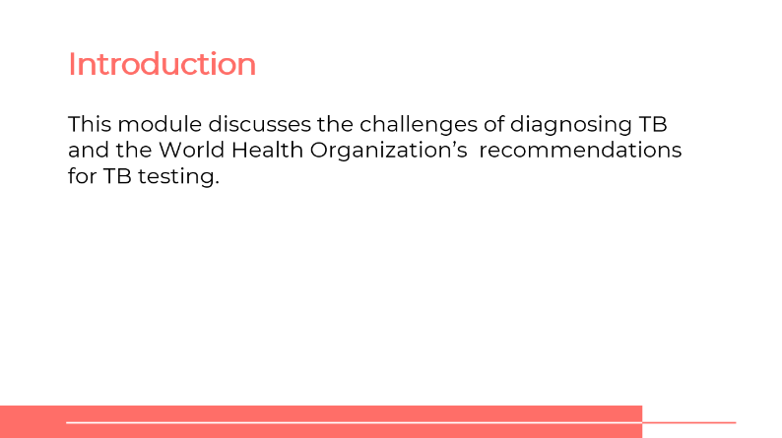
SAY: Our first topic is an introduction to Truenat. We will talk about challenges with diagnosing TB globally and in our country, the WHO recommendations for TB testing, and then we’ll look at some specific elements of Truenat.
Module 1: Introduction to Truenat
Slide: 4
Participant Guide Page: 0
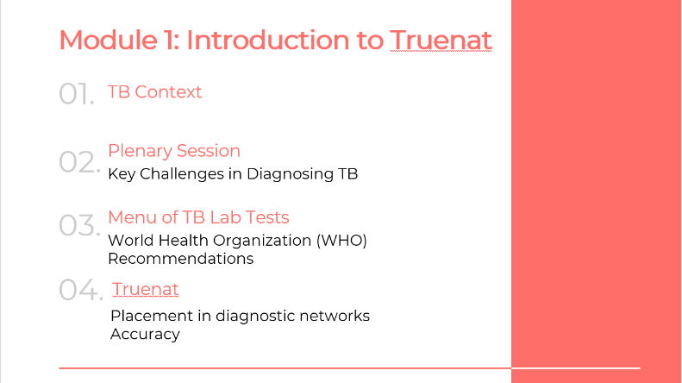
SAY: We will look at four topics in this module. The TB context globally and in our country, we’ll hold a plenary session on challenges with diagnosing TB, then we’ll go through the range of lab tests that area available for TB, and then will specifically talk about Truenat, including its placement in diagnostic networks and accuracy, including specificity and sensitivity.
Learning Objectives
Slide: 5
Participant Guide Page: 0
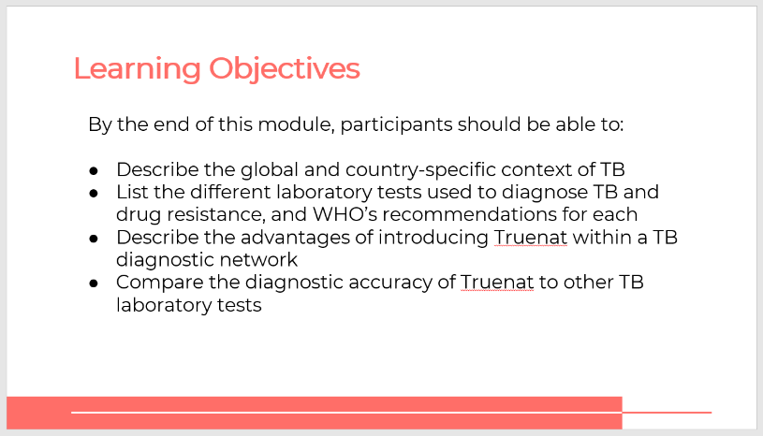
SAY: By the end of this module, you will be able to:
- Describe the global and country-specific context of TB.
- List the different laboratory tests used to diagnose TB and drug resistance, and WHO’s recommendations for each.
- Describe the advantages of introducing Truenat within a TB diagnostic network.
- Compare the diagnostic accuracy of Truenat to other TB laboratory tests.
ASK: What questions do you have before we move into the first lesson for this training?
DO: Allow participants time to ask questions and respond appropriately.

TB Context
Global TB Situation: Global Context
Slide: 7
Participant Guide Page: 0
SAY: Let’s take a look at the tuberculosis (TB) situation around the world and in our country.
ASK: How many people do you think are infected with TB every year?
DO: Click on the slide for animation to bring up the content.
ANSWER: 10 million people fall ill with TB every year. Ensure that participants record this answer in their participant guide.
SAY: TB is the world’s top infectious disease. One and a half million people die from TB each year. Statistics show that TB is the leading cause of death of people with HIV. It also contributes to antimicrobial resistance.
Global TB Situation: WHO End-TB Strategy
Slide: 8
Participant Guide Page: 0
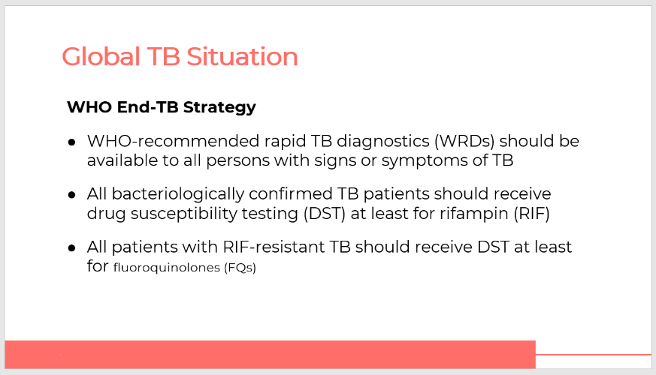
SAY: The World Health Organization (WHO) recommends that rapid TB diagnostics be available to anyone who shows signs or symptoms of TB. Drug susceptibility testing (DST) should be given to all bacteriologically confirmed TB patients. At the very least, all bacteriologically confirmed TB patients should receive DST for rifampin (RIF).
ASK: To what extent do you think your country is meeting these goals?
DO: Allow participants to share their experiences.
Global TB Situation: WHO Guidelines on DST
Slide: 9
Participant Guide Page: 0
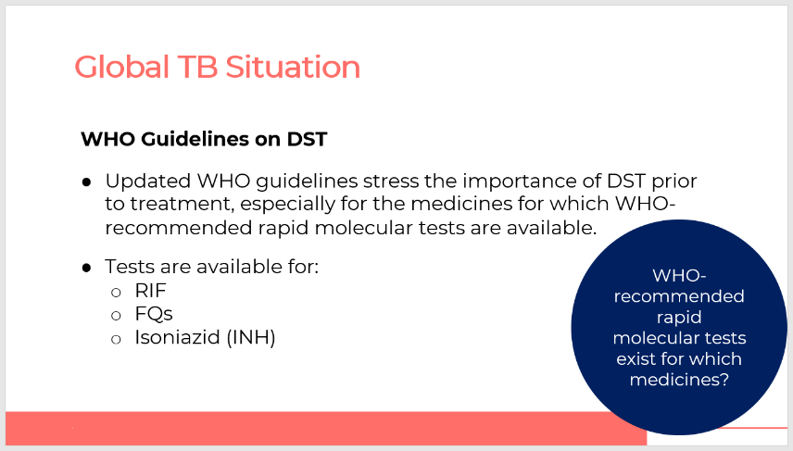
SAY: WHO has updated their guidelines to emphasize the importance of drug susceptibility testing prior to initiating treatment, especially for drugs for which rapid tests are available. The recommended treatments are rapid molecular tests, RIF, FQS and isoniazid (INH).
DO: Click on the slide to bring up the discussion question with animation.
ASK: Does anyone know which medicines have WHO-recommended rapid molecular tests?
DO: Allow participants time to answer.
DO: Click on the slide to bring up the answers to this question and read through them. Ensure that participants record the answers in their participant guide.
Country TB Context
Slides: 10, 11, and 12
Participant Guide Page: 2
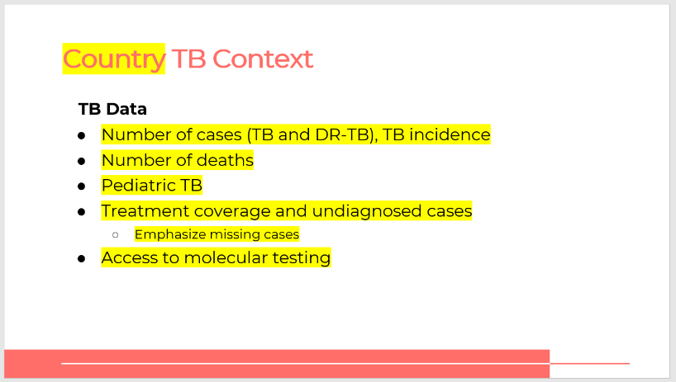
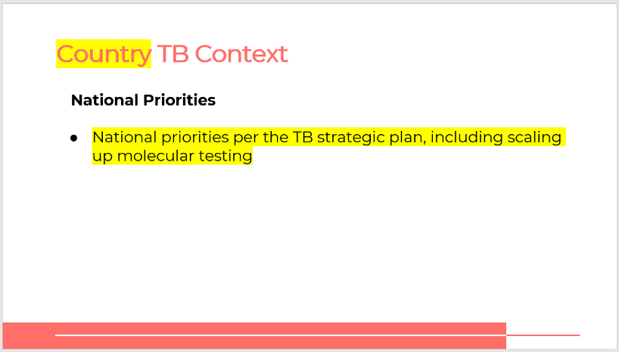
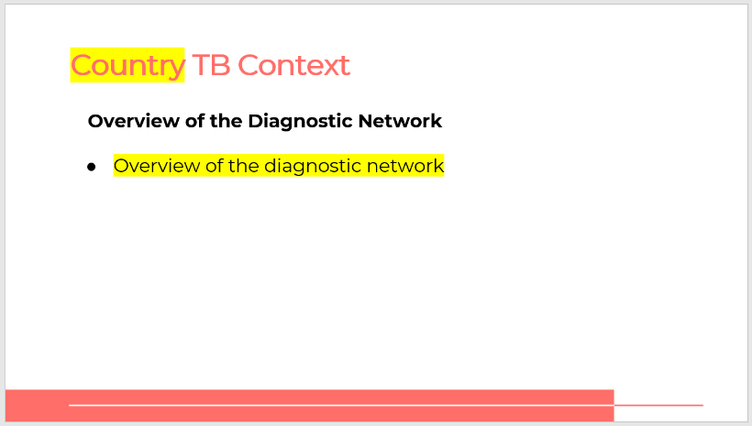
SAY: As a country, we face many challenges in ending the TB epidemic. Let’s talk through some basic facts about TB in our country.
DO: Share the data on the number of TB cases, deaths, pediatric TB cases and the treatment coverage and undiagnosed cases. Be sure to explain national priorities per the national strategic plan, and an overview of the diagnostic network for TB in the country.

Plenary Session
Challenges with Diagnosing TB in Country
Slide: 13
Participant Guide Page: 2
DO: Facilitate a plenary session with key experts in the country to discuss the main challenges with diagnosing TB. This session should last about one hour, with ample time at the end for Q&A.
ASK:
- How would you characterize the degree of access to molecular testing in our country? Does this differ in rural vs. urban areas?
- What are the main challenges with increasing access to molecular testing in our country?
- How does the country plan to scale up or increase access to molecular testing?
- Why is it important that more people have access to molecular testing for TB?
- How does Truenat help us meet these goals?
SAY: What questions do our participants have for our panelists?

TB Laboratory Tests
Menu of TB Lab Tests
Slide: 15
Participant Guide Page: 3
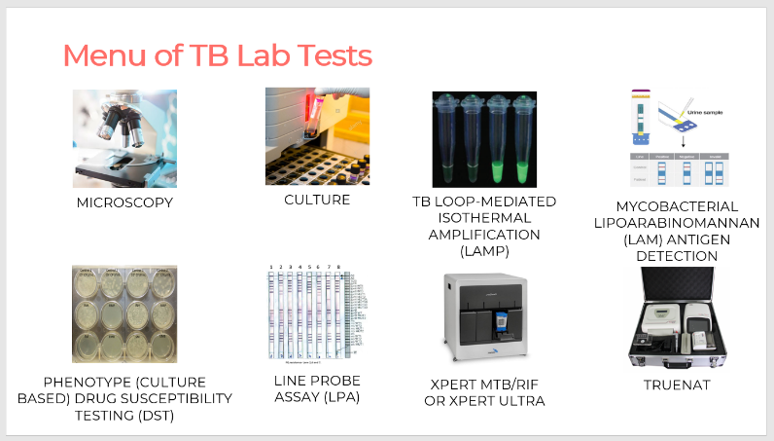
SAY: There are many lab tests that test for TB and drug resistance to drugs that treat TB. We are going to walk through each one and discuss its uses, benefits and limitations.
ASK: Aside from Truenat, are you familiar with all these tests, or are any of them new?
DO: Allow participants to share their responses.

Lab Tests for TB
Slide: 16-24
Participant Guide Page: 4
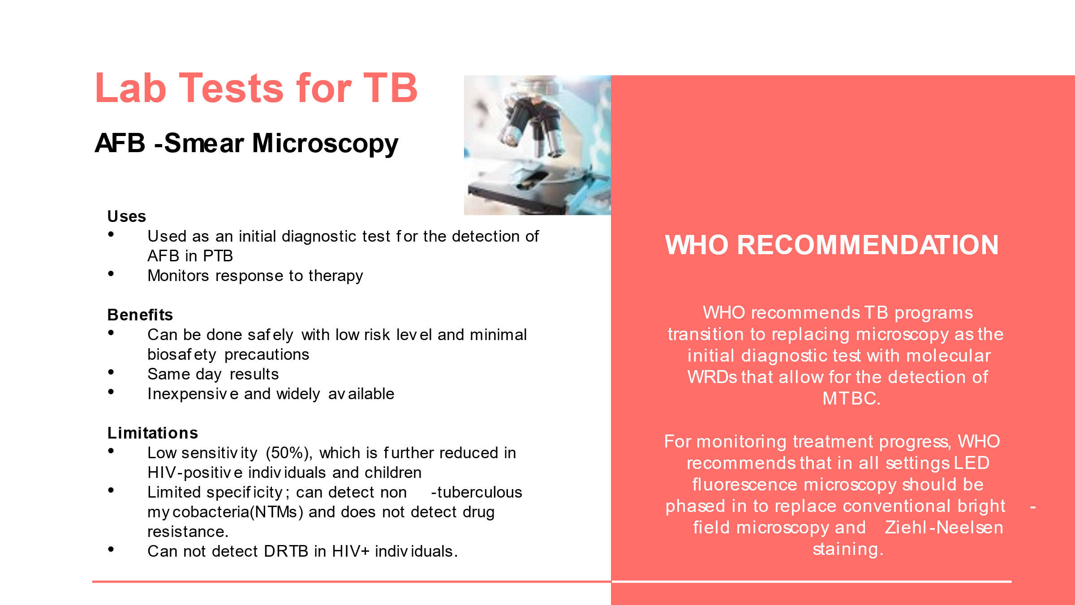
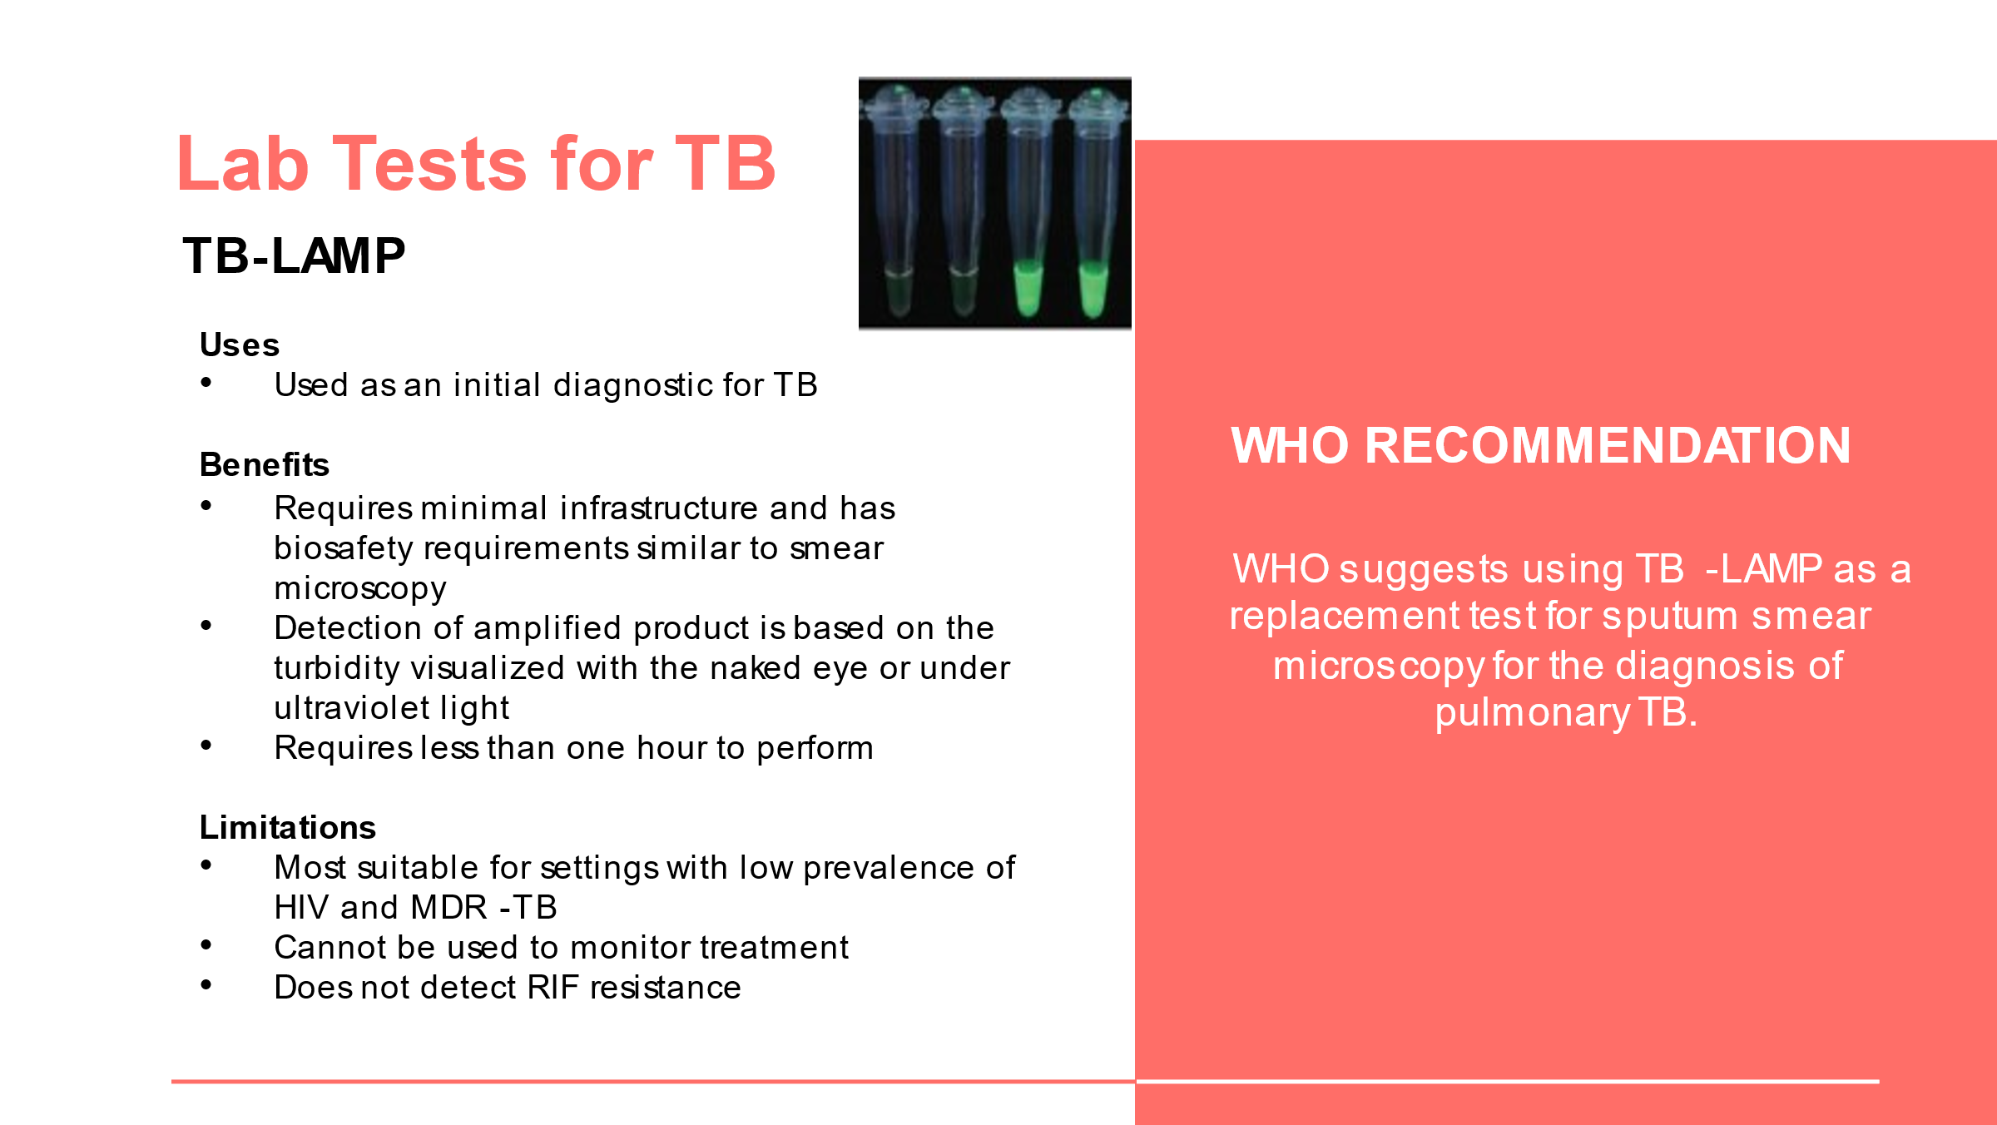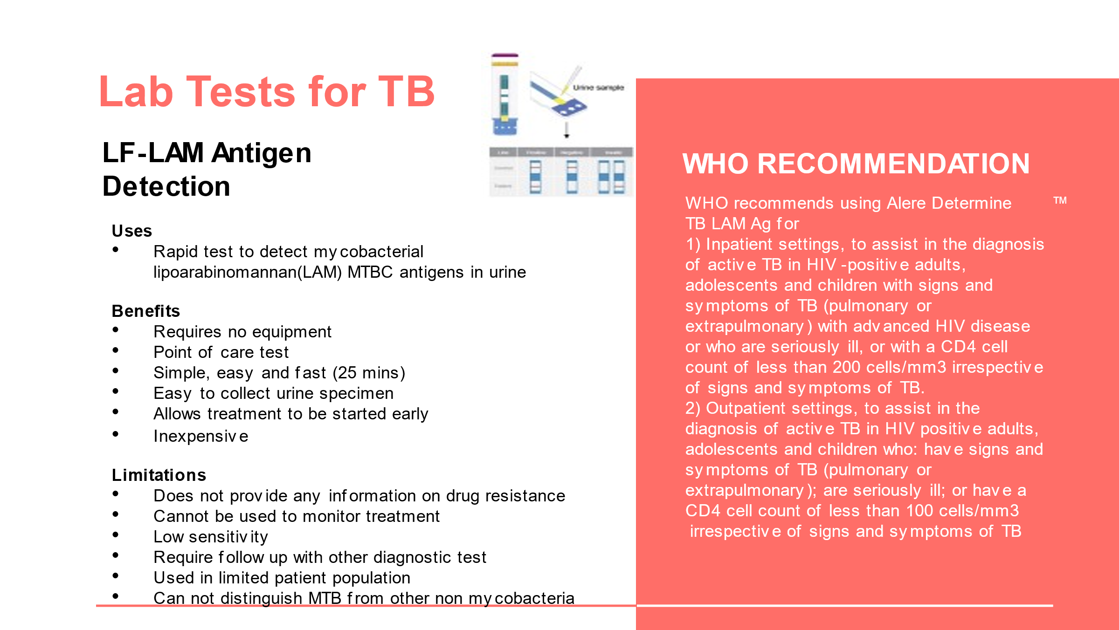
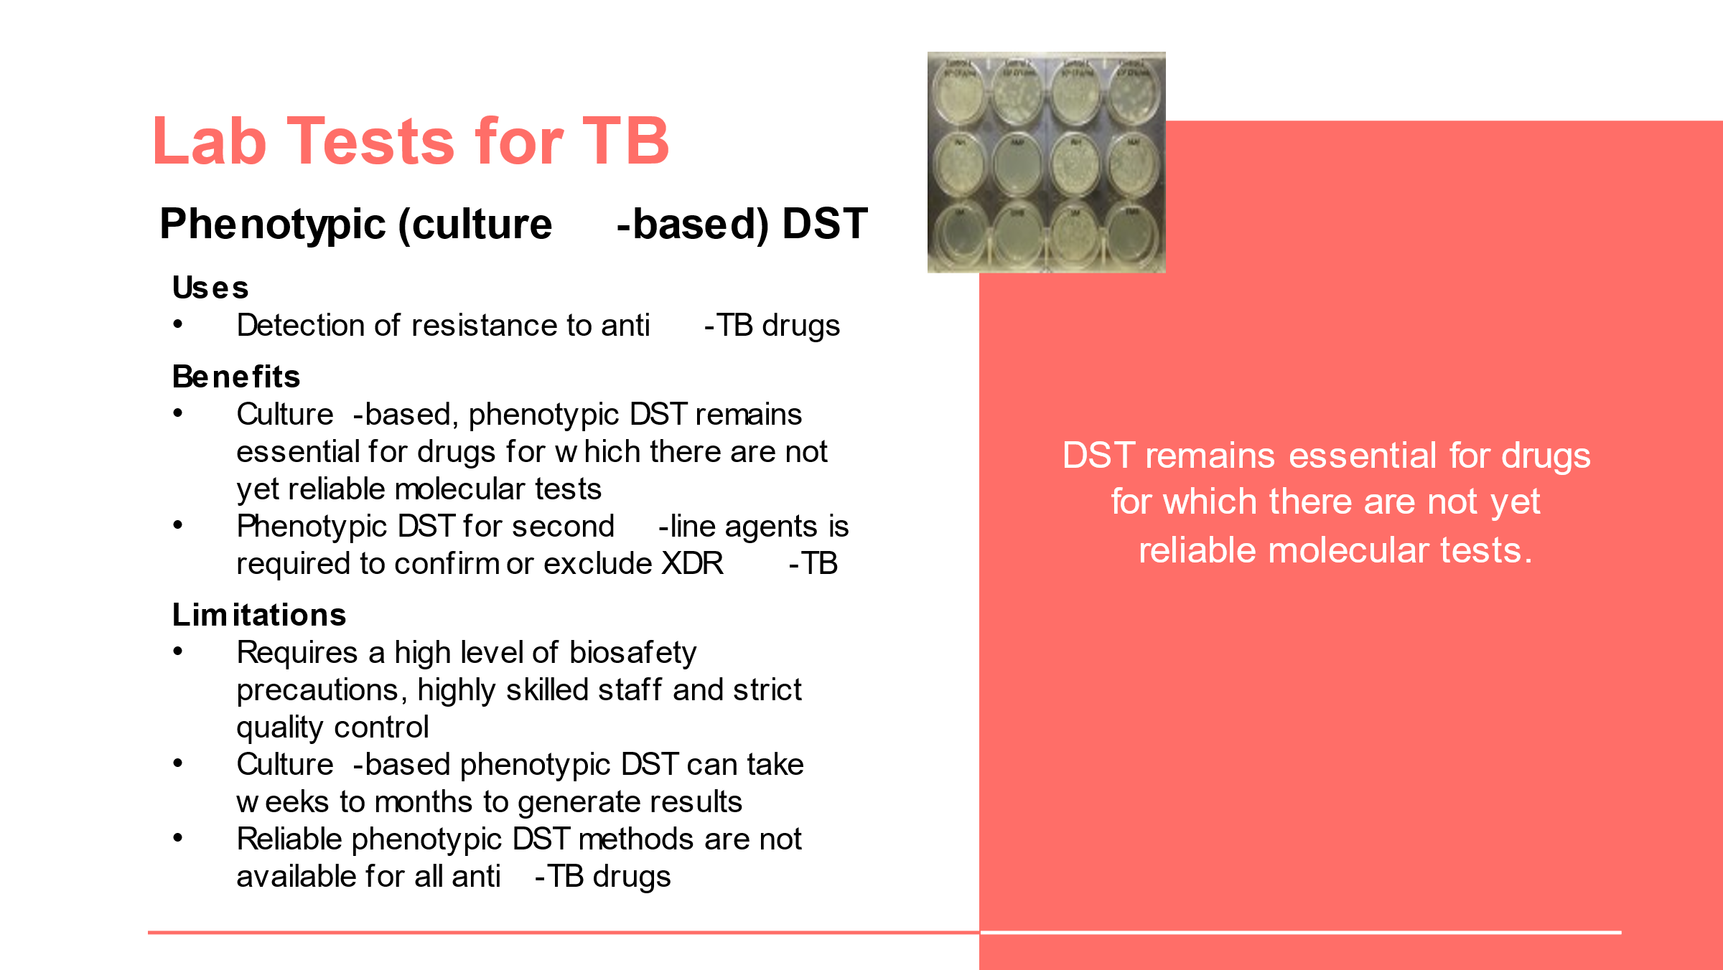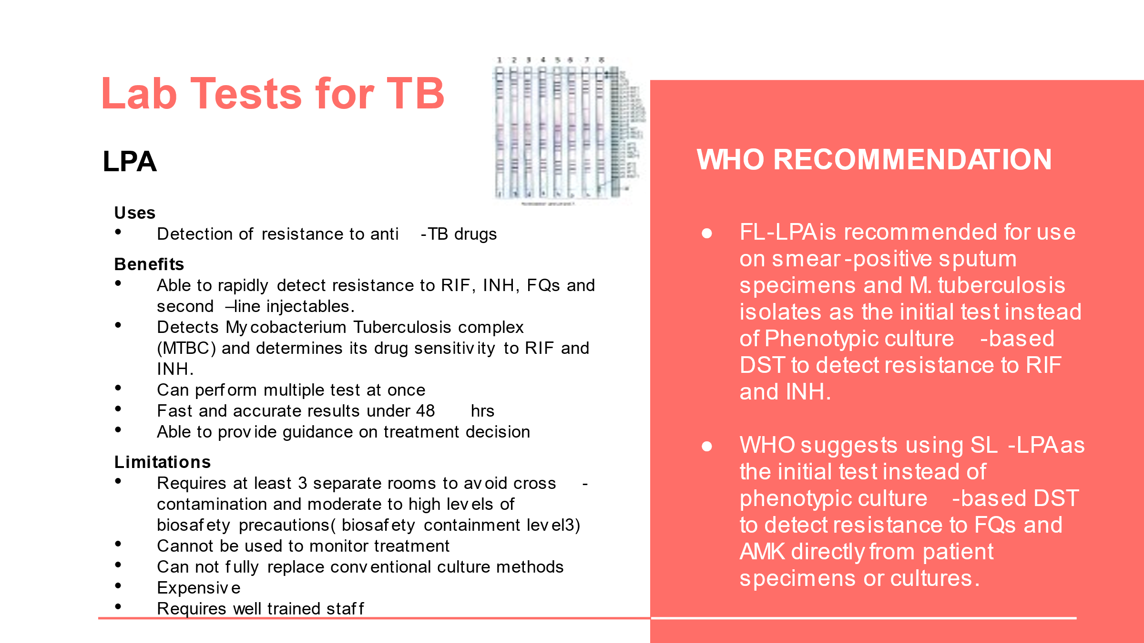
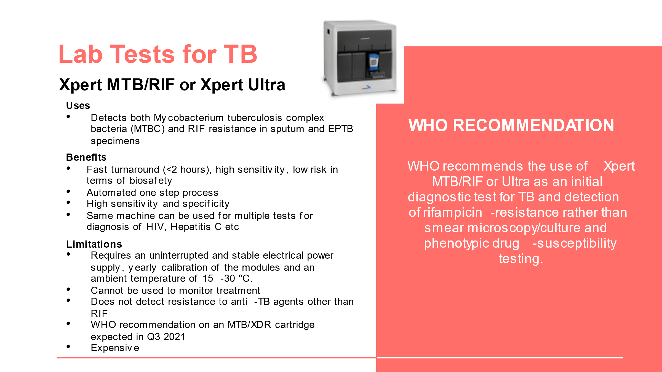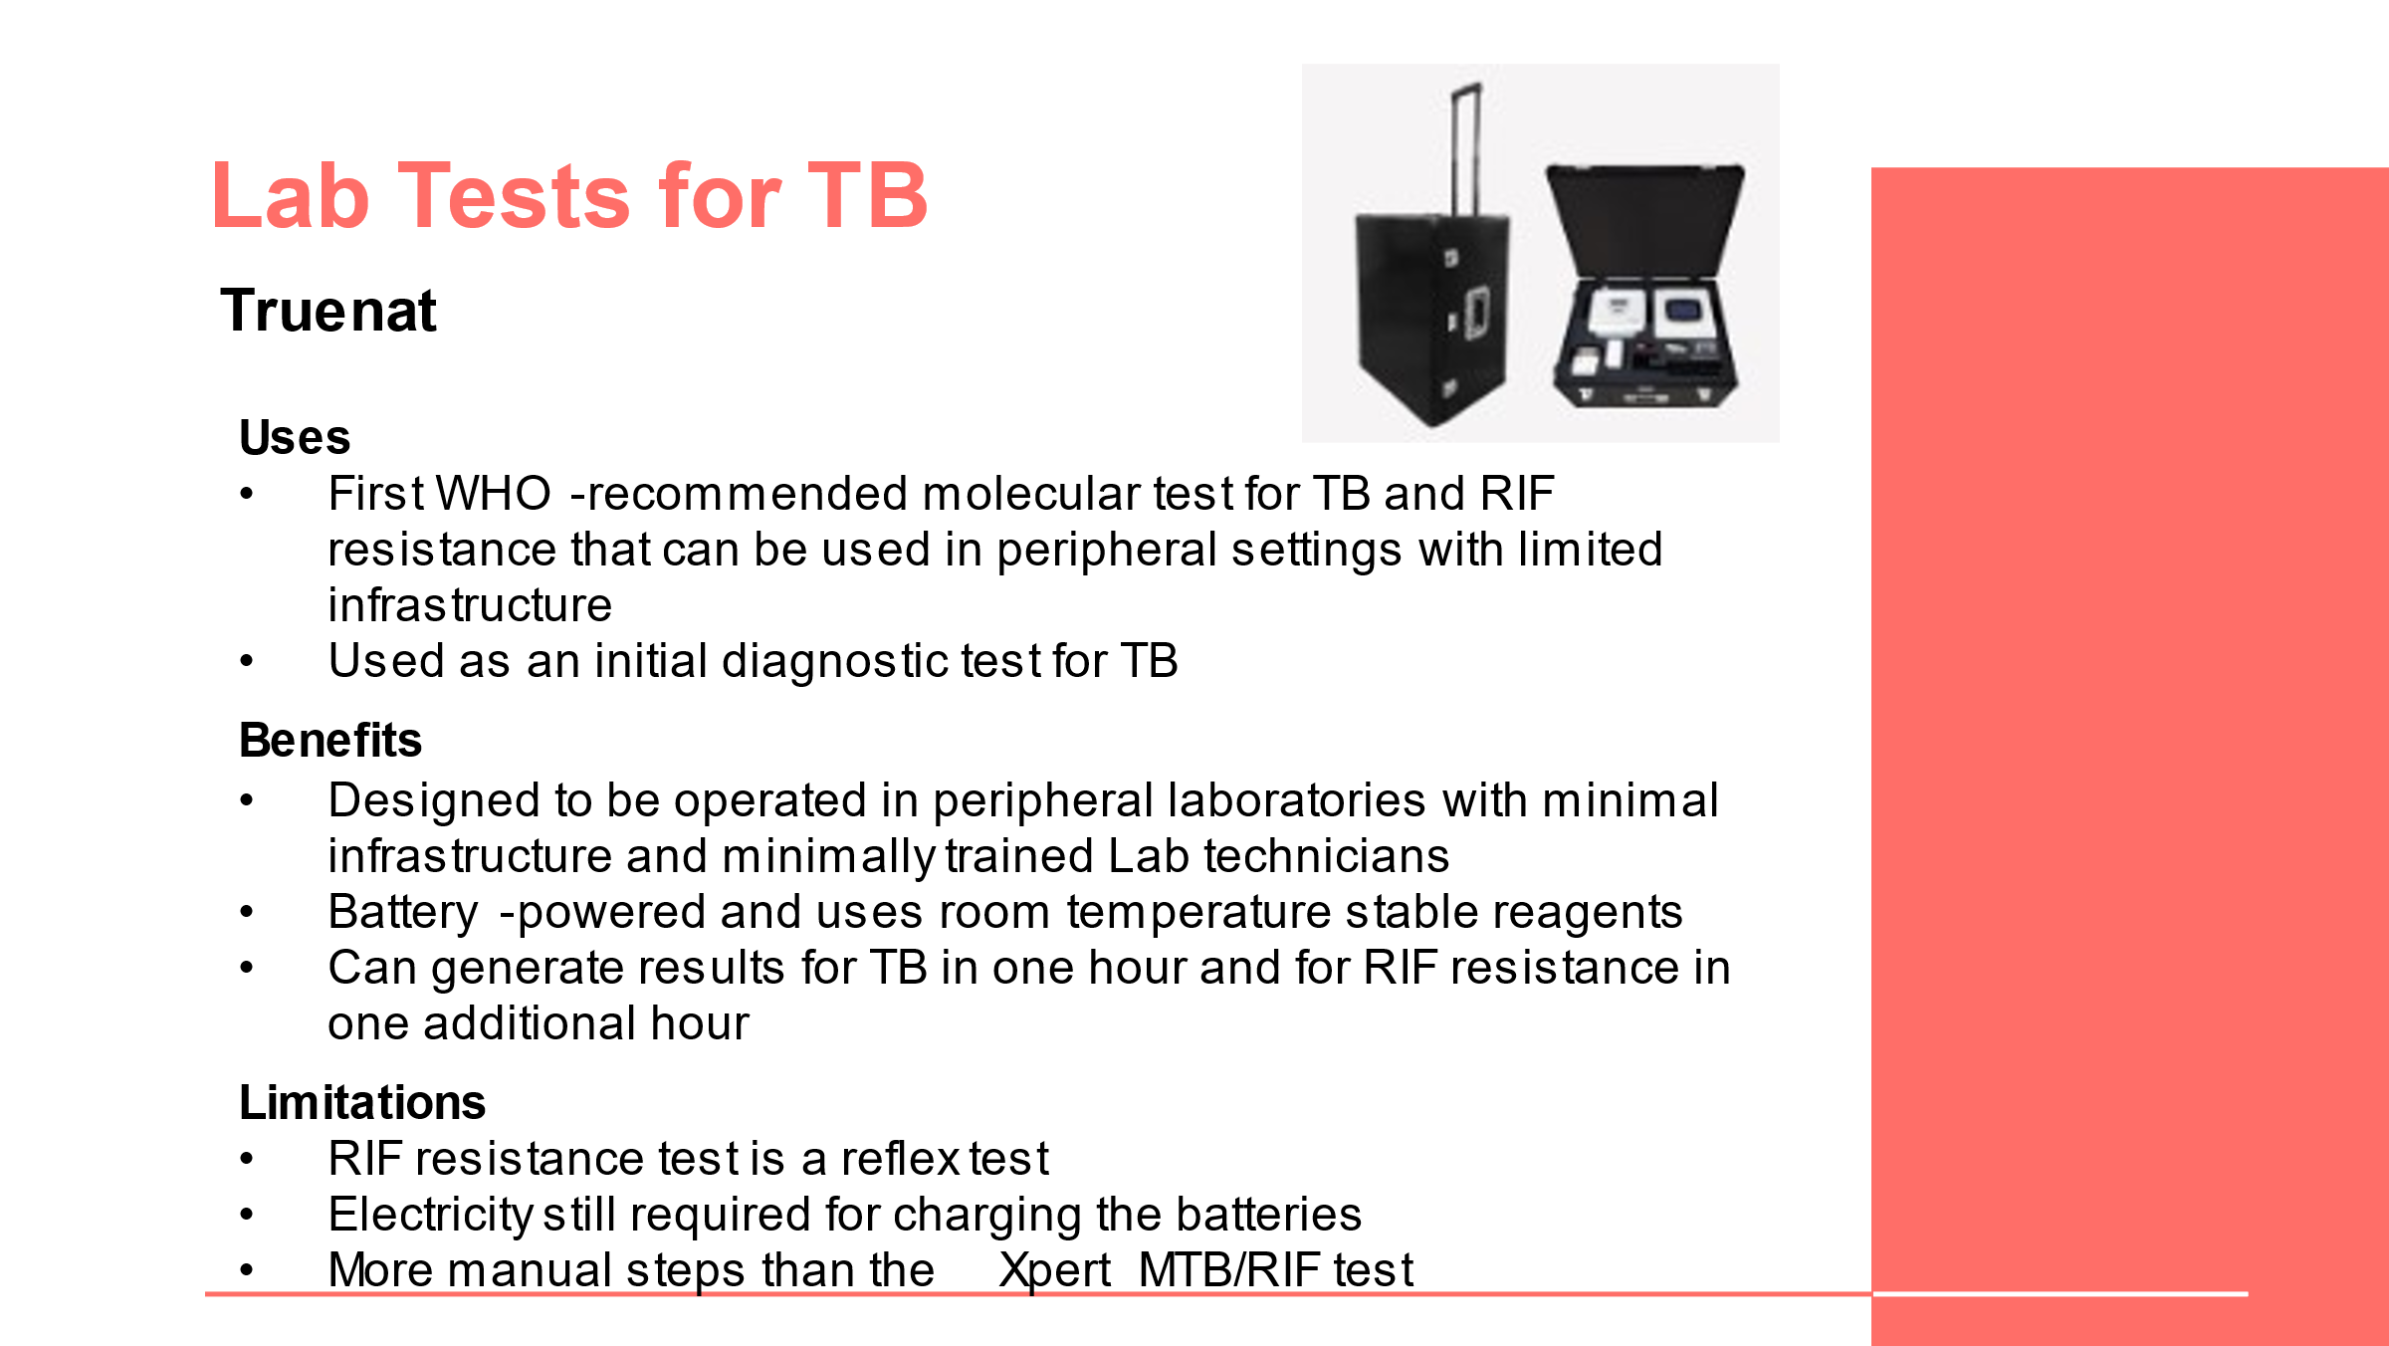
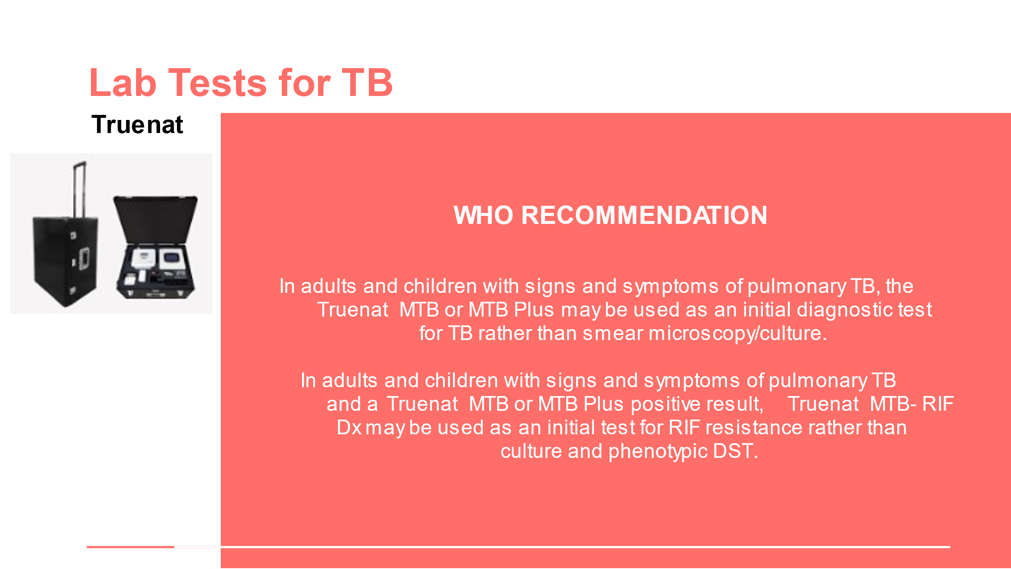
DO: Go over each lab test and talk about the uses, benefits and limitations of each. Share each WHO recommendation for each test. Consider asking a different participant to talk through the information on each slide.
Truenat Chips
Slide: 25
Participant Guide Page: 5
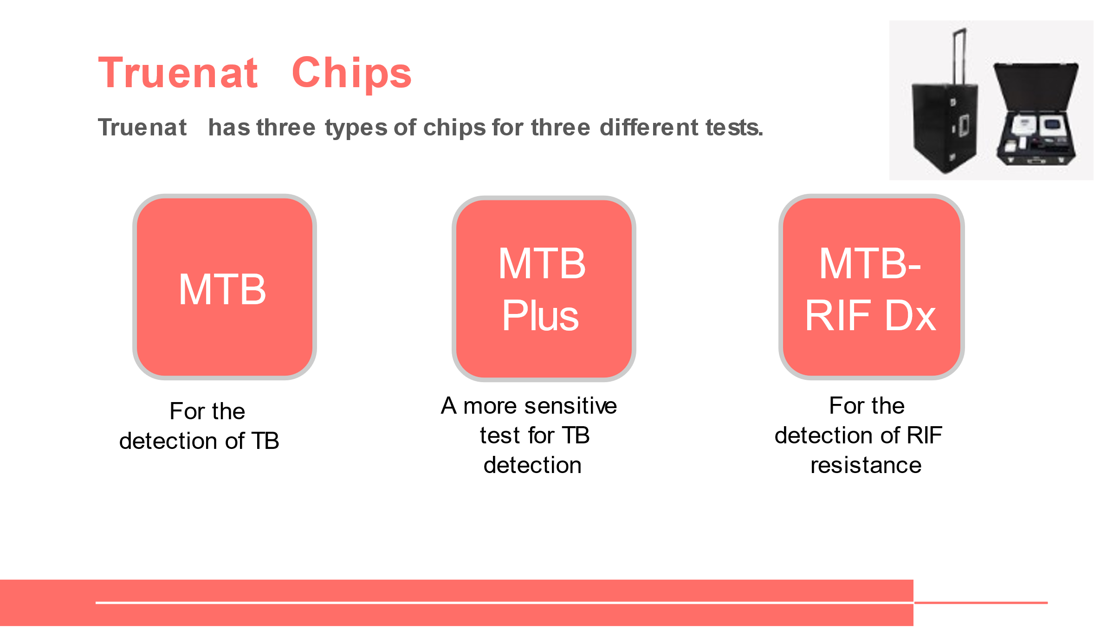
SAY: As you may have been able to tell from the previous slides, there are three different Truenat chips for the three different TB tests.
DO: Using the animation on the slide, show each of the tests and name them.

Placement of Truenat in Diagnostic Networks
Lab Tests for TB: Placement in the Network
Slide: 27
Participant Guide Page: 7
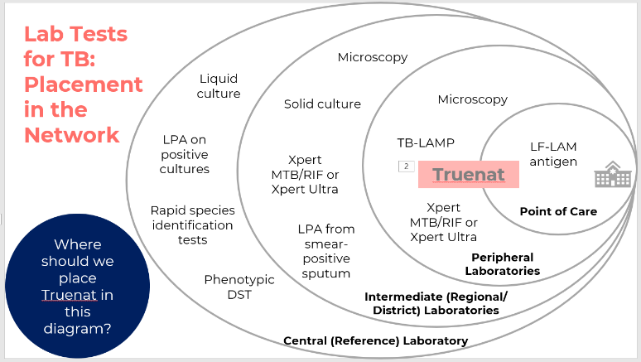
SAY: This is a visual depiction of where each of the tests we just discussed can be placed in the diagnostic network. Some tests are done at point of care, some tests are done at peripheral labs, and other more complex tests are done at intermediate labs or the central reference laboratory. You can see here that LF-LAM antigen is the only test that is a true point-of-care test, but there are three tests: microscopy, TB-LAMP, and Xpert, that can be done at peripheral labs.
DO: Click on the slide for animation to bring up the discussion question.
ASK: You may have noticed that Truenat is missing from this diagram. Based on what we talked about in the last lesson, where do you think Truneat should go on here?
DO: Allow participants to share their responses. Once finished, click on the slide for animation to bring up the Truenat box.
SAY: Yes, that is correct (or no, that is not correct). Truenat can be used at point of care or in the community, and can also be useful at peripheral laboratories, so you can see here that it is straddling these two levels.
Placement of Truenat in Diagnostic Networks
Slide: 28
Participant Guide Page: 8
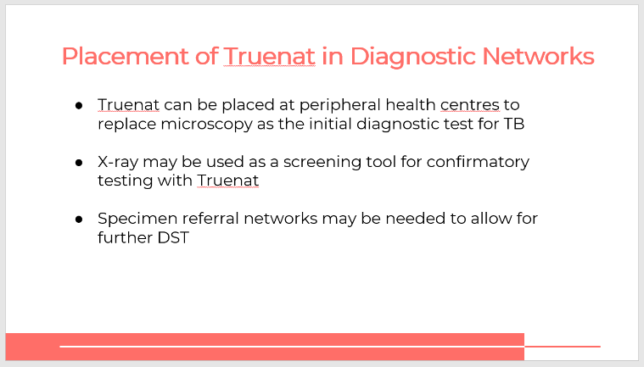
SAY: In many countries, Truenat will be placed at peripheral health centres to replace microscopy as the initial diagnostic test for TB. It is possible that an X-ray may be used as a screening tool for confirmatory testing with Truenat.
Specimen referral networks may be needed to allow for further DST.
ASK: Are there any questions before we move on to the next topic?
Positioning vs. Xpert or TB-LAMP
Slide: 29
Participant Guide Page: 8
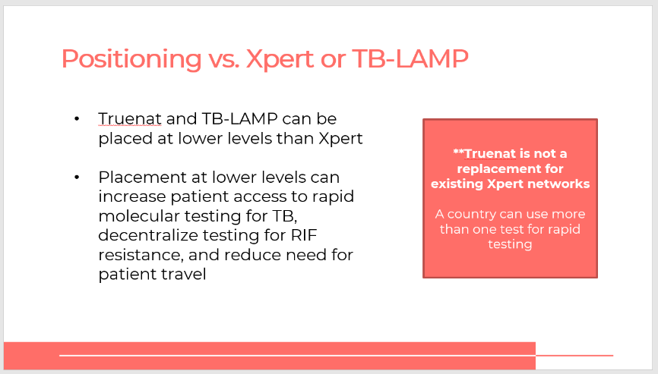
SAY: It’s important to note that Truenat is not a replacement for existing Xpert networks. When it comes to positioning versus Xpert or TB LAMP, a country can use more than one test for rapid testing. Truenat and TB-LAMP can be placed at lower levels of the network than Xpert.

Three things can happen when placement is at lower levels:
- Patient access to rapid molecular testing for TB can increase
- RIF resistance testing can be decentralized
- The need for patient travel can be reduced

Diagnostic Accuracy of Truenat
Diagnostic accuracy relative to culture, in microscopy center settings
Slide: 31
Participant Guide Page: 9
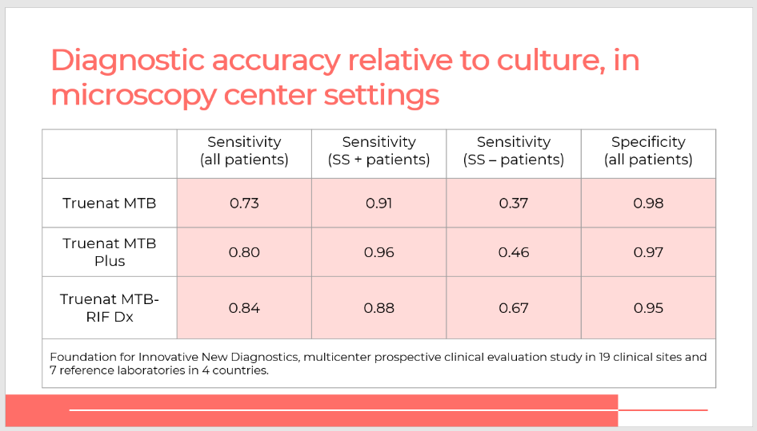
SAY: This table shows the diagnostic accuracy of each of the Truenat tests (MTB, MTB Plus, and MTB-RIF) relative to culture, in microscopy center settings.
ASK: Can someone explain to us what sensitivity and specificity mean?
DO: Allow participants to answer.
SAY: That’s right, (or, that’s close): sensitivity refers to a test's ability to designate an individual with disease as positive. A highly sensitive test means that there are few false negative results, and thus fewer cases of disease are missed. The specificity of a test is its ability to designate an individual who does not have a disease as negative.
ASK: What do you notice about the specificity and sensitivity of Truenat relative to culture? What stands out to you in this table?
DO: Allow participants to provide some responses. If not raised by participants, offer the following main points:
- In general, Truenat showed comparable results in terms of diagnostic accuracy relative to culture, which is the gold standard. The validation studies showed high sensitivity and specificity levels compared with culture.
- Truenat MTB Plus is a bit more sensitive relative to culture than Truenat MTB
Diagnostic Accuracy Relative to Culture, Reference Laboratory Settings
Slide: 32
Participant Guide Page:10
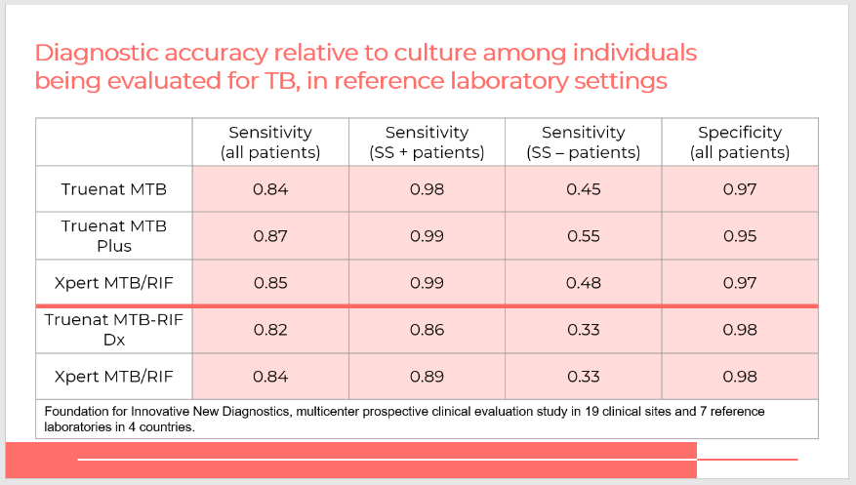
SAY: This table shows the diagnostic accuracy relative to culture in a reference laboratory setting for Truenat and Xpert tests.
ASK: What is the main point of the information in this table?
DO: Allow participants to respond. Emphasize that the main point is that the performance of Truenat MTB, MTB Plus and MTB-RIF Dx tests were generally comparable to their Xpert counterparts.
Effect of prior treatment on specificity
Slide: 33
Participant Guide Page:11
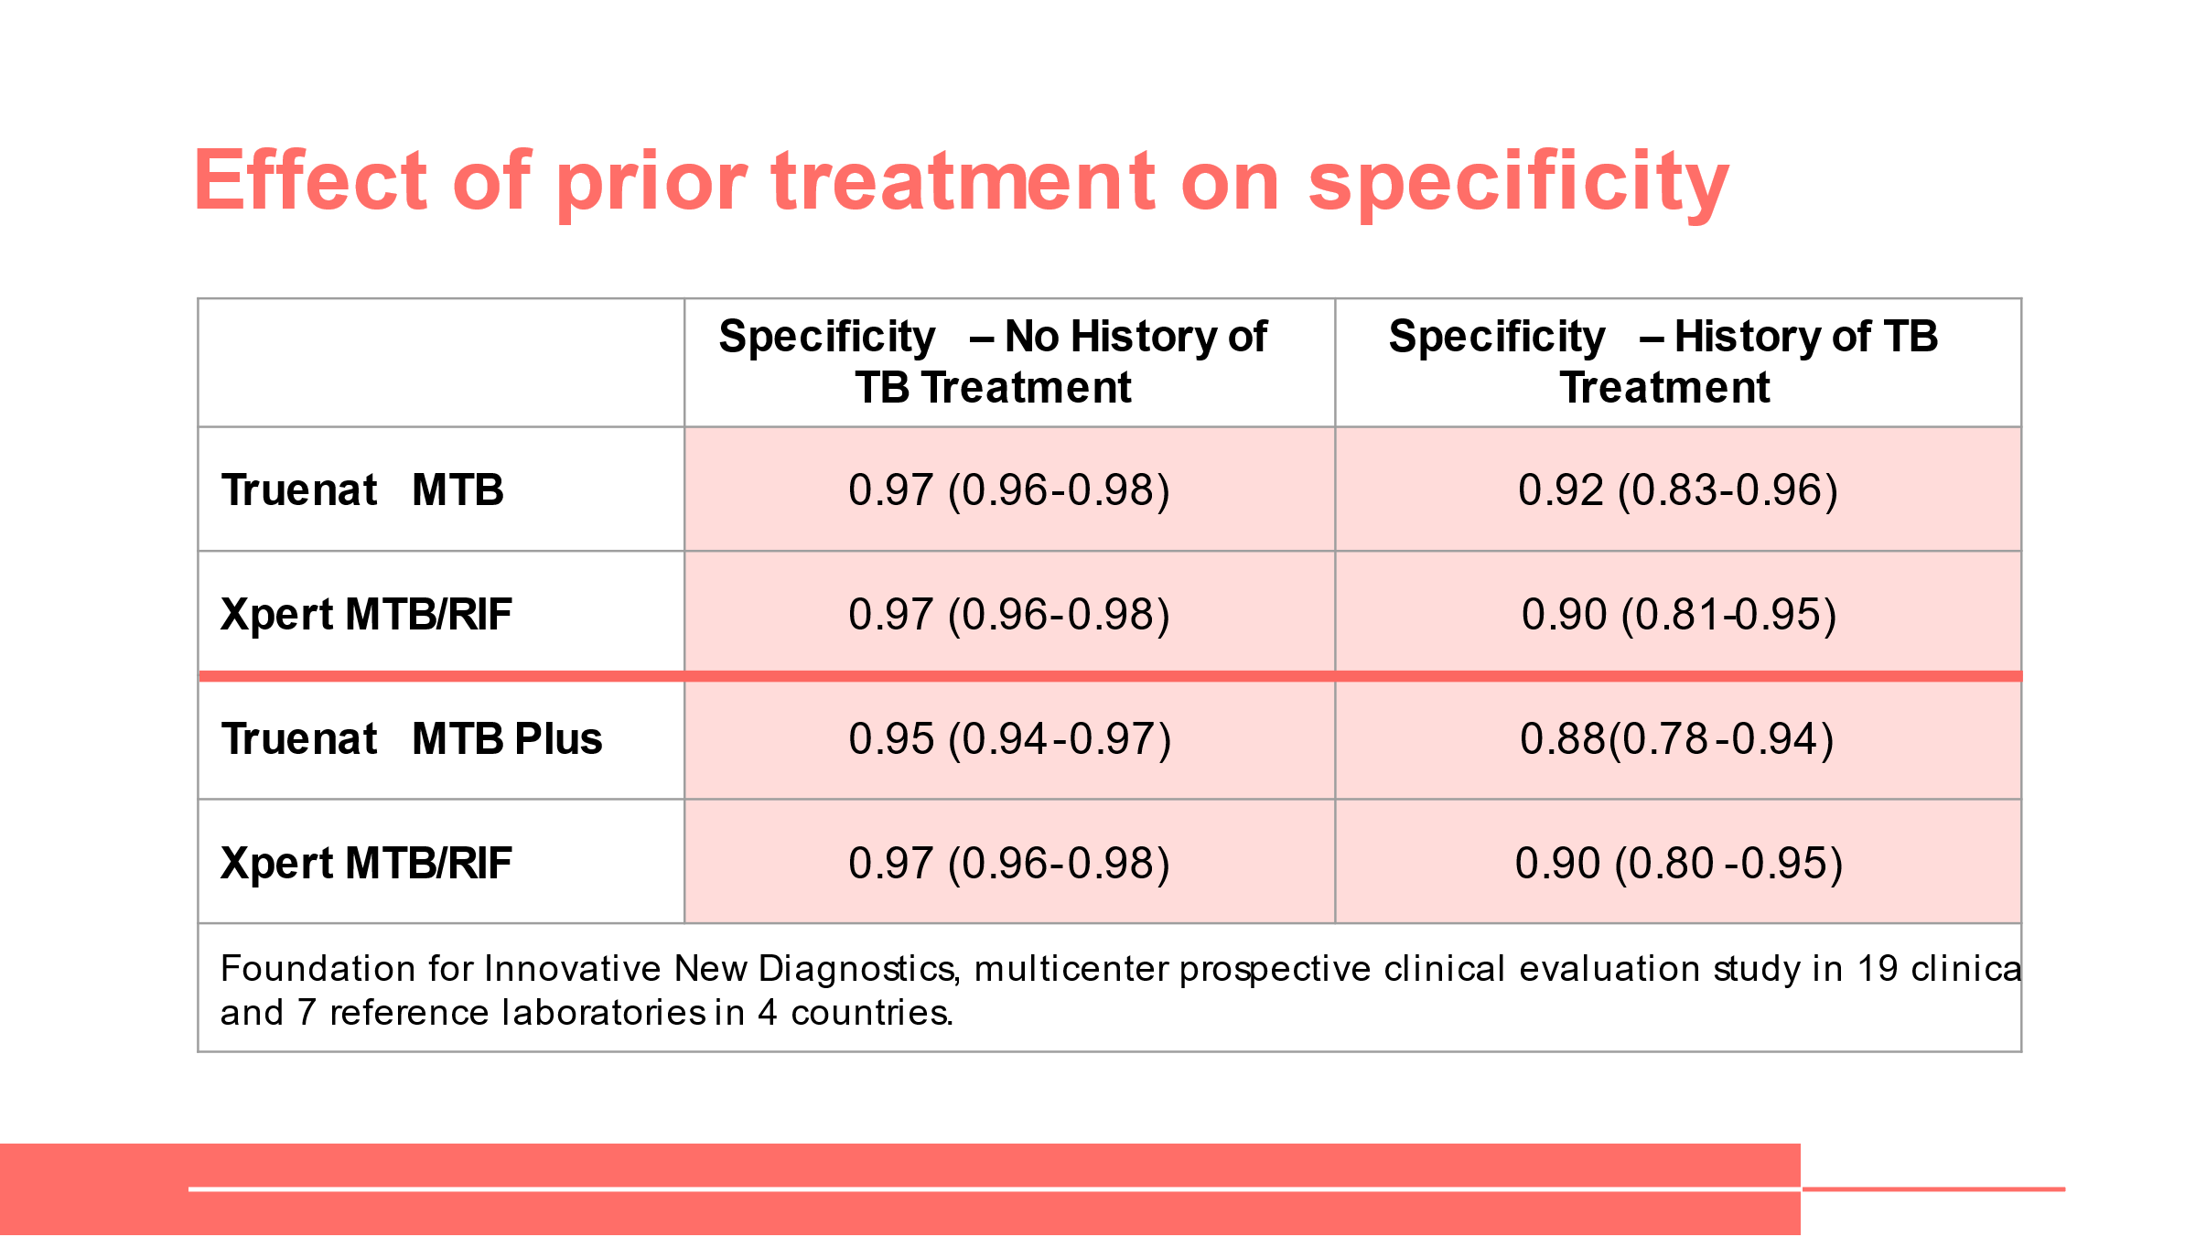
Sensitivity and Specificity Trade-Offs
Slide: 34
Participant Guide Page:11
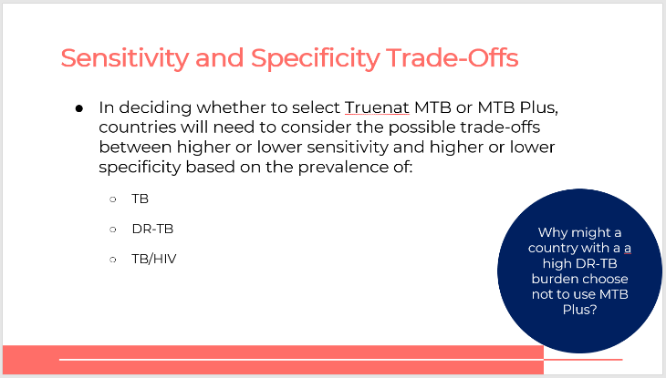
SAY: There is a similar consideration to make when selecting Truenat MTB or MTB Plus, which is more sensitive but less specific than the regular. We would have to consider the prevalence of TB, the prevalence of drug resistant TB, and the prevalence of TB-HIV co-infection.
DO: Click on the slide for animation to bring up the discussion question.
ASK: Why might a country with a high DR-TB burden choose not to use MTB Plus?
DO: Allow participants to answer, then move to next slide.
High HIV Burden Settings
Slide: 35
Participant Guide Page: 12
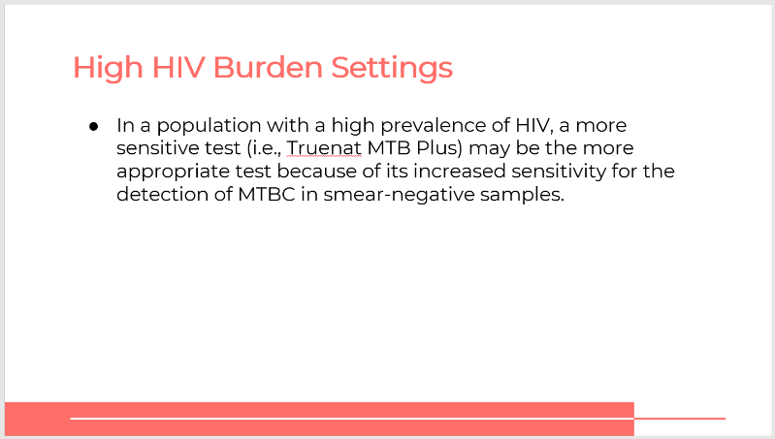
SAY: On the reverse side, in a population with a high prevalence of HIV, a more sensitive test like Truenat MTB Plus may be better because of its ability to detect MTBC in smear-negative samples.
Advantages of Truenat
Slide: 36
Participant Guide Page: 12
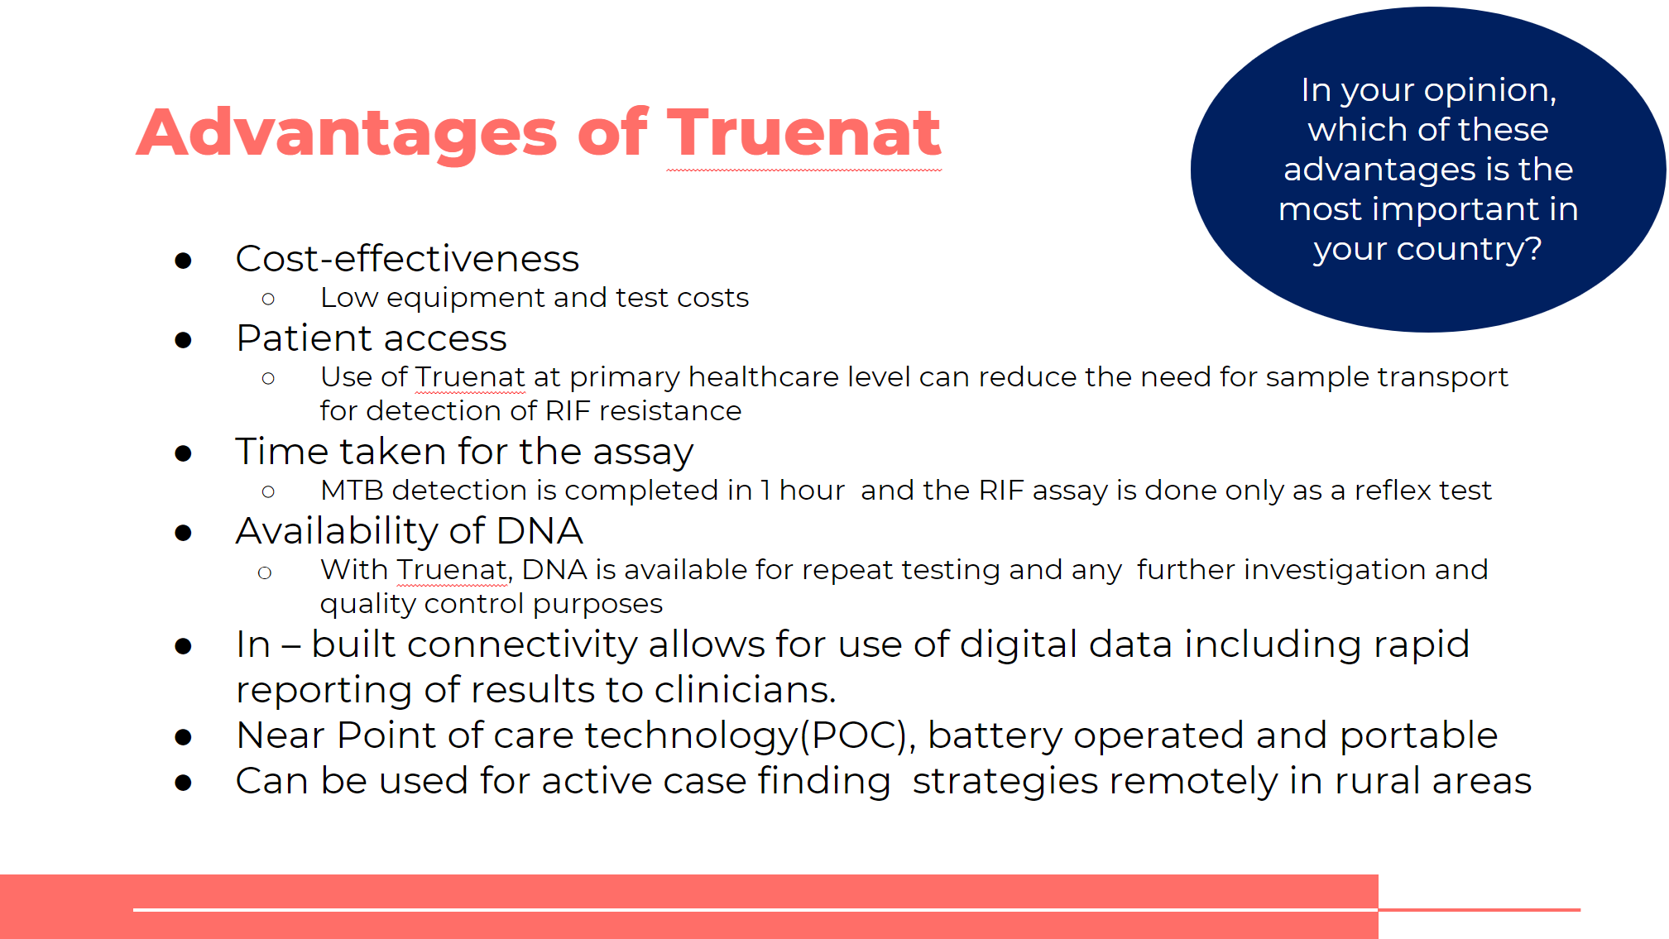
SAY: In addition to a high level of diagnostic accuracy, there are a few other key advantages of Truenat.
DO: Read through the material on the slide. Click on the slide for animation to bring up the discussion question, read it, and allow participants to respond. Their answers should speak to the key challenges that were identified at the beginning of this module.

Activity: Which Test Should I Use?
Activity: Which Test Should I Use?
Slides: 37-39
Participant Guide Page:13
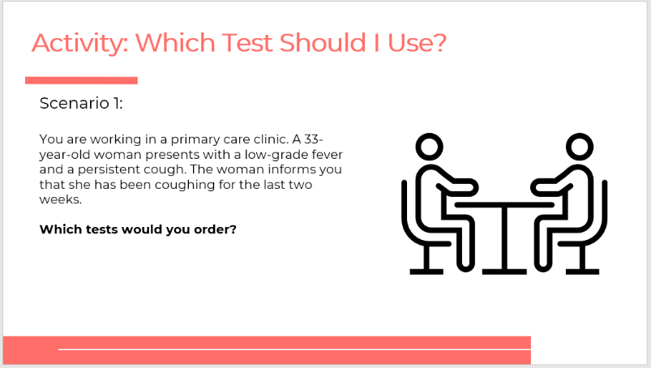
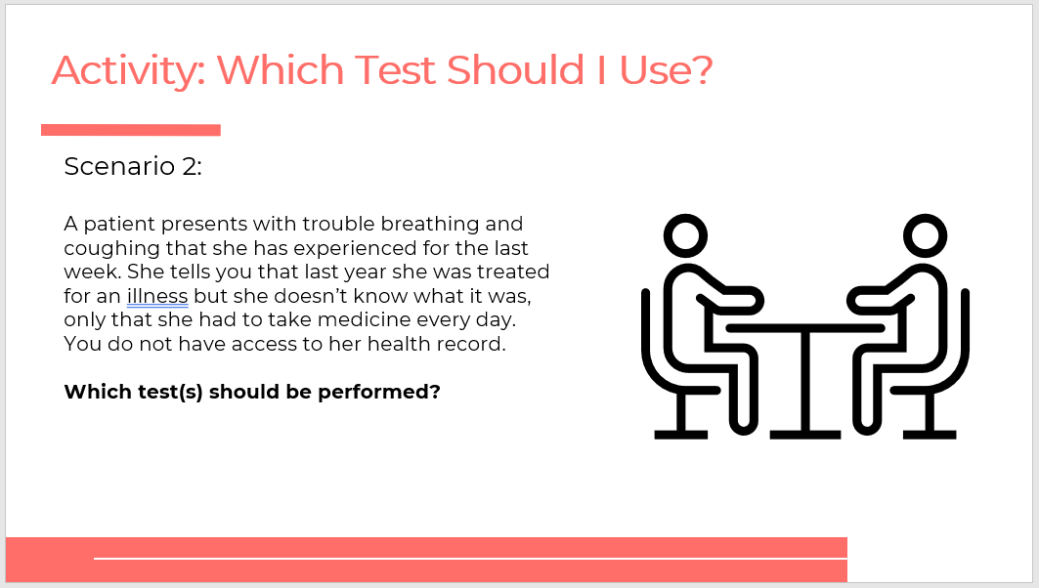
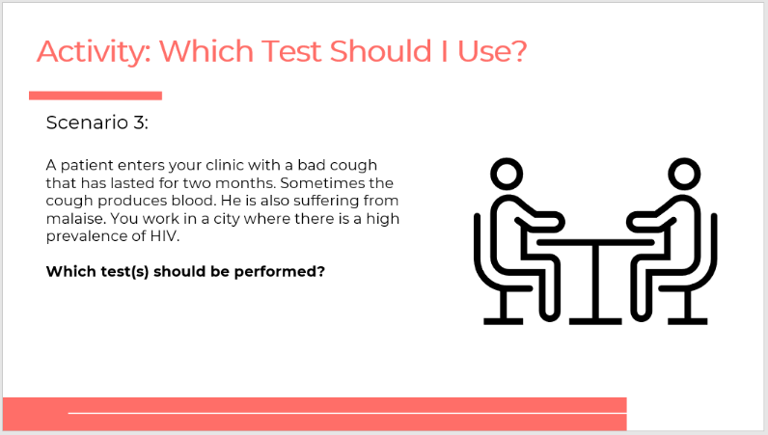
SAY: In your participant guide, starting on page 13, you will find three scenarios. With a partner, you are to read each scenario and determine which test or tests should be used. Be sure to write your rationale. You will have 10 minutes.
DO: Allow participants to answer the scenario questions in the Participant Guide with their partner. After 10 minutes, call on participants to share their responses. Be sure to correct any incorrect responses.
ANSWERS:
Scenario 1: According to WHO recommendations, Truenat MTB or MTB Plus testing should be ordered. Xpert or Xpert Ultra could also be correct – choosing between Truenat and Xpert will depend on national algorithms and which test is more accessible. You might also order a chest X-ray before performing tests to see if there are abnormalities.
Scenario 2: A less sensitive test, such as Truenat MTB, should be ordered and may require a confirmatory test.

Scenario 3: A more sensitive test, such as Truenat MTB Plus, should be ordered.

Summary
Summary
Slide: 40
Participant Guide Page:15
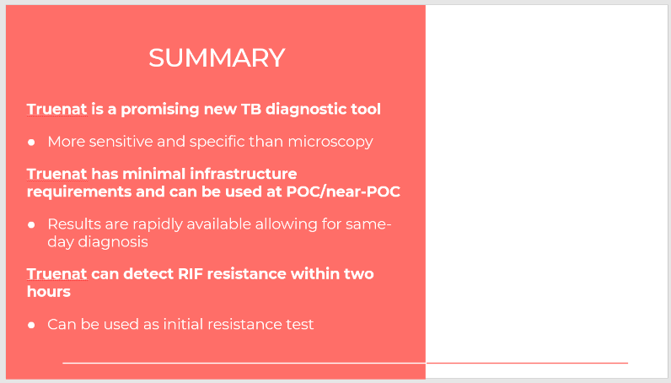
SAY: In this lesson, you learned about the global and country specific TB situation, different diagnostic TB lab tests, and the diagnostic accuracy of Truenat. The key takeaways from this module is that Truenat is a promising new TB diagnostic tool that is more sensitive and specific than microscopy. Truenat has minimal infrastructure requirements and results are rapidly available. It can also detect RIF resistance within two hours and can be used as an initial drug resistance test.
DO: Ask participants if they have any questions about today’s lesson. Allow participants to ask questions. Answer any clarifying questions.
SAY: Thank you for your attention today. Your next session will be on the Truenat diagnostic algorithm and results interpretation.

Knowledge Check
Knowledge Check
Slides: 41-44
Participant Guide Page: 15
DO: Explain that you will ask participants three knowledge check questions and may call on participants randomly to provide an answer. (These can also be programmed as poll questions in a virtual training – ensure that all participants respond before proceeding if using the poll feature).

If an answer provided in incorrect, ask if other participants would like to answer. Correct any incorrect answers that are given. If multiple participants get a question wrong, you may need to revisit the topic.

Note that knowledge check questions are not included in participant guides to avoid students seeing them during the lesson and only focusing on those pieces. Encourage participants to write down the answers in their guides in the notes field for future reference.
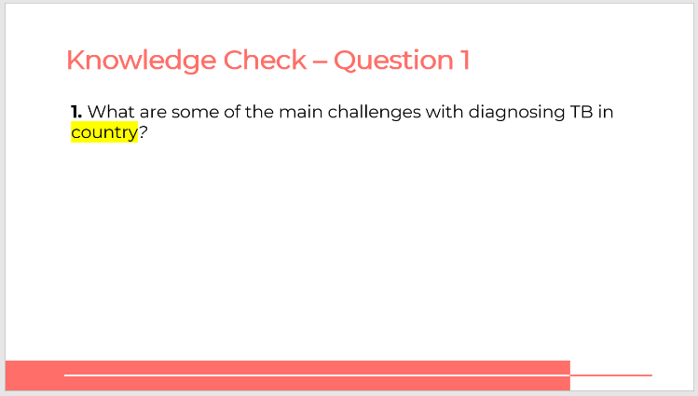
Answer: Answers will vary depending on the country.
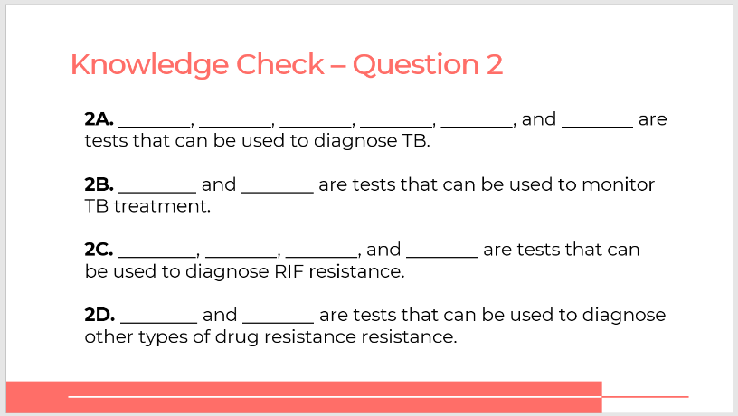
Answer:
- 2A: AFB-smear microscopy, culture, TB-LAMP, LF-LAM antigen, Xpert, Truenat
- 2B: AFB-smear microscopy, culture
- 2C: Phenotypic DST, LPA, Xpert, Truenat (and maybe culture – maybe, provides an isolate for DST)
- 2D: Phenotypic DST, LPA (and maybe culture – maybe, provides an isolate for DST)
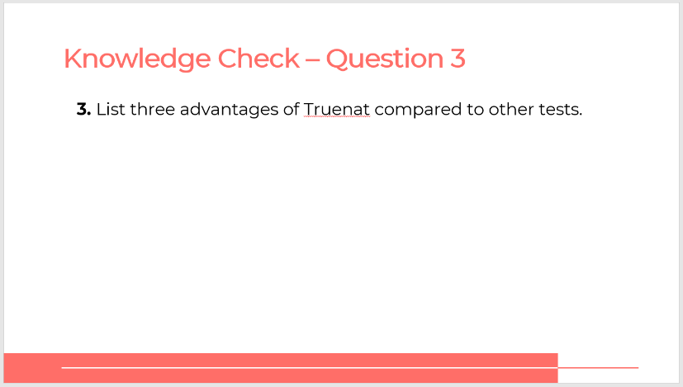
Possible Answers: Cost-effectiveness, patient access, time taken for the assay, availability of DNA for other tests
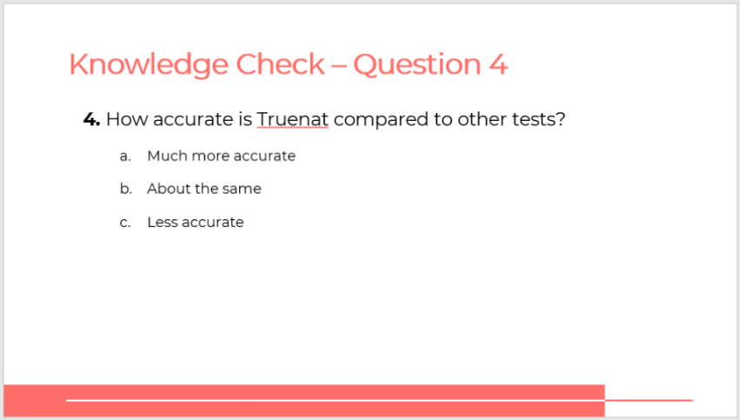
Answer: Truenat is generally as accurate as other tests, however, countries and service providers should weigh trade-offs between specificity and sensitivity in deciding which tests to use.

Module 2: Diagnostic Algorithm and Results Interpretation

Target Audience
The target audience for this course is:
- Lab technicians
- Lab managers
- Program managers
- Clinicians

Learning Objectives
Terminal Objective
- At the end of this session, participants should be able to use the Truenat algorithm to guide decisions around TB testing.

Module Objectives
- By the end of this session, participants should be able to:
  - Implement the WHO recommendations for using Truenat
  - Follow the Truenat algorithm and decision tree to use Truenat
  - Understand patient flow within the TB diagnostic network and describe procedures for patient referral

Materials
- Facilitator Guide
- Participant Guide
- Pens/Pencils

Advance Preparation
Countries may need to customize the Truenat algorithm to reflect specific context of TB testing in their country. If so, the slides in this module may need to be revised.

Lesson Plans

Introduction
Introduction
Slide: 3
Participant Guide Page: 16
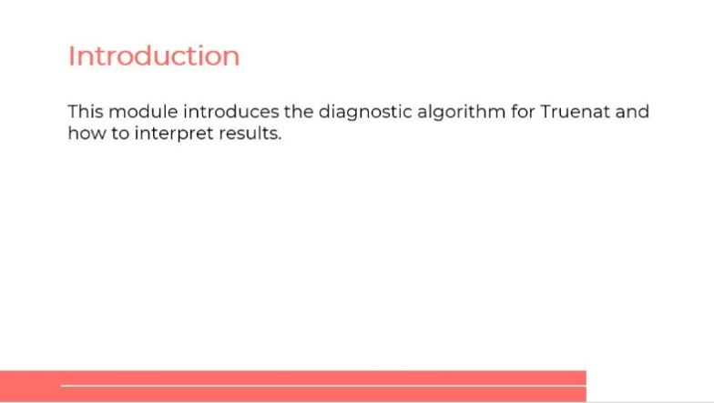
SAY: Our topic today is on the diagnostic algorithm for Truenat. We will talk about how to use the algorithm and interpret the results.
Module 2: Truenat Algorithm
Slide: 4
Participant Guide Page: 16
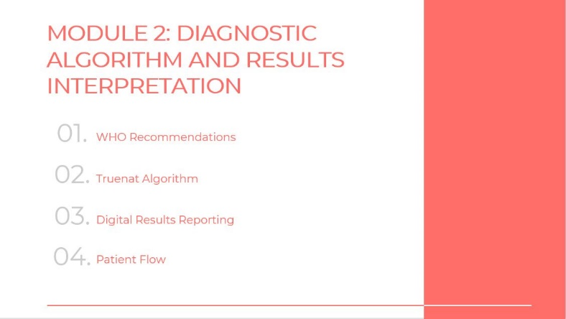
SAY: We will discuss WHO’s recommendations for utilizing Truenat, the algorithm, interpreting digital results and how to use patient flow.
Lesson Objectives
Slide: 5
Participant Guide Page: 16
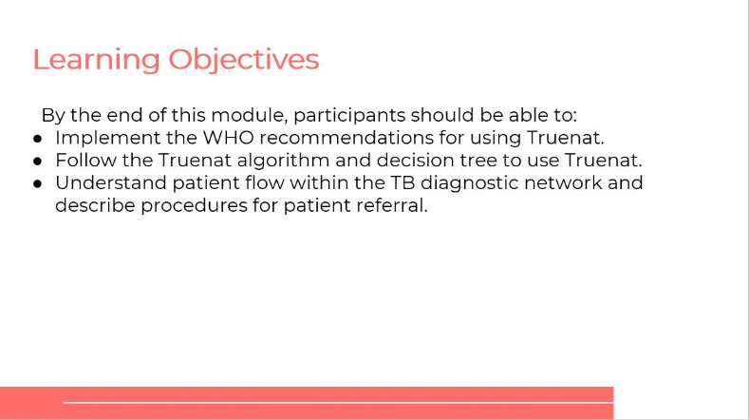
SAY: By the end of this module, you will be able to:
- Implement the WHO recommendations for using Truenat.
- Follow the Truenat algorithm and decision tree to use Truenat.
- Understand patient flow within the TB diagnostic network and describe procedures for patient referral.
ASK: What questions do you have before we move into the first lesson for this training?
DO: Allow participants time to ask questions and respond appropriately.

WHO Recommendations
WHO Recommendations
Slide: 7
Participant Guide Page: 16
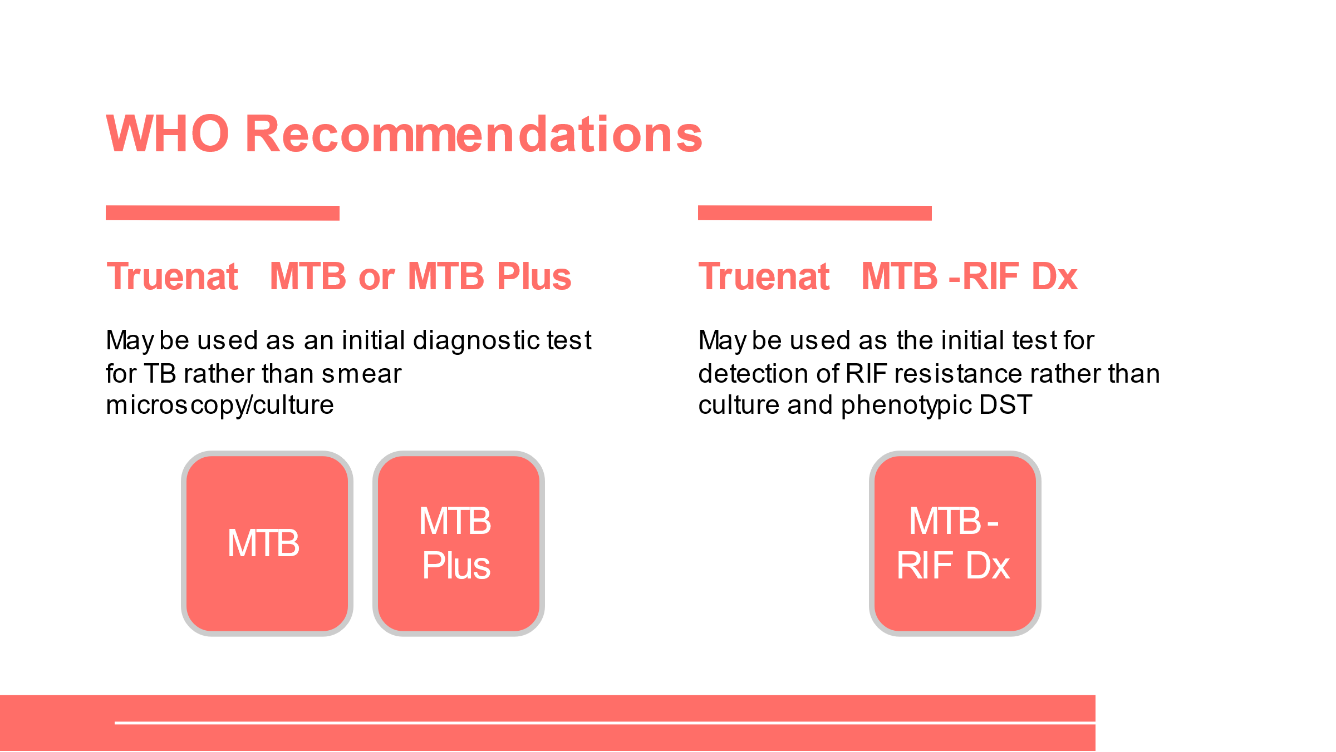
SAY: As we discussed in the last module, WHO has two recommendations related to Truenat testing. Truenat MTB or MTB Plus may now be used as an initial diagnostic test for TB rather than smear microscopy or culture in adults and children with signs and symptoms of pulmonary TB. Truenat MTB-RIF Dx can be used as the initial test for detection of RIF resistance rather than culture and phenotypic DST for persons with a Truenat MTB or MTB Plus positive result.
When to Use Truenat
Slide: 8
Participant Guide Page: 17
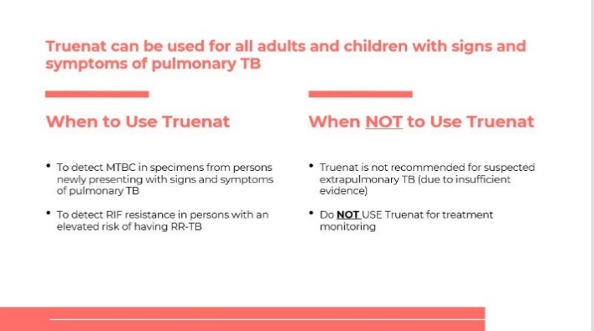
DO: Lead participants through a facilitated discussion on this slide. Review the bullets with them and then ask a series of questions to fill in the gaps. Inform participants to write the answer to the discussion questions in the Participant Guide.
SAY: These recommendations mean that Truenat can be used for all adults and children with signs and symptoms of pulmonary TB. You can use Truenat to detect MTBC in specimens from persons newly presenting with signs and symptoms of pulmonary TB, and to detect RIF resistance in persons with an elevated risk of having RR-TB (really, to detect RIF resistance in anyone with a positive TB test).

There are instances when Truenat should not be used. Due to insufficient evidence in this situation, Truenat should not be used for suspected extrapulmonary TB. You should also never use Truenat for treatment monitoring as the presence of dead bacilli may generate a false positive result.
ASK: What are the signs and symptoms of pulmonary TB?
ANSWER: Signs and symptoms of TB include breathing difficulty, chest pain, cough (usually with mucus), coughing up blood, excessive sweating, particularly at night, fatigue, fever, weight loss. Additionally, a chest X-ray with abnormalities is suggestive of pulmonary TB and may be used as a screening test before using Truenat.
ASK: Which persons have an elevated risk of RIF-resistant (RR)-TB? (Or, when should you suspect RR-TB?)
ANSWER:
Persons with an elevated risk of having RR-TB include previously treated patients with a new TB episode or potential relapse, previously treated patients who were non-converters, and previously treated patients who were lost to follow up. Participants might also include close contacts of RR/MDR-TB patients, patients with treatment failure, and smear-positive patients at the end of the third month of initial treatment.
ASK: What are the signs and symptoms of extrapulmonary TB?
ANSWER: Symptoms of extrapulmonary TB are similar to pulmonary TB (including fever, malaise, and weight loss. It is most common among young children, immunocompromised people, and the elderly). For this reason, health care providers may not be able to distinguish between pulmonary and extra-pulmonary TB before ordering a Truenat test. Again, it is not that Truenat does not work to diagnose extrapulmonary TB, but that there is insufficient evidence for WHO to recommend its use in these circumstances.
QUESTION: As covered in our last module, what tests can you use for TB treatment monitoring?
ANSWER: Culture, AFB-Smear microscopy

Truenat Algorithm
Truenat Algorithm
Slide: 10
Participant Guide Page: 19
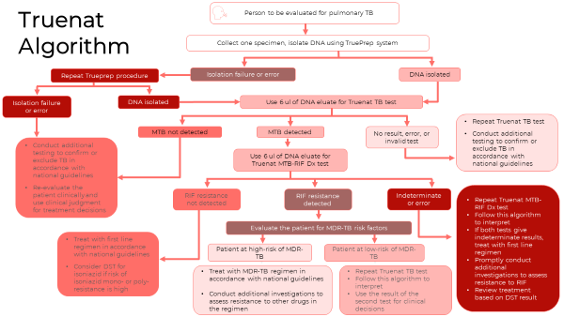
SAY: The Truenat algorithm breaks down the testing approach for using Truenat to detect MTBC and RIF-resistance. We will break down the algorithm in parts. Molbio has also developed a job aid that can be posted in laboratories for easy reference, and the algorithm is also included in the Truenat Implementation Guide
Algorithm Part 1: Isolate DNA
Slides: 11 – 13
Participant Guide Page: 20
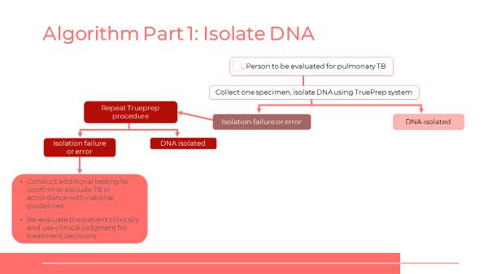
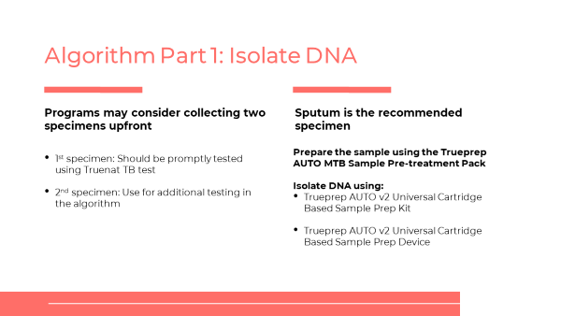
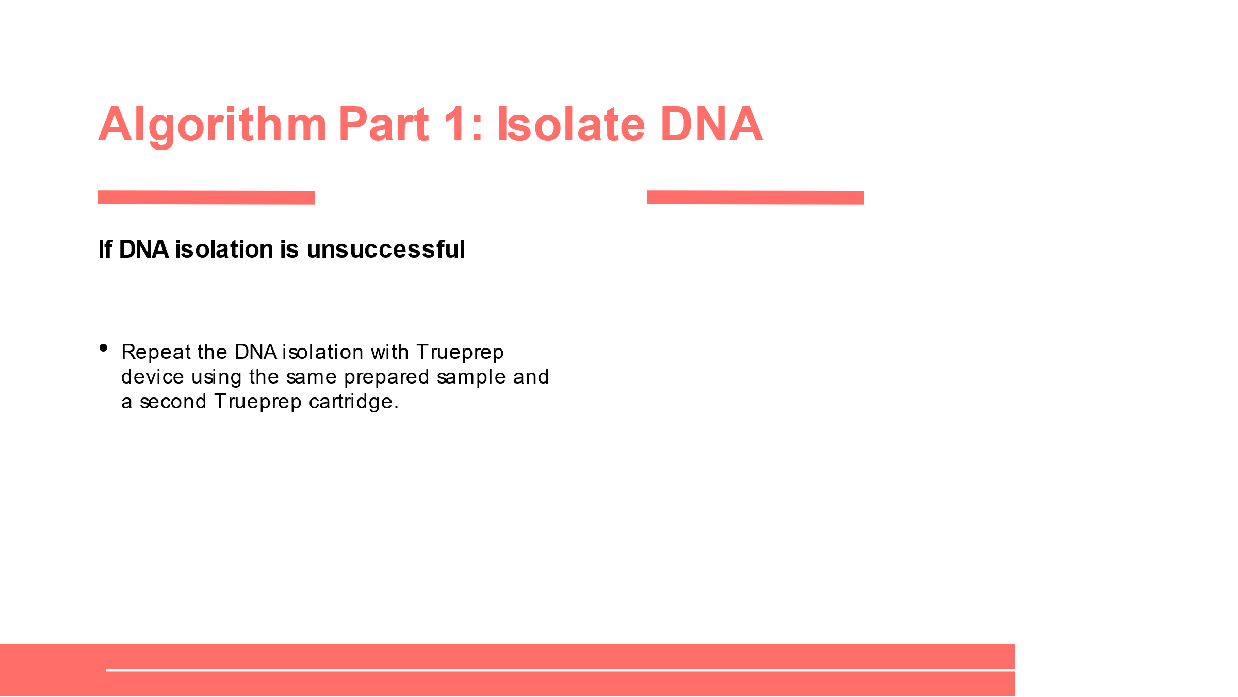
SAY: When it is decided that a person should be evaluated for pulmonary TB, a sputum sample should be collected from the patient. Programs might consider collecting two specimens upfront – one to test with Truenat, and the other to use for additional testing that may be needed per the algorithm. Once you have the specimen and it is pretreated, the DNA should then be isolated using the Trueprep system. We will talk about how to use the Trueprep and Truelab systems in the next module, but for now, you should just note that you will isolate the DNA. If the DNA is successfully isolated, you are done with the first step. If you get an isolation failure or error, you should repeat the Trueprep procedure, and if the DNA is isolated this time, again you are ready for the next step.
ASK: According to the algorithm, what should you do if you receive an isolation failure or error twice when trying to isolate the DNA?
DO: Inform participants that they can reference the algorithm in their participant guide. Ask them to write a response in their own words in the Participant Guide. Call on participants to share their answers. Correct any incorrect answers.
ANSWER: Conduct additional testing to confirm or exclude TB in accordance with national guidelines or re-evaluate the patient clinically and use clinical judgement for treatment decisions.
ASK: What are some additional tests you could use if the second attempt is also unsuccessful?
DO: Call on participants to share their answers. Correct any incorrect answers.
ANSWER: Additional testing can consist of a repeat test with a new specimen, further DST, a chest X-ray, smear microscopy, or cultures.
Algorithm Part 2: TB Test
Slides: 14-17
Participant Guide Page: 22
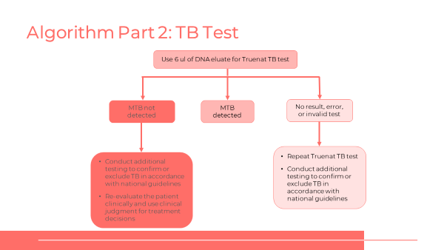
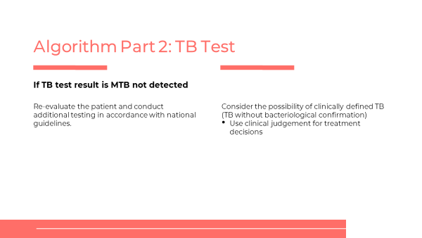
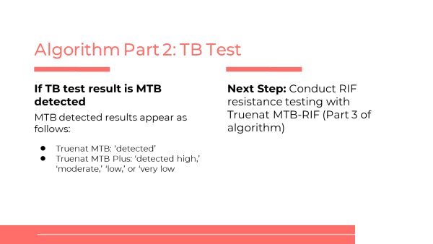
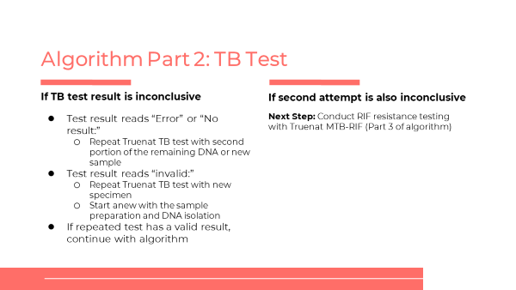
SAY: We are moving to part two of the Truenat algorithm, which is the TB test. Once you have the DNA isolated, use six ul of the DNA eluate for the Truenat TB test. There are three outcomes of the test: MTB not detected, MTB detected and no result, error or invalid test.
DO: Go over the procedures for TB results for MTB not detected, MTB detected and TB inconclusive.
ASK: In your participant guide, list as many re-evaluation options as possible to consider if a TB test result is MTB not detected.
DO: Allow participants three minutes to write their responses in the Participant Guide. Call on multiple students to answer the question. Correct any incorrect answers.
ANSWER: Further investigations for TB may include chest X-ray, additional clinical assessments, clinical response following treatment with broad-spectrum antimicrobial agents, additional Truenat TB testing, testing with other WHO-approved rapid diagnostic tests (e.g., Xpert MTB/RIF) or culture.
Algorithm Part 3: RIF Resistance Test
Slides: 18-22
Participant Guide Page: 25
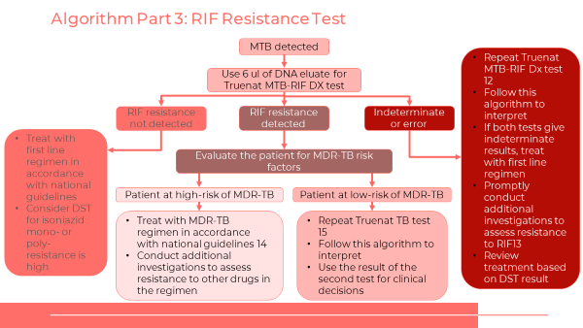

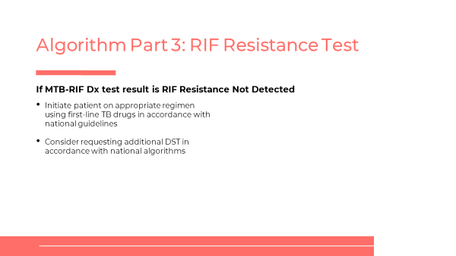
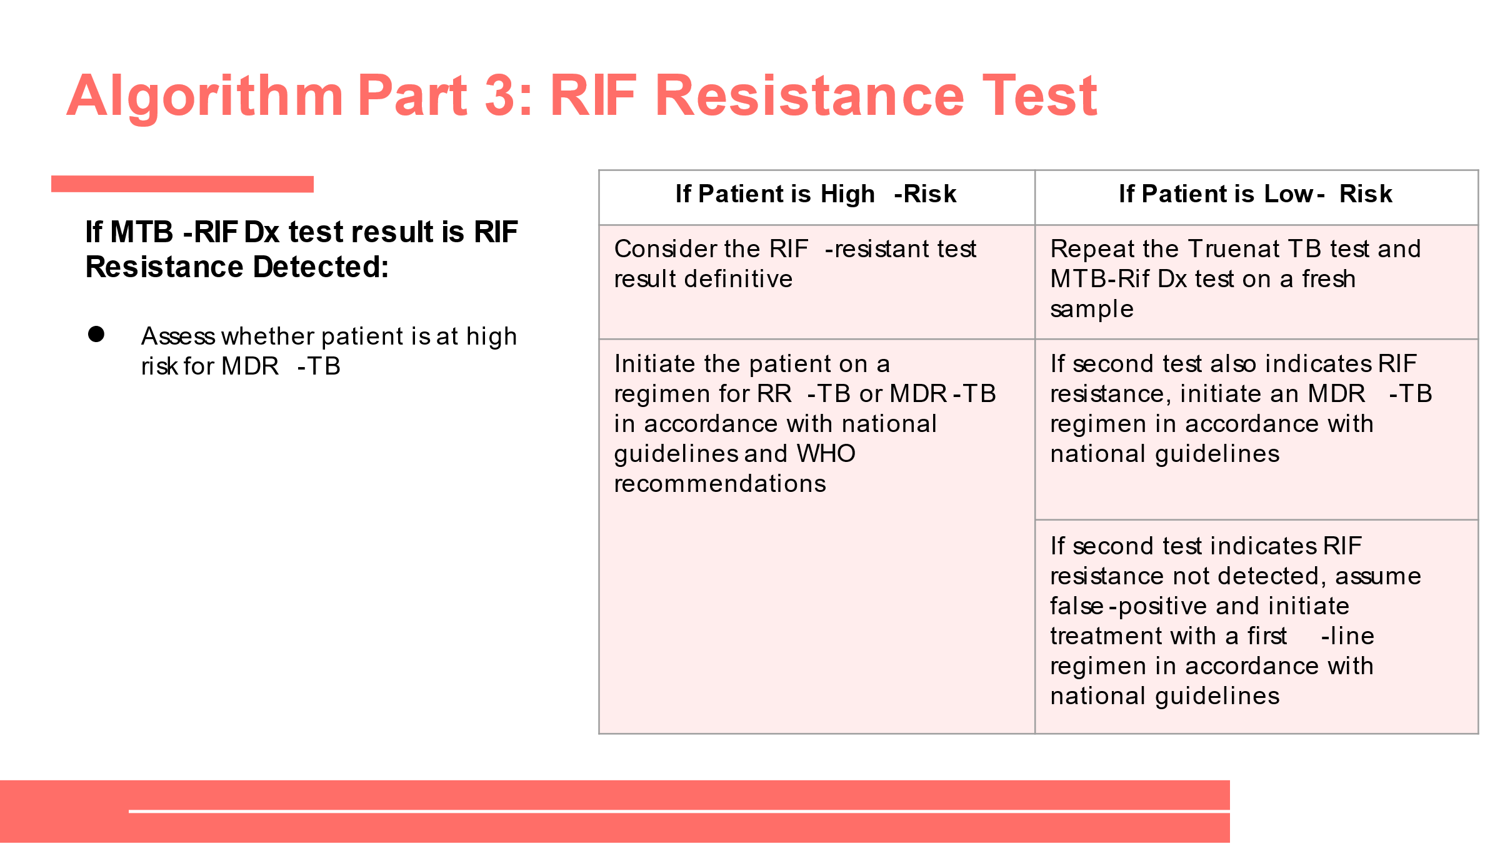
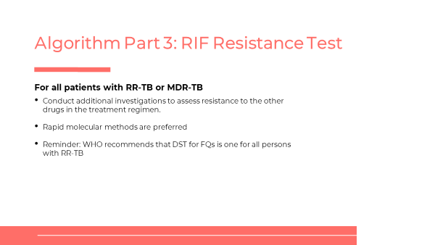
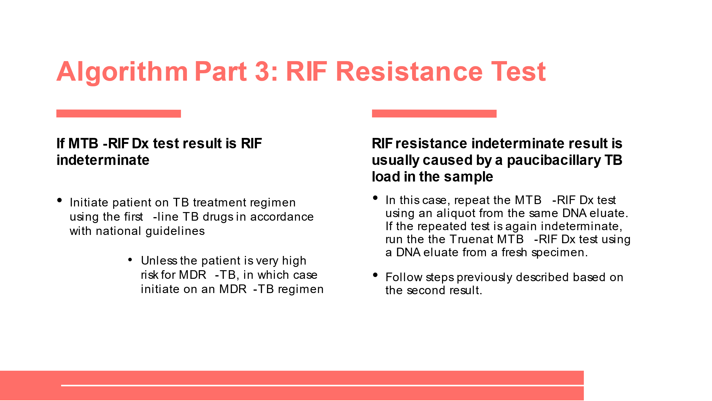
SAY: The third part of the algorithm is used if the specimen is positive for TB in the second part. In this case, you will:
- Use 6 ul of the same DNA eluate that was prepared for the TB test.
- Use the Truelab Real Time micro PCR Analyzer with the Truenat MTB-RIF Dx test cartridge.
- If there are delays in conducting the test, initiate treatment using first-line TB drugs in accordance to the national guidelines. If the patient is very high risk for MDR-TB, initiate on an MDR-TB regimen.
- There are three possible outcomes of MTB-RIF Dx test:
  - RIF resistance detected
  - RIF resistance not detached
  - RIF indeterminate
DO: Go over the procedures for each of the three possible outcomes.

Activity: Truenat Algorithm
Truenat Algorithm
Slide: 23
Participant Guide Page: 28
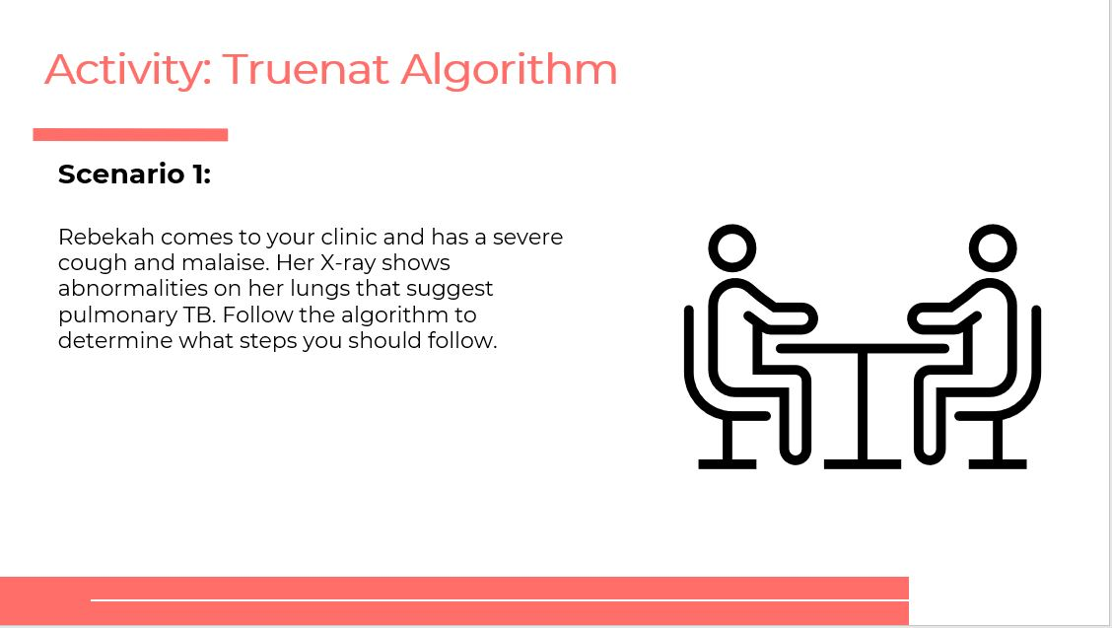
SAY: You will now get a chance to practice using the Truenat Algorithm. You will be placed in groups of 4-5 members. In your group you will complete the scenario in your Participant Guide. You have 15 minutes to complete the scenario.
DO: After 15 minutes, call on participant groups to share their responses. Ask other groups if they chose a different response and to share their rationale. Be sure to correct any incorrect responses.
ANSWERS:
- Rebeka should be tested for TB. You should collect a sputum sample, transport it to a site with Truenat, and isolate the DNA using the Trueprep system.
- Repeat the DNA isolation with Trueprep using the same prepared sample and a second Trueprep cartridge.
- The possible outcomes of the TB test are MTB Detected or MTB not detected or No result, error or invalid test.
- A RIF-resistance test
- The patient would be considered low-risk, so you should repeat the Truenat TB test and MTB Rif Dx test on a fresh sample.
- Assume the test was a false-positive and initiate treatment with a first-line regimen in accordance with national guidelines. (If in a country with high risk of isoniazid resistance, consider additional DST for isoniazid.)

What methods are available to evaluate drug resistance?

Patient Flow
Patient Flow
Slide: 25
Participant Guide Page: 29
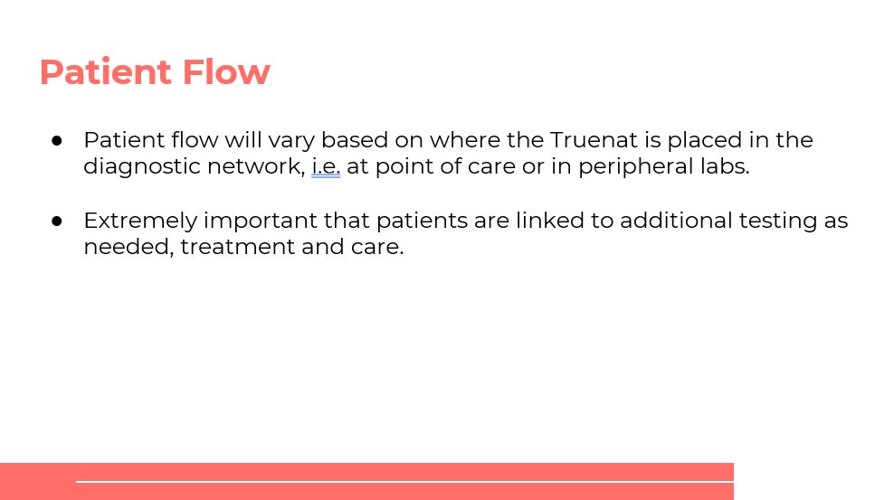
SAY: Patient flow will vary based on where the Truenat is placed in the diagnostic network. Regardless, it is extremely important that patients are linked to additional testing as needed, treatment and care.
ASK: Based on your experience, what are some key considerations in developing a patient referral pathway for Truenat in your country?
DO: Call on participants to respond to the question.
Answers will vary based on your country.
Questions to Consider About Patient Flow
Slide: 26
Participant Guide Page: 30
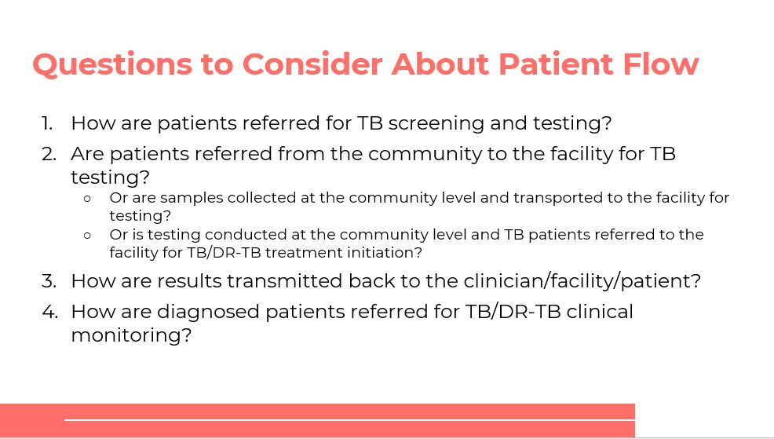
SAY: Let’s talk about some key considerations for patient flow for Truenat testing. Respond to the questions in your Participant Guide, starting on page 30.
DO: Allow participants five minutes to complete the questions in their Participant Guide.
Ask participants to share how the patient flow works in their country.
Example DS-DR-TB Patient Referral Pathway
Slide: 27
Participant Guide Page: 32
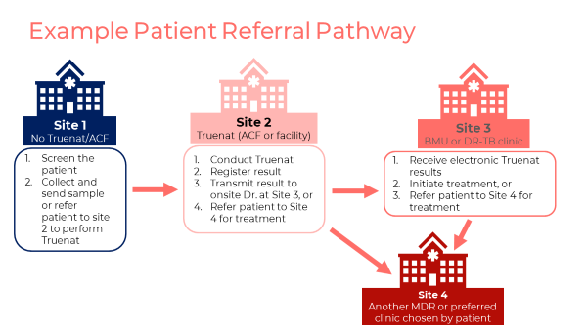
SAY: Let’s take a look at an example patient referral pathway.
DO: Review the patient referral pathway example slide.
SAY: Some key facts to remember about the patient referral pathway are:
- The sample flow must follow the patient referral pathway.
- It is important that Truenat testing sites ensure that results are transmitted back to the requesting site/community.
- If a site cannot initiate, DR-TB patients must ensure Truenat-RR-TB results are transmitted to the DR-TB clinic when patients are referred.
- Truenat is portable and can be used at the community level.
- Monitor the flow with quality assurance indicators, which will be discussed in a future module.
DO: Ask participants if they have any questions. Answer any clarifying questions.

Procedures for Patient Transfers and Referrals
Slide: 28
Participant Guide Page: 33
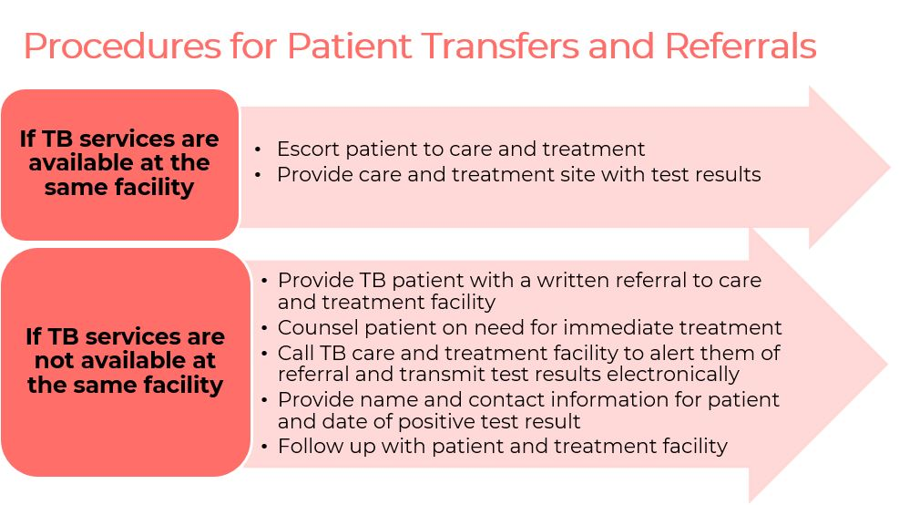
SAY: There are procedures that should be followed for patient transfers and referrals.
If TB services are available at the same facility, the patient should be escorted to care and treatment. The care and treatment site should be given the test results.

If TB services are not available at the same facility, follow these steps:
- Provide TB patient with a written referral to the care and treatment facility.
- Counsel patient on the need for immediate treatment.
- Call the TB care and treatment facility to alert them of the referral and transmit the test results electronically.
- Provide the patient’s name and contact information with the date of the positive test result.
- Follow up with patient and treatment facility.
DO: Ask participants if they have any questions. Answer any clarifying questions.
Digital Results Reporting
Slide: 29
Participant Guide Page: 34
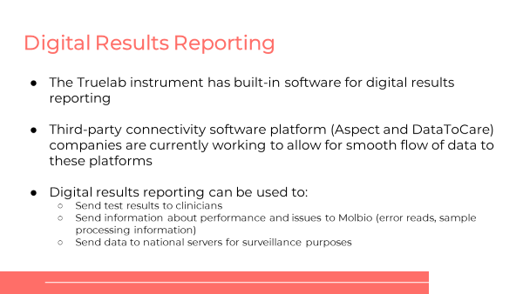
SAY: Next, we are going to look at some of the features of Truenat related to digital results reporting.

Every Truelab instrument has built-in software for digital results reporting. Third-party connectivity software platform (Aspect and DataToCare) companies are currently working to allow for smooth flow of data to these platforms.

Digital results reporting can be used to:
- Send test results to clinicians
- Send information about performance and issues to Molbio (error reads, sample processing information)
- Send data to national servers for surveillance purposes.
DO: Ask participants if they have any questions. Answer any clarifying questions.

Summary
Summary
Slide: 30
Participant Guide Page: 34
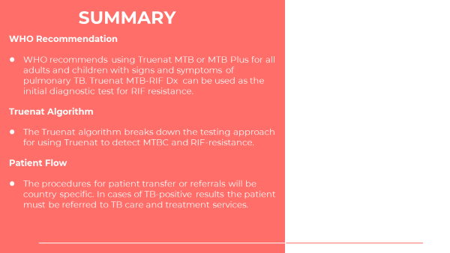
SAY: We have now come to the end of this session. Let’s recap.

- WHO recommends using Truenat MTB or MTB Plus and MTB-RIF Dx for all adults and children with signs and symptoms of pulmonary TB.
- The Truenat algorithm breaks down the testing approach for using Truenat to detect MTBC and RIF-resistance.
- The procedures for patient transfer or referrals will be country specific. In cases of TB-positive results the patient must be referred to TB care and treatment services.

Knowledge Check
Knowledge Check
Slides: 31 – 33
Participant Guide Page: 35
DO: Explain that you will ask participants three knowledge check questions and may call on participants randomly to provide an answer. (These can also be programmed as poll questions in a virtual training – ensure that all participants respond before proceeding if using the poll feature).

If an answer provided in incorrect, ask if other participants would like to answer. Correct any incorrect answers that are given. If multiple participants get a question wrong, you may need to revisit the topic.

Note that knowledge check questions are not included in participant guides to avoid students seeing them during the lesson and only focusing on those pieces. Encourage participants to write down the answers in their guides in the notes field for future reference.
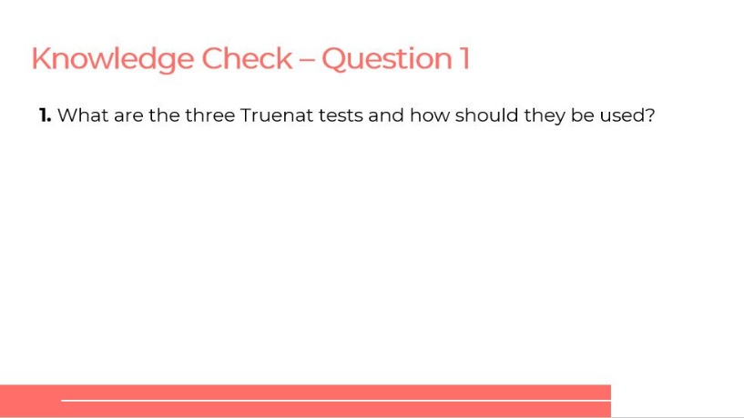
ANSWER: Truenat MTB, MTB Plus, and MTB-RIF and MTB Plus should be used as an initial diagnostic test for TB. MTB-RIF Dx should be used as the additional diagnostic test for RIF resistance.
ANSWER: Isolate DNA, TB test and RIF resistance test
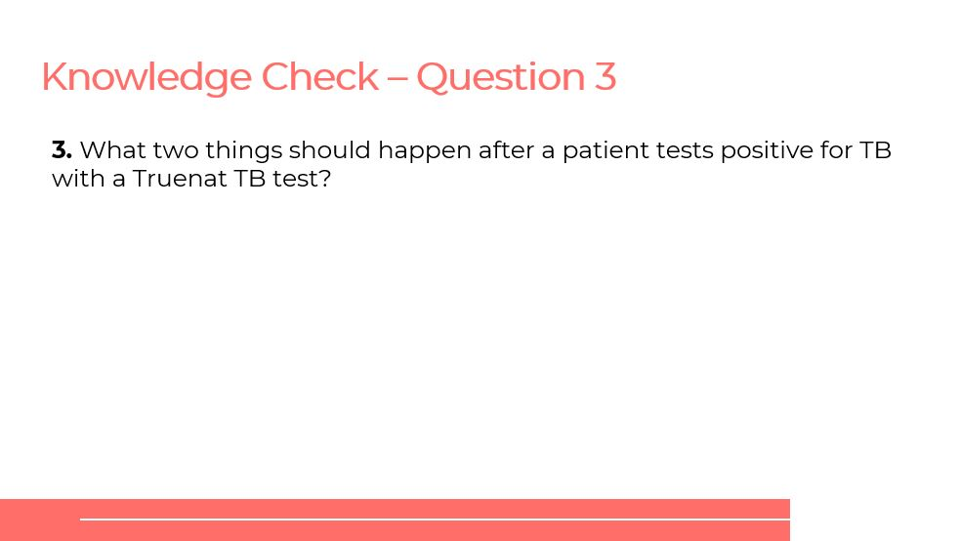
ANSWER:
1. Patient’s specimen should be tested for RIF resistance, 2. Patient should be referred for care and treatment. Facilitator should emphasize country-specific methods for referrals, e.g. ensuring test results are transmitted electronically, counseling, doing a warm-handoff to TB treatment facilities, etc.

Module 3: Operational Aspects

Target Audience
The target audience for this course is:
- Lab technicians
- Lab managers
- Program managers

Learning Objectives
Terminal Objective
- At the end of this session, participants should understand the operational aspects of Truenat testing, including generally how to use the Truenat equipment.

Module Objectives
- By the end of this module, participants should be able to
  - List the equipment and supplies needed to run Truenat tests
  - Describe the procedures for running a Truenat test
  - Describe the infrastructure requirements for using Truenat equipment

Materials
- Facilitator Guide
- Participant Guide
- Pens/Pencils
- Printed notecards for activity

Advance Preparation
Facilitators should assess whether Truenat equipment is available in country for practice. If logistics allow, training organizers may consider having a hands-on practice session in a lab following the delivery of the sections on process flow. An alternative activity is also described in this facilitator’s guide, which will involve printing out notecards for participants to reorder.

Facilitators should work with national program managers to understand how testing activities are currently recorded (i.e. what forms, registers etc. exist) and how they may need to be modified to incorporate Truenat. This content in the training may need to be tailored to reflect this information (as noted by yellow highlight).

Lesson Plans

Introduction
Introduction
Slide: 3
Participant Guide Page: 36
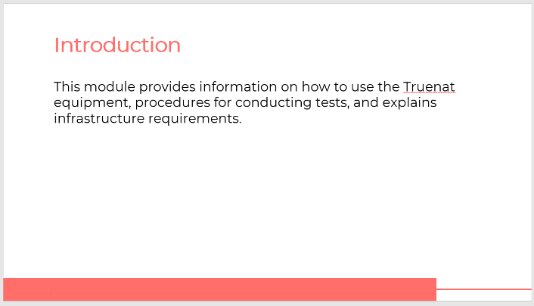
SAY: In this module we will learn about the operational aspects of Truenat. We will talk about the different pieces of Truenat equipment, the procedures for conducting TB and RIF-resistance tests, and I will explain the infrastructure requirements for installing Truenat.
Learning Objectives
Slide: 4
Participant Guide Page: 36
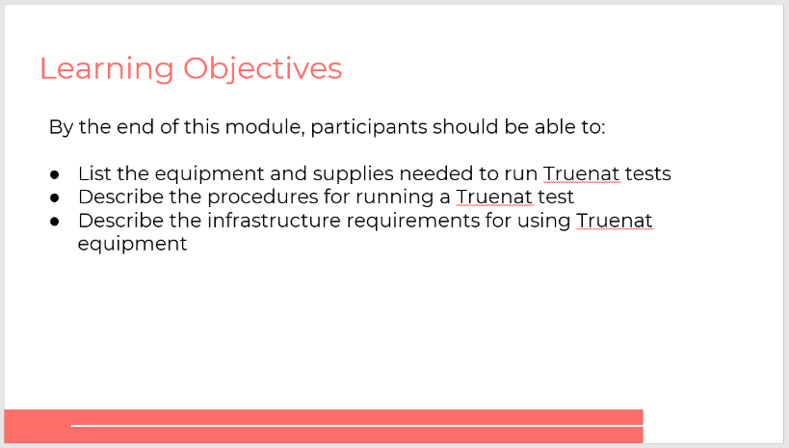
SAY: These are the learning objectives for this module.
DO: Read through the objectives. Ask if participants have any questions before you get started.
Module 3: Operational Aspects
Slide: 5
Participant Guide Page: 36
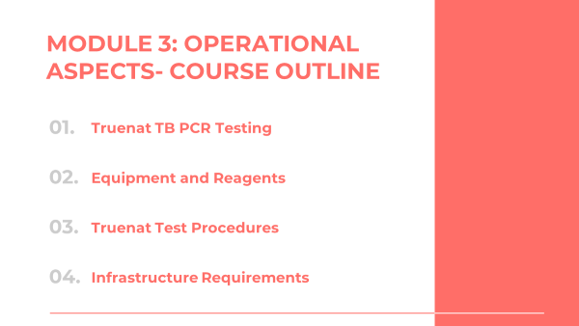
SAY: There are seven topics in this module. We’ll start with a brief introduction, then will move to equipment and supplies, Truenat test procedures, waste management, errors and troubleshooting, infrastructure requirements and recording testing activities.

Introduction
Introduction to Truenat TB PCR Testing
Slide: 6
Participant Guide Page: 36
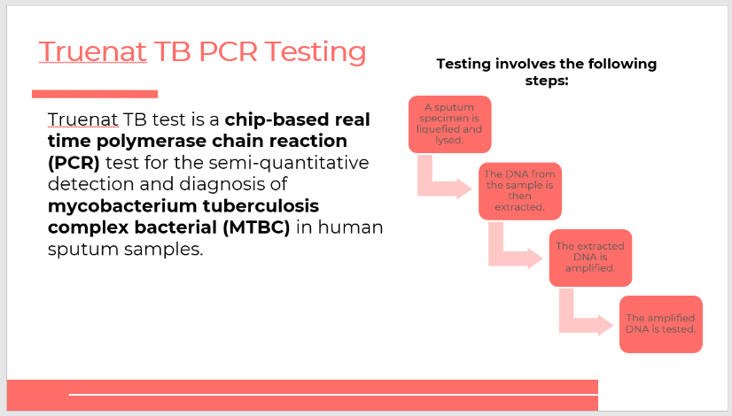
SAY: Before we get started, let’s talk briefly about how Truenat works. The Truenat TB test is a chip-based real time polymerase chain reaction (PCR) test for semi-quantitative detection and diagnosis of mycobacterium tuberculosis complex bacterial (MTBC) in human sputum samples.
DO: Click on the slide to bring up the animation one-by-one and read through each step.

Equipment and Supplies
Equipment – Trueprep
Slide: 8
Participant Guide Page: 37
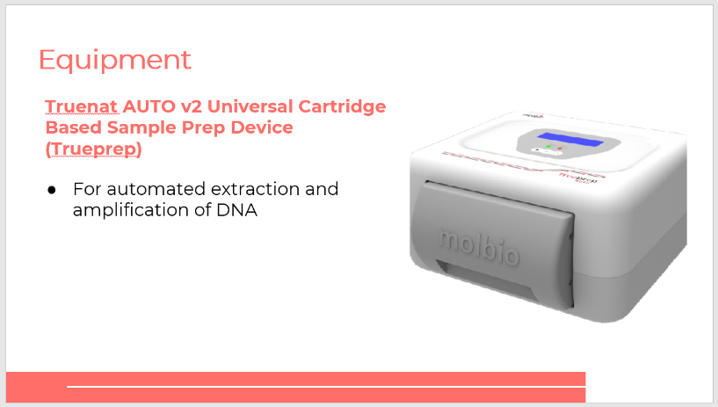
SAY: Let’s talk about equipment and supplies, starting with equipment. Truenat really consists of three different machines. The first one is called Trueprep – the formal name is the Truenat AUTO v2 Universal Cartridge Based Sample Prep Device. Trueprep is used for the automated extraction and amplification of DNA, or in other words, to prepare the sample for testing.
Equipment – Truelab
Slide: 9
Participant Guide Page: 38
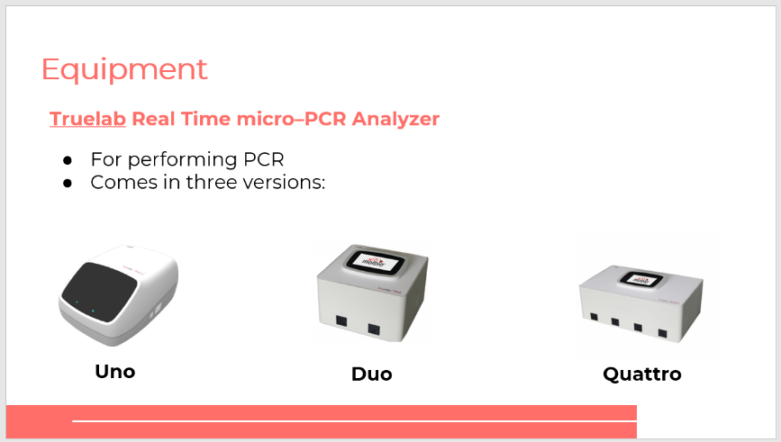
SAY: The second piece of equipment is the Truelab Real Time micro-PCR Analyzer, or just Truelab. Truelab is used for performing PCR and it comes in three versions: Uno, Duo, Quattro. Uno runs one test at a time, the Duo version runs two tests at a time, and how many tests do you think Quattro runs at a time? Yes, that’s right, four.
Different Models of Truenat Analyzers to Match Anticipated Throughput
Slide: 10
Participant Guide Page: 38
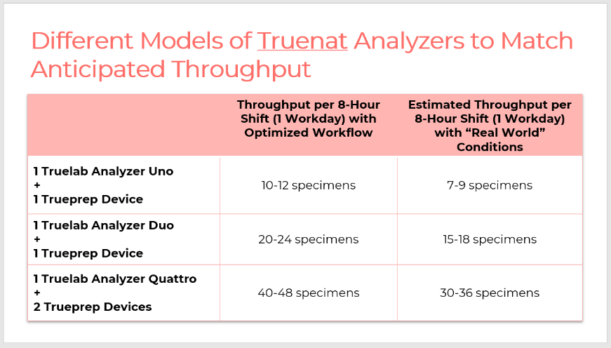
SAY: Let’s look at the throughputs of each version of Truelab. With one Truelab Uno and one Trueprep, you can test between 7-9 specimens during an 8-hour shift or workday under real world conditions. Under perfect conditions, you would be able to test between 10 and 12 specimens but you should use the real world conditions for planning purposes. It’s important to note that this combination of devices can be transported in a suitcase, so if you wanted, for example, to conduct Truenat testing in a community and anticipated testing between 7 and 9 specimens in one day, you could choose this combination.
With one Truelab Duo and one Trueprep, you can test between 15 and 18 specimens in one workday, and with one Truelab Quattro, which would require two Truepreps, you can test between 30-36 specimens.
So, understanding how many specimens you will want to test per day will determine which piece of equipment to procure and where to place it.
Equipment - Truelab Micro-PCR printer
Slide: 11
Participant Guide Page: 39
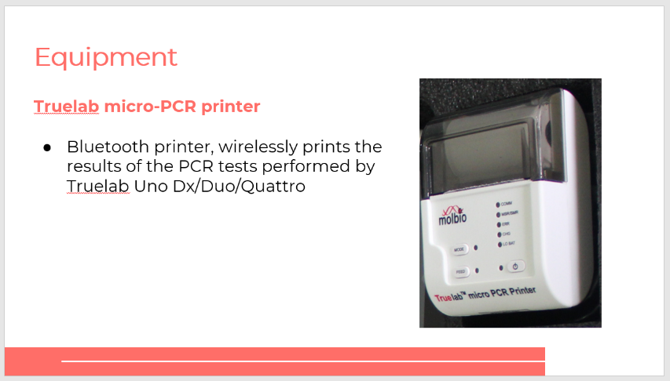
SAY: The third piece of Truenat equipment is the Truelab micro-PCR printer, which is a Bluetooth printer that wirelessly prints the results of the PCR tests performed by the Truelab machines. This is an optional piece of equipment – you don’t necessarily need to print the results of the tests, particularly if results are being sent digitally.
Reagents and Consumables
Slide: 12
Participant Guide Page: 40
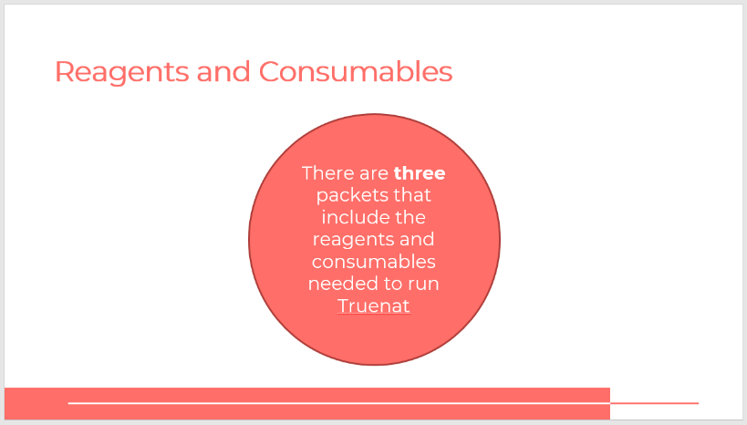
SAY: There are three packets that include the reagents and consumables needed to run Truenat. Let’s talk through each of them.

The Truenat Chip pack has three different chips: Truenat MTB, Truenat MTB Plus and Truenat MTB-RIF Dx.
  - Truenat MTB – for the detection of TB
  - Truenat MTB Plus – a more sensitive test for TB detection
  - Truenat MTB-RIF Dx – for the detection of RIF resistance
Trueprep AUTO MTB Sample Pretreatment Pack
Slide: 13
Participant Guide Page: 40
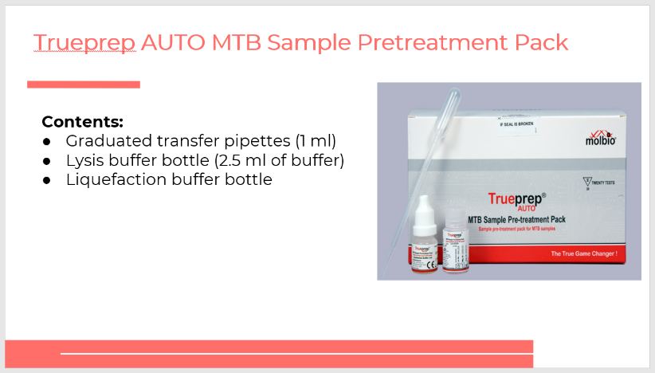
SAY: The first pack is the Trueprep AUTO MTB Sample Pretreatment Pack, which is for pretreating the sample. The pack contains graduated transfer pipettes, lysis buffer bottles, and liquefaction buffer bottles.
Trueprep AUTO v2 Universal Cartridge Based Sample Prep Kit
Slide: 14
Participant Guide Page: 40
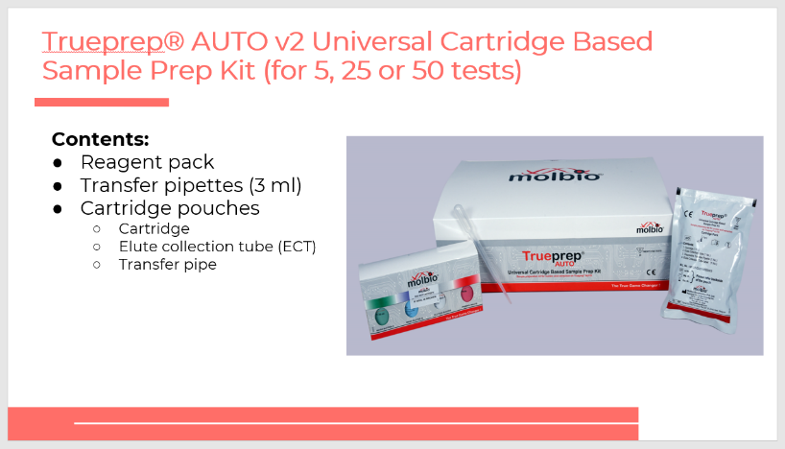
SAY: The Trueprep AUTO v2 Universal Cartridge-Based Sample Prep Kit contains a reagent pack, transfer pipettes, and cartridge pouches that contain a cartride, and elute collection tube, and a transfer pipette. You can order this pack for 5, 25, or 50 tests.
Truenat Chip Pack
Slide: 15
Participant Guide Page: 40
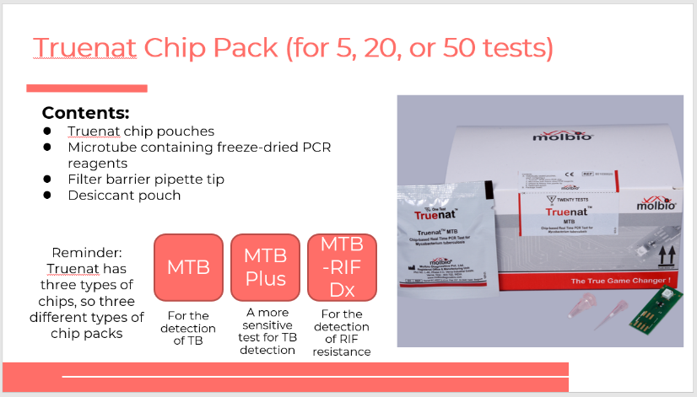
SAY: The Truenat Chip Pack (for 5, 20, or 50 tests), contains the chip pouches, microtube containing freeze-dried PCR reagents, filter barrier pipette tip and a desiccant pouch.
Remember, Truenat has three types of chips, so three different types of chip packs. The chip packs are: MTB, for the detection of TB; MB Plus, a more sensitive test for TB detection; and the MTB-RIF Dx, for the detection of RIF resistance.
SAY: What questions do you have before we move to the next topic?
DO: Allow participants time to ask questions and respond appropriately.

Truenat Test Procedures – Prepare Samples and Extract DNA
Section Introduction: Truenat Test Procedures – Prepare Samples and Extract DNA
Slide: 16
Participant Guide Page: 41
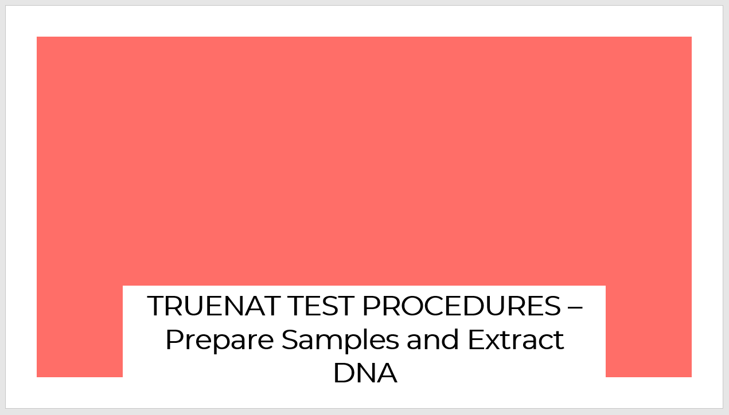
DO: Introduce the topic explaining that you are going to walk participants through the three parts of performing a Trueanat test. Note that this training is intended to be followed up with hands-on training by Molbio. Participants are not expected to be able to use Treunat after this training – this is more of an introduction to running the test.
Video: Prepare Sample and Extract DNA
Slide: 17
Participant Guide Page: 41
DO: Inform participants that they will watch a short video on preparing samples and extracting DNA. The video is found here: (85) Truenat- A Point-of-Care Real Time PCR Test for Tuberculosis - YouTube. Start the video at the :05 timestamp and stop the video at 8:41.
Equipment & Supplies for Preparing Samples and Extracting DNA
Slide: 18
Participant Guide Page: 42
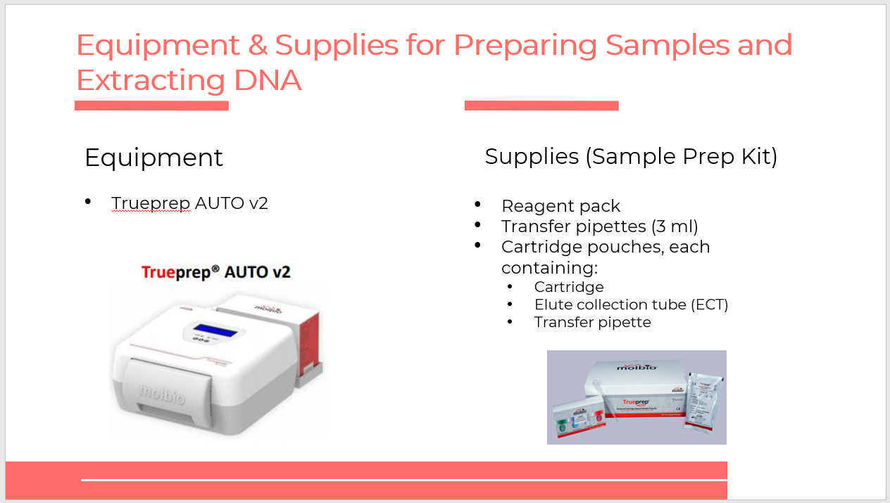
SAY: To prepare the sample and extract DNA, you will use the Trueprep machine. All the supplies needed are included in the sample prep kit, which as we discussed in our last module, contains the reagent pack, transfer pipettes (3ml) and cartridge pouches. The pouches contain a cartridge, elute collection tube (ECT), and a transfer pipette.
Prepare Sample and Extract DNA
Slides:19 – 22
Participant Guide Page: 42
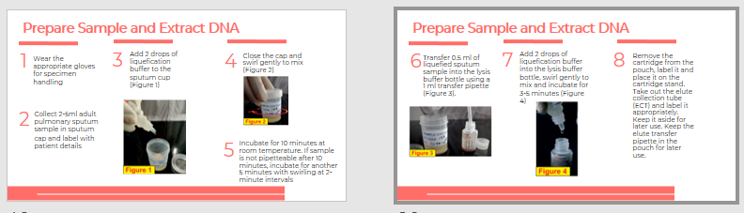
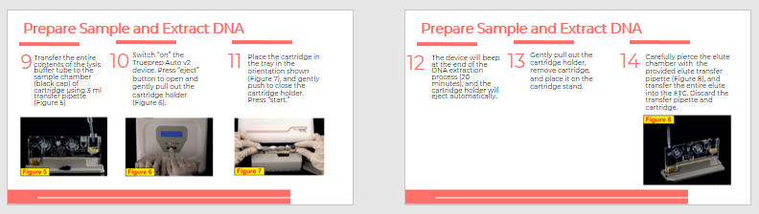
DO: Explain that there are 14 steps to preparing samples and extracting DNA. Read through each step. Consider asking for a participant to help read through.
- Make sure you wear the appropriate gloves for specimen handling.
- Collect 2-5ml adult pulmonary sputum sample in sputum cap and label with patient details.
- Add two drops of liquefication buffer to the sputum cup.
- Close the cap and swirl gently to mix.
- Incubate for 10 minutes at room temperature. If your sample is not pipetteable after 10 minutes, incubate for another five minutes with swirling at two-minute intervals.
- Transfer 0.5 ml of liquefied sputum sample into the lysis buffer bottle using a 1 ml transfer pipette.
- Add two drops of liquefication buffer into the lysis buffer bottle, swirl gently to mix and incubate for three to five minutes.
- Remove the cartridge from the pouch, label it and place it on the cartridge stand. Take out the elute collection tube (ECT) and label it appropriately. Keep it aside for later use. Keep the elute transfer pipette in the pouch for later use.
- Transfer the entire contents of the lysis buffer tube to the sample chamber (black cap) of cartridge using 3ml transfer pipette.
- Switch “on” the Trueprep Auto v2 device. Press “eject” button to open and gently pull out the cartridge holder.
- Place the cartridge in the tray in the orientation and gently push to close the catridge holder. Press “start.”
- The device will beep at the end of the DNA extraction process and the cartridge holder will eject automatically. This will take 20 minutes.
- Gently pull out the cartridge holder, remove cartridge, and place it on the cartridge stand.
- Carefully pierce the elute chamber with the provided elute transfer pipette, and transfer the entire elute into the ETC. Discard the transfer pipette and cartridge.

Truenat Test Procedures – Run a PCR TB Test
Video: Running a PCR TB Test
Slide: 24
Participant Guide Page: 44
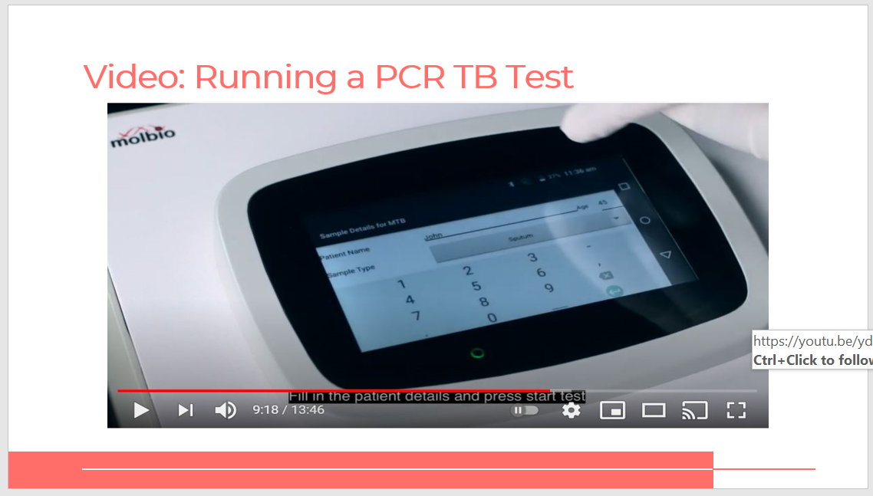
DO: Inform participants that they will watch another short video on running a PCR TB test.
The video is found here: (85) Truenat- A Point-of-Care Real Time PCR Test for Tuberculosis - YouTube. Start the video at the 9:18 timestamp and stop the video at the end.
Equipment and Supplies for Running a PCR TB Test
Slide: 25
Participant Guide Page: 44
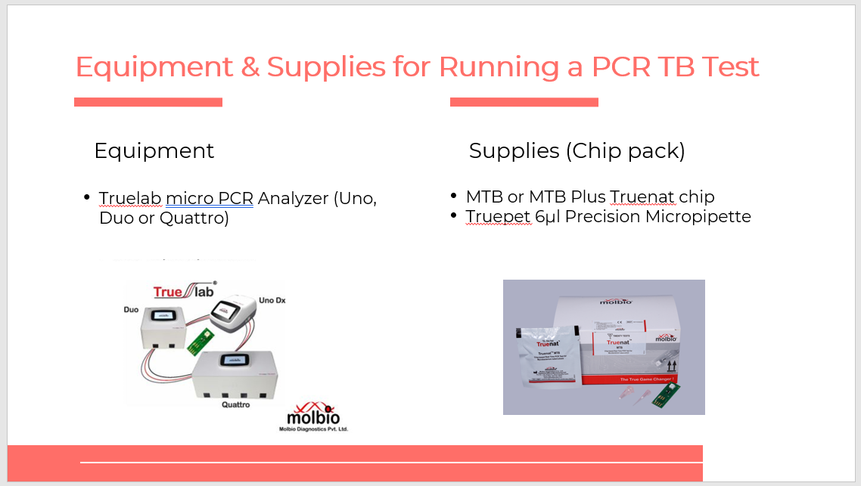
DO: To run the TB test, you will use the Truelab Uno, Duo, or Quattro depending on what you have. For supplies, you’ll need the chip pack, which includes the MTB or MTB Plus Truenat chip and the Truepet 6µl Precision Micropipette.
Process Flow-Running a PCR TB Test
Slides: 26 – 30
Participant Guide Pages: 45
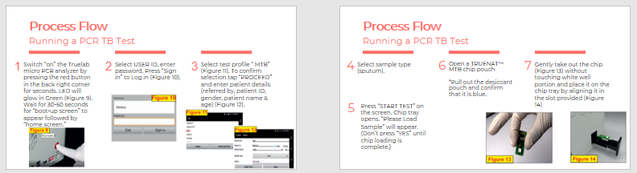
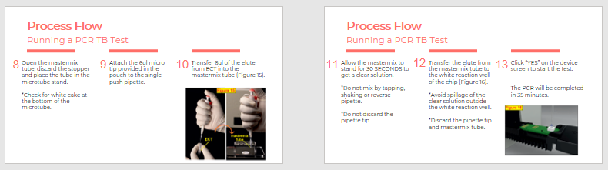
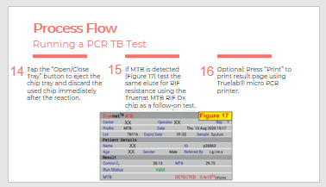
DO: Explain that there are 16 steps to running a PCR TB test. Read through each step. Consider asking for a participant to help read through.
- Switch “on” the Truelab micro-PCR analzyer by pressing the red button in the back right corner for seconds. Wait for 30-50 sections for the “boot-up screen” to appear followed by the “home screen.”
- Select USER ID and enter your password. Press “Sign in” to log in.
- Select test profile “MTB.” To confirm selection tap “PROCEED” and enter patient details.
- Select sample type (sputum).
- Press “START TEST” on the screen. Chip tray opens. “Please Load Sample” will appear. Be sure not to press “YES” until the chip loading is complete.
- Open a Truenat MTB chip pouch. Remember to pull out the desiccant pouch and confirm that it is blue.
- Gently take out the chip without touching the white well portion and place it on the chip tray.
- Open the mastermix tube, discard the stopper and place the tube in the microtube stand. Be sure to check for white cake at the bottom of the microtube.
- Next, attach the 6ul micro tip provided in the pouch to the single push pipette.
- Then transfer 6ul of the elute from ECT into the mastermix tube.
- Allow the mastermix to stand for 30 seconds to get a clear solution. Make sure you do not mix by tapping, shaking or reverse pipette. Do not discard the pipette tip.
- Transfer the elute from the mastermix tube to the white reaction well of the chip. Be sure to avoid spillage of the clear solution outside the white reaction well. Then discard the pipette tip and mastermix tube.
- Click “YES” on the device screen to start the test. It takes 35 minutes for the PCR test to complete.
- Tap the “Open/Close Tray” button to eject the chip tray and discard the used chip immediately after the reaction.
- If MTB is detected, test the same elute for RIF resistance using the Truenat MTB RIF Dx chip as a follow-on test.
- Press “Print” to print the result page using the Truelab micro-PCR print. This is optional.

Truenat Test Procedures – Run a RIF Resistance Test
Equipment & Supplies for Running a RIF Resistance Test
Slide: 32
Participant Guide Page: 47
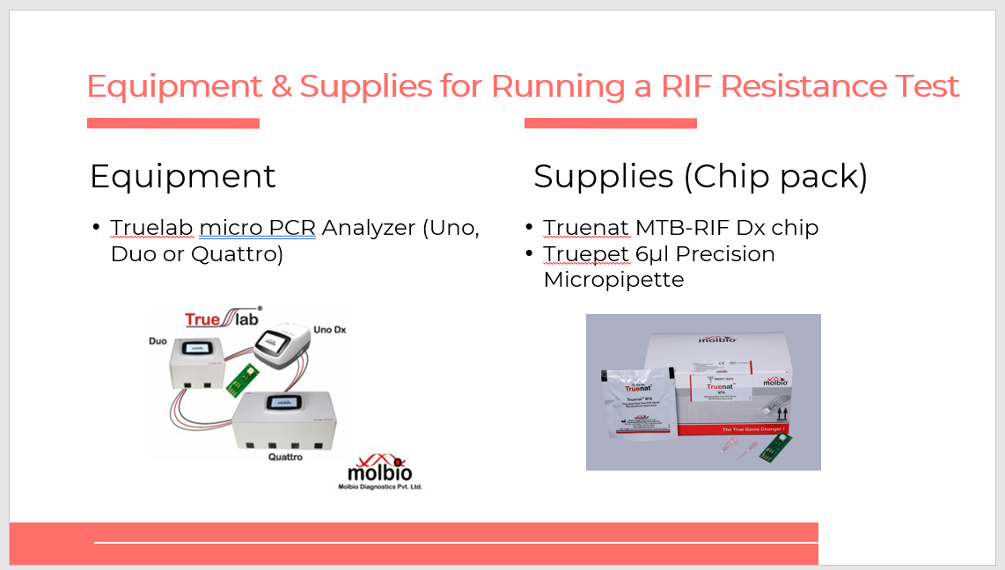
SAY: You will use the Truelab Uno, Duo, or Quattro for the RIF resistance test as well, and a RIF chip pack.
Process Flow: Running a RIF-Resistance Test
Slide: 33
Participant Guide Page: 48
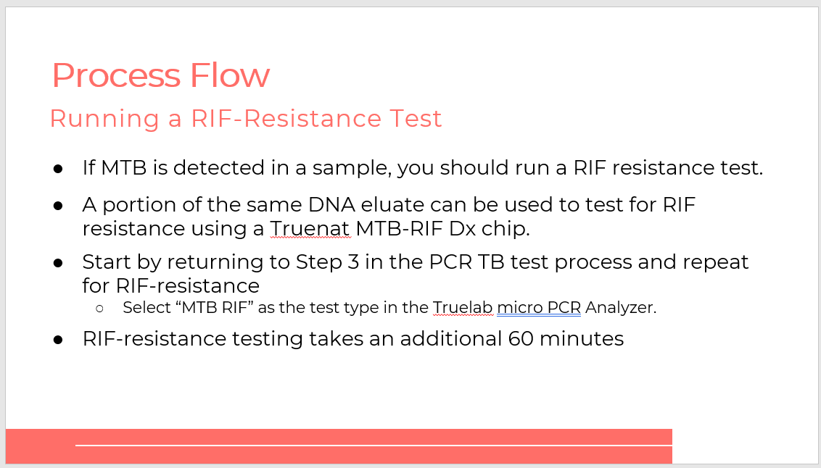
SAY: When MTB is detected in a sample, you should run a RIF resistance test. A portion of the same DNA eluate can be used to test for RIF resistance. When testing for RIF resistance use a Truenat MTB-RIF Dx chip.

To start the RIF resistance test, start from Step 3 in the PCR TB test process and repeat for RIF resistance. This will take an additional 60 minutes.

Class Activity
Activity: Let’s Practice
Slide: 34
Participant Guide Page:
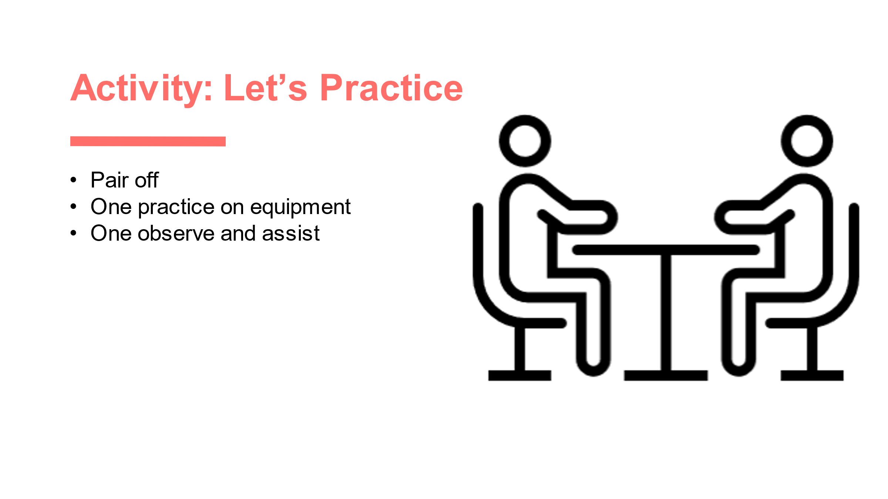
NOTE: If Truenat equipment is available at a lab near the training site, training organizers can consider having a hands-on learning session with the equipment. One person can use the equipment while others observe and remind them of the steps in the process flow.

Waste Management
Waste Management
Slide: 36
Participant Guide Page: 48
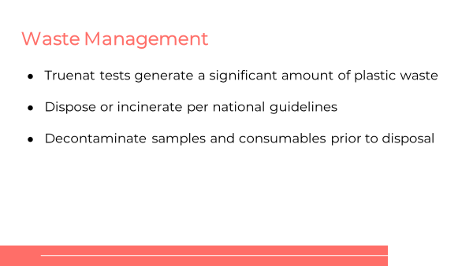
SAY: The Truenat tests generate a large amount of plastic waste, and it is important to dispose or incinerate the plastic based on national guidelines. Some samples and consumables need to be contaminated prior to disposal, so let’s talk about them.
Waste Disposal
Slide: 37
Participant Guide Page: 48
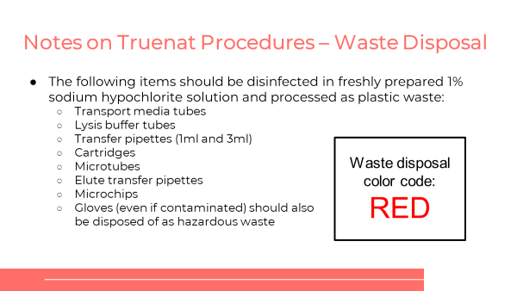
SAY: There are specific procedures that must be followed with waste disposal. The items listed on this slide are classified as red biohazardous waste and should be disinfected in freshly prepared 1% sodium hypochlorite solution and processed as plastic waste:
- Transport media tubes
- Lysis buffer tubes
- Transfer pipettes (1ml and 3ml)
- Cartridges
- Microtubes
- Elute transfer pipettes
- Microchips
- Gloves (even if contaminated) should also be disposed of as hazardous waste.
Waste Disposal (2)
Slide: 38
Participant Guide Page: 48
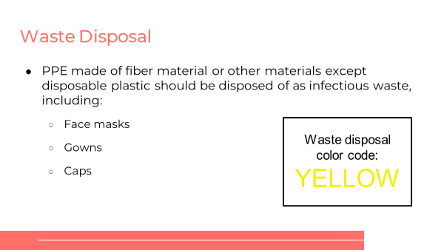
SAY: PPE made of fiber material or other materials except disposable plastic should be disposed of as “yellow” infectious waste, including:
- Face Masks
- Gowns
- Caps
Waste Disposal (3)
Slide: 39
Participant Guide Page: 48
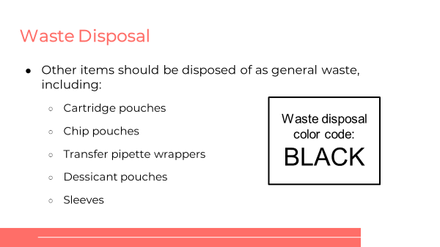
SAY: Other items are ok be disposed of as general waste, including:
- Cartridge pouches
- Chip pouches
- Transfer pipette wrappers
- Dessicant pouches
- Sleeves

Errors and Troubleshooting
Errors and Troubleshooting
Slide: 41
Participant Guide Page: 49
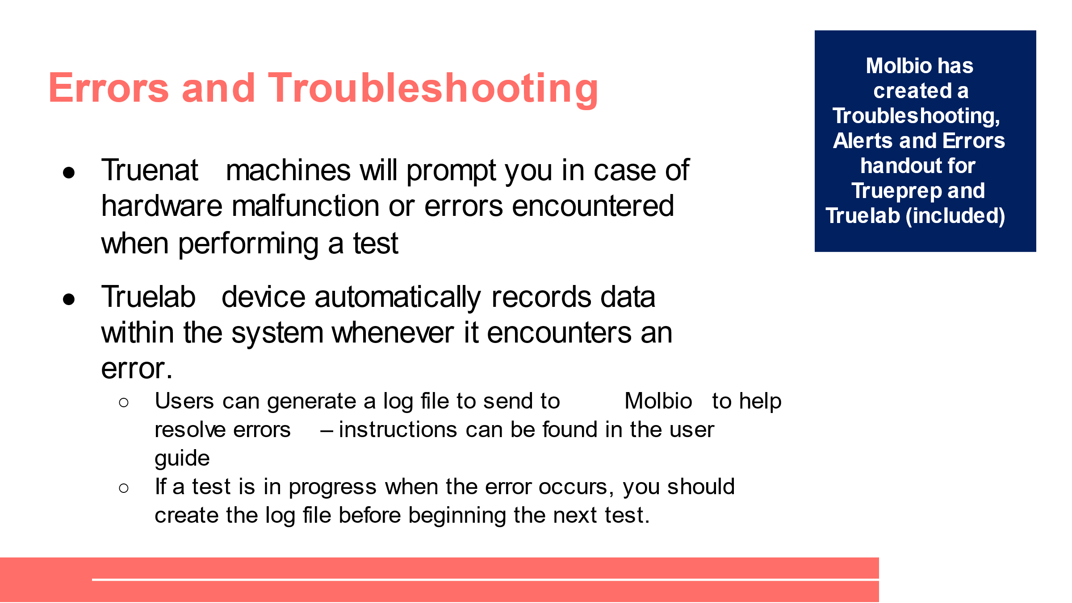
SAY: There are various errors you may encounter when using Truenat. The machines will alert you if there are hardware malfunctions or errors encountered when performing a test. Truelab automatically records data within the system whenever it encounters an error. If you need to communicate with Molbio to help resolve issues, this can be helpful, so it’s important to generate the log file before you restart a test whenever this happens and it is not a standard error that you can resolve yourself.
DO: Point out the “Troubleshooting, Alerts, and Errors” job aid to participants and explain that you will be walking through the errors on it.
Trueprep Error Messages
Slides: 42 – 48
Participant Guide Page: 49
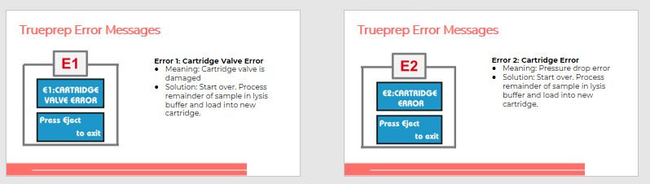
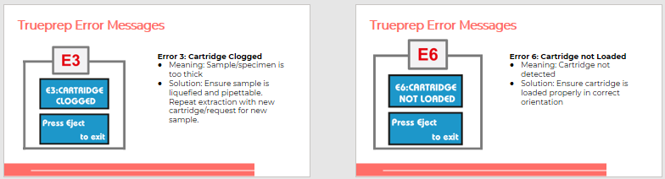
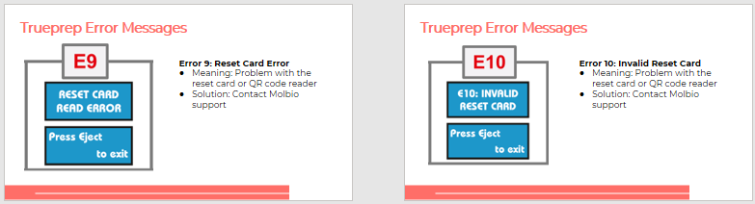
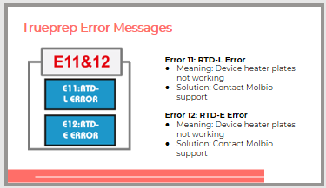
DO: Read through each error and explain how to resolve it.
Truelab Error Messages
Slides: 49 and 50
Participant Guide Page: 51
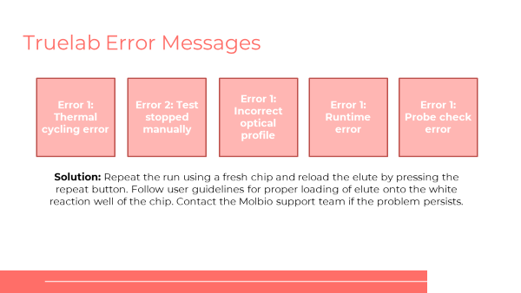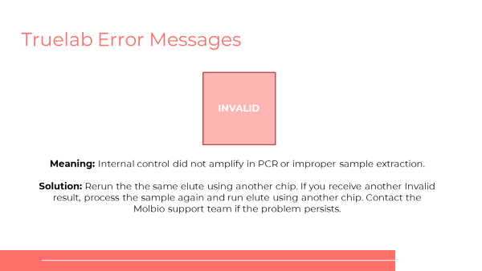
SAY: There are additional error messages you might see when using Truelab. There are several types of Error 1 that you will see on this screen. The solution to these is to repeat the run using a fresh chip and reloading the elute by pressing the repeat button. You might also see an invalid error message, which means that the Internal control did not amplify in PCR or improper sample extraction. The solution to this is also to rerun the same elute using another chip.
Truelab Alert Messages
Slides: 51 – 53
Participant Guide Page: 52
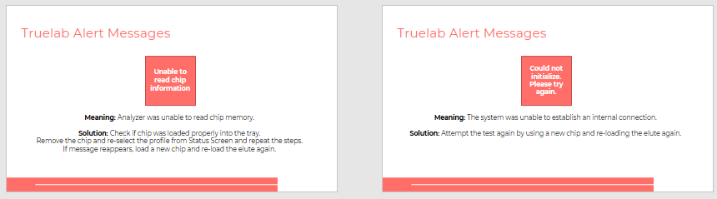
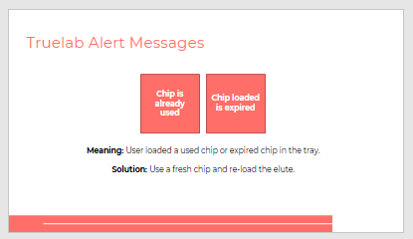
DO: Read through each alert and explain how to resolve it.

Class Activity
Activity: Fix the Error
Slide: 54
Participant Guide Page: 52
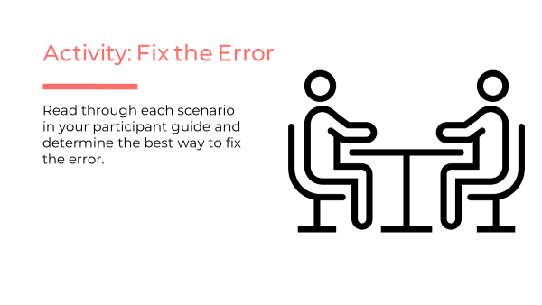
SAY: When you are using Truenat, you will sometimes get an error message. It is important to know what the error message means and how to fix it. We’ve gone over several errors that you might see – you can reference the troubleshooting handout to help figure out how to address these errors.
In pairs, you will read through the three scenarios in your Participant Guide, starting on page 52. Read through each scenario and determine the best way to fix the error. Be prepared to share your answers with the class.
DO: Give participants 8 minutes to work through scenarios and write down their responses. Call on 3 groups to share their answers. Correct any incorrect answers.

Scenario 1: You are preparing a sample and extracting DNA. You switch on the Trueprep AUTO v2 device and pull out the cartridge holder. You place your cartridge in the tray, close the door and receive a E3: Cartridge Clogged error. What does this error mean and what are your next steps?
Answer: E3: Cartridge Clogged error means the specimen used is too thick. Samples need to be liquefied and pipettable. To fix this error, press eject to exit and repeat the extraction in a fresh cartridge.

Scenario 2: You are extracting DNA using the Trueprep AUTO v2 device and receive an error message that says “could not initialize. Please try again.” What do you do?
Answer: This message means the system was unable to establish an internal connection and the test should thermal cycling error attempted again using a new chip and re-loading the elute again. If it happens again, alert Molbio support.

Scenario 3: You are using the Trueprep AUTO v2 device when you receive an alert that says “unable to read chip information.” You know you have completed each step carefully, but continuously get this message. What should you do?
Answer: The user should check if the chip was loaded properly into the tray. Remove the chip and re-select the profile from Status Screen and repeat the steps. If message reappears, load a new chip and re-load the elute again.
SAY: What questions do you have about error messages before we move to the next topic?
DO: Allow participants time to ask questions and respond appropriately.

Infrastructure Requirements
Power
Slide: 56
Participant Guide Page: 54
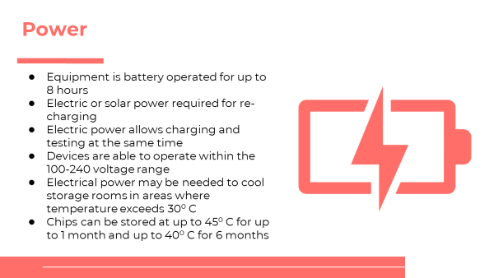
SAY: The Truenat system is designed to be operated in peripheral laboratories with minimal infrastructure, but there are key components that need to be considered for site preparation.

For electricity: Truenat is a battery-powered device with in-built batteries that allow for testing without power for up to eight hours. Devices will not even power up if they cannot complete at least one cycle. Batteries are expected to last five years. Solar power or electric is required to recharge the batteries. Using electric power will allow you to charge the device and run tests at the same time.

Devices are able to operate within the 100-240 voltage range and no additional voltage stabilization is required.

You may also need electrical power may be needed to cool rooms where the temperature exceeds 30C for the proper storage of test chips and refrigerating sputum samples.
Solar Power (Optional)
Slide: 57
Participant Guide Page: 54
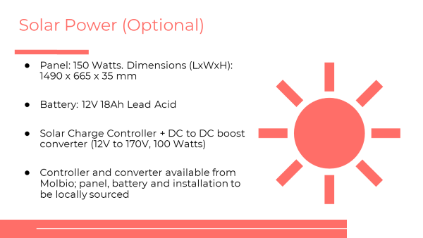
SAY: Again, you can use solar power to charge the Truenat batteries but this is entirely optional. Molbio sells the controller and converters, but the panel, battery and installation can be locally sourced.
Room Layout
Slide: 58
Participant Guide Page: 54
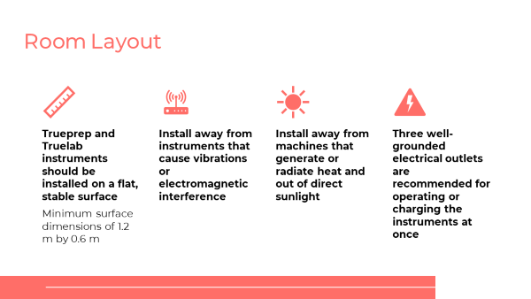
SAY: Trueprep and Truelab instruments should be installed on a flat, stable surface. Some key guidelines for the room layout are:
- Devices should be installed away from instruments that cause vibrations or electromagnetic interference.
- Devices should be installed away from machines that generate or radiate heat and out of direct sunlight.
- Three well-grounded electrical outlets are recommended for operating or charging the instruments at once.
Ambient Temperature
Slide: 59
Participant Guide Page: 54
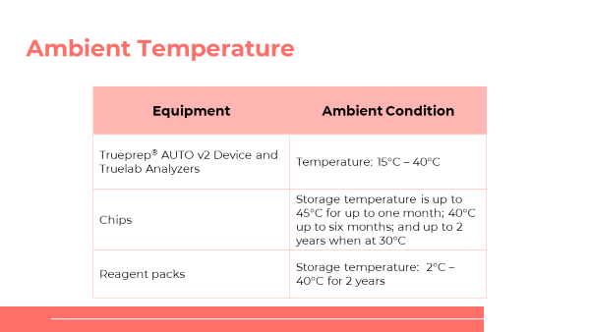
SAY: This chart shows the ambient temperature of the rooms where the equipment should be installed. Trueprep and Truelab can be stored in rooms that are between 15 and 30 degrees, or 40 degrees for up to 6 months. Relative humidity can be between 10% and 80%. Chips and reagents can also generally be stored at room temperature.
Dust
Slide: 60
Participant Guide Page: 55
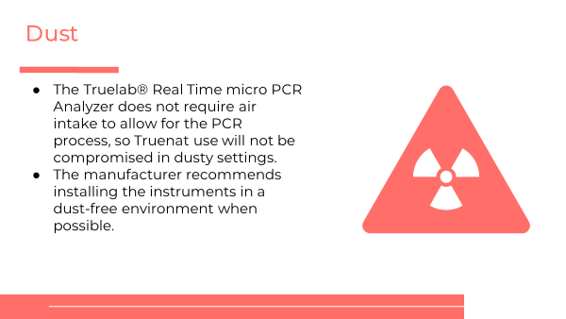
SAY: Truenat can be operated in dusty environments – but Molbio recommends installing it in a dust-free environment when possible.
Biosafety
Slide: 61
Participant Guide Page: 55
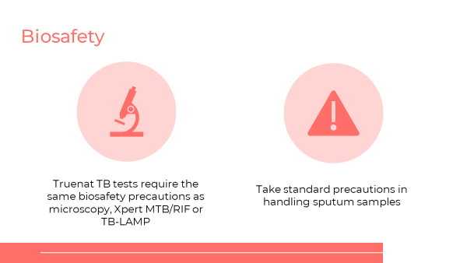
SAY: Truenat TB tests require the same biosafety precautions as microscopy, Xpert MTB/RIF or TB-LAMP. These include operating in a well ventilated room and use of PPE (lab coats and gloves) per national guidelines. Biosafety cabinets are not needed. You should follow recommendations for low-risk procedures from the WHO Tuberculosis Laboratory Biosafety Manual.

You should take standard precautions in handling sputum samples, including:
- Minimize aerosols
- Open specimen containers carefully to avoid splatters and spills
- Keep specimen containers upright
- Decontaminate leaky containers with disinfectant
- Wash hands

As discussed in the last module, you should decontaminate samples and consumables prior to disposal by submerging used consumables in freshly prepared 0.5% sodium hypochlorite solution for 30 minutes. This includes TruenatTM chips, microtube, microtube cap, transfer pipette, pipette tips, reagent bottles, etc.
Security
Slide: 62
Participant Guide: 55
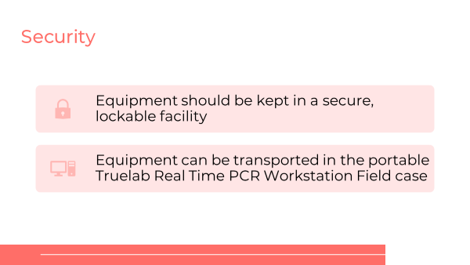
SAY: All laboratory equipment should be kept in a secure, lockable facility. As previously mentioned, the Truenat equipment can be transported in the portable Truelab® Real Time PCR Workstation Field Case, which should be stored in a secure lockable location when not in use.
Preventive Maintenance
Slide: 63
Participant Guide Page: 55
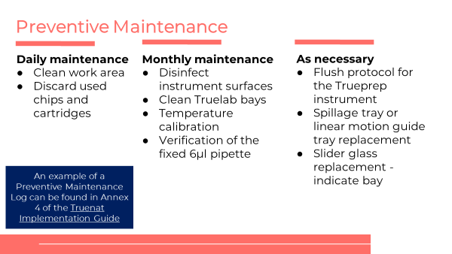
SAY: Minimal preventable maintenance is needed for Truelab and Trueprep equipment. Each day, someone should clea the work area and discard used chips and cartridges. On a monthly basis, instrument surfaces should be disinfected, Truelab bays should be cleaned, temperature should be calibrated, and the fixed pipette should be verified. As needed, someone should run a flush protocol for the Trueprep instrument, replace the spillage tray or linear motion group tray, and replace the slider glass. All of these should be tracked in a preventive maintenance log – there is an example of such a log in the Truenat Implementation Guide.
SAY: What questions do you have about infrastructure requirements before we move to the next topic?
DO: Allow participants time to ask questions and respond appropriately.

Class Activity
Activity: Preventive Maintenance
Slide: 64
Participant Guide Page: 55
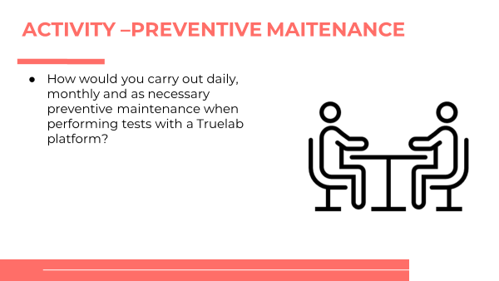
SAY: When you are using Truenat, you will need to conduct routine and as needed maintenance.
In pairs, you will define the daily, month and as needed preventive maintenance tasks.
DO: Working in pairs, have each team define the daily, monthly and as needed preventive maintenance tasks.
ANSWER:
Daily maintenance
- Clean work area
- Discard used chips and cartridges
Monthly maintenance
- Disinfect instrument surfaces
- Clean Truelab bays
- Temperature calibration
- Verification of the fixed 6µl pipette
As necessary
- Flush protocol for the Trueprep instrument
- Spillage tray or linear motion guide tray replacement
- Slider glass replacement -indicate bay

Recording Testing Activities
Recording Testing Activities
Slide: 66
Participant Guide Page: 56
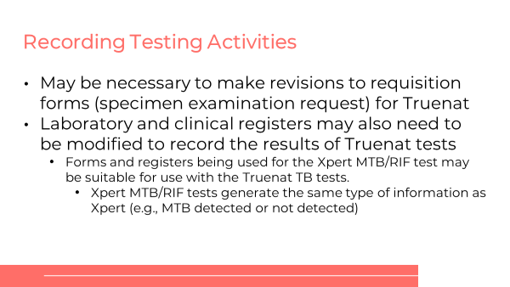
SAY: Depending on the current format of the country’s requisition form, it may be necessary to revise accommodate the Truenat TB tests. Similarly, laboratory and clinical registers may need to be modified to record the results of the Truenat TB tests and Truenat MTB-RIF Dx tests.
Recording Testing Activities
Slide: 67
Participant Guide Page: 56
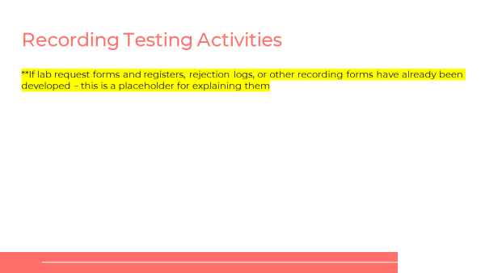
PLACEHOLDER: If lab request forms and registers, rejection logs, or other recording forms have already been developed, facilitators should modify this content and walk trainees through them.

Warranty

Warranty Conditions
Slide: 69
Participant Guide Page: 56
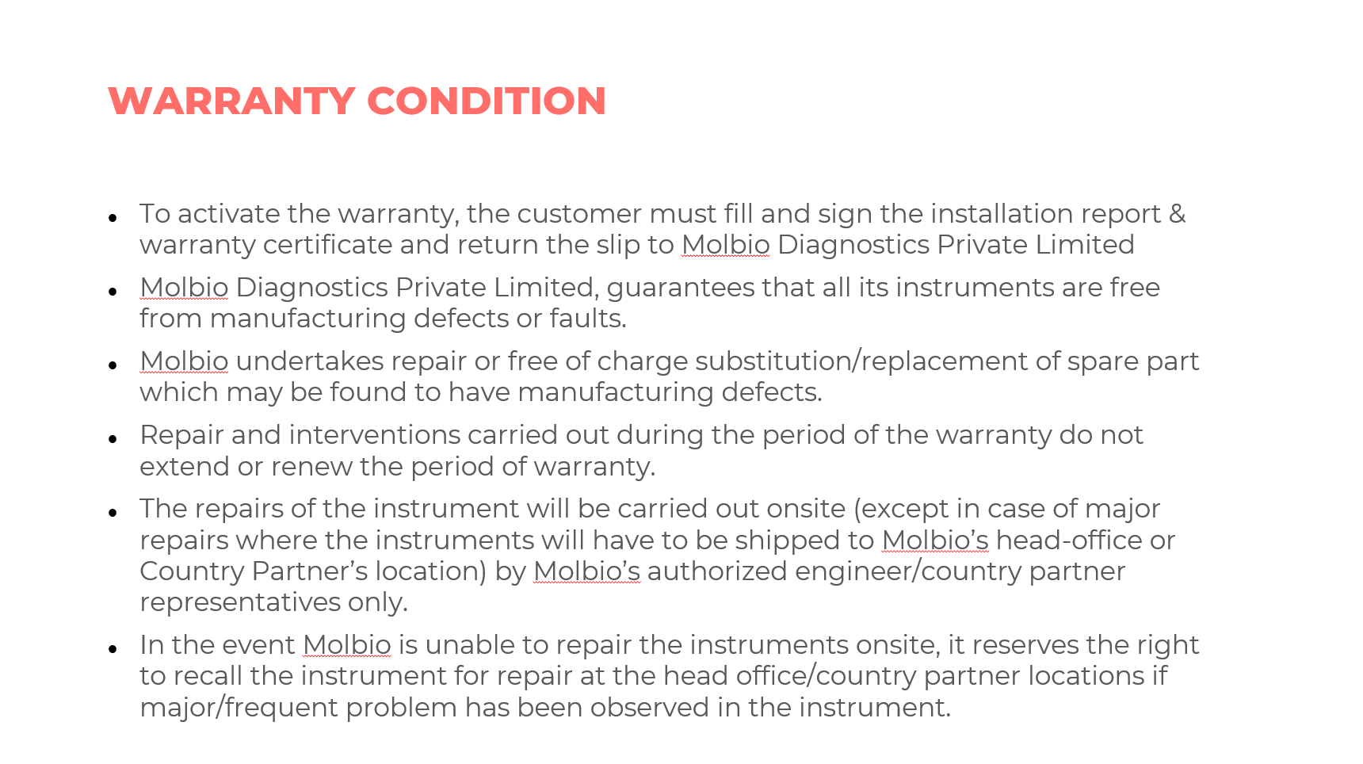
SAY:
- To activate the warranty, the customer must fill and sign the installation report & warranty certificate and return the slip to Molbio Diagnostics Private Limited
- Molbio Diagnostics Private Limited, guarantees that all its instruments are free from manufacturing defects or faults.
- Molbio undertakes repair or free of charge substitution/replacement of spare part which may be found to have manufacturing defects.
- Repair and interventions carried out during the period of the warranty do not extend or renew the period of warranty.
- The repairs of the instrument will be carried out onsite (except in case of major repairs where the instruments will have to be shipped to Molbio’s head-office or Country Partner’s location) by Molbio’s authorized engineer/country partner representatives only.
- In the event Molbio is unable to repair the instruments onsite, it reserves the right to recall the instrument for repair at the head office/country partner locations if major/frequent problem has been observed in the instrument.
Termination of Warranty
Slide: 70
Participant Guide Page: 57
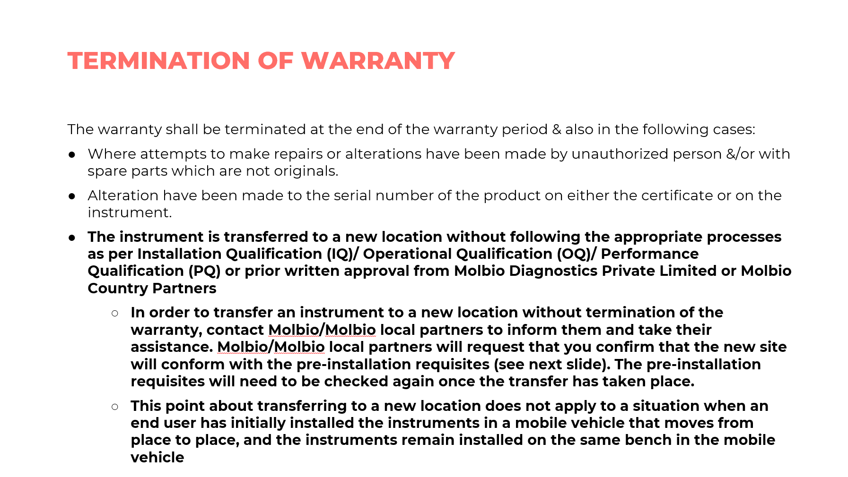
SAY: The warranty shall be terminated at the end of the warranty period & also in the following cases:
- Where attempts to make repairs or alterations have been made by unauthorized person &/or with spare parts which are not originals.
- Alteration have been made to the serial number of the product on either the certificate or on the instrument.
- The instrument is transferred to a new location without following the appropriate processes as per Installation Qualification (IQ)/ Operational Qualification (OQ)/ Performance Qualification (PQ) or prior written approval from Molbio Diagnostics Private Limited or Molbio Country Partners
  - In order to transfer an instrument to a new location without termination of the warranty, contact Molbio/Molbio local partners to inform them and take their assistance. Molbio/Molbio local partners will request that you confirm that the new site will conform with the pre-installation requisites (see next slide). The pre-installation requisites will need to be checked again once the transfer has taken place. [This point is very important to stress as many instruments may be transferred at some point.]
  - This point about transferring to a new location does not apply to a situation when an end user has initially installed the instruments in a mobile vehicle that moves from place to place, and the instruments remain installed on the same bench in the mobile vehicle
Preinstallation Requisites
Slide: 71
Participant Guide Page: 57
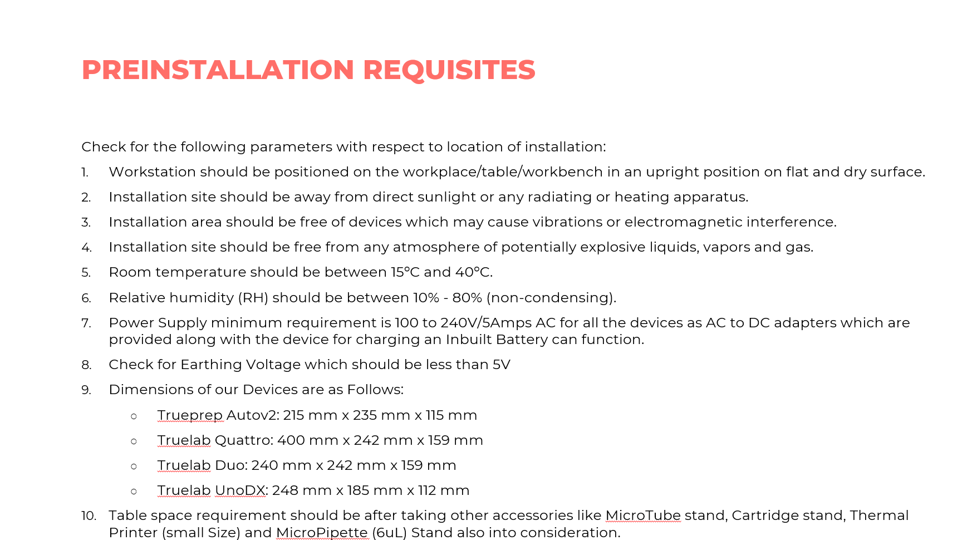
SAY: Check for the following parameters with respect to location of installation:
- Workstation should be positioned on the workplace/table/workbench in an upright position on flat and dry surface.
- Installation site should be away from direct sunlight or any radiating or heating apparatus.
- Installation area should be free of devices which may cause vibrations or electromagnetic interference.
- Installation site should be free from any atmosphere of potentially explosive liquids, vapors and gas.
- Room temperature should be between 15ºC and 40ºC.
- Relative humidity (RH) should be between 10% - 80% (non-condensing).
- Power Supply minimum requirement is 100 to 240V/5Amps AC for all the devices as AC to DC adapters which are provided along with the device for charging an Inbuilt Battery can function.
- Check for Earthing Voltage which should be less than 5V
- Dimensions of our Devices are as Follows:
  - Trueprep Autov2: 215 mm x 235 mm x 115 mm
  - Truelab Quattro: 400 mm x 242 mm x 159 mm
  - Truelab Duo: 240 mm x 242 mm x 159 mm
  - Truelab UnoDX: 248 mm x 185 mm x 112 mm
- Table space requirement should be after taking other accessories like MicroTube stand, Cartridge stand, Thermal Printer (small Size) and MicroPipette (6uL) Stand also into consideration.
Other Warranty Information
Slide: 72
Participant Guide Page: 58
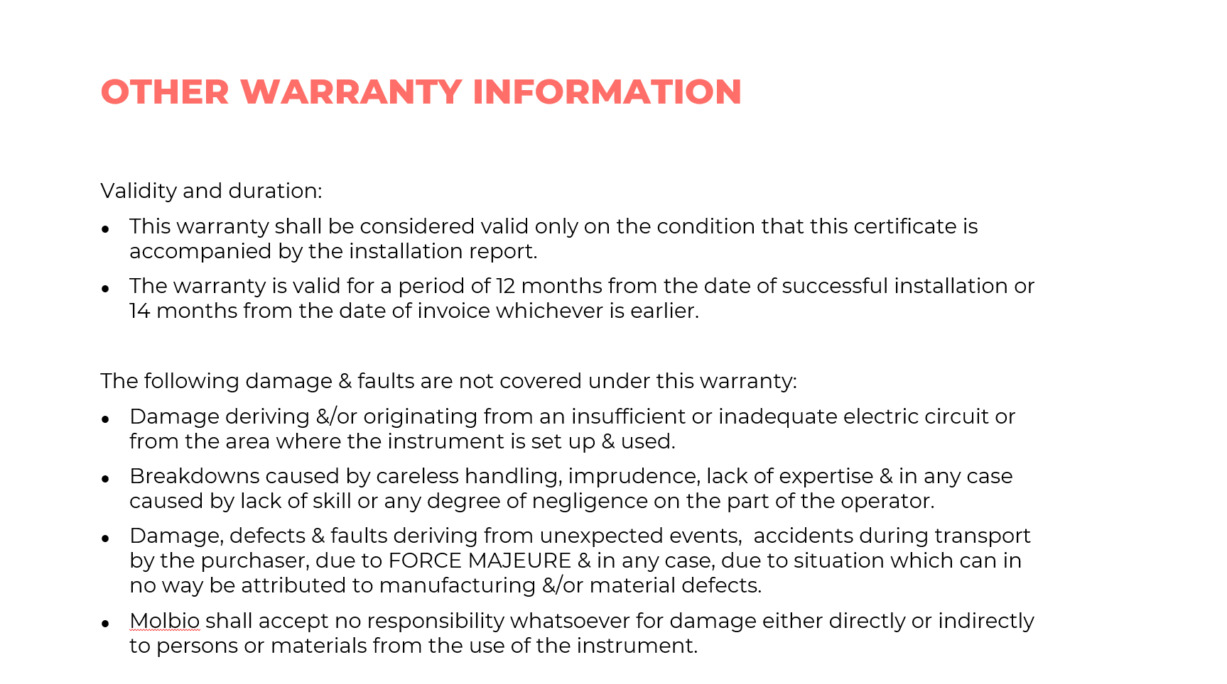
SAY:
Validity and duration:
- This warranty shall be considered valid only on the condition that this certificate is accompanied by the installation report.
- The warranty is valid for a period of 12 months from the date of successful installation or 14 months from the date of invoice whichever is earlier.
The following damage & faults are not covered under this warranty:
- Damage deriving &/or originating from an insufficient or inadequate electric circuit or from the area where the instrument is set up & used.
- Breakdowns caused by careless handling, imprudence, lack of expertise & in any case caused by lack of skill or any degree of negligence on the part of the operator.
- Damage, defects & faults deriving from unexpected events, accidents during transport by the purchaser, due to FORCE MAJEURE & in any case, due to situation which can in no way be attributed to manufacturing &/or material defects.
- Molbio shall accept no responsibility whatsoever for damage either directly or indirectly to persons or materials from the use of the instrument.

Summary
Summary
Slide: 73
Participant Guide Page: 58
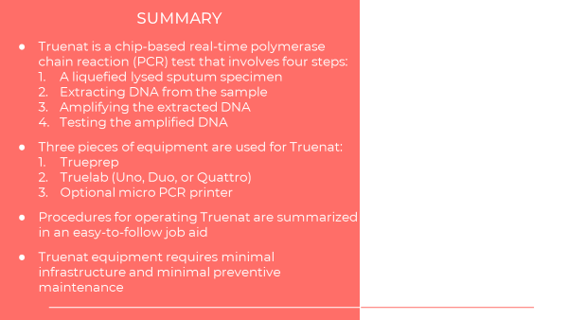
SAY: Let’s review what we learned in this module.

Truenat is a chip-based real-time polymerase chain reaction (PCR) test that involves four steps:
  - A liquefied lysed sputum specimen
  - Extracting DNA from the sample
  - Amplifying the extracted DNA
  - Testing the amplified DNA
Three pieces of equipment are used for Truenat:
- Trueprep
- Truelab (Uno, Duo, or Quattro)
- Optional micro PCR printer

Procedures for operating Truenat are summarized in an easy-to-follow job aid.

Truenat equipment requires minimal infrastructure and minimal preventive maintenance.
ASK: Does anyone have any questions before the quick knowledge check?
DO: Answer any clarifying questions from participants.

Knowledge Check
Knowledge Check
Slides: 74 – 76
Participant Guide Page: 59
DO: Explain that you will ask participants three knowledge check questions and may call on participants randomly to provide an answer. (These can also be programmed as poll questions in a virtual training – ensure that all participants respond before proceeding if using the poll feature).

If an answer provided in incorrect, ask if other participants would like to answer. Correct any incorrect answers that are given. If multiple participants get a question wrong, you may need to revisit the topic.

Note that knowledge check questions are not included in participant guides to avoid students seeing them during the lesson and only focusing on those pieces. Encourage participants to write down the answers in their guides in the notes field for future reference.
ANSWER:
- 3 – Trueprep, Truelab, and Truelab printer
- 3 – Sample pretreatment pack, cartridge-based sample prep kit, chip pack
ANSWER:
- Uno, Duo and Quattro
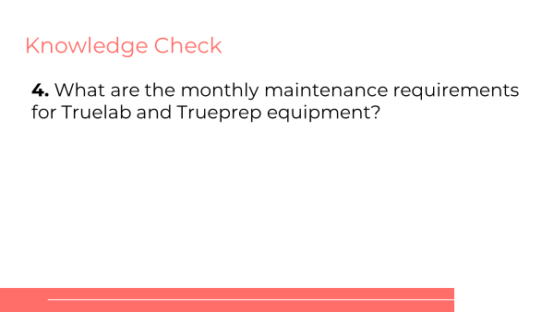
ANSWER:
- Disinfect instrument surfaces
- Clean Truelab bays
- Temperature calibration
- Verification of the fixed 6µl pipette

Module 4: Order Planning and Quality Assurance (QA) and Control

Target Audience
The target audience for this course is:
- Lab managers
- Program managers

Learning Objectives
Terminal Objective
- At the end of this session, participants should have a foundation in how to ensure quality of Truenat testing at their sites.

Module Objectives
- By the end of this module, participants should be able to:
  - Explain how to forecast for Truenat supplies
  - List the key elements of good stock management
  - Identify some quality assurance procedures for Truenat testing

Materials
- Facilitator Guide
- Participant Guide
- Pens/Pencils

Advance Preparation
Instructors should ensure they understand the activity on stock management in advance of delivering the lesson.

Lesson Plans

Introduction
Introduction
Slide: 3
Participant Guide Page: 60
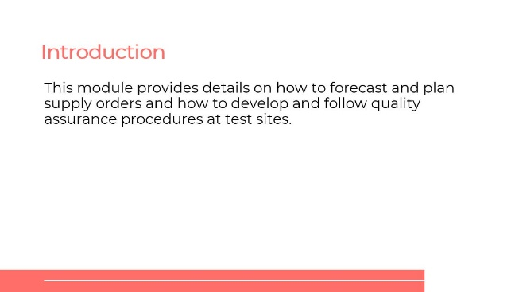
SAY: In this lesson, we will talk about how to forecast and plan supply orders, and how to develop and follow quality assurance procedures at test sites.
Learning Objectives
Slide: 4
Participant Guide Page: 60
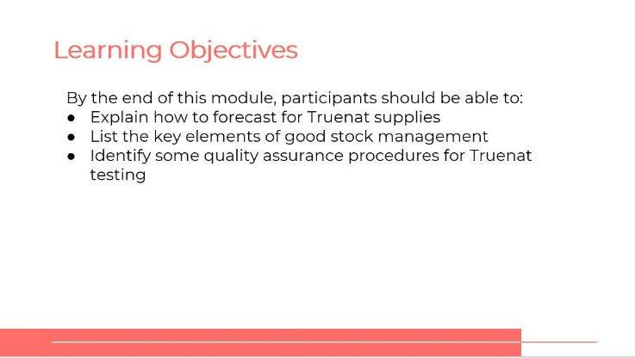
SAY: By the end of this module, you will be able to:
- Explain how to forecast for Truenat supplies.
- List the key elements of good stock management.
Identify some quality assurance procedures for Truenat testing.
ASK: What questions do you have before we move into this training?
DO: Allow participants time to ask questions and respond appropriately.
Module 4: Order Planning and Quality Assurance and Control
Slide: 5
Participant Guide Page: 60
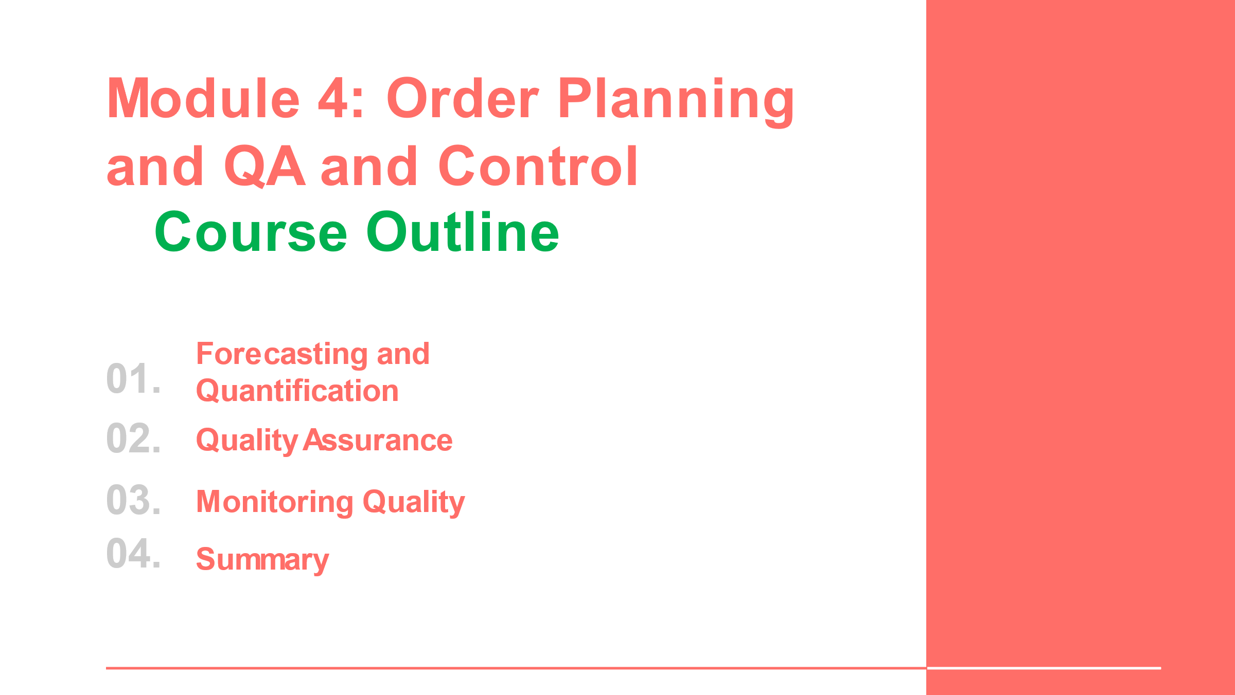
SAY: We will look at four topics in this module: forecasting and quantification, quality assurance and control and monitoring quality.

Forecasting and Quantification
Reagents and Consumables
Slide: 7
Participant Guide Page: 60
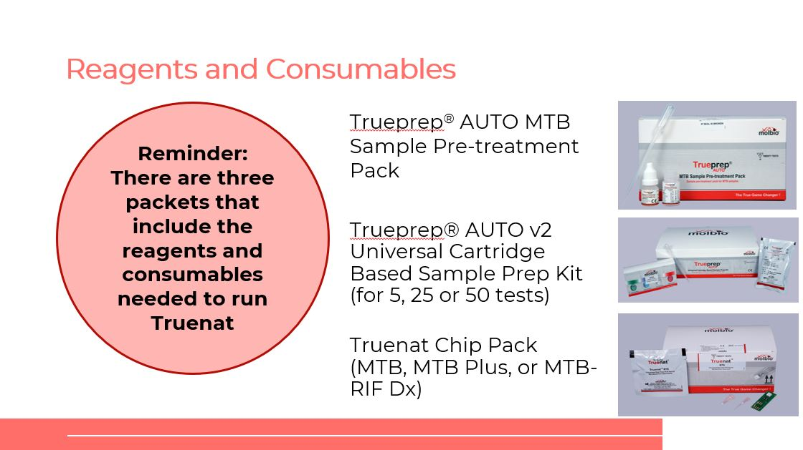
SAY: Remember there are three packets that include the reagents and consumables that are needed to run Truenat: Trueprep AUTO MTB Smample Pre-treatment Pack, Trueprep AUTO v2 Universal Cartridge Based Sample Prep Kit and the Truenat Chip Pack.

Do not forget the Truenat Chip pack has three different chips: Truenat MTB-for the detection of TB, Truenat MTB Plus- a more sensitive test for TB detection, and Truenat MTB-RIF Dx-for the detection of RIF resistance.
Ordering Reagents and Consumables
Slide: 8
Participant Guide Page: 60
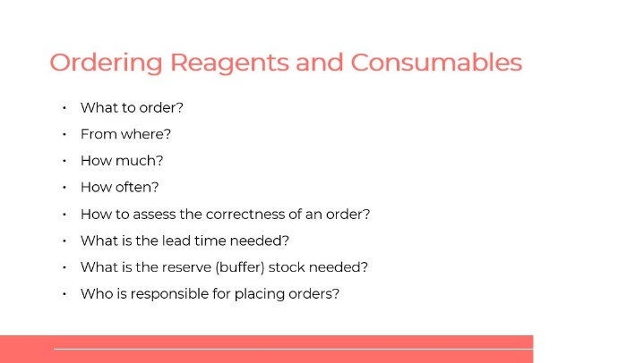
DO: Review the type of questions that participants should consider when ordering reagents and consumables.
Pricing
Slide: 9
Participant Guide Page: 61
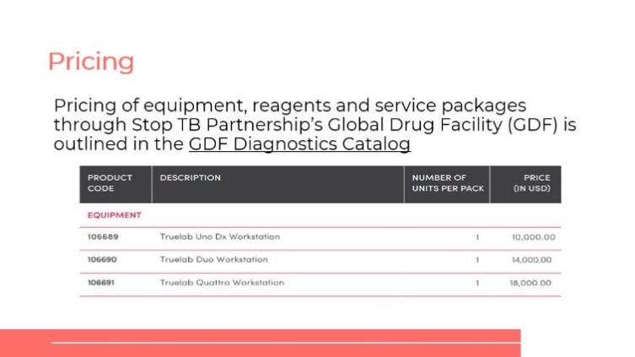
SAY: The Global Drug Facility (GDF) Diagnostics Catalog outlines the pricing of equipment, reagents and service packages through Stop TB Partnership’s GDF.
DO: If working online, open the link to the GDF Diagnostics Catalog and explore with participants the items on there.
Storage Conditions and Shelf-Life of Consumables
Slide: 10
Participant Guide Page: 61
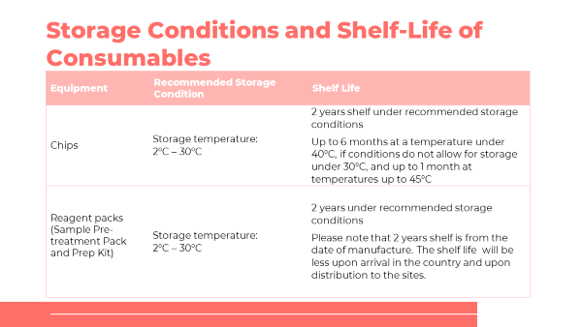
SAY: The shelf life of reagents and their required storage conditions must be taken into consideration.

The recommended storage conditions for the Truenat TB chips is 2°C–30°C and for the Sample Pre-treatment Pack and Prep Kit is 2°C–40°C.

The shelf-life of all reagents is 2 years under recommended storage conditions. Truenat TB chips can be stored for up one month at a temperature under 45°C and up to 6 months at a temperature under 40°C, if conditions do not allow for storage under 30°C.
Quantities for an Initial Order of Reagents
Slide: 11
Participant Guide Page: 62
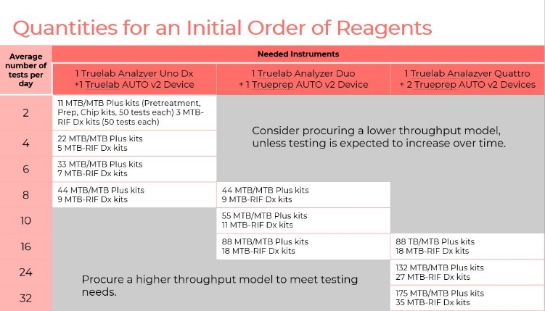
SAY: This table shows the number of reagents to order for one year of testing based on planned average number of tests per day in 260 working days.
DO: Review the overall chart with participants. Consider having a participant go through the slide.
Order Quantities
Slide: 12
Participant Guide Page: 63
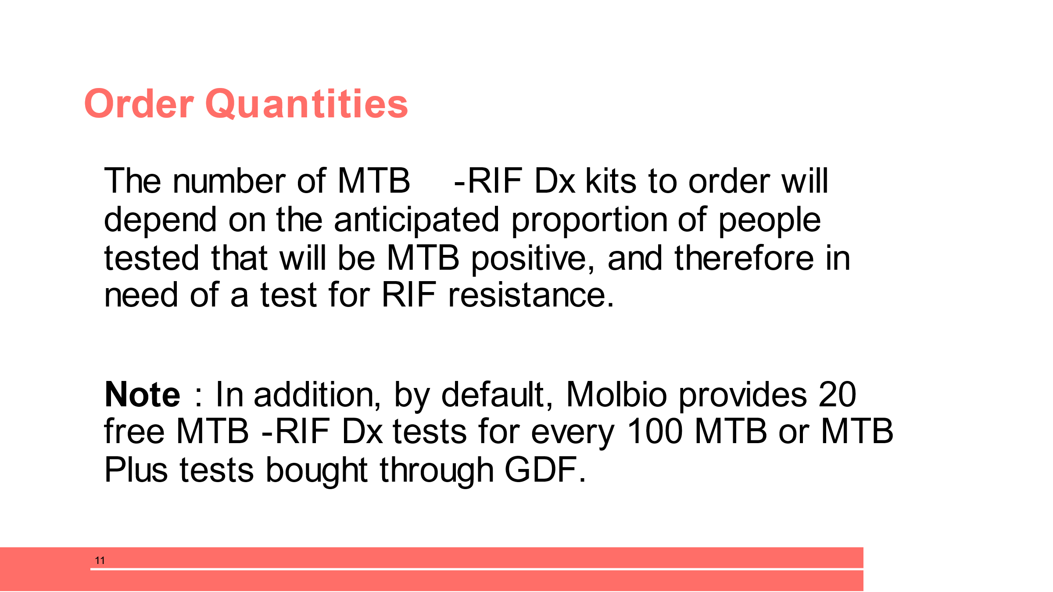
SAY: The number of MTB-RIF Dx kits to order should depend on the anticipated proportion of people tested that will be MTB positive, and therefore in need of a test for rifampicin resistance.
The anticipated number of tests needed should include the number of repeat rifampicin resistance tests that will be required given the need to confirm rifampicin-resistant results among patients in whom the result is unexpected and for tests that give errors or indeterminate results.

In the previous table, an estimate of 20% is used. Tests are increased by 5% to account for potential wastage, and the resulting number of tests is rounded up to the nearest kit (50 tests per kit). Note that other kit sizes are available (kits with 5 or 20 tests).
Data Needed for Regular Forecasting
Slide: 13
Participant Guide Page: 63
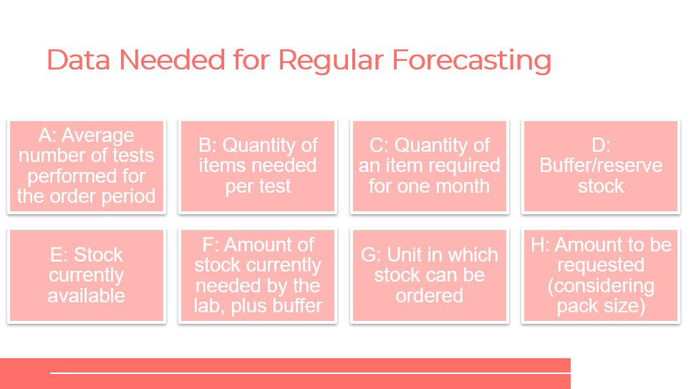
SAY: There is certain data you need for regular forecasting.
DO:
Review the data to collect with participants.

Share with participants that stock currently available is the physical count. The amount of stock currently needed by the laboratory to be able to continue testing for one quarter, plus buffer considering what the lab already has currently available (F).

Activity: Regular Forecasting
Regular Forecasting Activity
Slide: 14
Participant Guide Page: 64
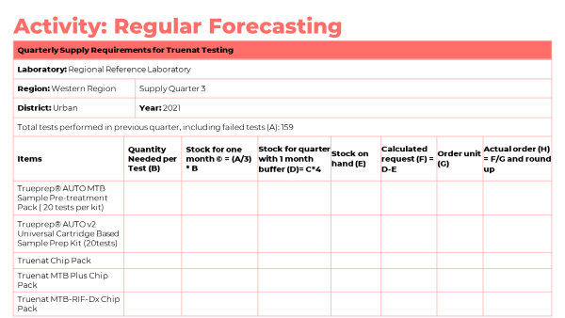
SAY: In groups of two, you are going to practice calculating supply requirements by completing the Quarterly Supply Requirement table in your Participant Guide. Be prepared to share your findings in a whole group discussion.
DO: Before participants start, share with them how to calculate how much to order. Have them refer to their participant guide for the formula. The calculations are:
  - Calculating how much of a supply to order:
    - a = quarterly number of tests performed (e.g, 210 tests)
    - b = number of months (e.g, 3 months)
    - c = average usage per month (a ÷ b) (e.g, 210 ÷ 3 = 70 tests per month)
    - d = lead time (e.g, 4 months)
    - e = stock in-hand (e.g, 140 cartridges)
    - f = recommended buffer stock (2 months average usage = 140 tests)
  - Minimum quantity to order for a four-month lead time: (c × d) – e + f = (70 × 4) – 80+140 = 340 cartridges.

Give participants 15 minutes to complete the table. Help pairs as they go through the calculations with their partner. Use Module 3 Technical Modules for Xpert Stop TB Partnership – Global laboratory Initiative (GLI) for guidance.

After 10 minutes, call on participants to share their calculations. Correct any incorrect answers and allow other participants to explain their answer if it is different.
ANSWERS:
Quarterly Supply Requirements for Truenat Testing
Laboratory: Regional Reference Laboratory
Region: Western Region |  |  | Supply Quarter 3
District: Urban |  |  | Year: 2021
Total MTB tests performed in previous quarter, including failed tests (A): 630
Item | Quantity Needed per Test (B) | Stock for one month (C) = (A/3) * B |  | Buffer stock requirement  (2 month average usage) | Stock for quarter with 1 month buffer (D)= C*5 | Stock on hand (E) | Calculated request (F) = D-E | Order unit (G) | Actual order (H) = F/G round up
Trueprep® AUTO MTB Sample Pre-treatment Pack | 1 | 210 |  | 420 | 1,050 | 450 | 600 | 1 pack | 600 packs
Trueprep® AUTO v2 Universal Cartridge Based Sample Prep Kit (for 25 tests) | 1 | 210 |  | 420 | 1,050 | 420 | 630 | 25 tests | 26 kits
Truenat MTB Chip Pack | 1 | 210 |  | 420 | 1,050 | 300 | 750 | 1 pack | 750 packs

SAY: What questions do you have before we move into the next slide?
DO: Allow participants time to ask questions and respond appropriately.

Stock Management
Stock Management
Slide: 16
Participant Guide Page: 66
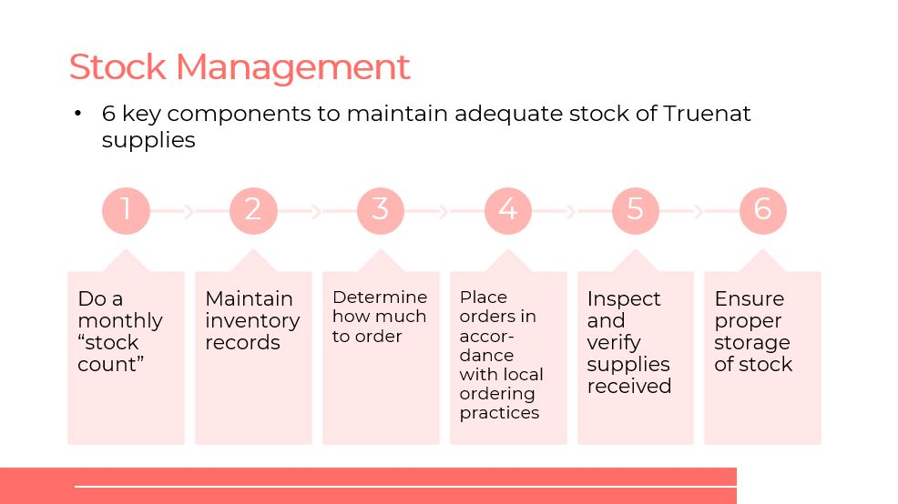
SAY: The purpose of determining how much supplies to order is because it helps avoid stock-outs and expiring of cartridges. A designated person is needed for supply management.
There are six key components to maintaining an adequate stock of Truenat supplies. The components are as follows:
- Do a monthly “stock count.”
- Maintain inventory records.
- Determine how much to order.
- Place orders in accordance with local ordering practices.
- Inspect and verify supplies received.
- Ensure proper storage of stock.
Stock Log
Slide: 17
Participant Guide Page: 67
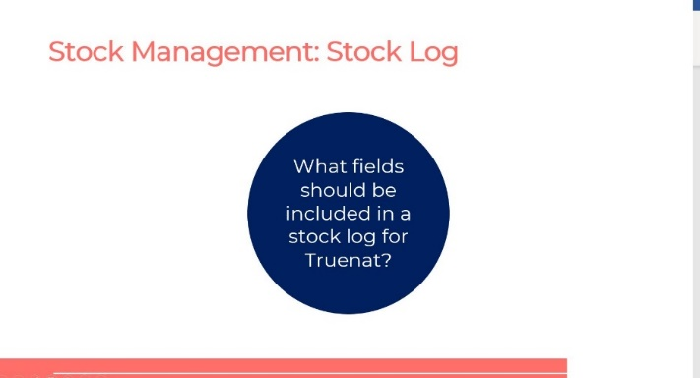
ASK: What fields should be included in a stock log for Truenat?
DO: Lead a whole group discussion and help the participants come up with the different content in the surrounding circles. Once the discussion reaches a logical stopping point, show the rest of the content on the slide.
ANSWER:
- Date and amount ordered
- Date of receipt of item
- Amount received
- Lot number
- Expiration date
- Amount of used items
- Balance of items still in stock
Temperature and Shelf Life
Slide: 18
Participant Guide Page: 67
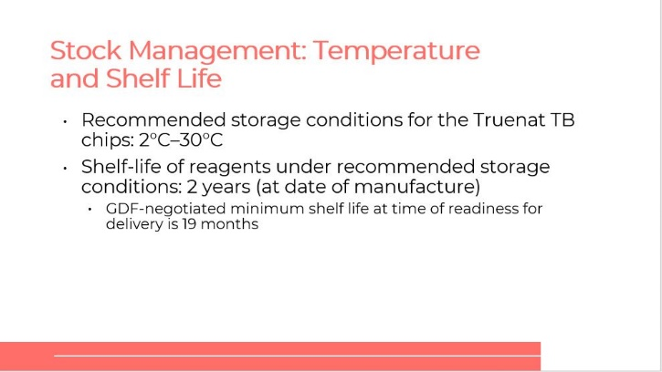
NOTE: Storage information on this slide has been discussed previously. This slide is a recap. The key point on this slide is the note on GDF-negotiated minimum shelf life at time of readiness for delivery is 19 months.
SAY: The recommended storage conditions for the Sample Pre-treatment Pack and Prep Kit is 2°C–40°C. Shelf life of reagents under recommended storage conditions is 2 years from the date it was manufactured. GDF-negotiated minimum shelf life at time of readiness for deliver is 19 months.
If conditions do not allow for storage under 30°C – Truenat TB chips can be stored for up to 6 months under 40°C.

Storage and Expiry
Slide: 19
Participant Guide Page: 68
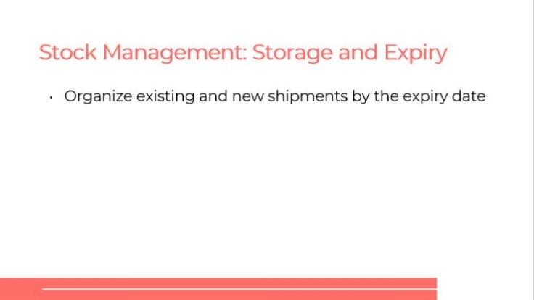
SAY: When storing equipment, organize any existing and new shipments by the expiry date. This is so supplies with the soonest expiry date will be used first.

Quality Assurance and Control
QA and Control
Slide: 21
Participant Guide Page: 68
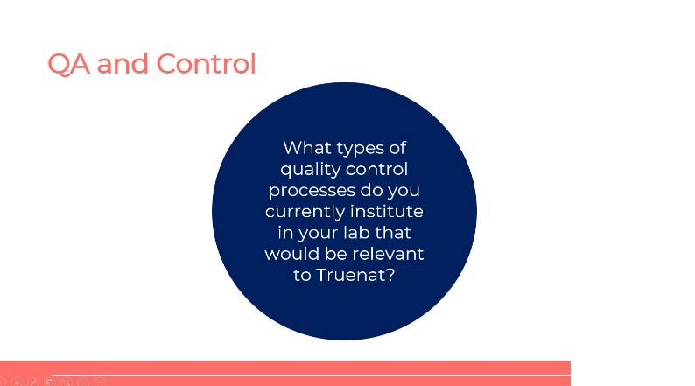
ASK: What types of quality control processes do you currently institute in your lab that would be relevant to Truenat?
DO: Call on participants to share their experiences about QA programs and external quality control processes in their labs.
Roles of Ensuring Quality
Slide: 22
Participant Guide Page: 69
SAY: Lab managers are responsible for overseeing QA activities at large facilities. The Health Facility Quality Committee (HFQC) may provide oversight and coordination for QA activities at larger facilities.
Quality Assurance Program
Slide: 23
Participant Guide Page: 69
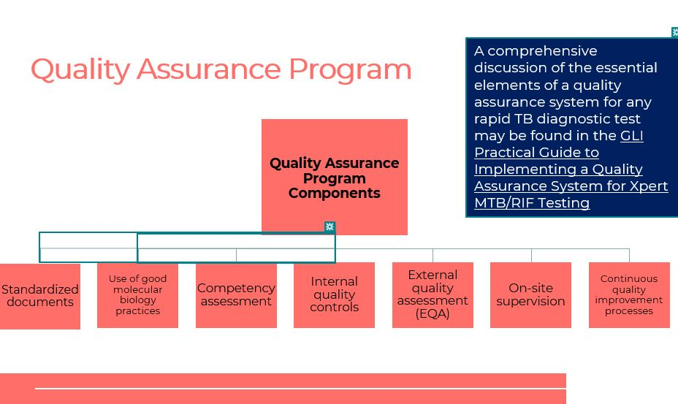
SAY: Many components go into creating a quality assurance program. For Truenat having standardized documents, use of good molecular biology practices, competency assessment internal quality controls, EQAs, on-site supervision and continuous quality improvement processes are essential elements of a quality assurance system for any rapid TB diagnostic test.
DO: Inform participants that Standardized documents include identification, tailoring and ensuring use.
Good Molecular Biology Practices
Slide: 24
Participant Guide Page: 70
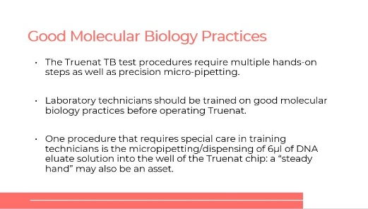
SAY: The Truenat TB test procedures require multiple hands-on steps as well as precision micro-pipetting. Laboratory technicians should be properly trained on all procedures and in good molecular biology practices.

Competency Assessment
Slide: 25
Participant Guide Page: 70
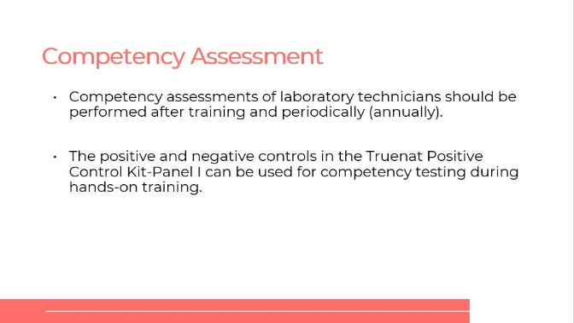
SAY: Competency assessments of a lab technician should be performed after training and periodically (annually). After competency assessments of laboratory techs, there should be assessments of the knowledge and skills for performing each of the tasks involved in a diagnostic test.
Standardized Documents (SOPs)
Slide: 26
Participant Guide Page: 71
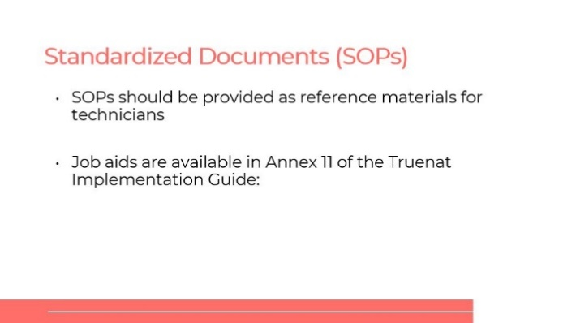
SAY: Standardized Documents should be provided as reference materials for lab technicians. The following job aids are available in Annex 11 of the Truenat Implementation guide:
- Truenat PCR Process Flow: Sample to Result
- Troubleshooting, Alerts, and Errors
- Do’s and Don’ts

Internal Quality Control (IQC)
Slide: 27
Participant Guide Page: 71
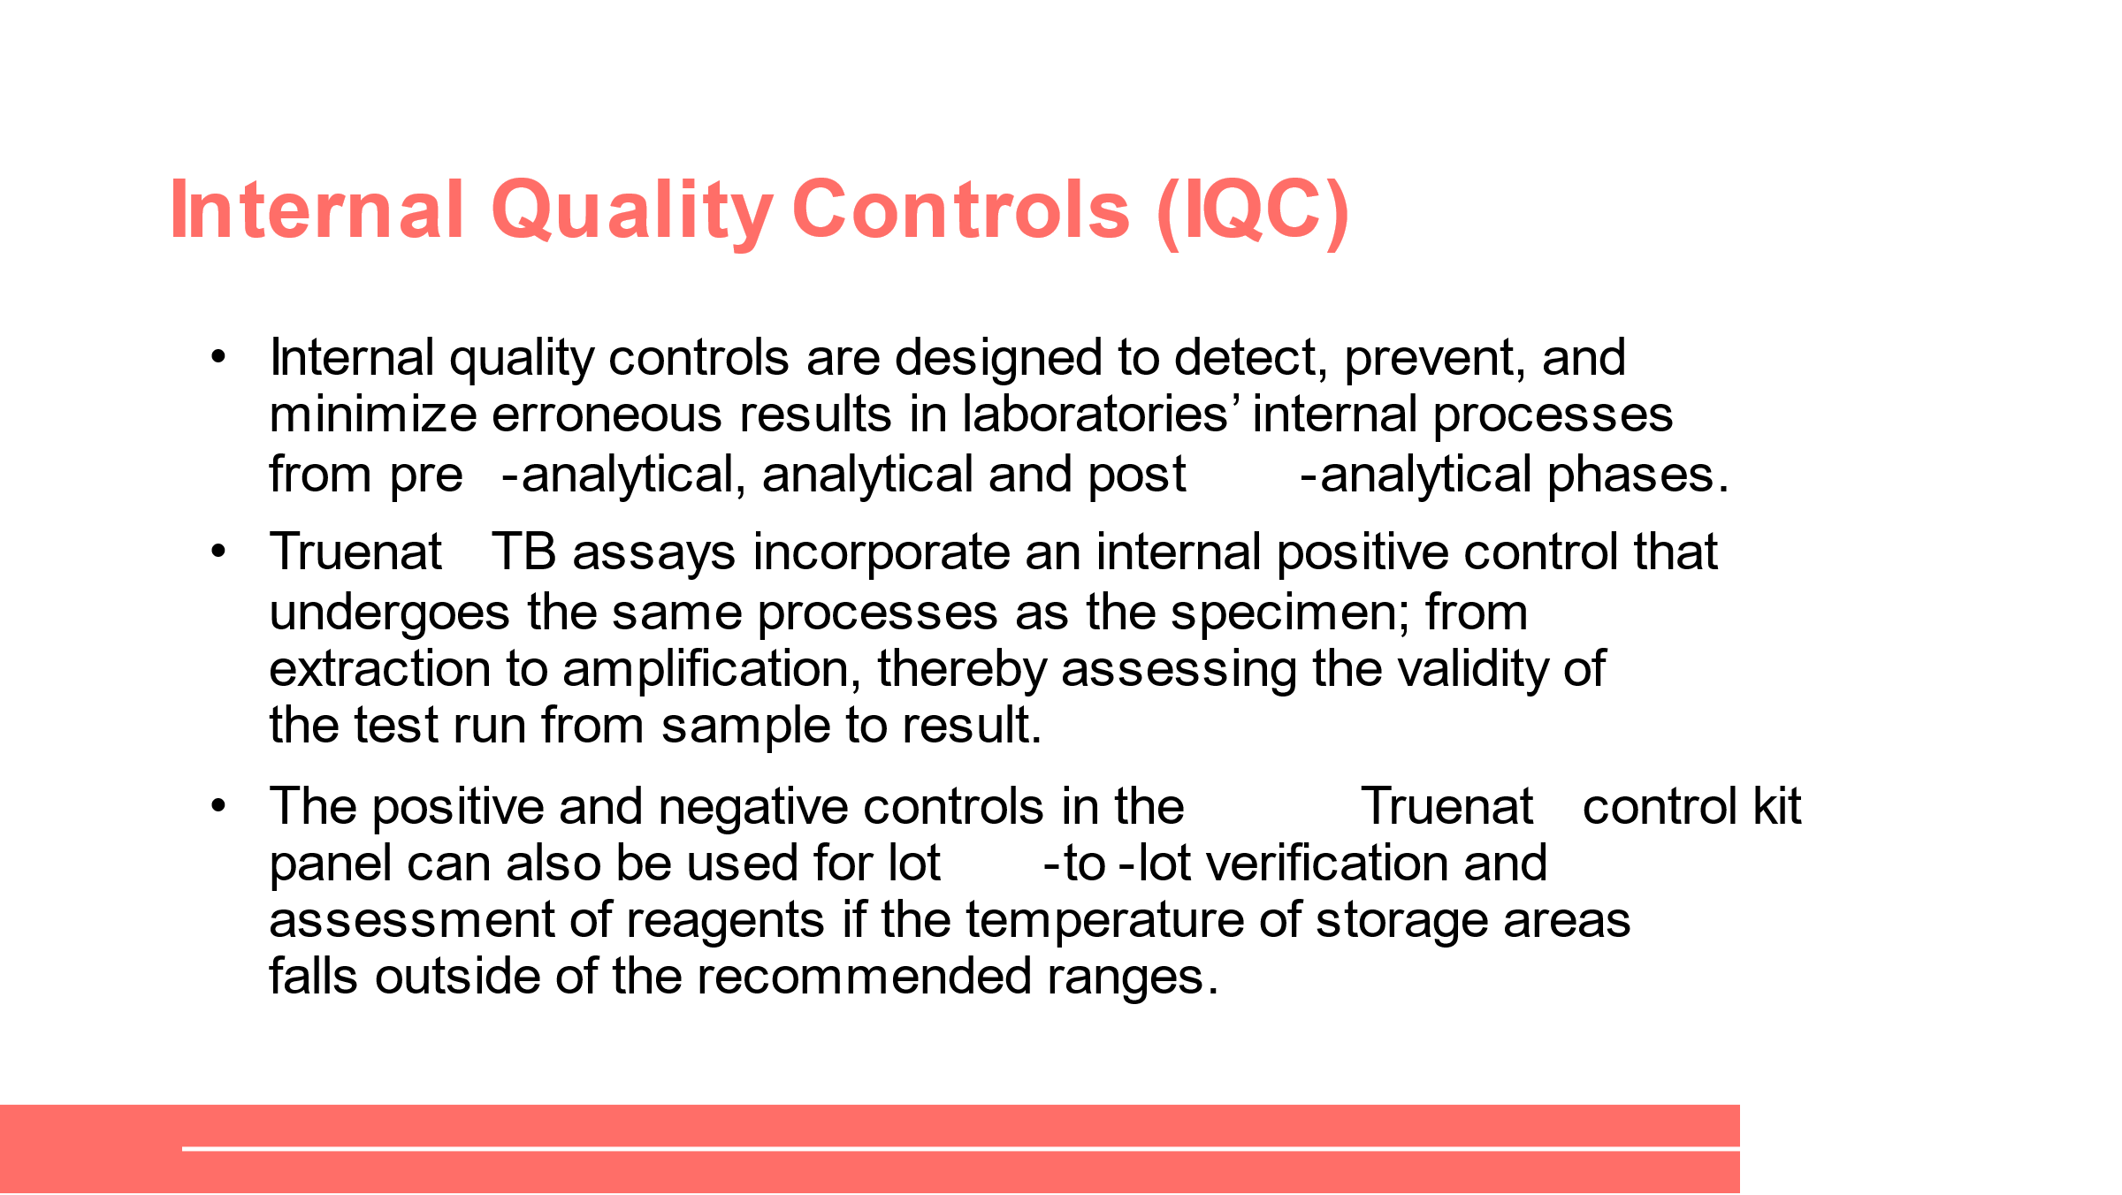
SAY: Truenat TB assays incorporate internal quality controls through positive and negative controls that follow the same processes as the specimen.
External Quality Assessment (EQA)
Slide: 28
Participant Guide Page: 72
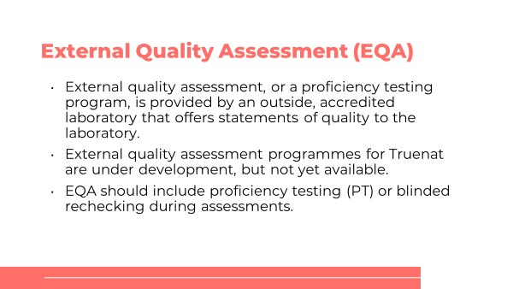
SAY: External Quality Assessments or EQAs for Truenat are not yet available, but it can be modeled after the proficiency testing programme used for the Xpert MTB/RIF test.
It is recommended to test 10-15 specimens per week to maintain proficiency of staff.

Initial Calibration/Verification Panels
Slide: 29
Participant Guide Page: 72
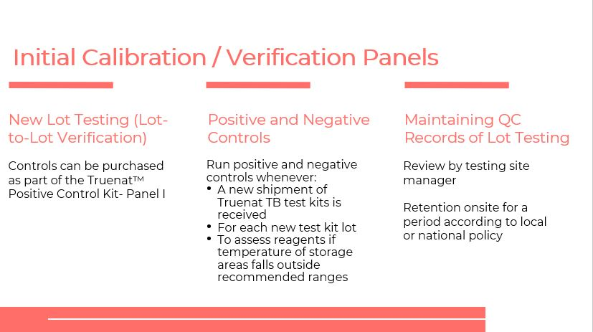
SAY: New lot testing, positive and negative controls and maintaining QC records are the components that involve initial calibration and verification panels.

New lot testing (lot-to-lot verification) control:

Positive and negative controls are used for new batches of reagents.

Maintaining and monitoring QC records of lot testing should be reviewed by testing site manager and retention on site for a period according to local or national policy.
Regular Maintenance
Slide: 30
Participant Guide Page: 73
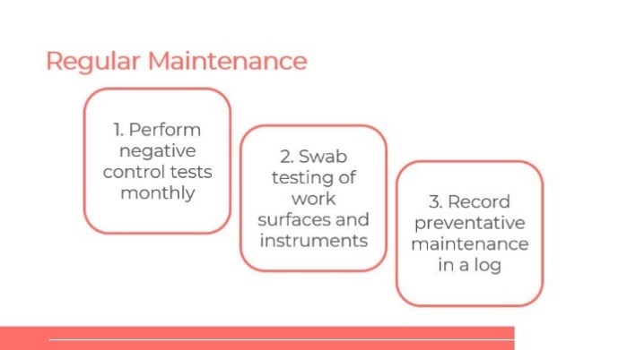
SAY: Although, Truelab and Trueprep instruments require minimal preventive maintenance as per the manufacturer, there are some tasks that should be done monthly.
DO: Review the maintenance chart with participants.
Warranty and Repair
Slide: 31
Participant Guide Page: 74
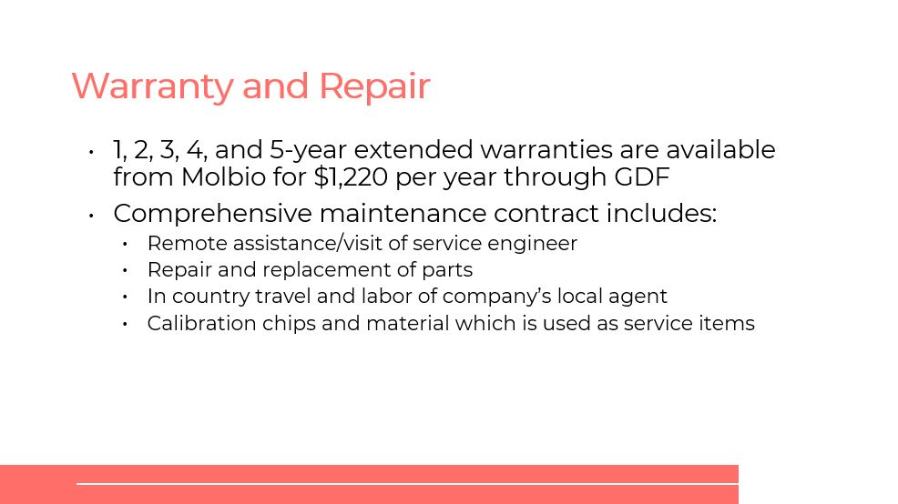
SAY: Molbio offers one-to-five-year extended warranties per year through GDF.

A comprehensive maintenance contract includes:
- Remote assistance/visit of service engineer
- Repair and replacement of parts
- In country travel and labor of company’s local agent
- Calibration chips and material which is used as service items

For the repair and replacement of parts remember that:
- If a machine is not repairable at the site, a stand-by machine will be provided.
- If the machine needs to be replaced free replacement will be provided at Molbio’s cost.

Monitoring Quality
General Laboratory Performance Indicators
Slide: 33
Participant Guide Page: 75
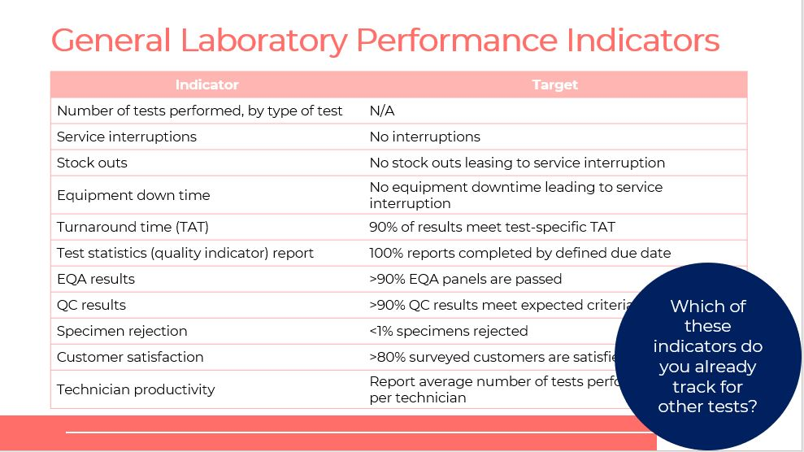
SAY: On this slide, you will see general lab performance indicators and their targets.
DO: Review what is on the slide with participants.
ASK: Which of these indicators do you already track for other tests?
DO: Call on participants to share their experiences.
Performance Indicators for Truenat TB Test
Slides: 34 and 35
Participant Guide Page: 75
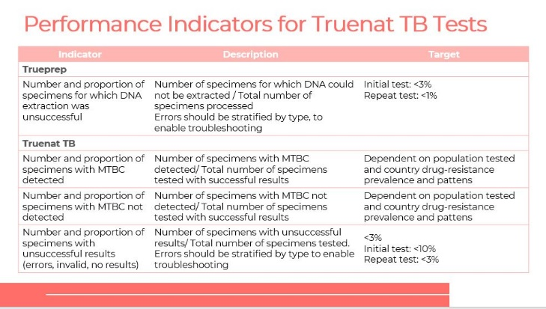

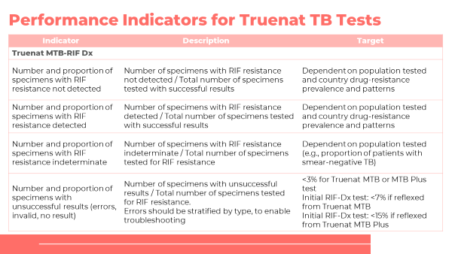
DO: Review what is on the slide with participants.
SAY: The performance indicators for Truenat TB tests are modeled after GLI-recommended performance indicators for Xpert MTB/RIF testing that should be monitored monthly by each testing site. Some targets are setting-specific. Labs should monitor indicators and establish local targets and ranges. Deviations from expected value should be investigated.
Performance Indicators for Monitoring Patient and Sample Flow
Slide: 36
Participant Guide Page: 76
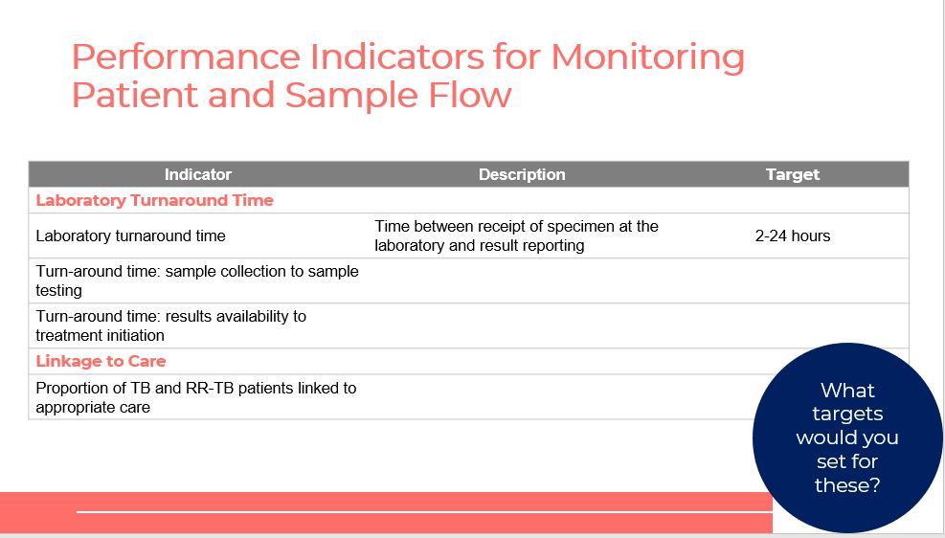
SAY: On this slide, you will see performance indicators for monitoring patient and sample flows.
DO: Review what is on the slide with participants.
ASK: What targets would you set for these, based on your experience?
DO: Call on participants to share their experiences.

Summary
Summary
Slide: 37
Participant Guide Page: 77
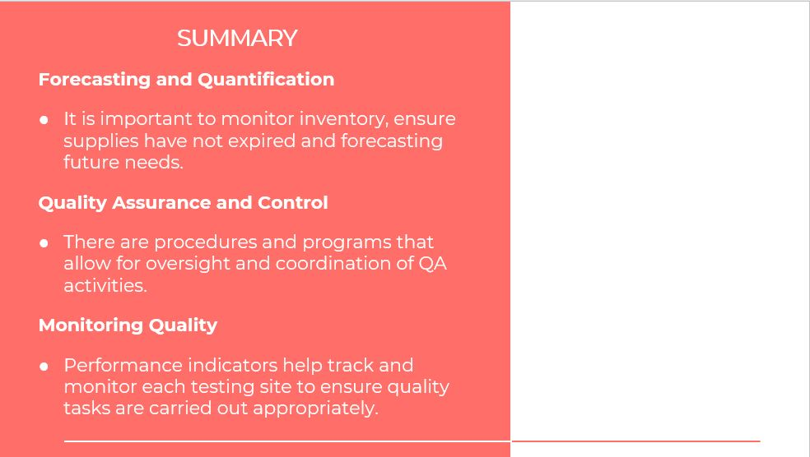
SAY: It is important to monitor inventory, ensure supplies have not expired and forecasting future needs.

There are procedures and programs that allow for oversight and coordination of QA activities.

Performance indicators help track and monitor each testing site to ensure quality tasks are carried out appropriately.

Knowledge Check
Knowledge Check
Participant Guide Page: 78
Slides: 39 – 41
DO: Explain that you will ask participants three knowledge check questions and may call on participants randomly to provide an answer. (These can also be programmed as poll questions in a virtual training – ensure that all participants respond before proceeding if using the poll feature).

If an answer provided in incorrect, ask if other participants would like to answer. Correct any incorrect answers that are given. If multiple participants get a question wrong, you may need to revisit the topic.

Note that knowledge check questions are not included in participant guides to avoid students seeing them during the lesson and only focusing on those pieces. Encourage participants to write down the answers in their guides in the notes field for future reference.
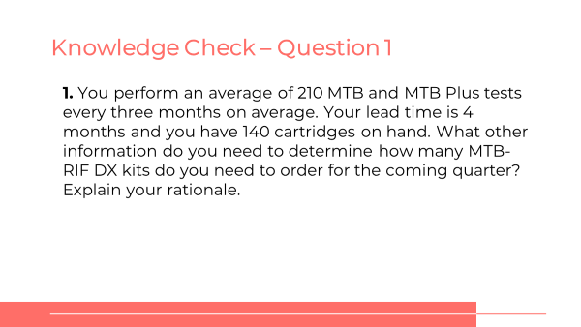
ANSWER: The number of MTB-RIF Dx kits to order will depend on the anticipated proportion of people tested that will be MTB positive, and therefore in need of a test for RIF resistance. More information is needed about the proportion of the 210 tests that were positive.
ANSWER:
- Do a monthly “stock count”
- Maintain inventory records
- Determine how much to order
- Place orders in accor-dance with local ordering practices
- Inspect and verify supplies received
- Ensure proper storage of stock
- Keep a stock log
- Organize existing and new shipments by the expiry date
ANSWER:
- Standardized documents
- Use of good molecular biology practices
- Competency assessment internal quality controls
- External quality assessment (EQA)
- On-site supervision
- Continuous quality improvement processes

Module 5: Monitoring & Evaluation (M&E)
The monitoring and evaluation lesson provides participants with the knowledge of establishing a monitoring and evaluation plan for Truenat.

Target Audience
The target audience for this course is:
- Lab managers
- Program managers

Learning Objectives
Terminal Objective
- At the end of this session, participants should be able to describe how to establish a monitoring and evaluation plan for Truenat.

Module Objectives
- By the end of this module, the participant will be able to:
  - Outline a general approach to monitoring and evaluating the impact of Truenat on TB-related targets and goals.

Advance Preparation
Instructors may need to tailor the content at the end of this module to reflect any changes to M&E processes and systems that have already been developed. This section is indicated in yellow highlight.

Lesson Plans

Introduction
Introduction
Slide: 3
Participant Guide Page: 79
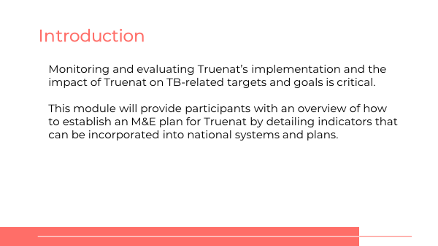
SAY: In this module, we will talk about M&E aspects of Truenat. The focus will be on indicators and how to establish or revise an M&E plan that will allow you as a country to assess the impact of Truenat on meeting targets and goals.
Module Learning Objectives
Slide: 4
Participant Guide Page: 79
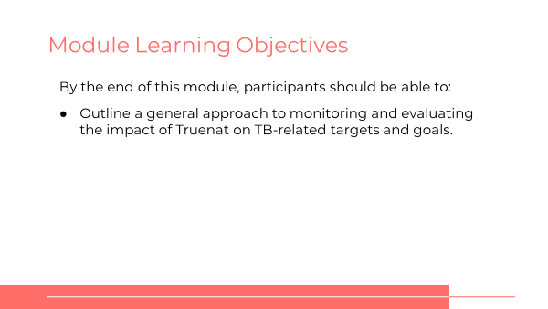
SAY: The learning objective for this module is that by the end of this training topic, you will be able to outline a general approach to monitoring and evaluating the impact of Truenat on TB-related targets and goals.
Introduction
Slide: 5
Participant Guide Page: 79
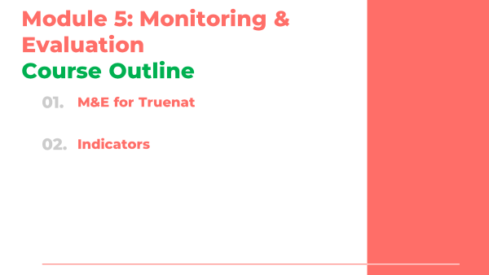
SAY: This is a short module, with just two topics. First we’ll talk in general about M&E For Truenat, then we’ll walk through what indicators may be available to track.

M&E for Truenat
Inroduction
Slide: 7
Participant Guide Page: 79
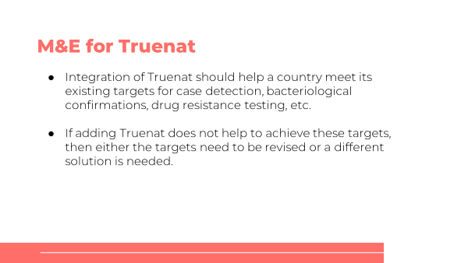
SAY: The main idea behind developing an M&E system for Truenat is the idea that integrating Truenat into a diagnostic network should help a country meet its existing targets for case detection, bacteriological confirmation, drug resistance testing, or other TB-related indicators. If adding Truenat does not help achieve targets, then either the targets need to be revised or Truenat is not the right solution.
ASK: What targets will Truenat help achieve in country? (Answers will vary but should be tied to the discussion in Module 1 about priority diagnostic challenges.)
QA vs. M&E
Slide: 8
Participant Guide Page: 79
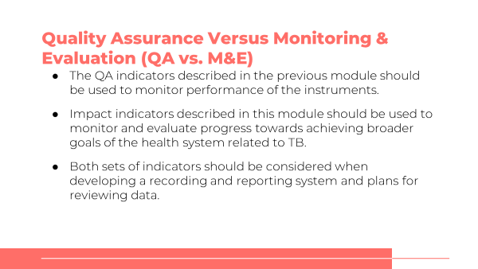
SAY: Before we move on, I just wanted to make a quick note about the difference between the QA indicators that we talked about in the last module versus the indicators we are about to talk about for M&E. QA indicators should be used to monitor the performance of the instruments and the technicians using the instruments to make sure everything is working properly. Impact indicators described in this lesson should be used to monitor and evaluate progress towards achieving goals of the health system related to TB.
Both sets of indicators should be considered when developing a recording and reporting system and plans for reviewing data.

Indicators

Impact Indicators
Slide: 10
Participant Guide Page: 80
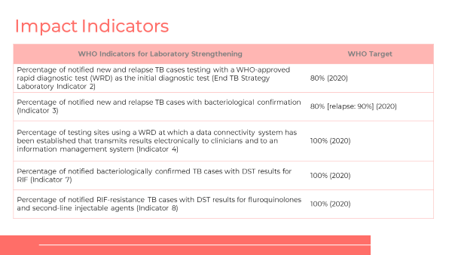
SAY: WHO has indicators on laboratory strengthening that you are probably already familiar with. Let’s go over them.
DO: Go through each possible impact indicator.
ASK: Which of these indicators are already being measured in your country? (Answers will depend on the country.)
DO: Ask for a volunteer to provide an answer and have participants note correct answers in their participant guide.
Other Possible Impact Indicators
Slides: 11 and 12
Participant Guide Page: 82
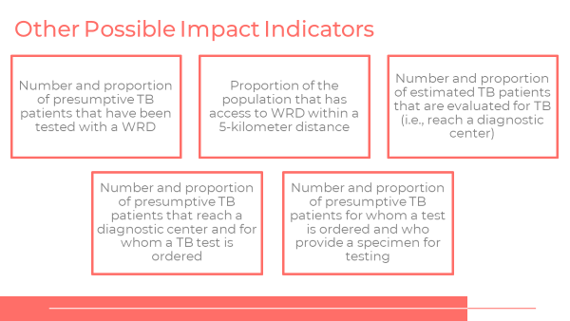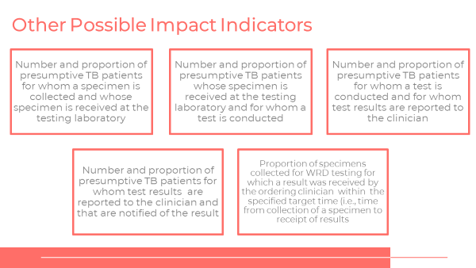
SAY: There are other impact indicators that also may be relevant.
DO: Go through each possible impact indicator.
Diagnostics Connectivity
Slides: 13 and 14
Participant Guide Page: 83
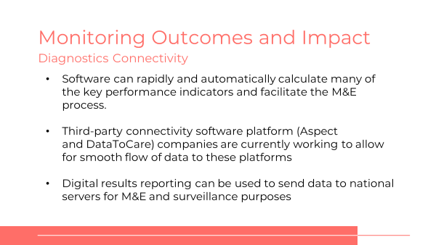

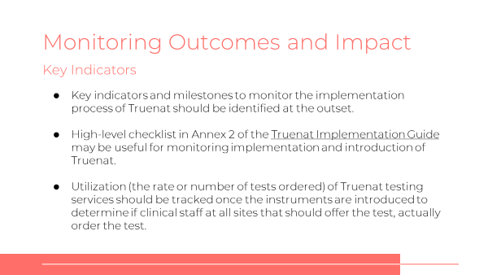
SAY: To help monitor the indicators that are chosen more easily, you might consider using the connectivity features of Truenat. Software can rapidly and automatically calculate many of the key performance indicators and facilitate the M&E process.

Third-party connectivity software platform (Aspect and DataToCare) companies are currently working to allow for smooth flow of data to these platforms​.

Digital results reporting can be used to send data to national servers for M&E and for surveillance purposes​.

Summary
Summary
Slide: 16
Participant Guide Page: 84
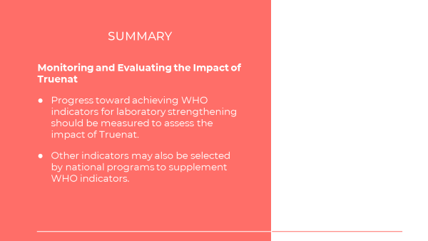
SAY: The main point of this module was to emphasize that progress toward achieving WHO and other impact indicators should be measured to assess the impact of Truenat.
ASK: Does anyone have any questions about this lesson?
DO: Answer any clarifying questions from participants.

Knowledge Check
Knowledge Check
Slide: 17 and 18
Participant Guide Page: 84
DO: Explain that you will ask participants three knowledge check questions and may call on participants randomly to provide an answer. (These can also be programmed as poll questions in a virtual training – ensure that all participants respond before proceeding if using the poll feature).

If an answer provided in incorrect, ask if other participants would like to answer. Correct any incorrect answers that are given. If multiple participants get a question wrong, you may need to revisit the topic.

Note that knowledge check questions are not included in participant guides to avoid students seeing them during the lesson and only focusing on those pieces. Encourage participants to write down the answers in their guides in the notes field for future reference.
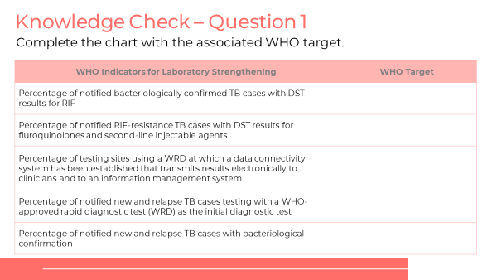
SAY: Open your participant guide to page 85. Read and answer the knowledge check question. Be ready to share your answer.
DO: Allow participants five minutes to respond to the knowledge check question. Inform participants to write down their answers in their participant guide. Allow a participant to share their response.
ANSWERS:
- 100%
- 100%
- 100%
- 80%
- 80%, Relapse: 90%
Knowledge Check
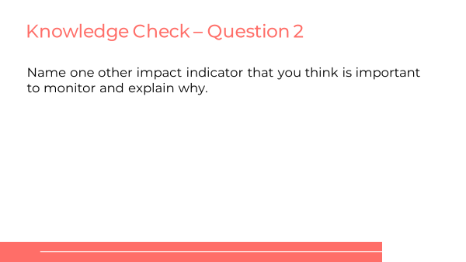
DO: Read question aloud and allow participants time to respond in their participant guide. Depending on the size of the group, consider calling on all participants to share their answers.
ANSWER: Answers will vary.

Module 6: Biosafety and Specimen Collection and Referral
This lesson introduces the proper procedures for specimen collection and referral.

Target Audience
The target audience for this course is:
- Lab technicians
- Lab clinicians

Learning Objectives
Terminal Objective
- At the end of this session, participants should be able to explain the processes for specimen collection, pretreatment, and referral for Truenat.

Module Objectives
By the end of this module, participants should be able to:
- Demonstrate good biosafety practices and risks when performing Truenat testing
- Collect and pretreat a sputum sample
- Describe storage requirements for collected specimens
- Understand the process for specimen referral

Materials
- Facilitator Guide
- Participant Guide
- Pens/Pencils
- Index cards

Advance Preparation
- Instructors will need to understand if the national program has already made decisions about the number of specimens that should be collected, or about referral processes more generally. If so, the content of this module should be tailored to reflect these decisions.

Lesson Plans

Introduction
Introduction
Slide: 3
Participant Guide Page: 85
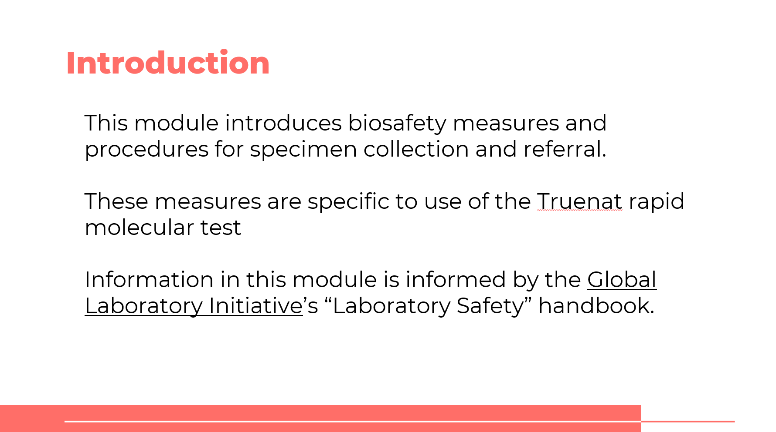
SAY: Our final module introduces biosafety and the procedures for specimen collection and referral.
Course Outline
Slide: 4
Participant Guide Page: 85
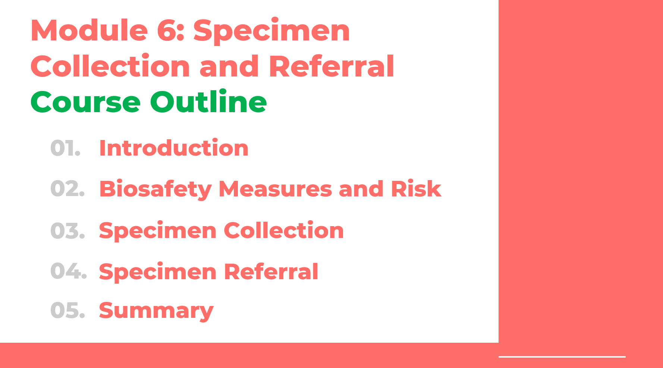
SAY: We will look at three topics– biosafety, specimen collection and specimen referral

Learning Objectives
Slide: 5
Participant Guide Page: 85
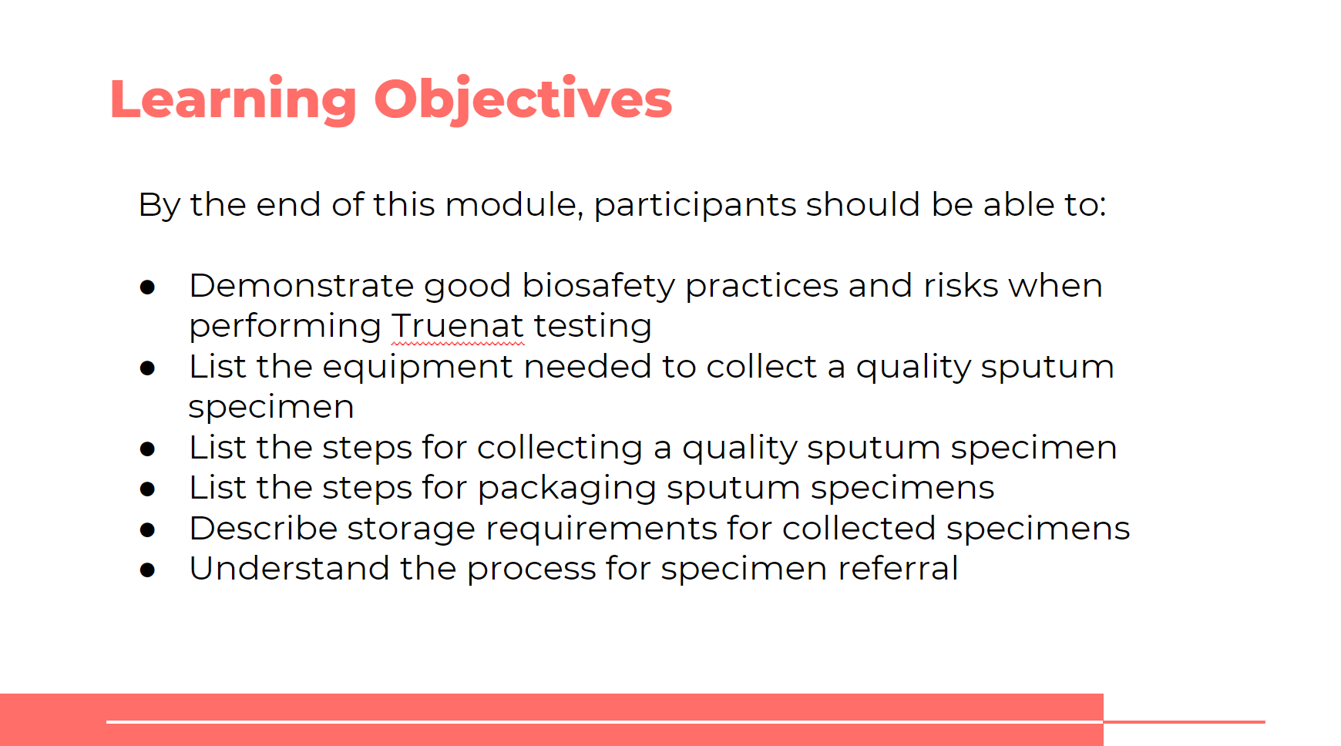
SAY: By the end of this module, you should be able to:
- Demonstrate good biosafety practice when using Truenat
- Collect and pretreat a sputum sample for Truenat testing (note that we are assuming that all training participants are familiar with the basic principles of collecting sputum samples)
- Describe storage requirements for collected specimens
- Describe packaging of specimens for transportation
- Understand the process for specimen referral
ASK: What questions do you have before we move into the first lesson for this training?
DO: Allow participants time to ask questions and respond appropriately.

Biosafety Measures and Risk

General Principles of Biosafety
Slide: 7
Participant Guide Page: 85
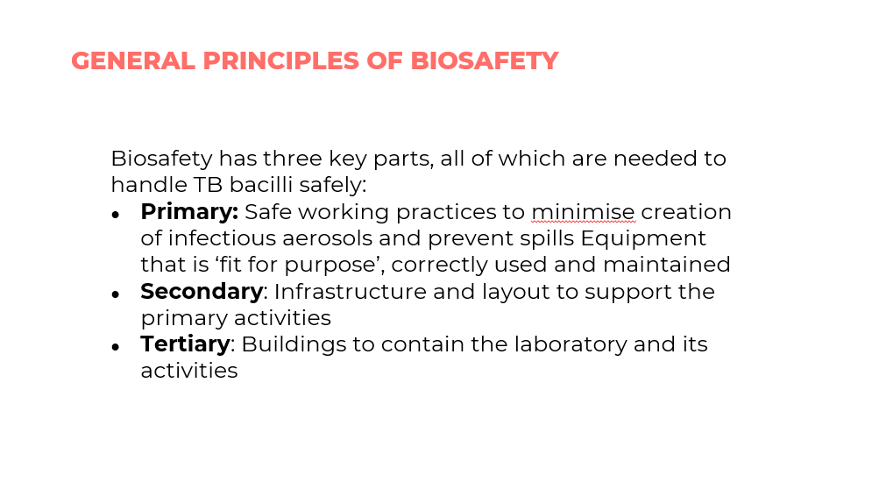
SAY: Biosafety has three key important components needed to handle TB bacilli safely: Primary safe working practices to minimize generation of infectious aerosols, Secondary infrastructure and layout support for primary activities and Tertiary buildings to contain the laboratory and its activities.
Importance of Biosafety
Slide: 8
Participant Guide Page: 85
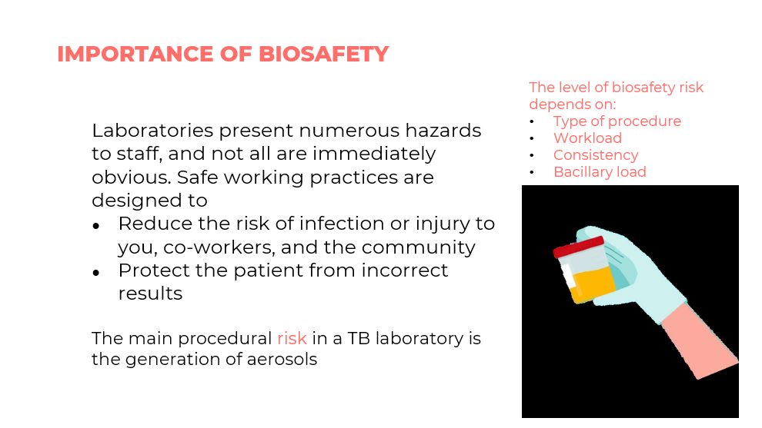
SAY: The importance of biosafety is to reduce the risk of infection or injury to you, coworkers, and the community. The main procedural risk in a TB laboratory is generation of aerosols.
Standard Microbiological Procedures
Slide: 9
Participant Guide Page: 85
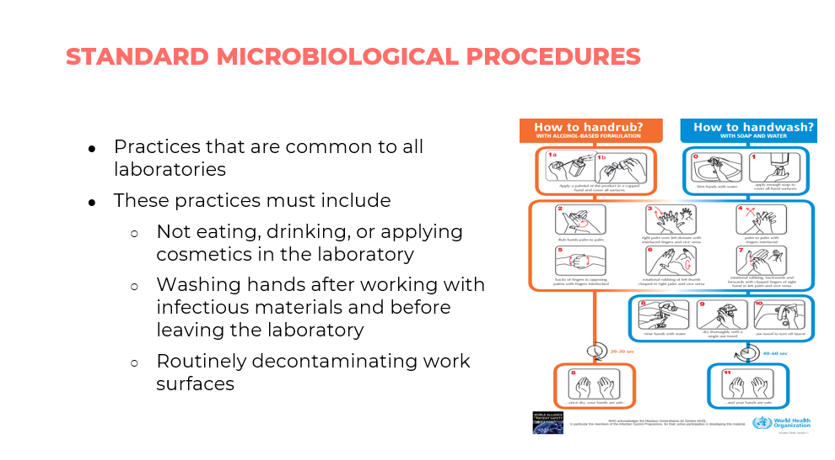
SAY: The standard microbiological procedures are not eating, drinking, or applying cosmetics in the laboratory. This also includes washing hands after working with infectious materials and before leaving the laboratory and routinely decontaminating work surfaces in the laboratory.
Addressing Biosafety
Slide: 10
Participant Guide Page: 85
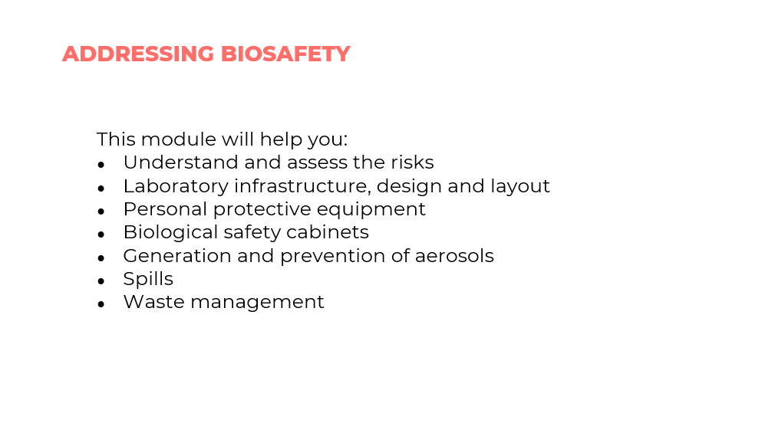
SAY: This section of the module will help you understand the following: a) The risks in a TB lab, b) Laboratory infrastructure, design and layout, c) Personal protective equipment, d) Biological safety cabinets, e) Generation and prevention of aerosols, f) Spills and g) Waste management.

Assessing Risk
Risk Biosafety Levels
Slide: 12
Participant Guide Page: 86
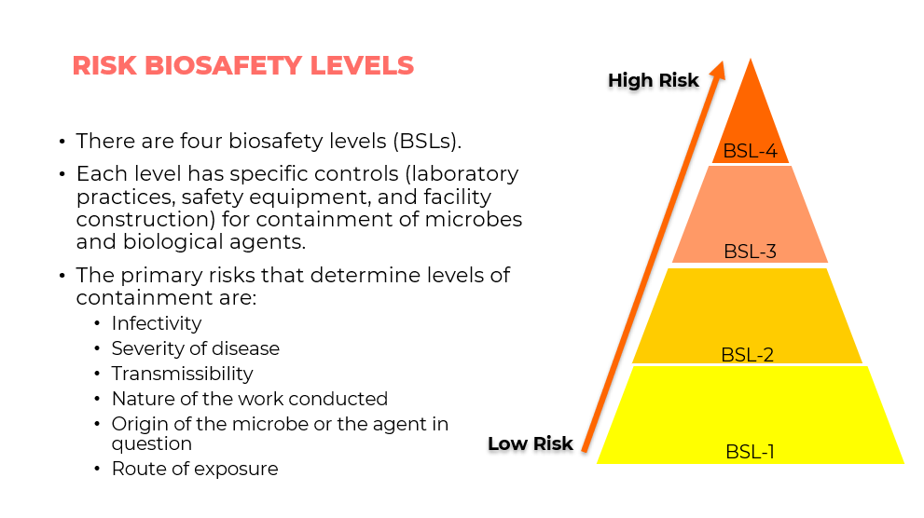
SAY: We are going to discuss the four biosafety levels (BSLs 1,2, 3 and 4) as well the risks that determine the levels of containment. Each level has a specific control (laboratory practices, safety equipment, and construction) for containment of microbes and biological agents.
Characteristics of Biosafety Levels
Slide: 13
Participant Guide Page: 86
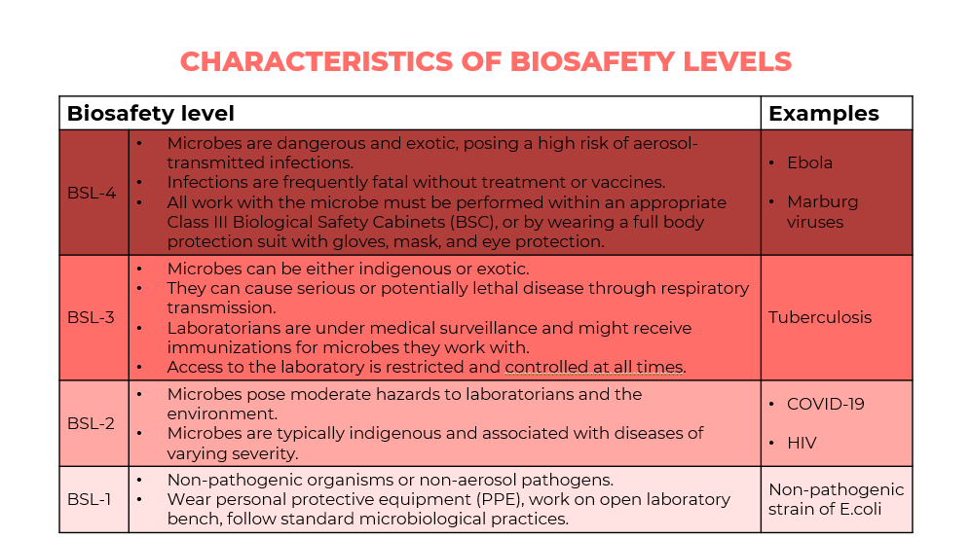
SAY: We will discuss the characteristics of the biosafety levels (BLS-1, BLS-2, BLS 3, and BLS-4) and give examples of the microbes.
DO: Read off each biosafety levels and examples of each.
Biosafety Measures According to Risk Levels
Slide: 14
Participant Guide Page: 86
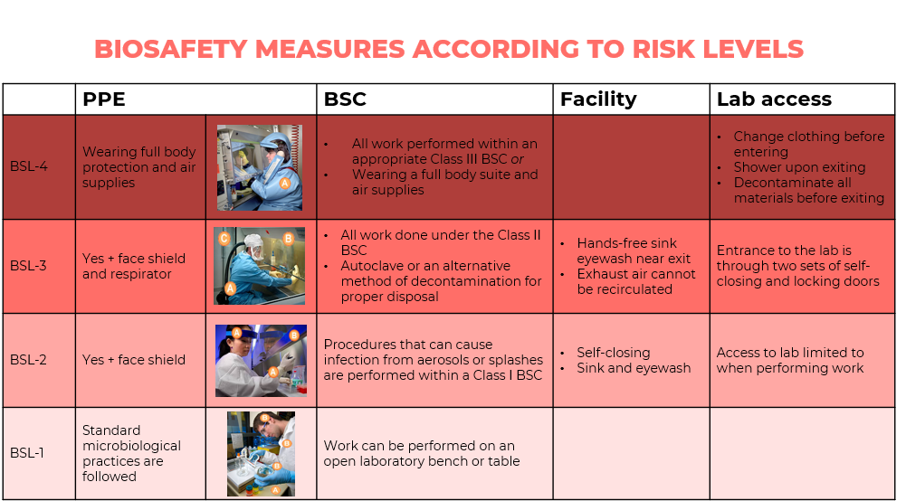
SAY: We will walk through each BSL to discuss biosafety measures according to risk levels.
DO: Provide an overview of biosafety measures at each risk level.
Risk Precaution Levels
Slide: 15
Participant Guide Page: 86
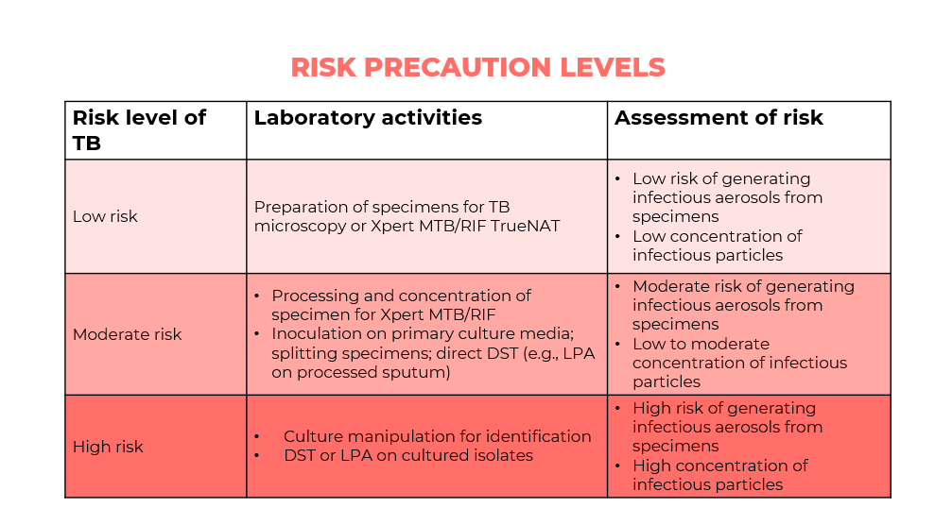
SAY: We will discuss the risk precaution levels of TB with the laboratory activities and assessment of risk.
DO: Discuss the laboratory activities and risk at each level.

Laboratory Infrastructure
Ventilation and Laboratory Setup
Slide: 17
Participant Guide Page: 87
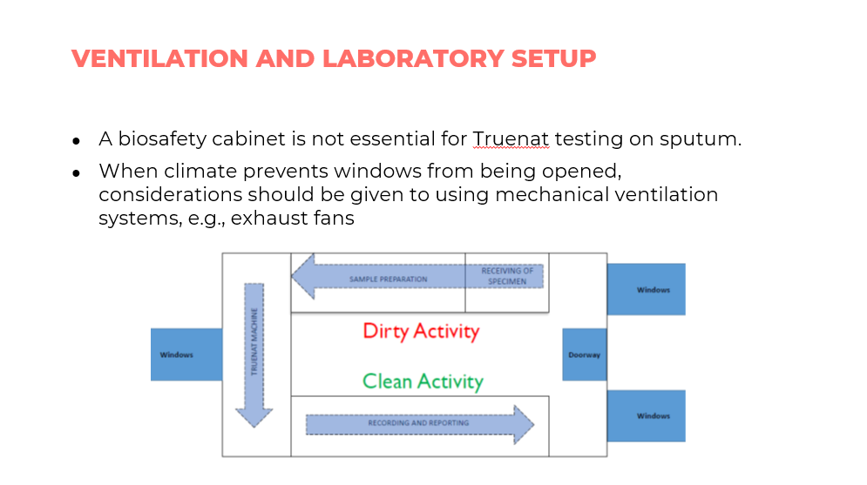
SAY: It is important to note that a biosafety cabinet is not essential for Truenat testing. You only need a safe, well-ventilated laboratory setup. Where windows cannot be opened, consider using mechanical ventilation systems, such as exhaust fans.

Personal Protective Equipment
Matrix of Recommended PPE According to Activity
Slide: 19 and 20
Participant Guide Page: 88
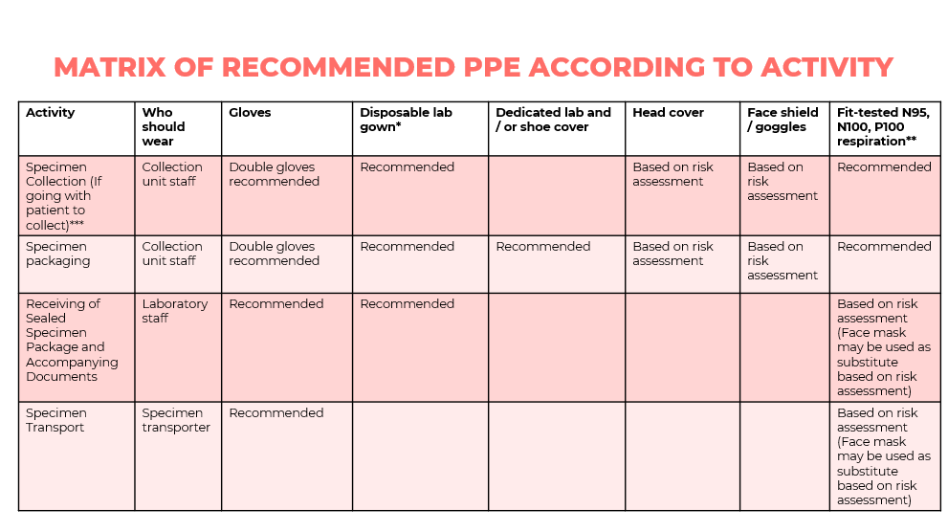
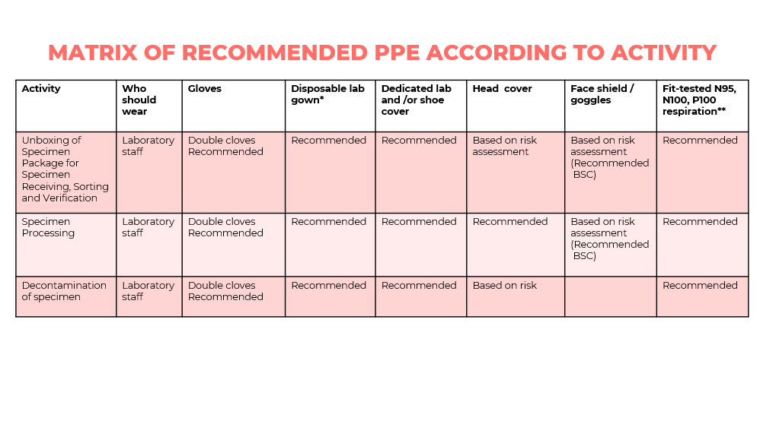
SAY: We will walk through the matrix of the recommended PPE according to activity.
DO: Highlight the PPE needed for each activity.
Proper Order for Donning PPE
Slide: 21
Participant Guide Page: 89
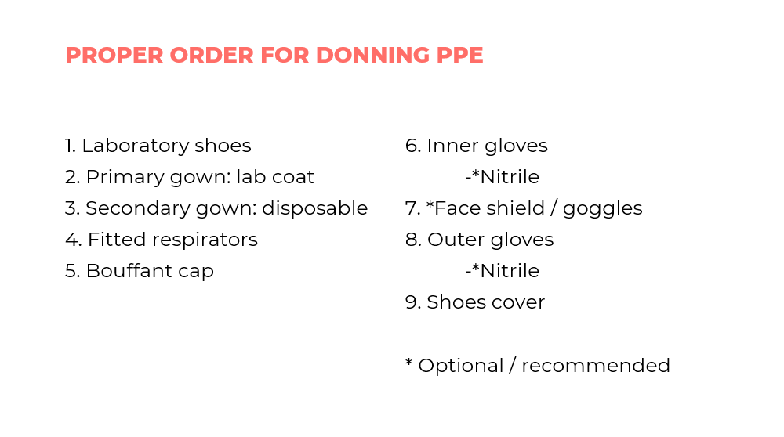
SAY: On this slide, you will see a list of proper order for donning PPE.
PPE: Gloves and Shoes
Slide: 22
Participant Guide Page: 89
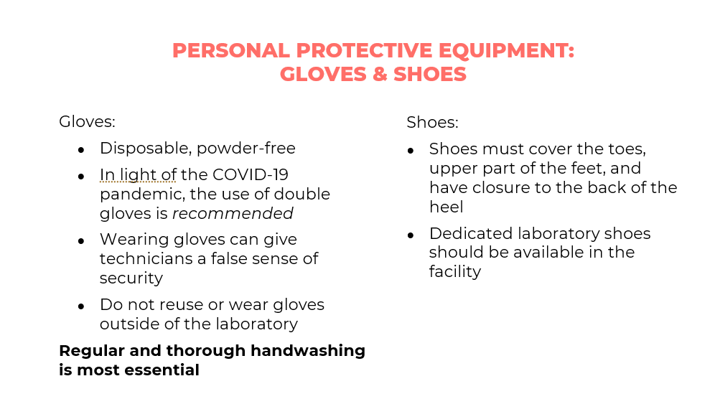
DO: Read through the uses for gloves and shoes.
PPE: Laboratory Coat and Gown
Slide: 23
Participant Guide Page: 89
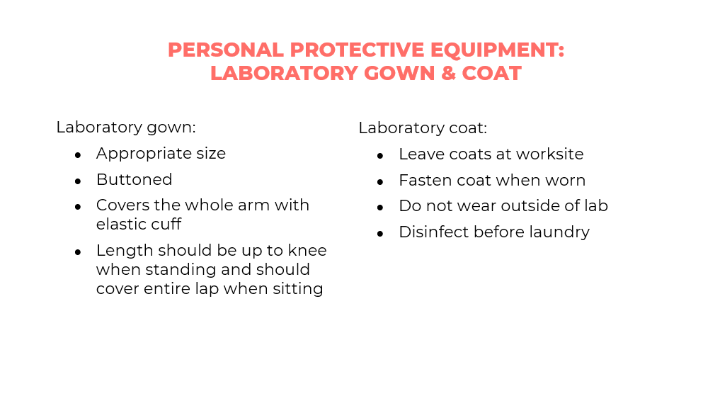
DO: Read through the uses for gowns and coats.
PPE: Respirators and Masks
Slide: 24 – 27
Participant Guide Page: 89
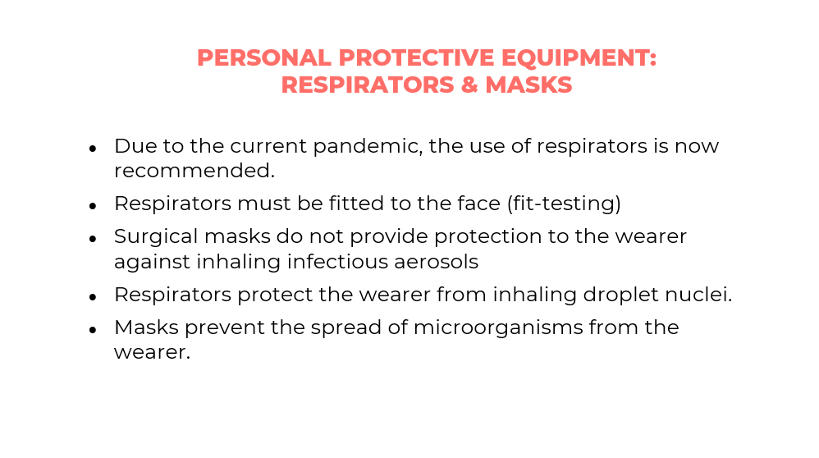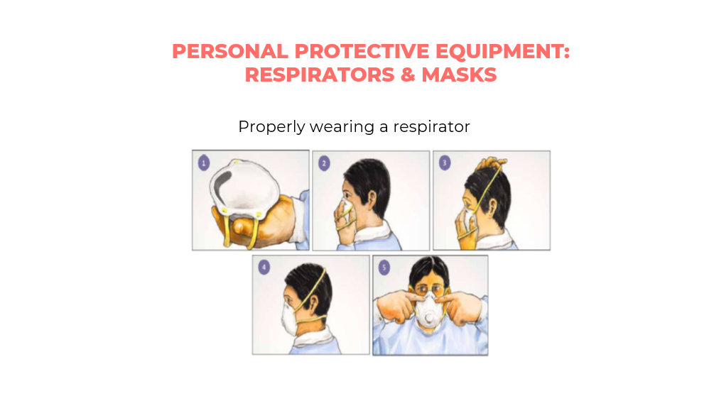
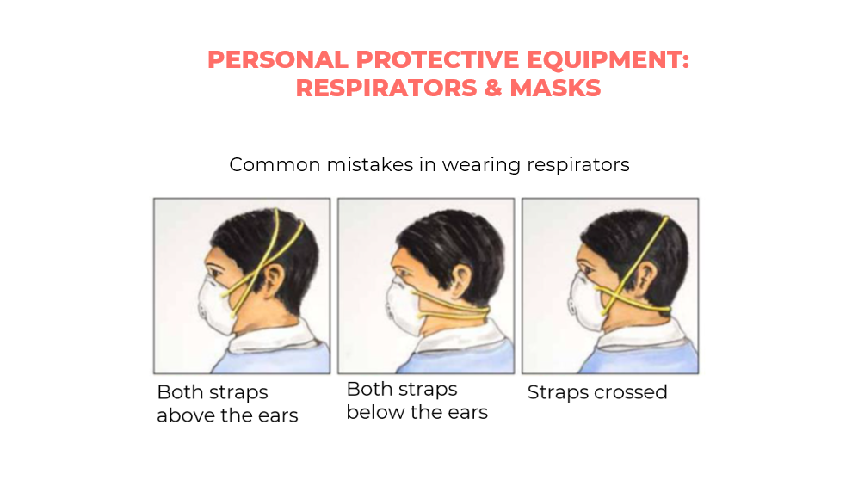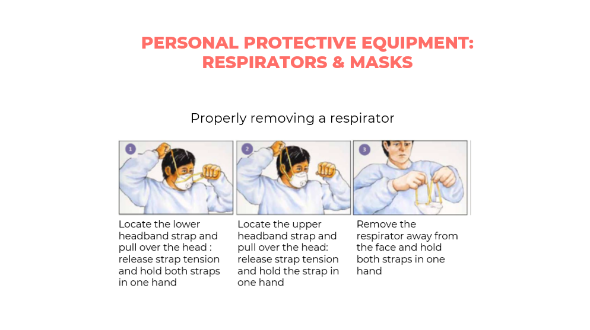
SAY: These slides describe the respirators and masks, and how to properly wear the respirators as well as properly removing
DO: Discuss common mistakes in wearing respirators and how to properly wear one.
PPE: Face Shields and Goggles
Slide: 28
Participant Guide Page: 89
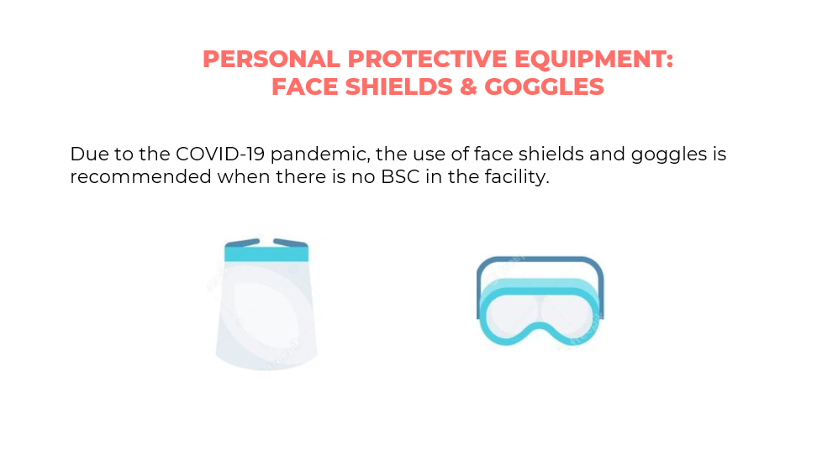
SAY: Face shields and goggles should be used in facilities where there is no BSC due to the COVID-19 pandemic.

Biosafety Cabinets
Biosafety Cabinets
Slide: 30
Participant Guide Page: 89
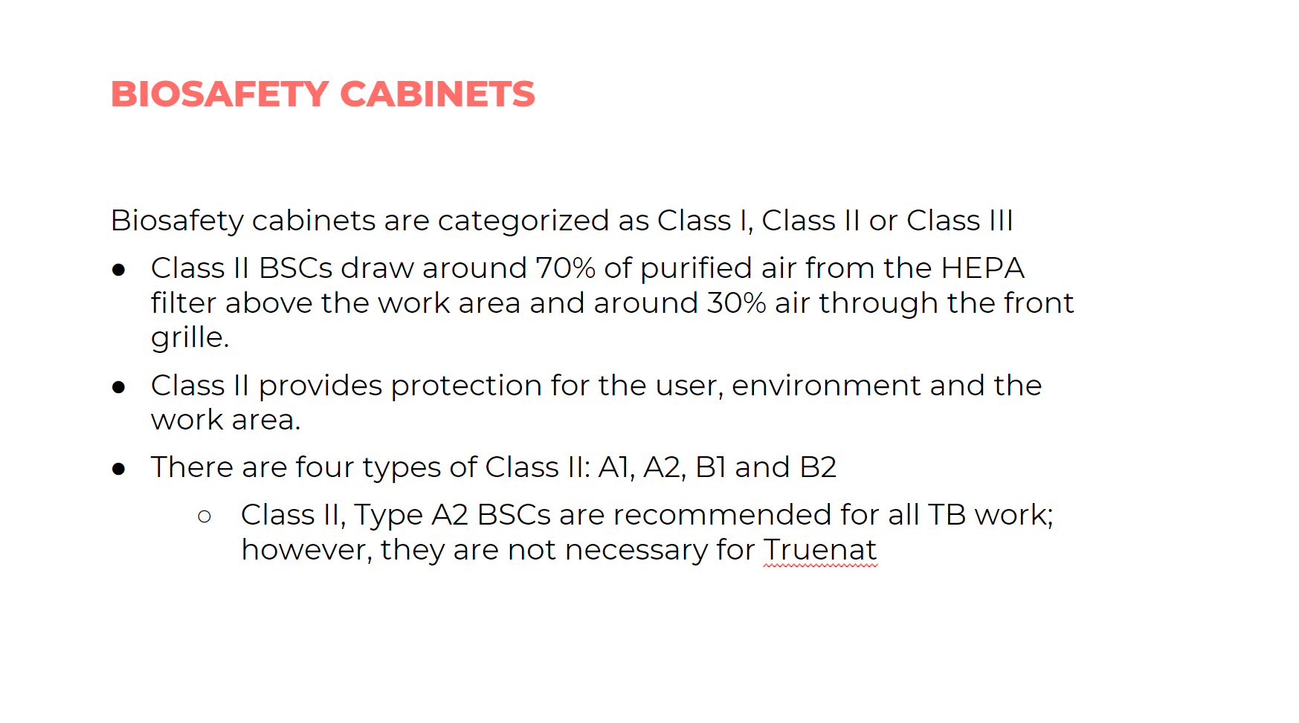
SAY: Biosafety cabinets are categorized as Class 1, II or Class II. Class 1I provides protection for the user, environment and work area. There four types of Class I1: A1, A2, B1, and B2. Class 11 type A2 BSC are recommended for all TB work but are not necessary for Truenat testing.
Performing Tests without BSC
Slide: 31
Participant Guide Page: 90
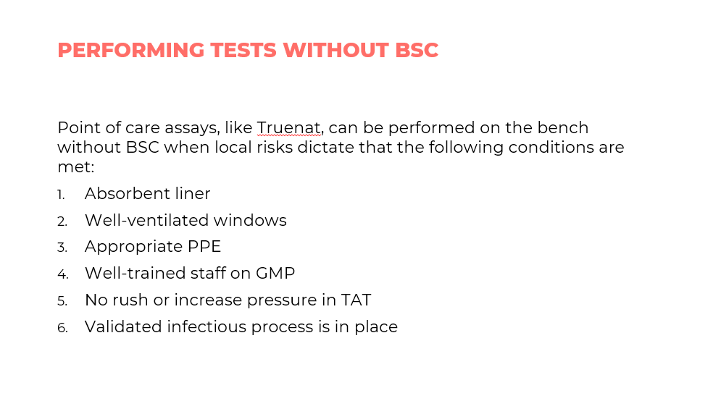
SAY: This slide discusses the requirements of how to perform tests without BSC.
These conditions are:
- Absorbent liner
- Well-ventilated windows
- Appropriate PPE
- Well-trained staff
- No rush in turnaround time
- Validated infectious processes

Generation and Prevention of Aerosols
Generating Aerosols
Slide: 33
Participant Guide Page: 90
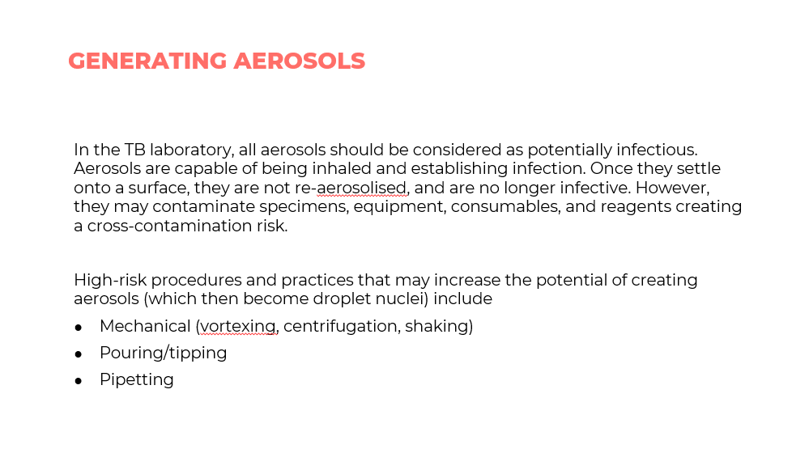
SAY: In the TB laboratory, highly infectious aerosols can be generated. High risk procedures and practices that may increase potential of creating aerosols include mechanical (vortexing, centrifugation, shaking), pouring /tipping, and pipetting.
Minimizing Aerosol Formation
Slide: 34
Participant Guide Page: 91
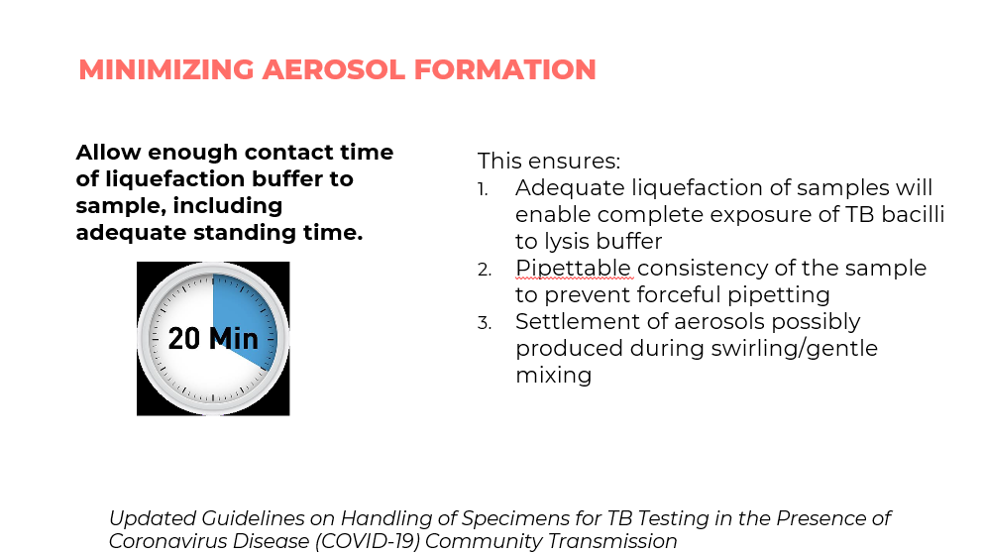
SAY: To minimize aerosol formation, always allow enough contact time of liquefication buffer to sample, including adequate standing time.
Minimizing Aerosol Formation
Slide: 35
Participant Guide Page: 91
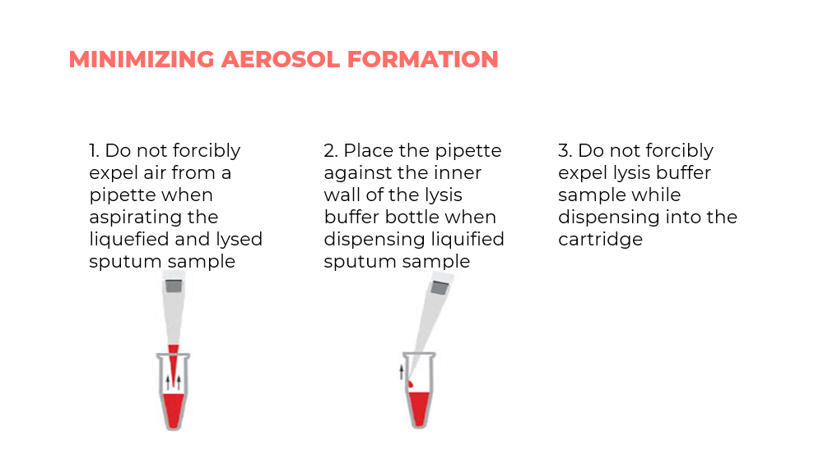
SAY: Minimize aerosol formation during pipetting by not forcibly expelling air from the pipette when aspirating the liquified and lysed sputum and place the pipette against the inner wall of the lysis buffer bottle when dispensing liquified sputum sample. Do not forcibly expel lysis buffer sample while dispensing it into the cartridge.

Managing Spills
Managing and Responding to Spills
Slide: 37 and 38
Participant Guide Page: 92
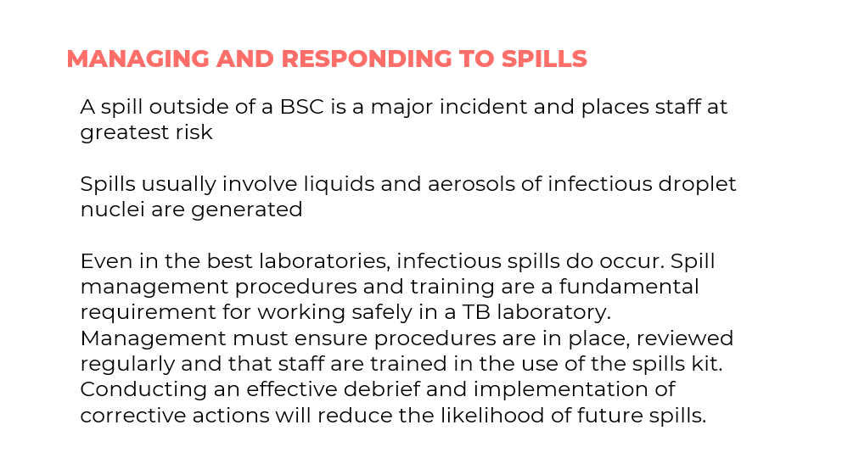
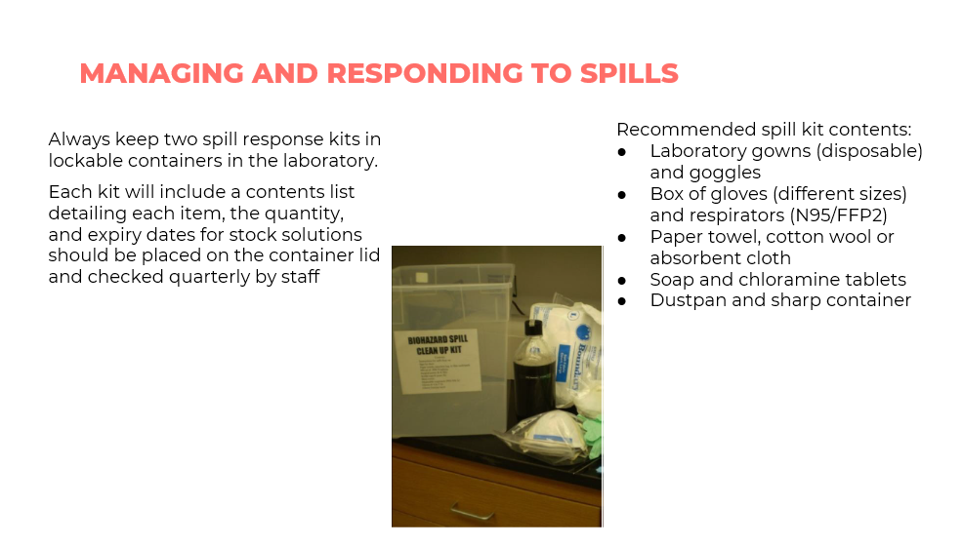
SAY: Spills usually involve liquids, and aerosols of infectious droplet nuclei can be generated. Spills outside of a BSC is a major incident and places staff at greatest risk. Spill management procedures and training are important requirement for working safely in a TB laboratory. The staff should be trained in the use of spill kit. Always keep two spill kits with the recommended contents. Let us list the contents of the spill kit.
Commonly Used Disinfectants for Spills
Slide: 39
Participant Guide Page: 92
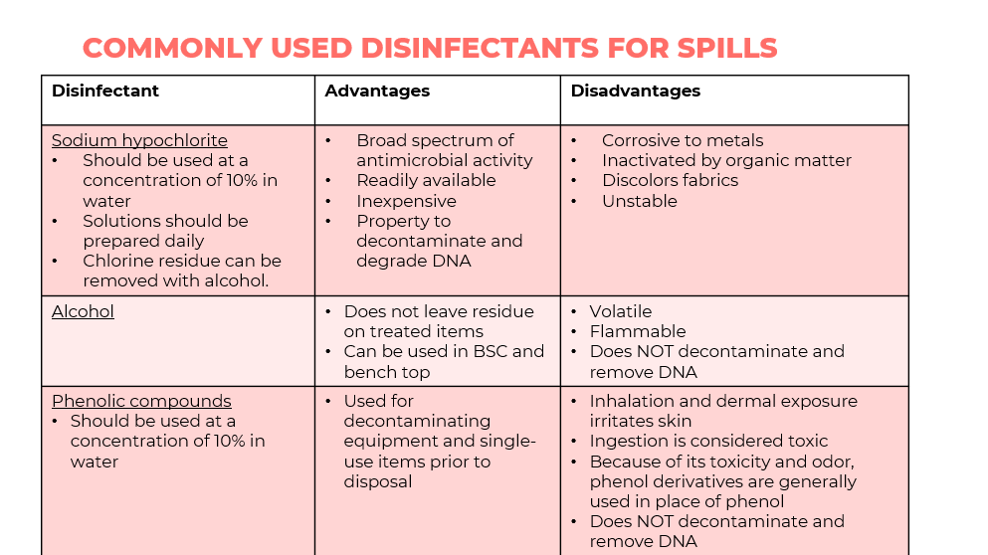
SAY: This slide shows the commonly used disinfectants for spills their advantages and disadvantages.
DO: Discuss each disinfectant and when its use would be appropriate.

Waste Disposal
Waste Disposal
Slide: 41
Participant Guide Page: 93
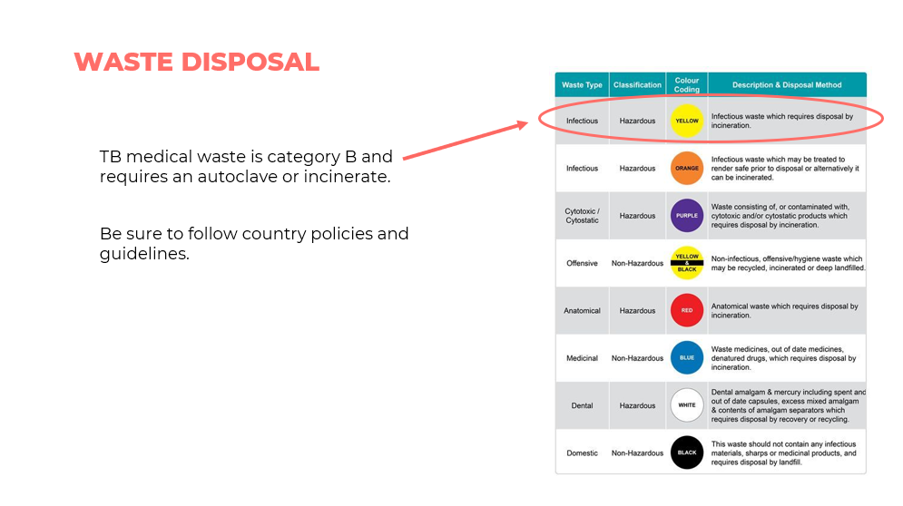
SAY: TB medical waste is category B and requires an autoclave or incineration disposal mechanism. Be sure to follow country policies and guidelines on waste disposal.
Safe Management of TB-Contaminated Medical Waste
Slide: 42
Participant Guide Page: 93
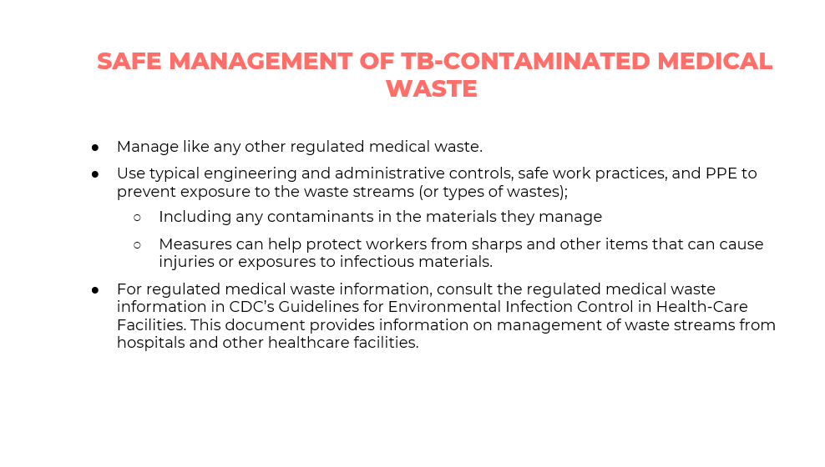
SAY: Manage all TB contaminated medical waste safely, like any other regulated medical waste. For regulated medical waste, use reference information from CDC’s Guidelines for Environment Infection Control in Health Care Facilities.
Laboratory Waste Mangement and Disposal
Slide: 43
Participant Guide Page: 93
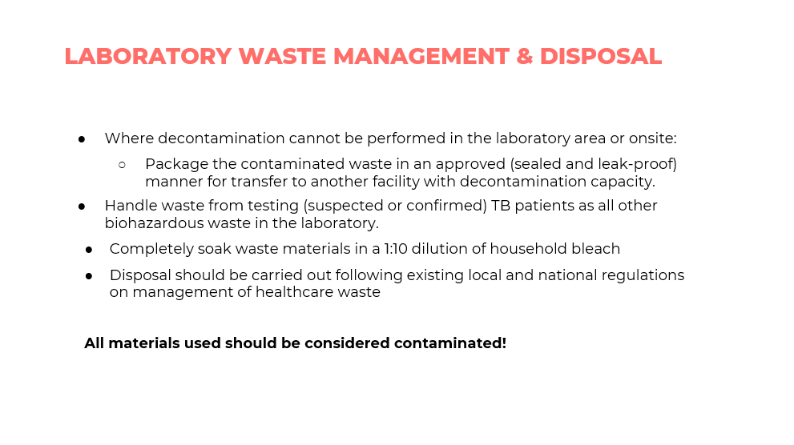
SAY: For laboratory waste management and disposal, remember that all waste materials generated in the laboratory are regarded as highly infectious and should be decontaminated by soaking in a 1:10 dilution of household bleach or autoclaving and disposal by incineration. Always follow existing local and national regulation on management of health care waste.
Mental Checklist for Biosafety and Risk Management
Slide: 44
Participant Guide Page: 93
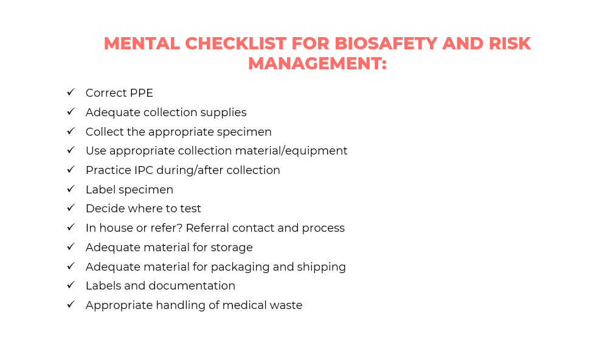
SAY: We will walk through the mental checklist for biosafety and risk management.
DO: Read off the points on the checklist
Useful Biosafety Resources
Slide: 45
Participant Guide Page: 94
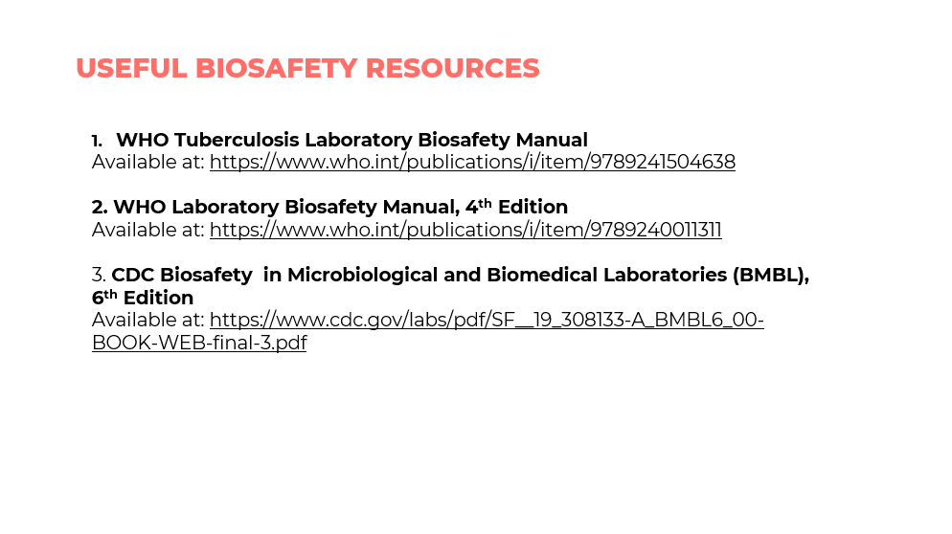
SAY: The slide shows a list of useful biosafety reference materials, which you may want to refer back to.

Specimen Collection Procedures

Specimen Collection Slides 47 – 52
Participant Guide Page : 94
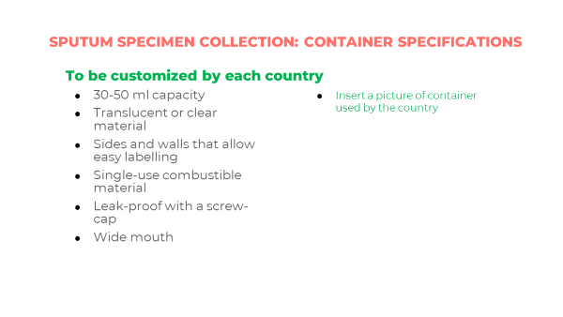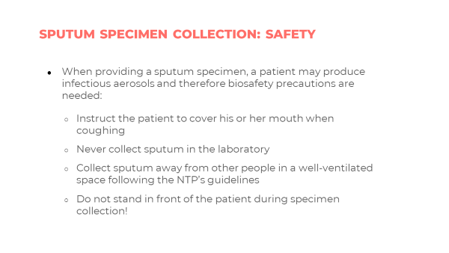
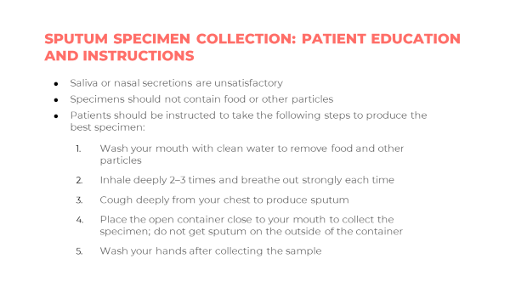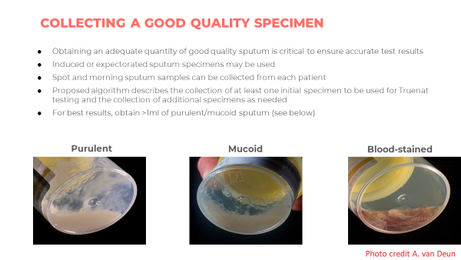
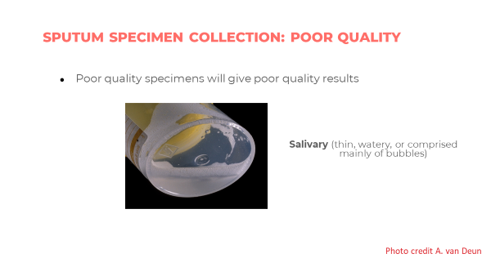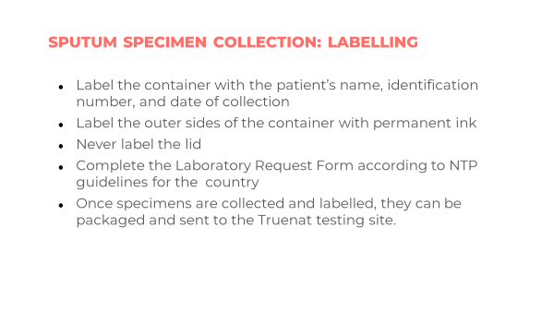
SAY: There are four key points to note about collecting specimens for Truenat.
- Induced or expectorated sputum samples may be used. Remember that there is insufficient evidence on using specimens other than sputum for Truenat testing so this is not recommended.
- Spot and morning sputum samples can be collected from each patient.
- The algorithm describes the collection of one initial specimen to be used for Truenat TB testing and the collection of additional specimens as needed. If two specimens are to be collected, they can be spot specimens, or a spot and morning specimen, to use for repeat testing or further DST, for smear microscopy or for culture as a baseline for treatment monitoring as needed.
- Sputum samples with contaminants such as betel nut, khat, tobacco, or food particles should be rejected.
Packaging and Storing the Specimen
Slides: 53 and 54
Participant Guide Page: 95
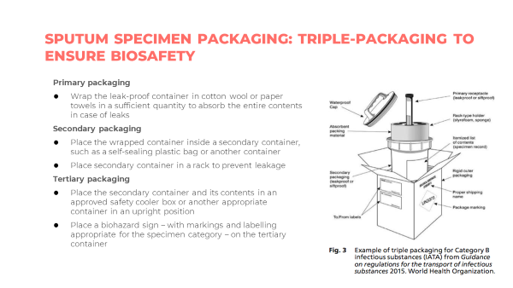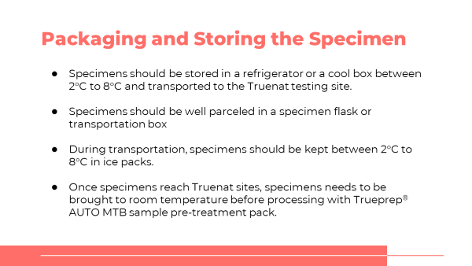
SAY: Truenat is meant to be used at facilities without uniterrupted power supplies, so their ability to store samples for more than a few hours is limited. Idally, specimens should be stored in a fridge between 2 and 8 degrees and transportated to the testing lab. A sample should always be packaged in a sample flask or transportation box.

Specimen Referral
Lab Forms Slide: 57
Participant Guide Page: 97
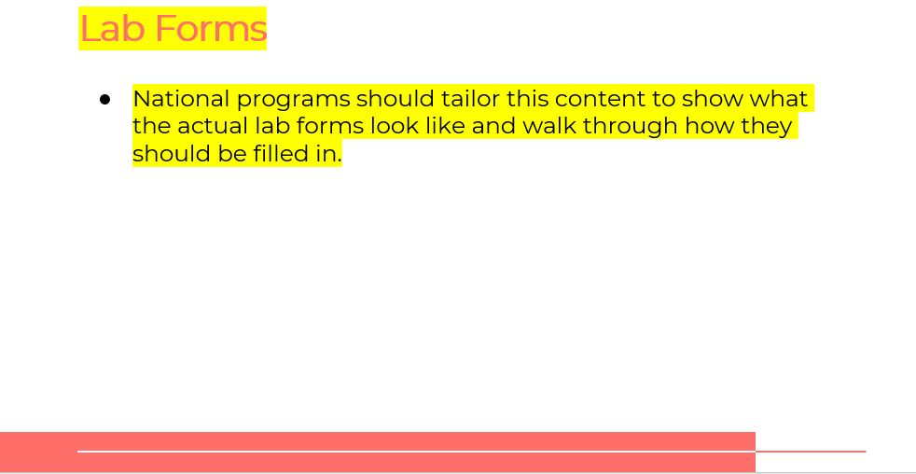
PLACEHOLDER: Lab forms are country specific. Edit this section to include the specific forms used for your country. Be sure to update the corresponding PowerPoint and Participant Guide with the updated information.
Integrated Specimen Referral Systems Slide: 58
Participant Guide Page: 97
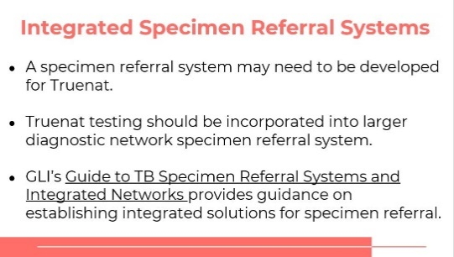
SAY: Depending on where Truenat is placed in the diagnostic network, a specimen referral system may need to be developed for Truenat and incorporated into a more extensive diagnostic network specimen referrals system. GLI’s Guide to TB Specimen Referral Systems and Integrated Networks provides guidance on establishing integrated solutions for specimen referral.
Specimen Referral - Results Reporting
Slide: 59
Participant Guide Page: 98
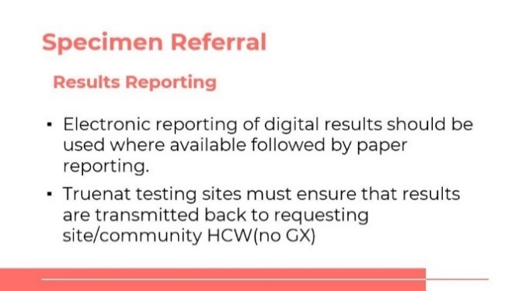
DO: Go over specimen referral guidelines for transportation and results reporting.
Questions to Consider about Sample Flow
Slide: 60
Participant Guide Page: 98
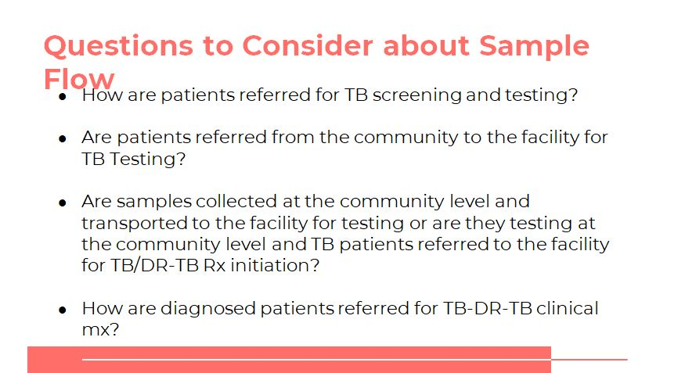
DO: Note that some of these questions were previously explored in a previous module. Ask for a volunteer to recount the responses that were developed last time and respond to the new ones.
Specimen Referral System-Example
Slide: 61
Participant Guide Page: 100
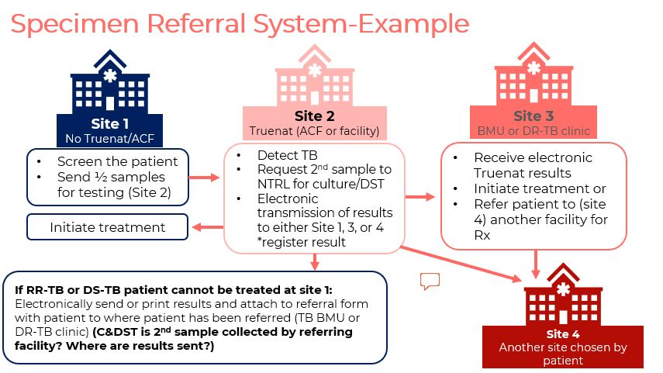
DO: Go over the specimen referral system example.

Summary
Summary
Slide: 62
Participant Guide Page: 101
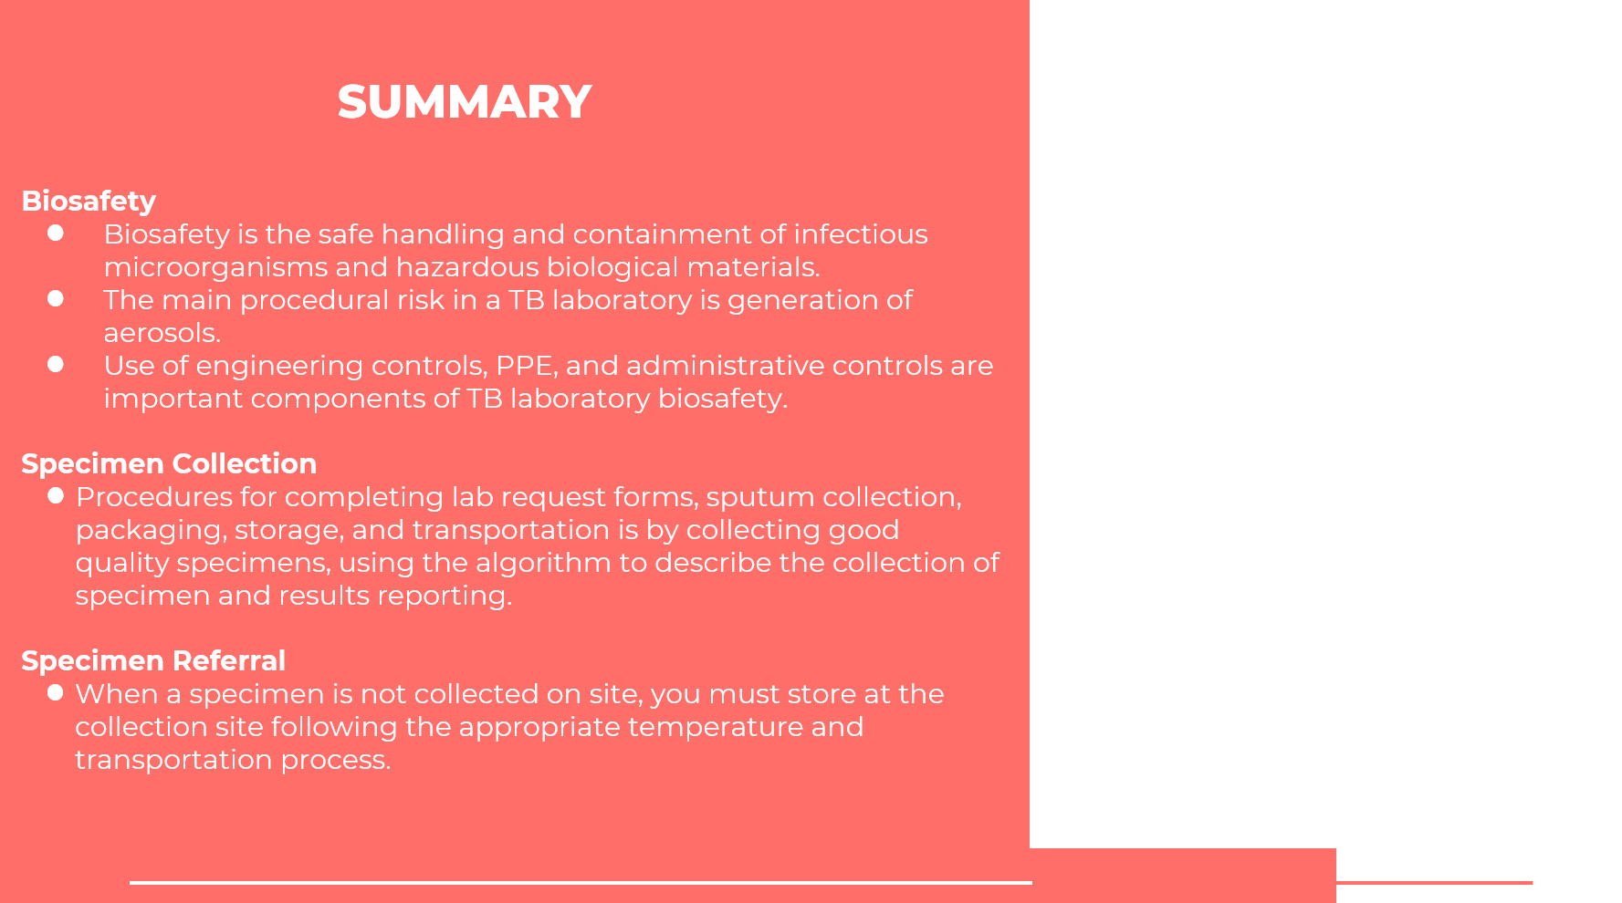
SAY: In this module, you learned about the importance of biosafety when using Truenat and how to collect a quality specimen and pretreat it for Truenat testing. You also learned that specimen referral networks may need to be established or adapted for Truenat testing. It is vital that Truenat testing sites ensure that results are transmitted back to the requesting site, health care worker, or community – digitally where feasible.
ASK: Does anyone have any questions about this lesson?
DO: Answer any clarifying questions from participants.

Knowledge Check
Knowledge Check
Slides: 63 – 65
Participant Guide Page: 102
DO: Explain that you will ask participants three knowledge check questions and may call on participants randomly to provide an answer. (These can also be programmed as poll questions in a virtual training – ensure that all participants respond before proceeding if using the poll feature).

If an answer provided in incorrect, ask if other participants would like to answer. Correct any incorrect answers that are given. If multiple participants get a question wrong, you may need to revisit the topic.

Note that knowledge check questions are not included in participant guides to avoid students seeing them during the lesson and only focusing on those pieces. Encourage participants to write down the answers in their guides in the notes field for future reference.
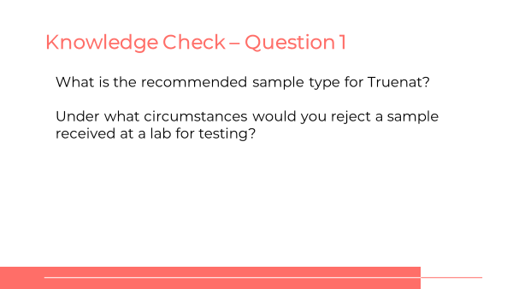
ANSWER:
- Sputum
- Sputum samples with contaminants such as betel nut, khat, tobacco, or food particles should be rejected.
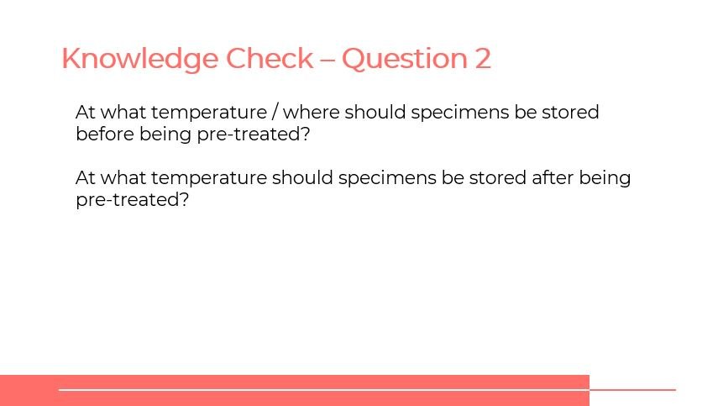
ANSWER: Specimens should be stored in a refrigerator or coolbox until they are pretreated. After pretreatment, specimens should be stored at -20° C.
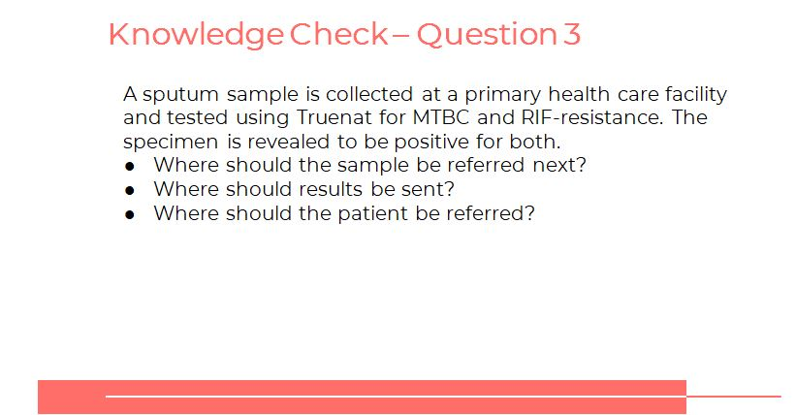
ANSWER: Answers will vary depending on the country. Samples that test positive for RIF-resistance may need to be referred to for culture/DST. The patient should be referred for treatment (if not available at the site where he or she was tested), and their results should be sent (preferably digitally) to the site where he or she will go.

