Computer-Assisted Detection of Tuberculosis using Ultra-Portable X-Ray
Central-Level Training
Facilitator’s Guide

Table of Contents

Table of Contents 2
Training Schedule 4
Customizing this Training 4
Training Format 5
Facilitator Preparation 5
Course Introduction 6
Module 1: WHO Guidance on TB Screening for Early Case Finding: Recommended Tools and Algorithms 7
Target Audience 7
Learning Objectives 7
Materials 7
Advance Preparation 7
Lesson Plans 7
Introduction 8
TB Context 9
TB Screening Tools 12
TB Screening Algorithms Overview 16
Summary 21
Module 2: New Tools for TB Screening: Introduction to Computer-Aided Detection (CAD) and Ultra-Portable X-Ray 22
Target Audience 22
Learning Objectives 22
Materials 22
Advance Preparation 22
Introduction 23
Computer-Aided Detection (CAD) Software for Screening and Triage of TB 25
CAD Products in the GDF Catalogue 32
Introducing Ultra-Portable X-Ray 37
Delft Light 40
Summary 44
Module 3: Program Planning and Implementation Considerations 45
Target Audience 45
Learning Objectives 45
Materials 45
Advance Preparation 45
Introduction 46
Program Planning and Site Selection and Preparation 48
Implementation Considerations – Delft Light 54
Challenges and Lessons Learned from Early Users of CAD and UP-XR 61
Summary 62
Module 4: Introduction to Threshold Selection 64
Target Audience 64
Learning Objectives 64
Materials 64
Introduction 65
Threshold Score Selection 66
How to Select a Threshold Score Suitable for the Local Context 70
How to Analyze Program Data for Threshold Selection Optimization 77
Planning for Screening 81
Summary 82
Module 5: Monitoring & Evaluation for CAD-enabled digital X-ray as part of TB screening​ 83
Target Audience 83
Learning Objectives 83
Materials 83
Introduction 84
Connecting CAD-Enabled X-Ray to Confirmatory Diagnosis 86
Setting up an M&E System for CAD 87
Selecting Indicators for a Chest X-Ray/CAD Screening Program 88
Practicalities of Introduction of CAD-Enabled X-Ray 90
Closure 92

Introduction
The Computer-Assisted Detection (CAD) of Tuberculosis using Ultra-Portable X-Ray Central-Level Training was developed to provide countries with a tool to introduce ultra-portable x-ray instruments equipped with artificial intelligence-enabled interpretation to key stakeholders in their country. This training is intended to be delivered at a central or national level, with additional hands-on onsite training from Delft Imaging and FujiFilm, the manufacturers of ultra-portable x-ray equipment and artificial intelligence software, for radiologists. The training is divided into five modules:
- WHO Policy Update on TB Screening for Early Case Finding: Recommended Tools and Algorithms
- Introduction to Computer-Aided Detection (CAD) and Ultra-Portable X-Ray
- Program Planning and Implementation Considerations
- Introduction to Threshold Selection
- Integration of CAD-enabled X-ray into diagnostic algorithms and monitoring & evaluation frameworks

This training is based on and intended to serve as a complement to the Screening and Triage for TB using Computer-Aided Detection (CAD) Technology and Ultra-portable X-Ray Systems: A Practical Guide developed by the Stop TB Partnership. Two versions of the modules are available: one for decision makers and one for end users. This facilitator guide is for the decision maker modules, which are designed to empower TB programme managers to deliver training for clinicians and end-users tailored to meet local need.

Training Schedule
 | Estimated Instructional Time | Participants
Module 1 | 2 hours | Case finding program managers, coordinators, NTP staff
Module 2 | 2 hours | Program managers, coordinators; NTP staff
Module 3 | 4 hours | Program managers, coordinators; NTP staff
Module 4 | 4hours | Program managers, coordinators; NTP staff
Module 5 | 2 hours | Program managers, coordinators

Customizing this Training
This training is designed to be customized by countries to meet their individual needs and two different versions are available, tailored to decision makers and end-users respectively. In the PowerPoint slides, text that is highlighted in yellow is intended to be replaced with information pertinent to the country. All other text should also be reviewed by national program managers and may also need to be customized.
Countries will, through the course of the training, develop a CAD / X-Ray implementation plan that identifies items such as where in the diagnostic network ultra-portable X-ray instruments will be placed, who will be trained to use ultra-portable X-ray, which forms and reporting tools need to be developed, and how patients and results will flow through the diagnostic network.
The PowerPoint slides use a basic template that was designed to convey information visually and be easy to understand. Countries might consider uploading their logo to the existing template using the Slide Master. They can also change the template to a national one using these instructions from Microsoft. The slides use the Montserrat font – if this font is not installed on training facilitators’ computers, it can either be downloaded or installed or the font can be changed in the slide master. Similarly, colors can also be changed in the slide master and then using the “reset function” on each slide.
Please note that any customization to the training may require changes to the facilitator guide and PowerPoint slides.

Training Format
This training is designed to be delivered in person but can be slightly modified to be delivered virtually if preferred. The main changes that need to be considered will be to the activities and discussion questions. Instructors should consider using features such as breakout rooms, poll questions, and the chat function. Participants should be encouraged to participate as much as possible, preferably by coming off mute in a small group, or through the chat if in a large group.

Facilitator Preparation
Instructors can use the checklist below to help successfully plan and deliver each training module.
SESSION PREPARATION
Customize PowerPoint slides and facilitator guide as needed
Familiarize yourself with the facilitator guide and the Stop TB Practical Guide
Review and test materials requiring technology (website links, video links, etc.)
Confirm meeting room and technology equipment for date and time of session (if needed)
REGULAR SESSION MATERIALS
Gather the following materials for each session:
Facilitator Guide
Stop TB Practical Guide
Nametags or name tents
PowerPoint presentation
Timer (watch, clock, or phone app) (Use the timer to keep activities within the time limits)
Pens or pencils
Index cards
DAY OF SESSION
Arrive early
Arrange tables and chairs in a formation that invites large and small group discussion.
Test technology (computer, projector, internet) to make sure it is working.
Write down needed text on a flipchart or whiteboard to prepare for session activities, if needed
Greet participants

Course Introduction
Before beginning the course, the instructor should provide a basic overview of the training, including what ultra-portable X-ray and artificial intelligence (AI)-powered computer-aided detection (CAD) products are, why the training is being delivered, how long the training will last and the schedule/structure of each day. They should also explain to participants that note-taking is encouraged. The instructor should emphasize that this is a highly participatory training and facilitate an “ice breaker” for participants to get to know one another. If the training is being delivered virtually, an overview of the technology should also be provided.

The audience should be aware that these trainings are designed to complement those given by the manufacturers of the relevant products and are not intended to give detailed, hands-on training with the products, but provide a comprehensive, impartial background.

Module 1: WHO Guidance on TB Screening for Early Case Finding: Recommended Tools and Algorithms

Target Audience
The target audience for this course is:
  - Program managers, coordinators
  - NTP staff

Learning Objectives
Terminal Objective
- At the end of this session, participants should understand the WHO-recommended screening methods for TB case detection.

Module Objectives
- By the end of this module, participants should be able to
  - Understand the requirements and role of systematic screening in the global TB response.
  - Describe the advantages and disadvantages of each of the WHO-recommended screening tools.
  - Recognize the different TB screening algorithms appropriate for the general population, persons living with HIV, and children.
  - Describe the current TB situation in the country, including screening and diagnostic practices.

Materials
- Facilitator Guide
- Pens/Pencils

Advance Preparation
- No customization required

Lesson Plans
NOTE TO PRESENTER:
Wherever you see highlighted text, please adjust your language to refer to your specific country and data/context.

Introduction
Introduction | Slide: 2
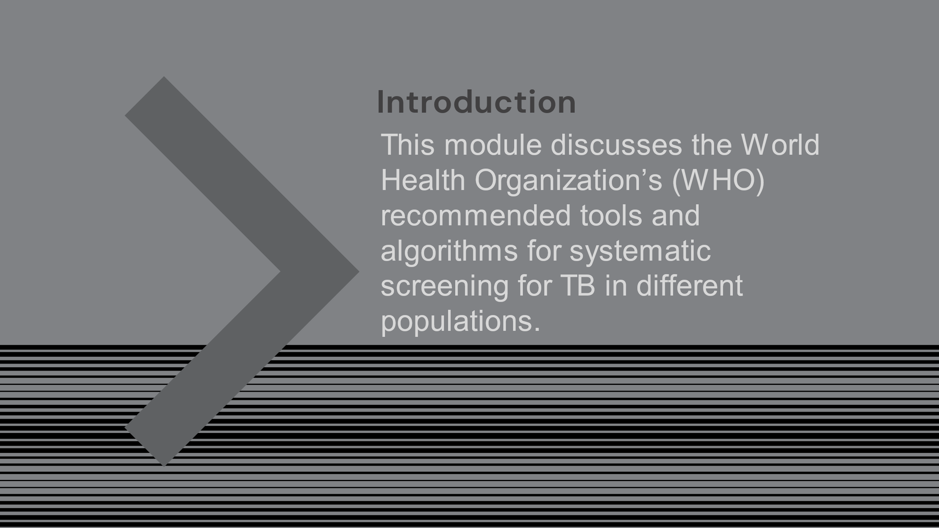
SAY: Our first topic is discussion of TB screening in general and the challenges with detecting TB globally and in our country. We will discuss the current WHO recommendations for TB screening and look at some algorithms for systematic screening across various populations.
The ultimate goal of this training is to determine how ultra-portable x-ray technology may be integrated into our country’s screenings for tuberculosis.

Introduction | Slide: 3
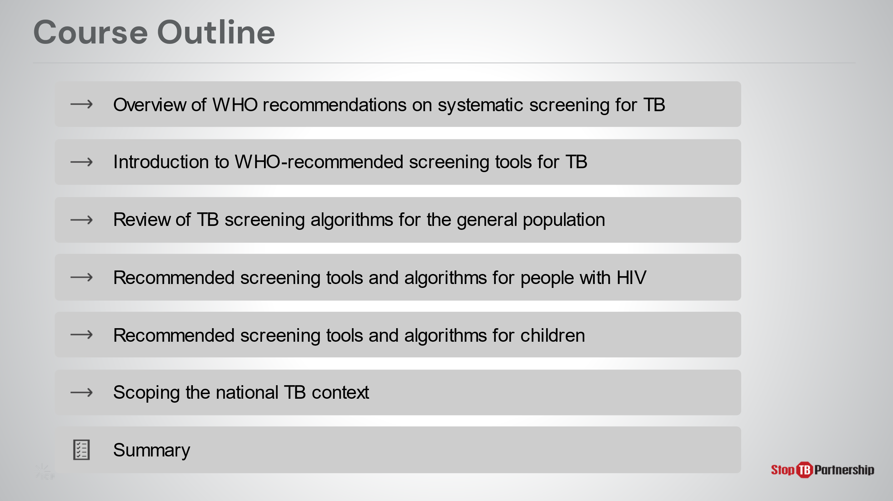
SAY: In this module, we will look at WHO’s recommendations for screening, introduce recommended tools, including the use of x-ray, and explore screening algorithms and tools for the general population, as well as higher risk populations, such as those with HIV and children. Finally, we will take a look at this information in the context of your country and explore how ultraportable x-ray might fit into your existing efforts.

Introduction | Slide: 4
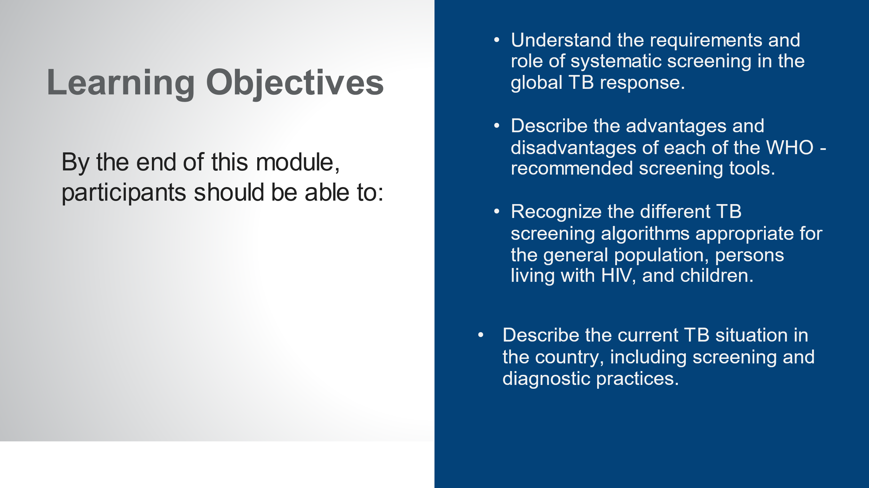
SAY: By the end of this module, you will be able to:
- Understand the requirements and role of systematic screening in the global TB response.
- Describe the advantages and disadvantages of each of the WHO-recommended screening tools.
- Recognize the different TB screening algorithms appropriate for the general population, persons living with HIV, and children.
- Describe the current TB situation in your country, including screening and diagnostic practices.
ASK: What questions do you have before we move into the first lesson for this training?
DO: Allow participants time to ask questions and respond appropriately.

TB Context
Global TB Situation: Global Context | Slide: 6
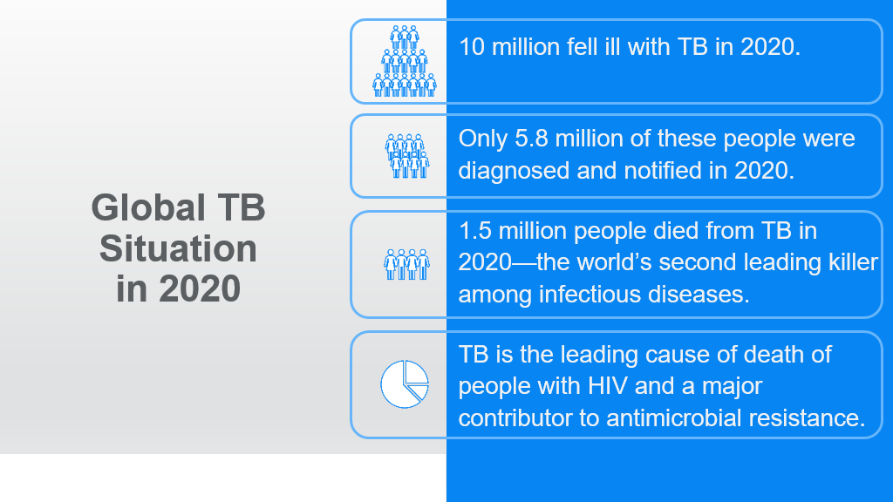
SAY: Let’s take a look at the current tuberculosis situation around the world.
ASK: How many people do you think are infected with TB every year, globally?
DO: Collect responses from participants. Click on the slide for animation to bring up the content.
SAY: 10 million people fell ill with TB in 2020.
ASK: How many of you were close in your estimation? (show of hands)
SAY: 10 million infected, and yet only 5.8 million diagnoses…
ASK: How many of you were closer to the 5.8 million figure in your estimations? (show of hands)
DO: Ensure that participants record the numbers of ill versus diagnosed in their notes.
SAY: TB is the world’s second-leading cause of death from an infectious disease; second only to Covid-19. One and a half million people die from TB each year. Statistics show that TB is the leading cause of death of people with HIV. It also contributes to antimicrobial resistance. IT is also a leading cause of maternal and childhood mortality.
SAY: We will discuss your country’s TB context in a while, so write in your notes what you think these statistics may look like in our country. We will come back to these estimates later.
Global TB Situation: WHO Guidelines on Systematic Screening | Slide: 8
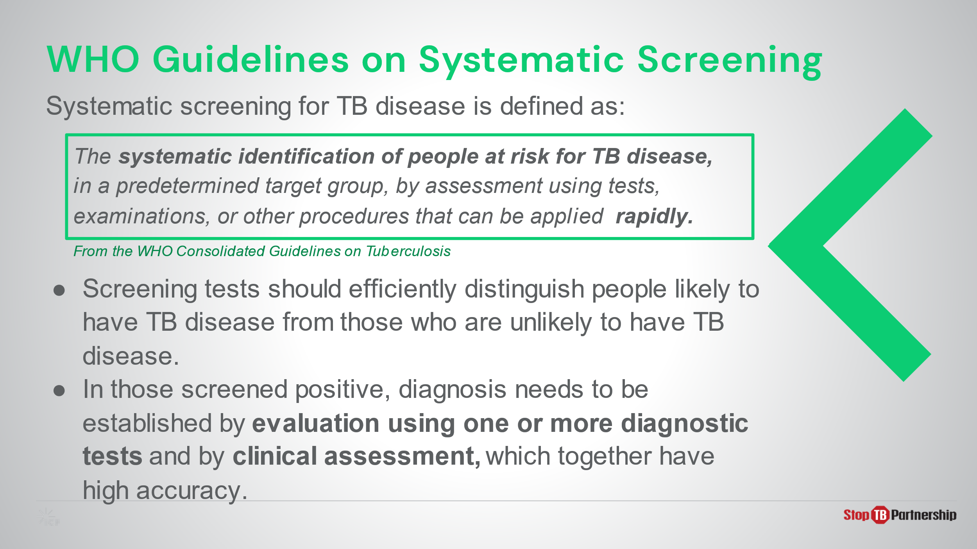
SAY: The World Health Organization (WHO) begins its recommendations by defining systematic screening for TB. You will see that a keyword in this definition is “rapidly.”
Within these recommendations, the WHO states, “screening tools should efficiently distinguish between persons likely to have active TB from those who are unlikely to have active TB.” In other words, these tools should offer both high sensitivity and high specificity.
Persons screening positive for TB need to be evaluated bacteriologically and clinically for diagnostic confirmation for high accuracy. This should follow soon after the screening process.

Global TB Situation: WHO Guidelines on Systematic Screening | Slide: 9
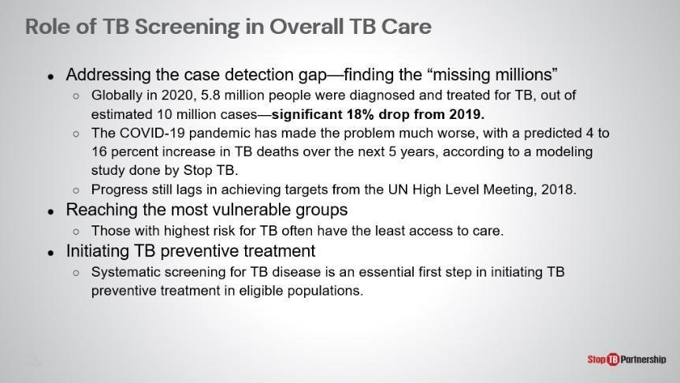
SAY: TB screening helps to close the gap of the “missing millions.” It can be tailored to vulnerable and under-served groups and enable preventive treatment. As we discussed earlier, only 5.8 million of 10 million cases were diagnosed worldwide, meaning roughly 42 % were not reported. The COVID-19 pandemic has exacerbated the problem; a modeling study conducted by Stop TB has predicted that TB-related deaths will increase 4-16% over the next 5 years. This further stalls progress towards achieving the United Nations high level meeting targets set in 2018.
SAY: Screening is a valuable tool for reaching the most vulnerable groups, with the highest levels risk often have the least access to care. Additionally, for those who are high risk but screen negative for TB, we should be engaging with them to initiate preventative care to halt the chain of transmission.

Global TB Situation: WHO Guidelines on Systematic Screening | Slide: 10
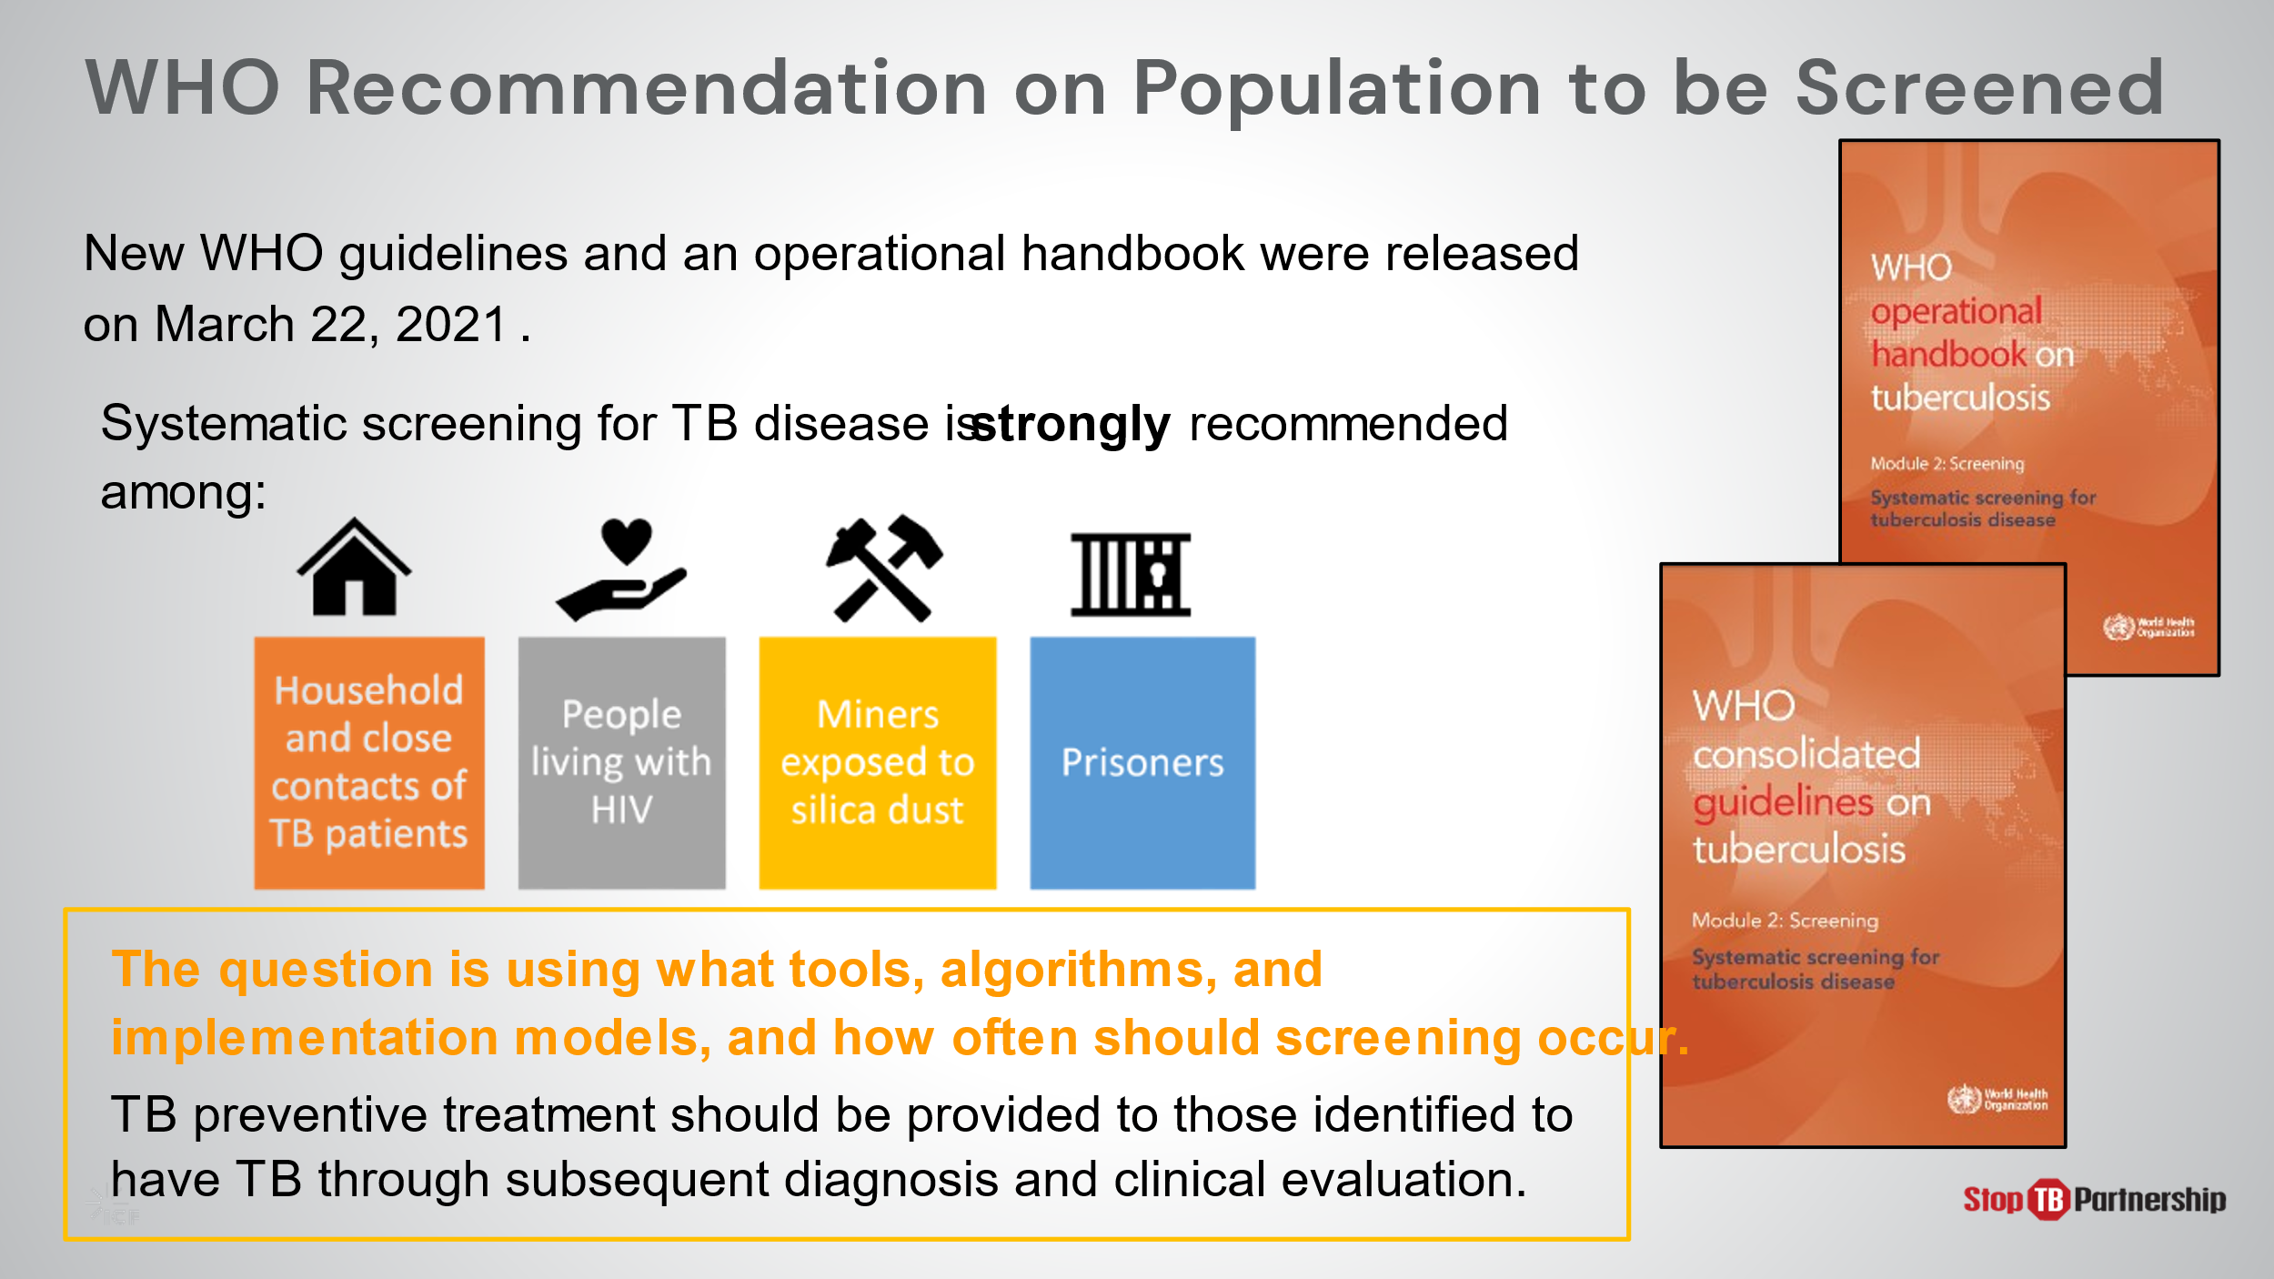
SAY: In March 2021, the WHO released guidelines and operational support for systematic screening for TB disease in. In these documents, recommendations were made for which populations should be subject to screening: those in close contact with TB patients, those living with HIV, those with occupational risks (like miners exposed to silica dust), and those who have been internally displaced (such as prisoners). The questions on our minds should be: What tools, models, and algorithms can be used? How often should we engage in screening? How can we link preventative and disease treatment with those who have undergone the screening process?

Global TB Situation: WHO Guidelines on Systematic Screening | Slide: 11
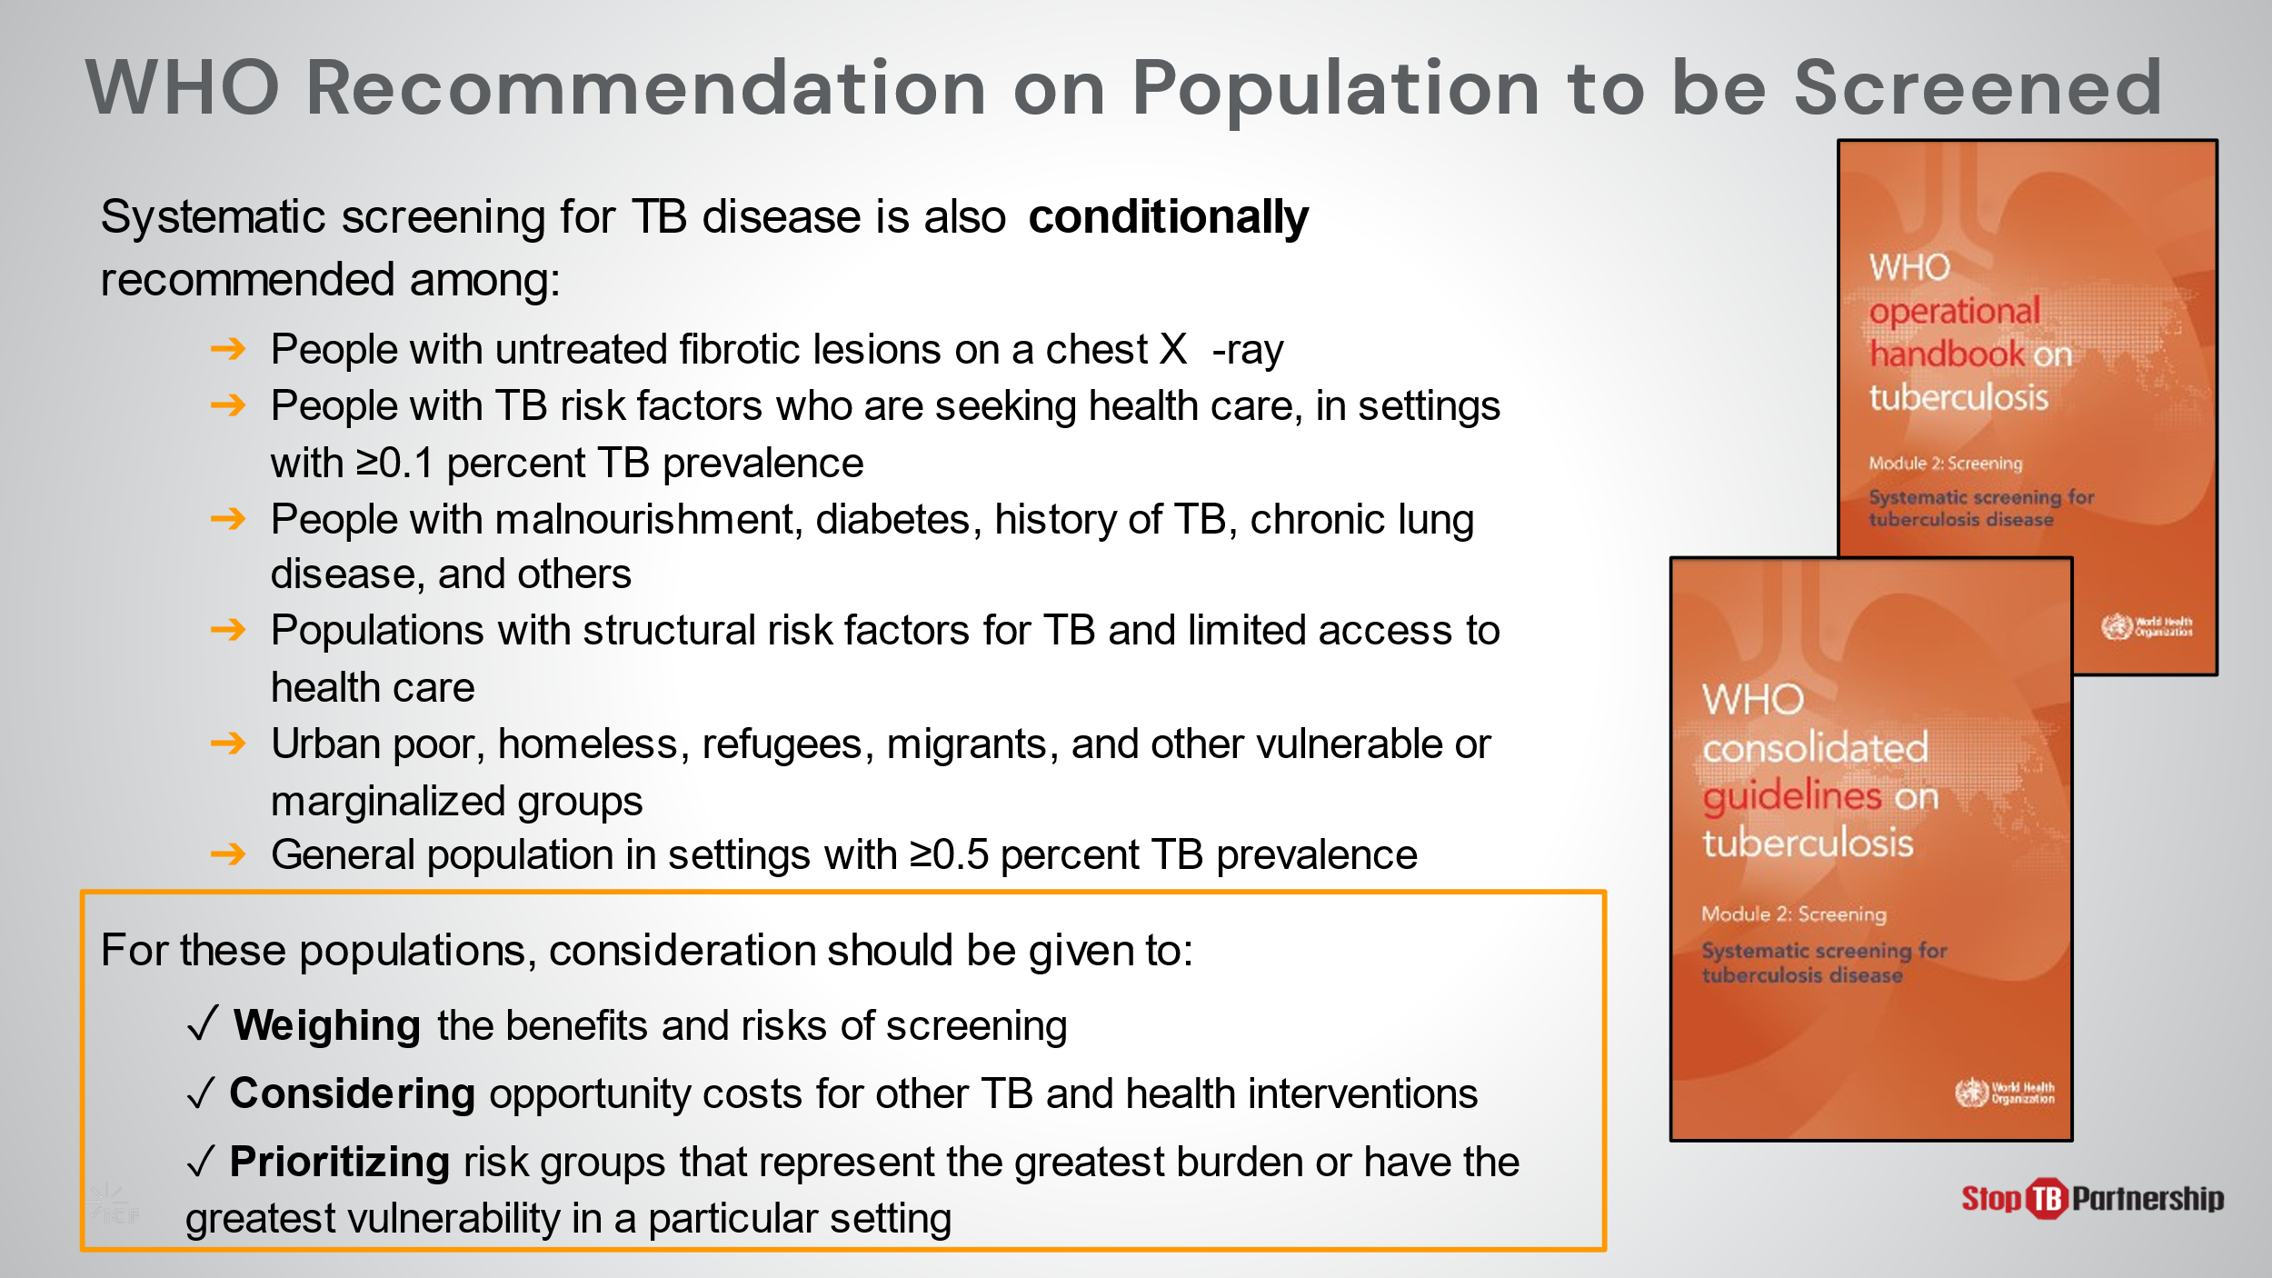
SAY: Systematic screening is also conditionally recommended, in consideration of these factors. [If these cannot easily be read by participants, read them aloud, and/or summarize them]. When deciding whether systematic screening is appropriate for these portions of the population, we need to weigh the benefits and risks of screening, consider opportunity costs, and prioritize those with the greatest risk/vulnerabilities.
SAY: Let’s pause and reflect from these global recommendations and guidelines to your experience?
ASK: To what extent do you think your country is meeting the WHO-recommended goals for TB screening?
DO: Allow participants to share their experiences.
ASK: To what extent has the Covid-19 pandemic impacted your TB efforts in this country?
DO: Allow participants time to respond. Encourage them to take notes.
ASK: In your country, what populations and groups are targeted for screening? What tools and methods are currently used?
DO: Allow participants to share their experiences. Encourage them to take notes.
ASK: What conditionally recommended populations are prevalent in your country? Which (if any) would you recommend as priorities for screening at this point? Or if, not at this point, which would be priorities in the future?
DO: Allow participants to share their experiences. Encourage them to take notes.

TB Screening Tools

Recommended Tools to Screen | Slide: 13
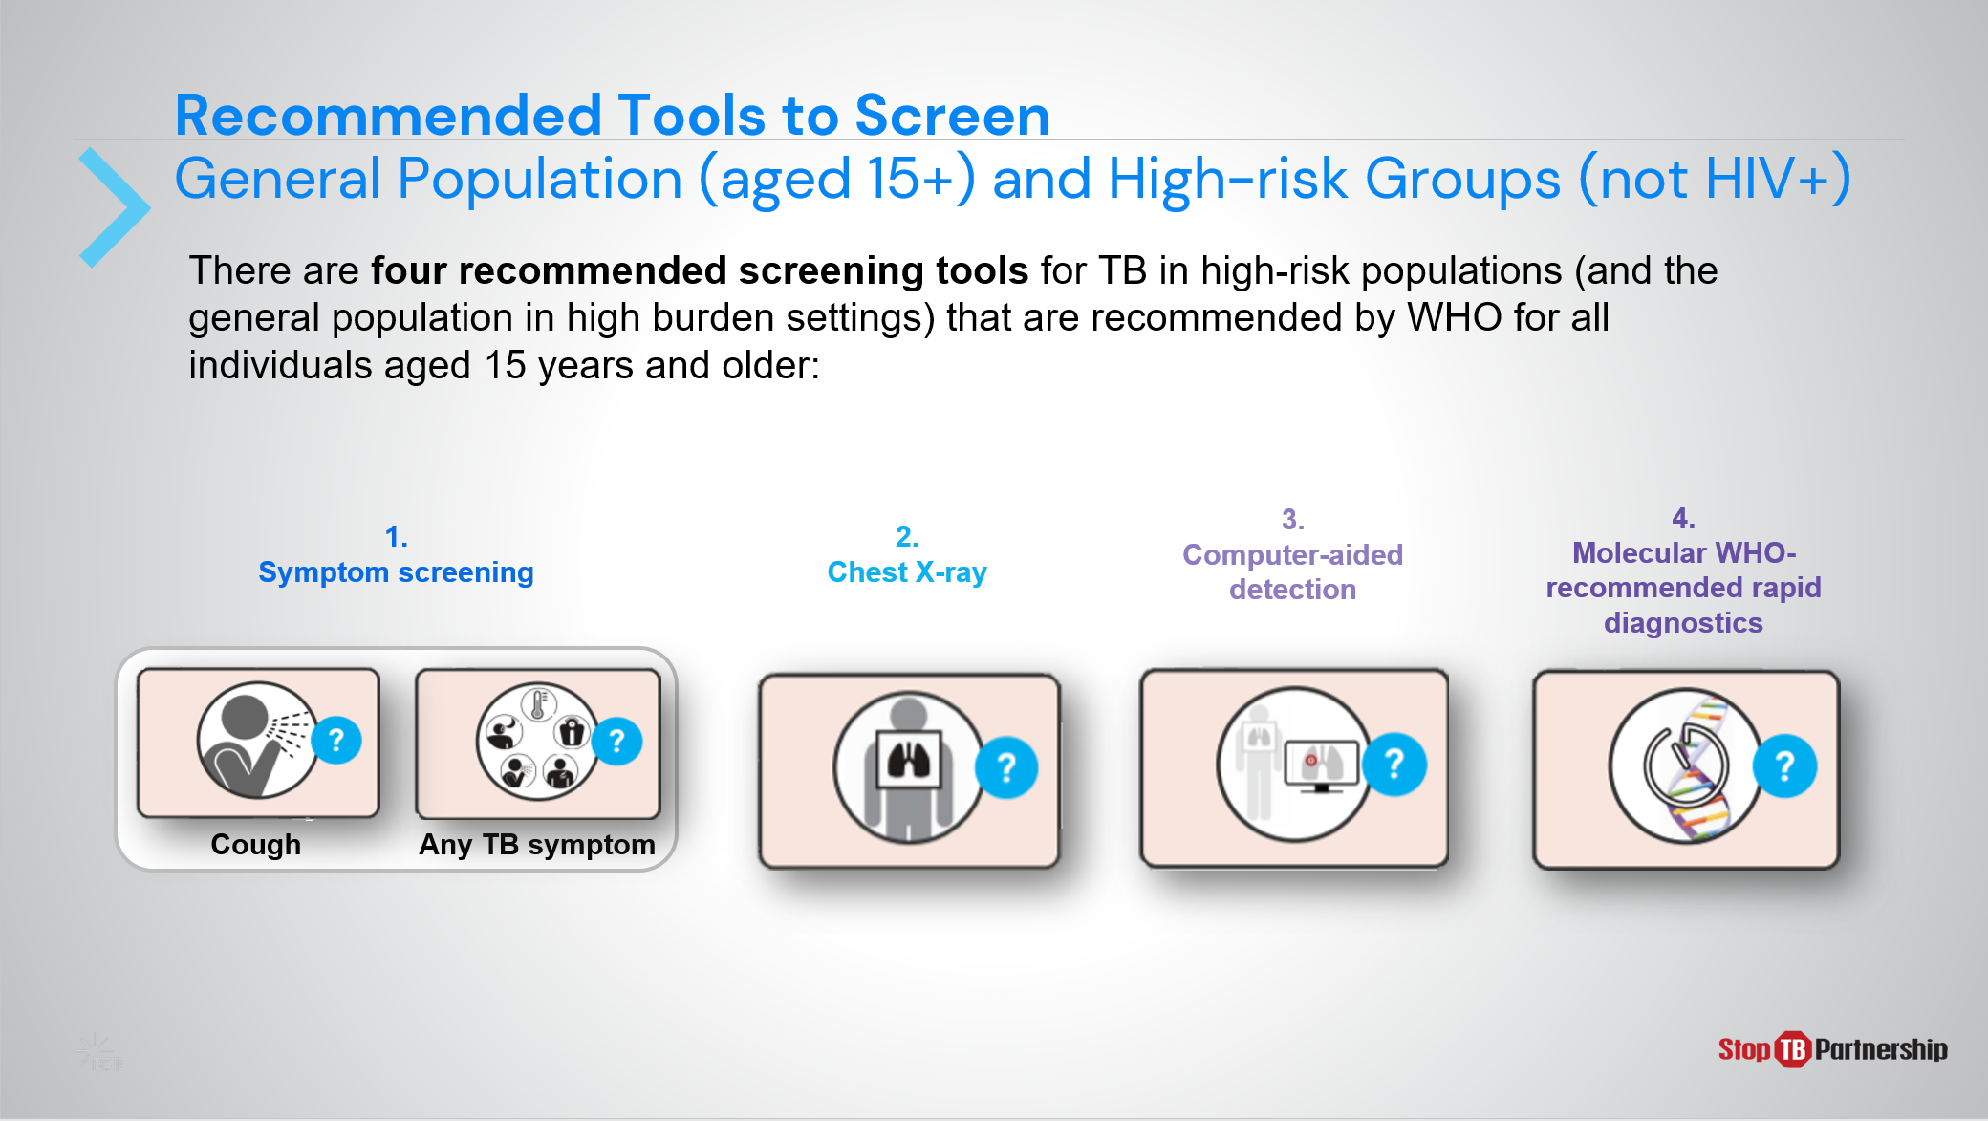
SAY: The four WHO recommended tools to screen general populations aged 15 or older and high risk groups excluding those with HIV include symptom screening, chest x-ray, computer-aided detection, and rapid molecular diagnostics.

Symptom Screening | Slide: 14
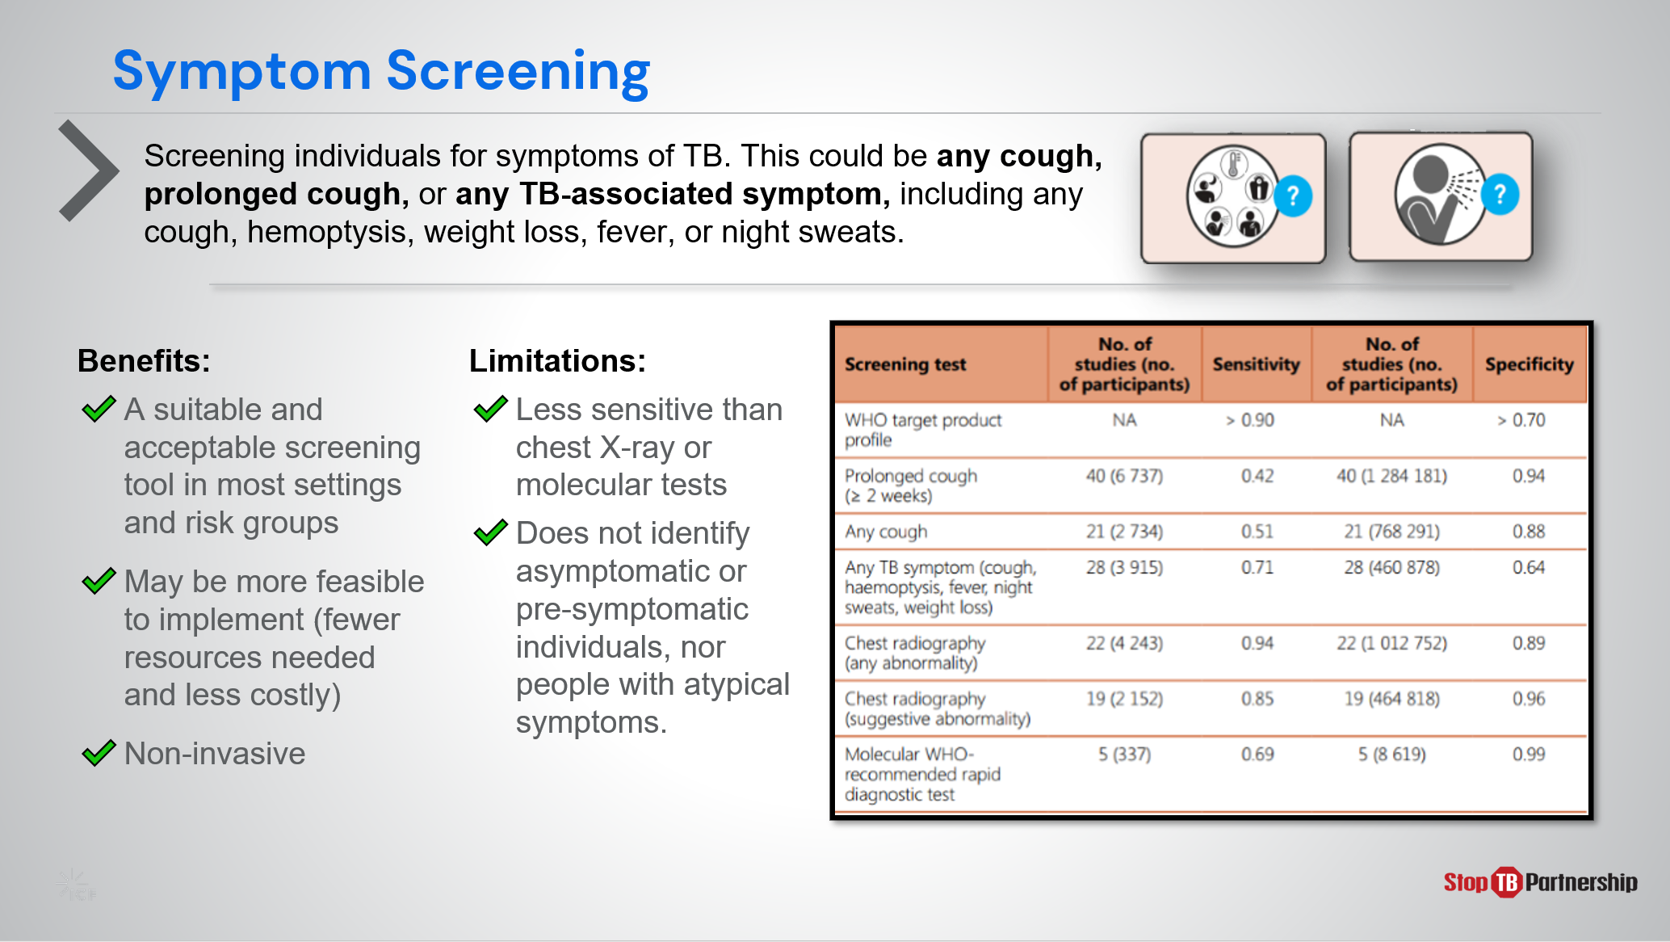
SAY: When implementing symptom screening as a tool, we are looking for common symptoms of TB, such as cough (any or for longer than 2 weeks), hemoptysis, weight loss, fever, or night sweats. This tool is generally beneficial in that it is rapid, simple to implement, non-invasive, requires minimal resources, generally acceptable in most settings and risk groups. However, it faces limitations in sensitivity and will not identify asymptomatic individuals or those with atypical symptoms.

Chest X-ray | Slide: 15
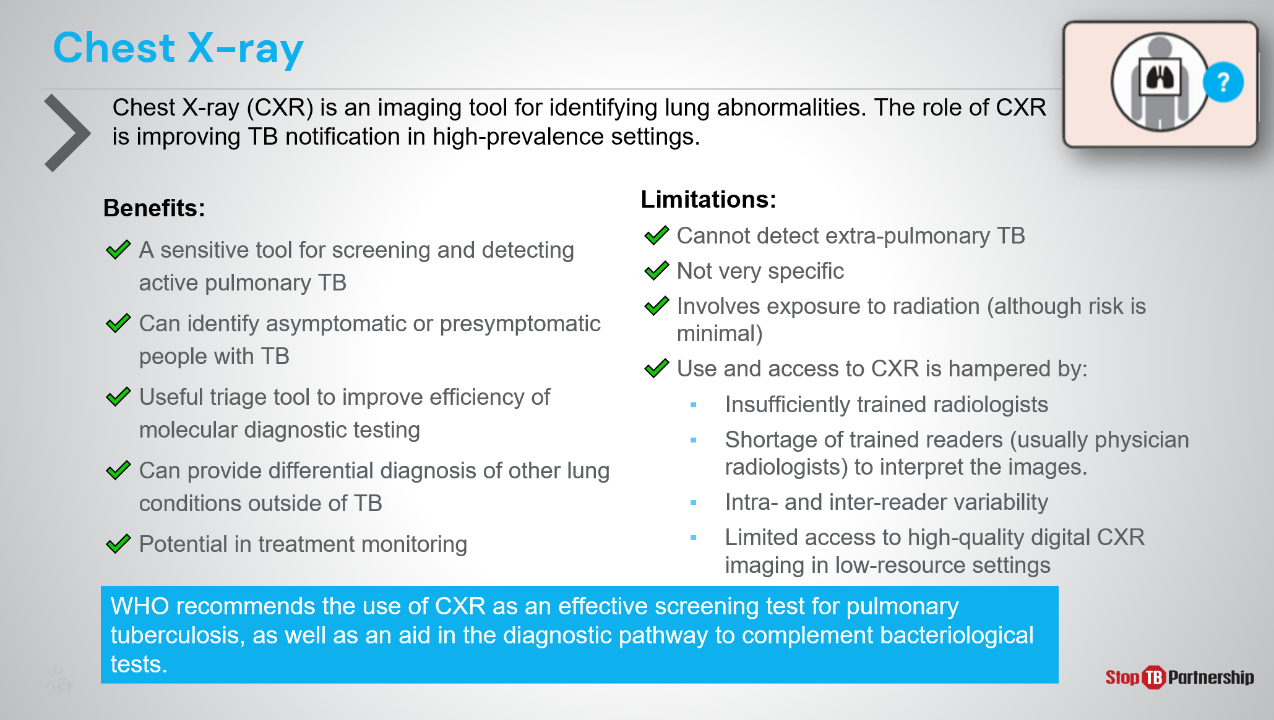
SAY: Chest x-ray is one of the most commonly used tools for TB screening and has been part of the diagnostic algorithm for decades. It has relatively high sensitivity , can identify asymptomatic individuals or those with atypical symptoms, serves as triage to improve molecular rapid testing efficiency, can provide potential diagnosis of non-TB lung conditions, and demonstrates potential in treatment monitoring.

Chest x-ray is not without limitations. It cannot detect extra-pulmonary TB, is not highly specific, and involves some – though minimal – exposure to radiation. Its largest limitations reside in the resources required for proper implementation. Radiologists must be sufficiently trained, and there is often a shortage of trained readers, and a disparity among those trained in their efficiency and accuracy. Access to high quality digital CXR imaging is also quite limited in certain settings.
ASK: To what extent are digital chest X-rays available in your country?
DO: Allow participants time to respond. Encourage them to take notes.

Computer-aided Detection Software | Slide: 16
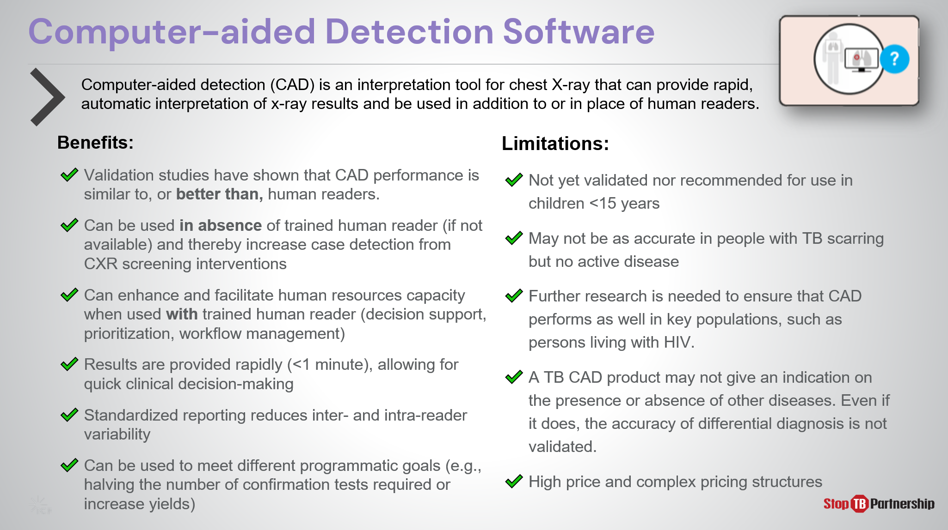
SAY: CAD software is a way to help reduce the burden on radiology resources. It can be used as an interpretation tool for chest X-ray, providing rapid, automatic interpretation of screening x-ray results. Validation studies have shown that CAD performance is similar to, and in some cases better than that of human readers; thus, CAD technology enhances and facilitates human resource capacity when used with trained human reader (decision support, prioritization, workflow management) and can be used in place of a human reader when none is available . This increased availability can improve CXR screening intervention case detection. Results are provided in less than a minute, allowing for quick clinical decision-making, and standardized reporting reduces inter- and intra-reader variability. CAD’s potential to triage can be modified to meet program goals or resource limitations such as availability of confirmation tests.
However, this technology is not without limitations. For example, it is not yet validated or recommended for children under 15 years of age and may be less accurate for patients with TB scarring but no active disease. Further research is also needed to ensure that CAD performs well in key populations, such as persons living with HIV. A TB CAD product may not give an indication on the presence or absence of other diseases and even if it does, the accuracy of differential diagnosis is not validated. Finally, we cannot ignore the cost. This tool requires specialized software and there is a “per screen” pricing structure when procured directly from the manufacturers, though a lower price and more appropriate pricing structure is available through Stop TB Partnership’s GDF Catalog.

Molecular WHO-recommended Rapid Diagnostics | Slide: 17
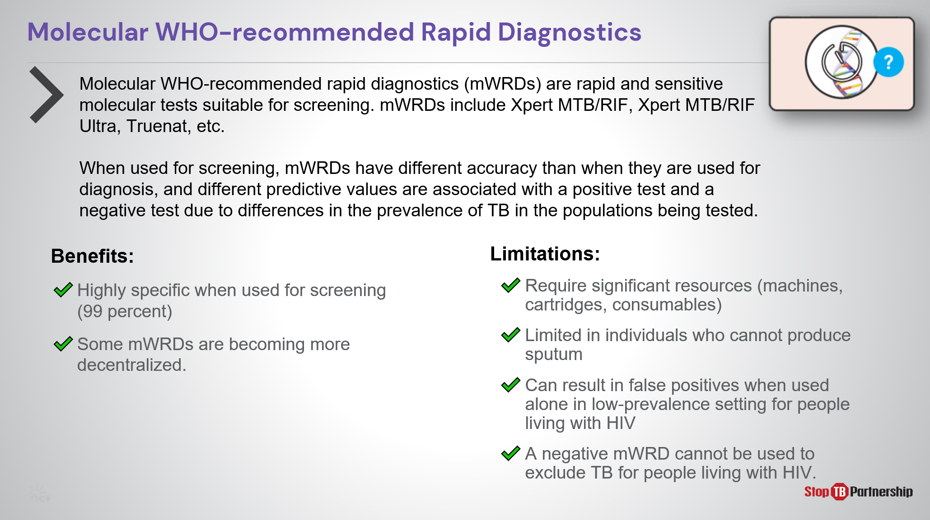
SAY: mWRDs are rapid and sensitive molecular tests suitable for screening. These are rapid, sensitive molecular tests, including Xpert, Xpert Ultra, and Truenat. [if country uses them for diagnosis, mention here]. mWRDs have different accuracy when used for screening than when they are used for diagnosis, with different predictive values are associated with a positive test and a negative test due to differences in the prevalence of TB in the populations being tested. When screening, they are highly specific, and some rapid molecular tests are becoming decentralized. However, these tests require significant resources – financial and infrastructure - and cannot serve individuals who are unable to produce sputum. Additionally, these tests can result in false positives if used alone in a low prevalence setting or among those with HIV. Finally, we must remember that these tests cannot be used to exclude TB for people living with HIV and AIDS.

Tools for Screening People Living with HIV | Slide: 18
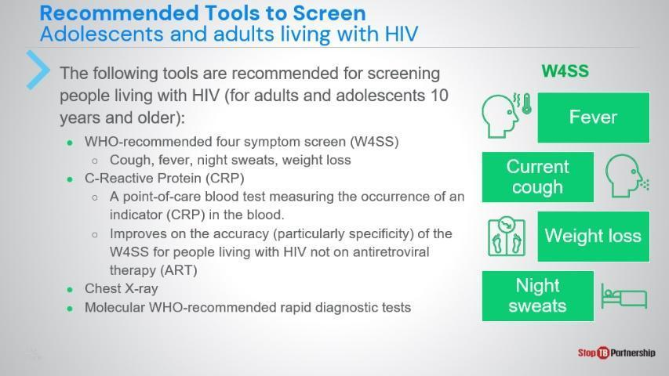
SAY: Because many of the tools already discussed have limitations involving people living with HIV, we need to employ different tools to serve this portion of the population. We start with the recommended 4-symp om screen, which looks for cough, fever, night sweats, and weight loss. Then we can use the C-reactive protein test, which measures the occurrence of this indicator in the blood. Chest x-ray and molecular rapid tests can also be used.

C-Reactive Protein | Slide: 19
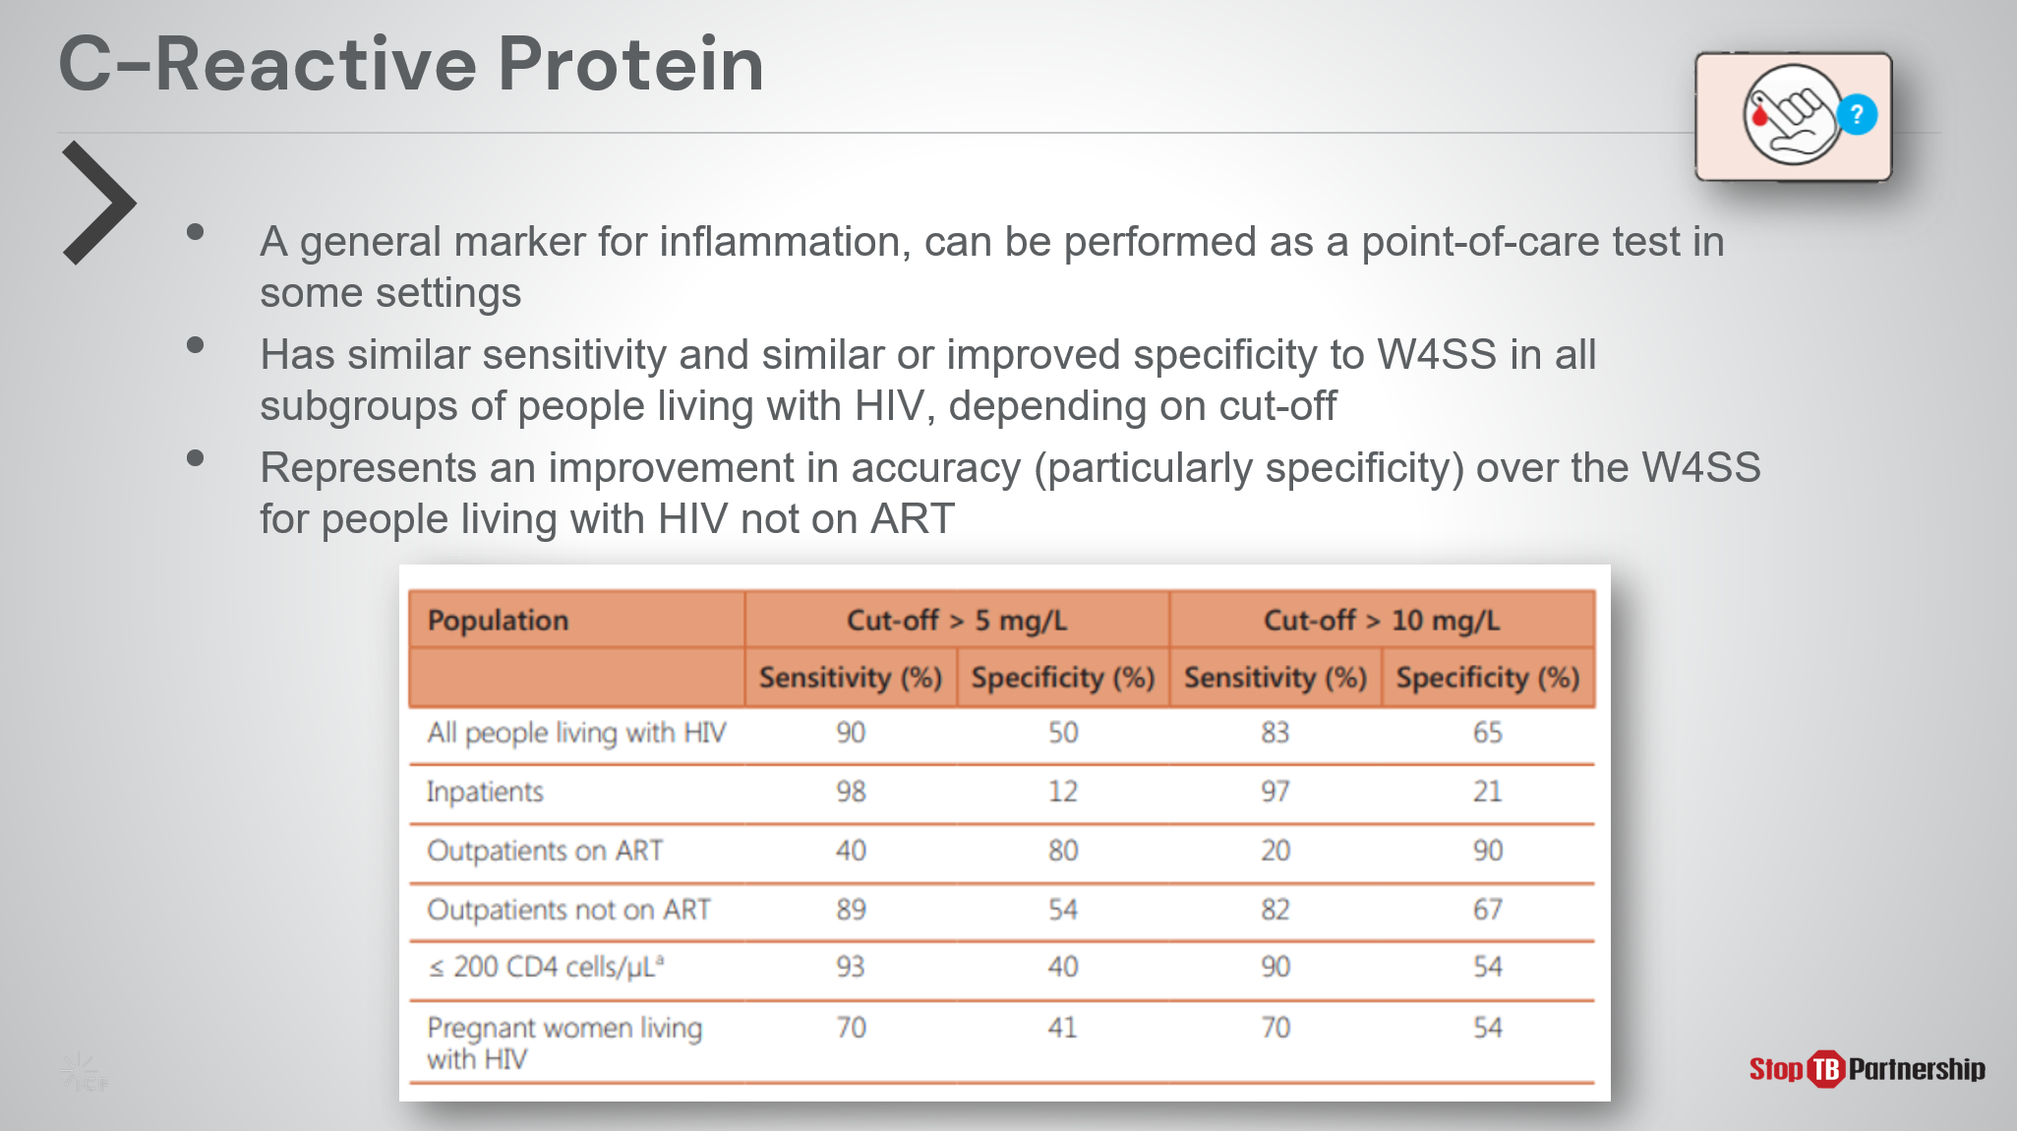
SAY: As we just discussed, the C-reactive protein test is best used as a follow-up to a 4-symptom screening. This test has a higher specificity in people with HIV compared to the 4 symptom- screen , especially in those not on antiretroviral therapy.

Tools for TB Screening in Children | Slide: 20
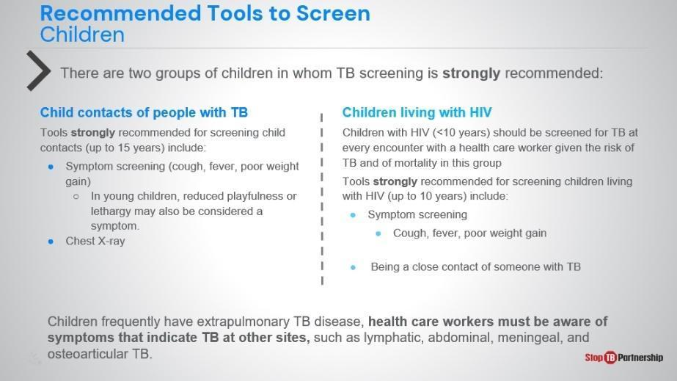
SAY: Just as the general population screening methods are different from methods for those living with HIV, we also need alternate tools when screening children. The WHO strongly recommends TB screening for two groups of children: those under 15 in contact with people who have TB, and those living with HIV -especially those under 10.

For children in contact with TB-positive patients, we use symptom screening and chest x-ray. We look for symptoms in older children, such as cough, fever, and poor weight gain, and in young children, reduced playfulness or lethargy may also be considered symptoms.

Children living with HIV should undergo symptom screening for TB at every encounter with a health care worker, as they are at high risk of TB and mortality. They should also be screened if they are a close contact of someone with TB.

However, we must remember that children frequently have extrapulmonary TB disease, so we must be aware of symptoms that indicate TB at other sites, such as lymphatic, abdominal, meningeal, and osteoarticular TB.
ASK: Thinking back on all the screening tools that we discussed in different populations, which of these are being used in your country? What do you think are the advantages and disadvantages of these tools?
DO: Allow participants to share their experiences. Encourage them to take notes.

TB Screening Algorithms Overview
Overview of TB Screening Algorithms | Slide: 21
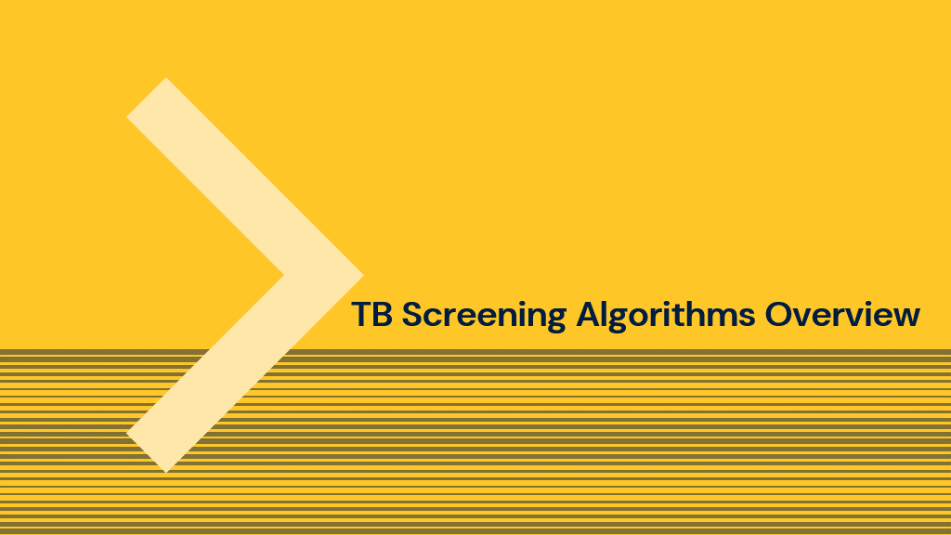
SAY: We have talked a great deal about the tools recommended by the WHO, now let’s pivot a bit and discuss how screening is performed by applying those tools into a screening algorithm.

Overview of TB Screening Algorithms | Slide: 22
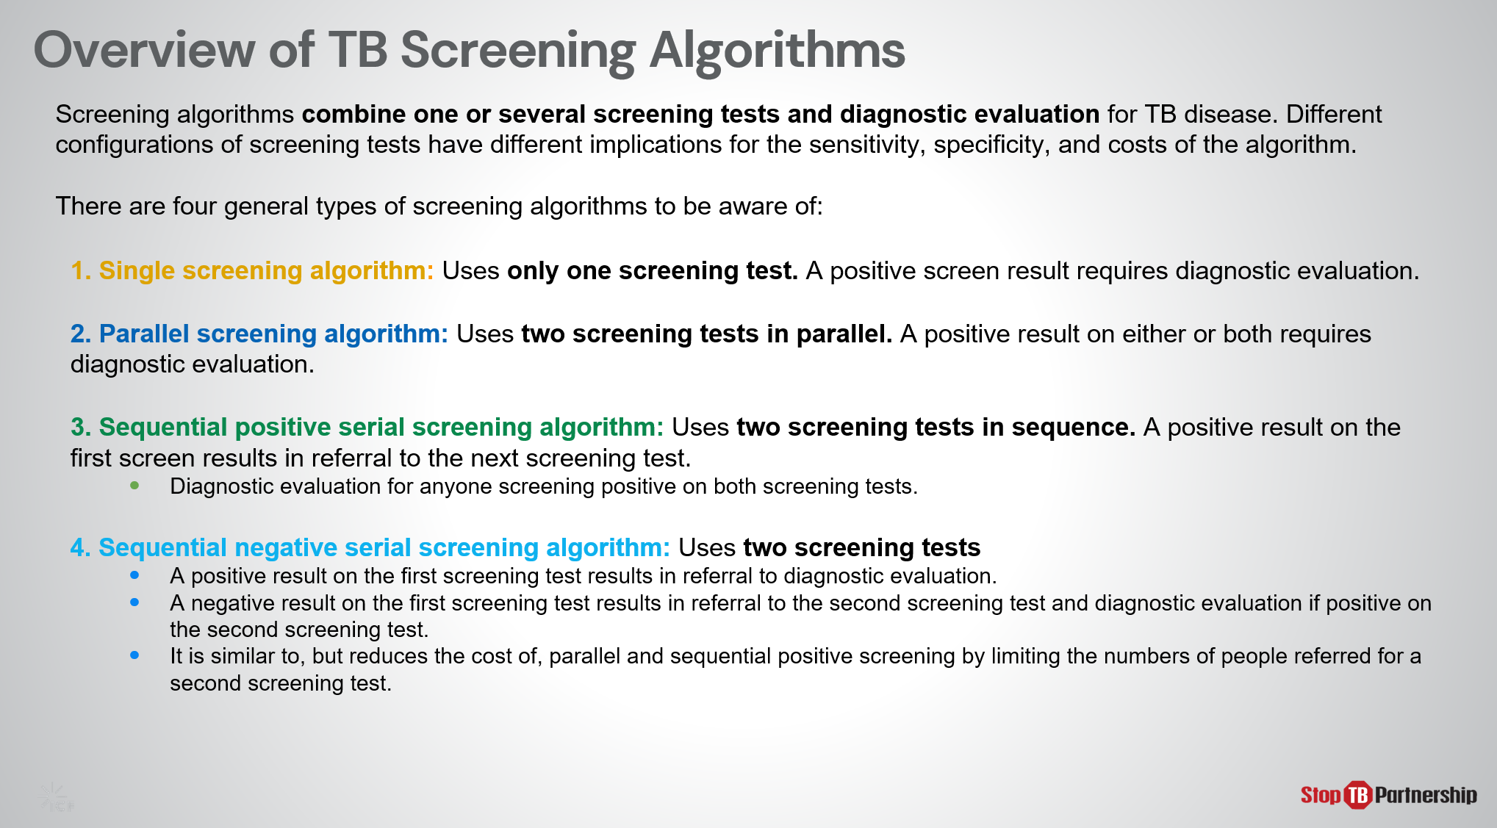
SAY: Screening algorithms combine one or more screening tests and diagnostic evaluation for active TB disease. Different configurations of screening tests have different implications for the algorithm’s accuracy and cost.
There are 4 general types of screening algorithms: Single, Parallel, Sequential Positive, and Sequential Negative.
- A Single screening algorithm uses just one screening test, using any of the tools we previously discussed. In this algorithm, a positive screen result requires diagnostic evaluation.
- Parallel and Sequential algorithms each employ 2 screening tests, but the sequencing varies. In parallel screening, these tests are run at the same time. A positive result on either or both requires diagnostic evaluation.
- Sequential algorithms employ two tests, one after the other.
  - In sequential positive serial screening, a positive result on the first screen results in referral to the next test. Diagnostic evaluation follows for anyone screening positive on both tests.
  - In sequential negative serial screening, a negative result on the first test results in referral to the second screening test. A diagnostic evaluation follows for anyone screening positive during either the first or second test.
Sequential negative serial screening reduces costs of parallel and sequential positive screening by limiting the numbers of people referred for a second test.

General Population (aged 15+) and High-risk Groups (not HIV+) | Slide: 23
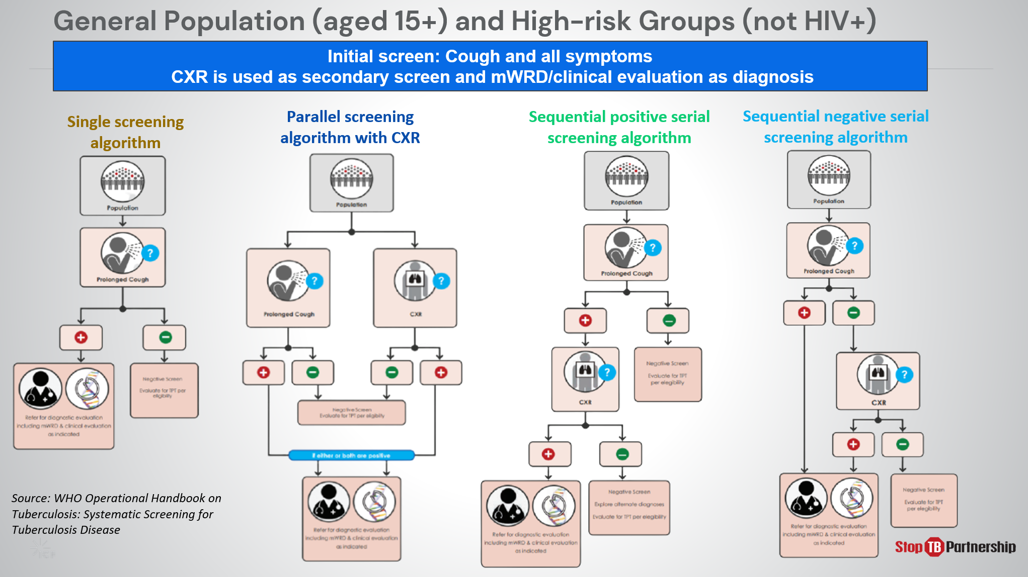
SAY: And here we present an example of each algorithm for use in the general population (15+ years old) and high-risk groups (not HIV). All use symptom as the initial screen. CXR is used as a secondary screen, and mWRD for diagnosis.
ASK: Do any of these algorithms represent the way you are currently screening for TB? What considerations have led to the employment of these methods?
DO: Allow participants to share their experiences. Encourage them to take notes.

General Population (aged 15+) and High-risk Groups (not HIV+) | Slide: 24
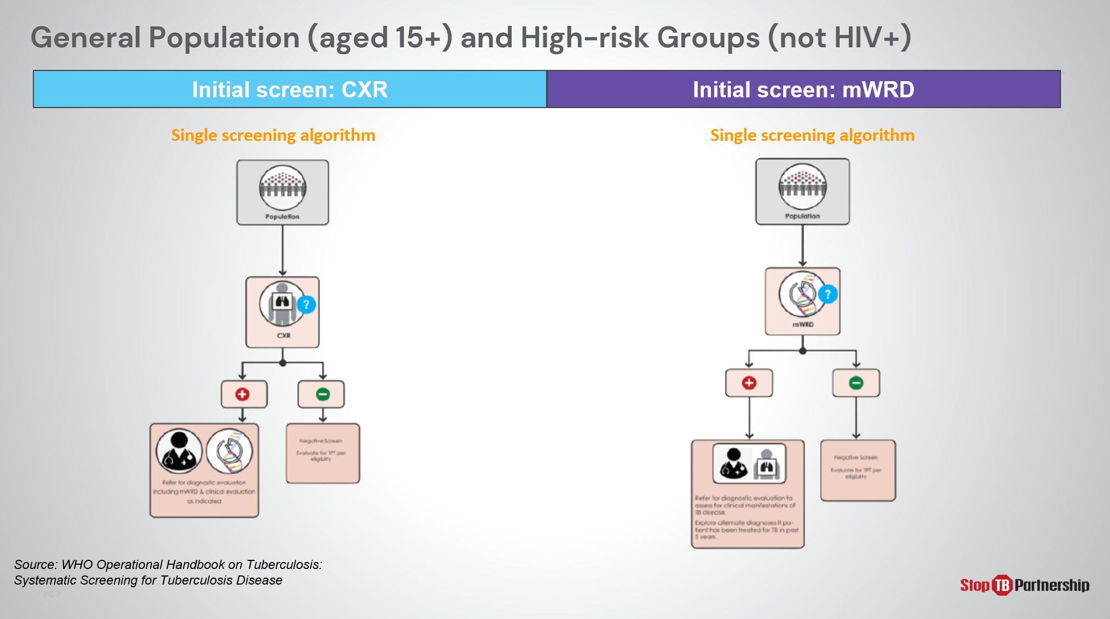
SAY: When we look at the general population and high-risk groups, we may also use chest x-ray or molecular diagnostics as an initial screening tool. [walk through an example of each].

Screening Algorithms for Adults and Adolescents Living with HIV involving X-ray | Slide: 25
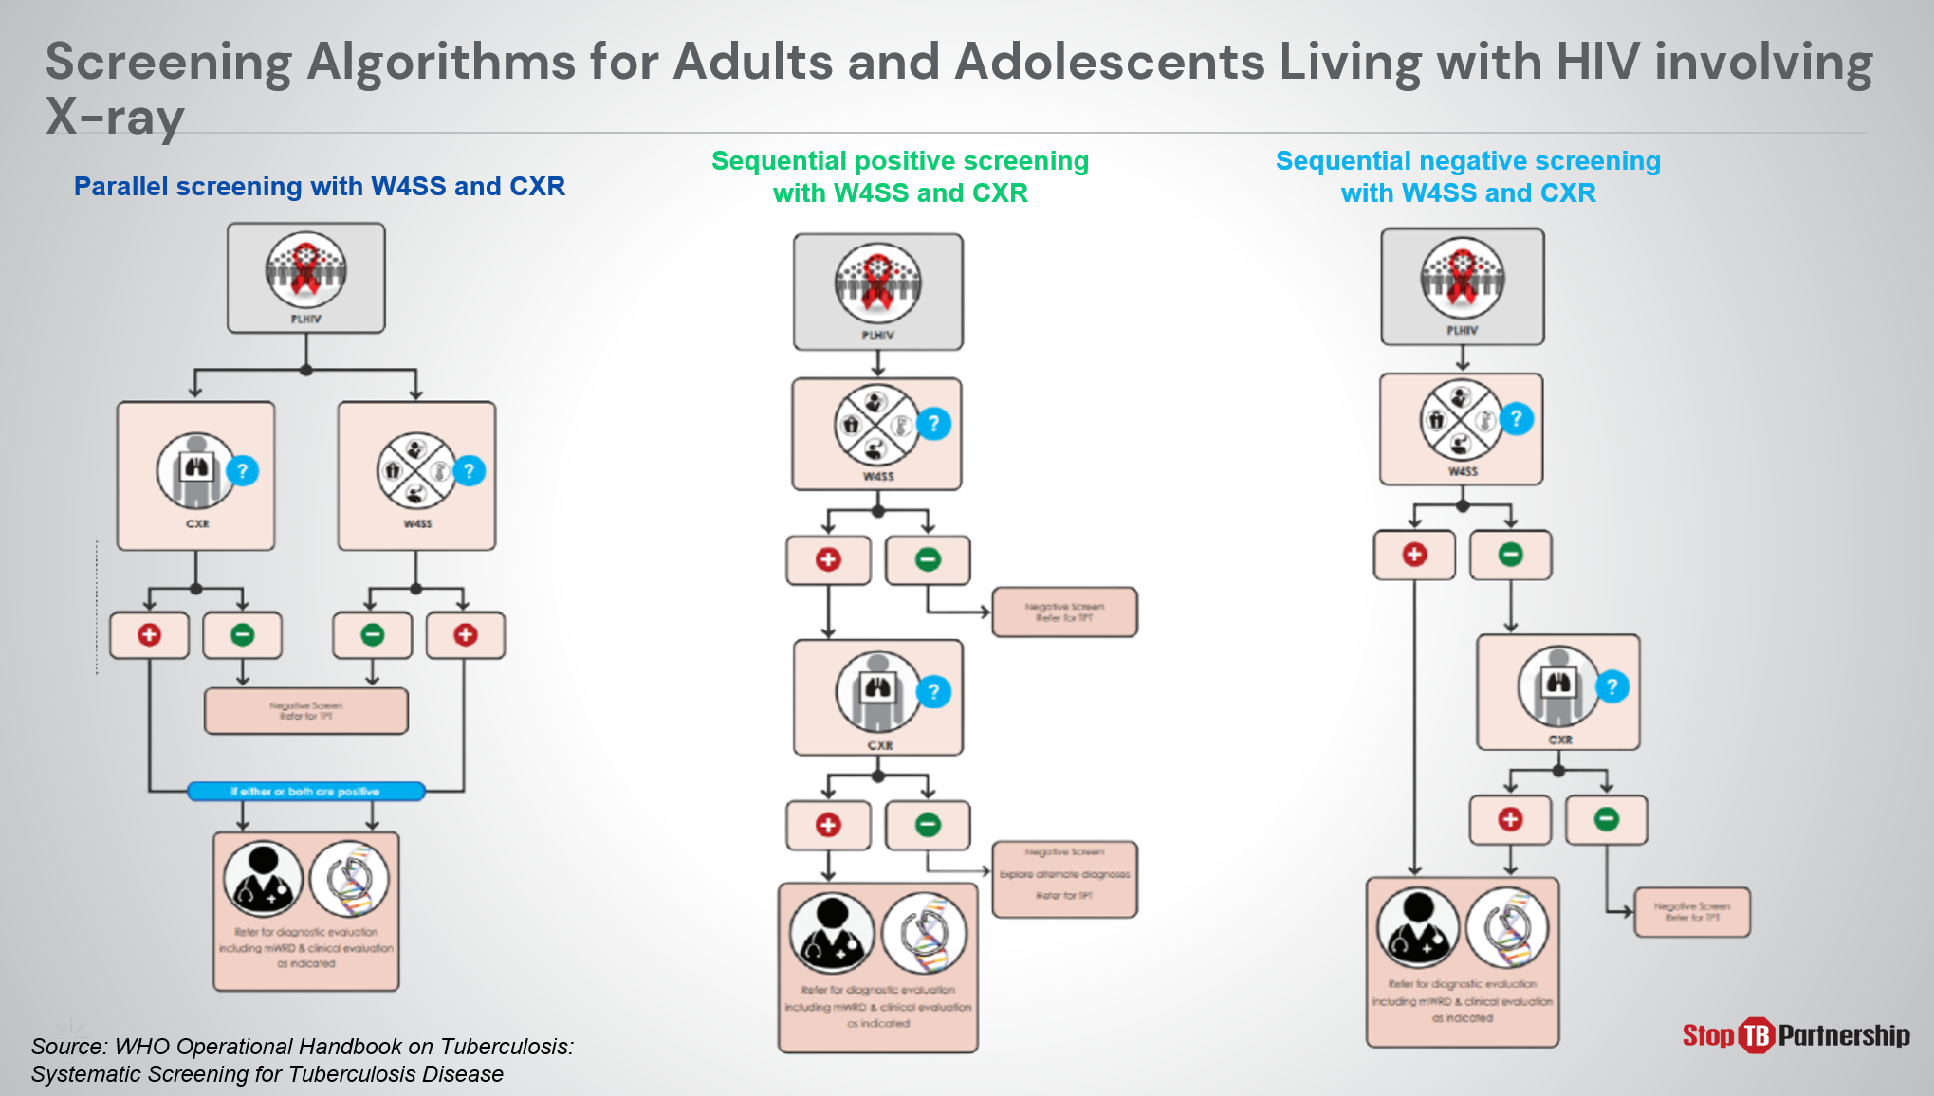
SAY: For adults and adolescents living with HIV, chest X-ray may be used in combination with other recommended screening tools for this group. For example [walk through an example]

Screening Algorithms for Children involving X-ray | Slide: 26
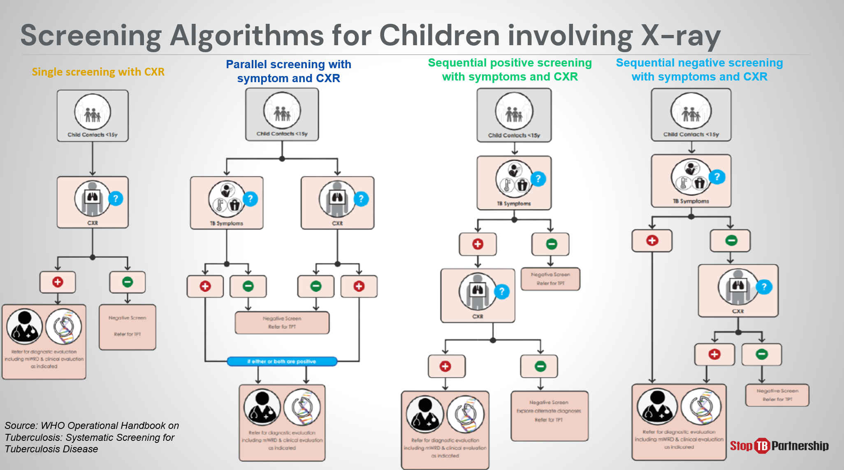
SAY: When screening children, we may also employ chest X-ray in a single screening algorithm or in combination with other recommended screening tools for this group. [walk through an example ].

Different Screening Program Models | Slide: 27
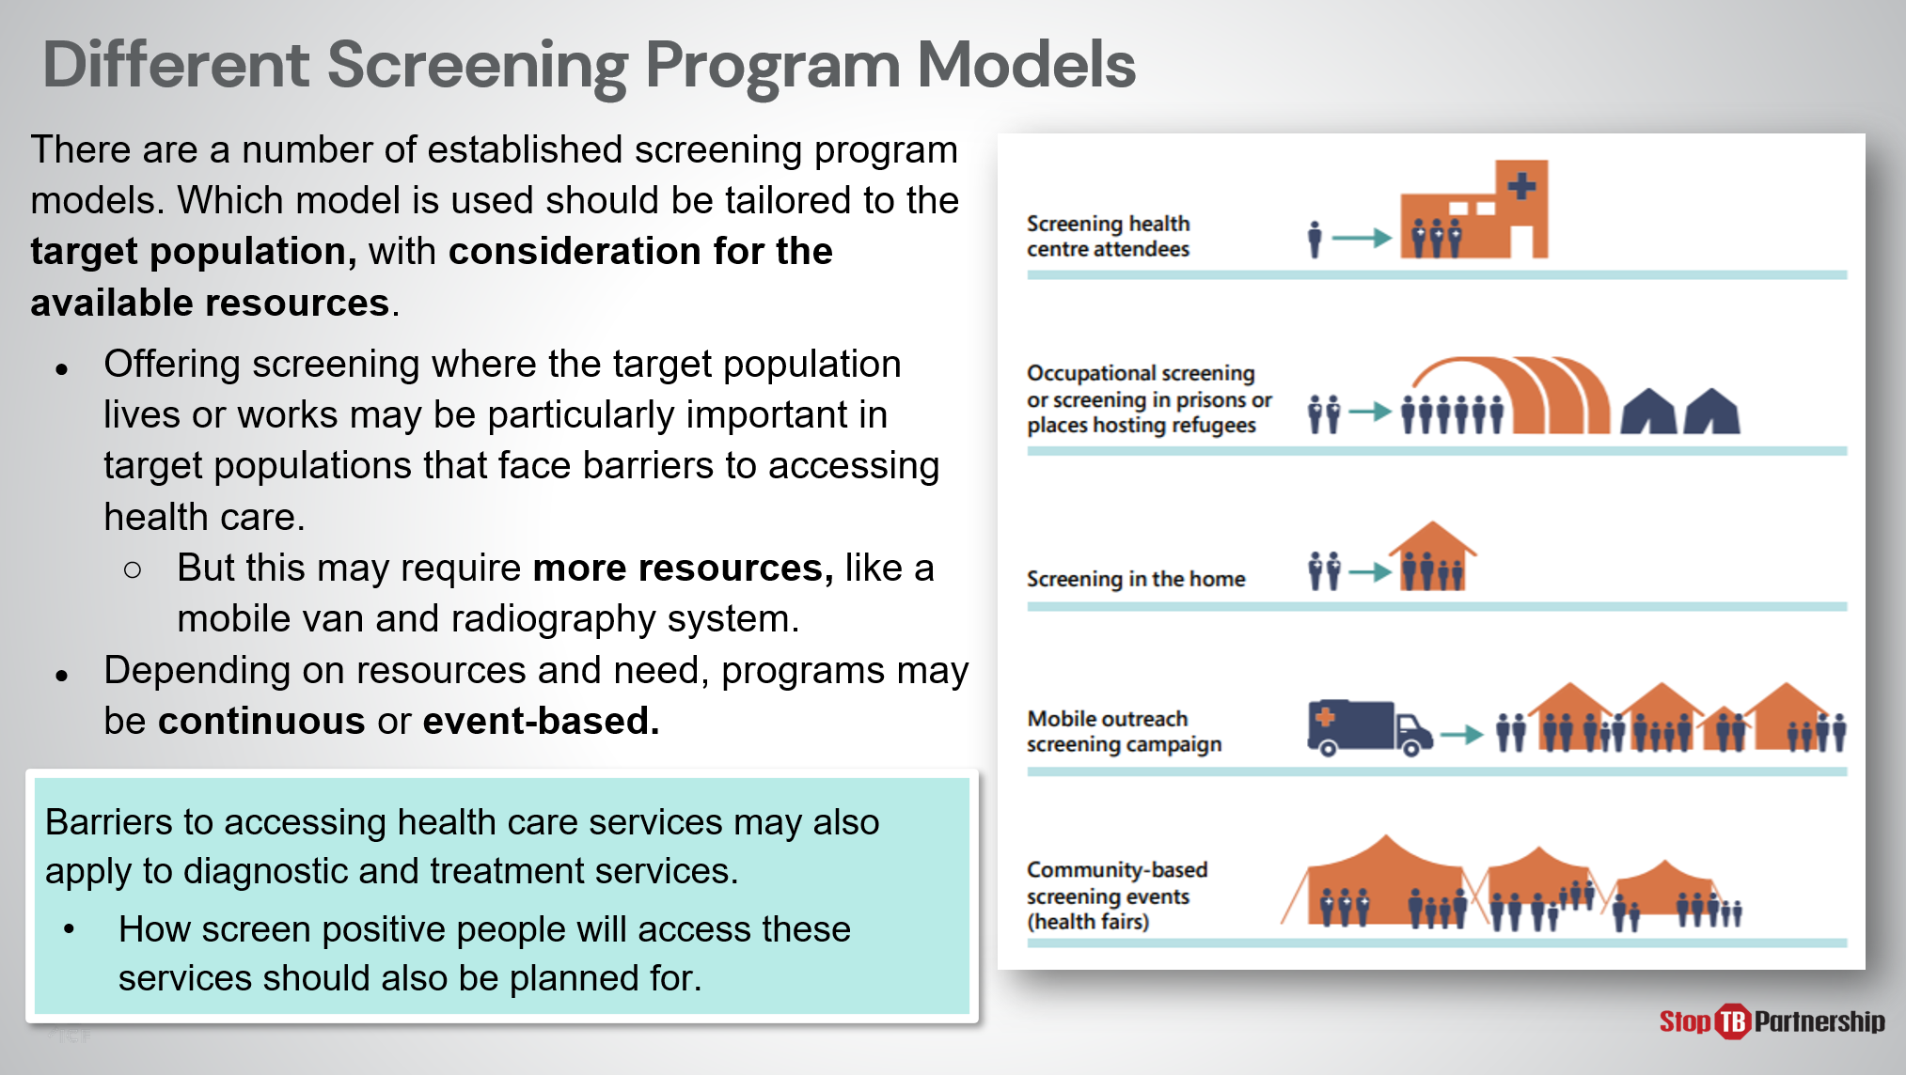
SAY: When we think about screening, we also need to think about screening models – that is, the application of the algorithm and the tools in a programmatic setting. How, where, and how often will we do this screening?
We could consider:
- Screening at health centers
- Occupational site or communal living (refugee host sites, prisons, or other facilities) screenings
- Home screening
- Mobile outreach screening campaigns
- Screening events
However, when we plan these screening events, we must also make sure that those screened not only have access to the screening service, but also can access ongoing services, such as diagnosis, treatment, and follow-up care, so that those who DO screen positive for TB have access to the care they need.
ASK: What options have been employed thus far to support your populations? What worked well, and what led to that success? What challenges have you faced, and what lessons-learned will help you have more future success?
DO: Allow participants to share their experiences. Encourage them to take notes.

Algorithm Considerations for Risk Groups | Slide: 28
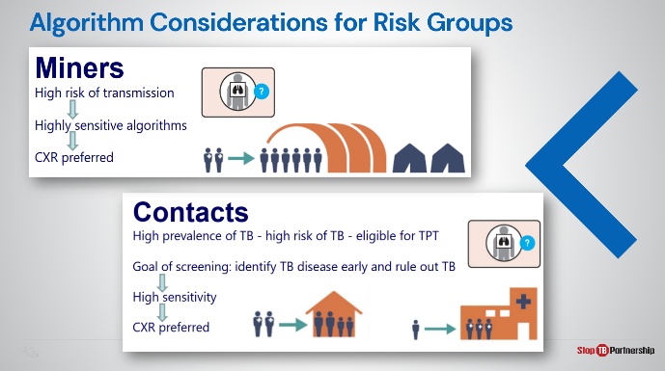
SAY: When we think about specific risk groups, we want to consider characteristics that might make certain screening tools preferred over others. For example, those in the mining profession have a high risk of transmission, so we need very sensitive algorithms, making chest x-ray a preferred tool. Similarly, people in close contact of those positive for TB are at high risk and in need of either treatment or preventative care. In this case, chest x-ray is also an appropriate choice.

Algorithm Considerations for Risk Groups | Slide: 29
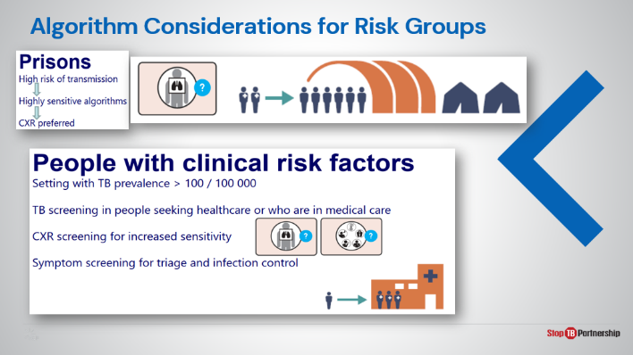
SAY: In settings, such as prisons, we again have a high risk of transmission and need that high sensitivity in algorithm, so a chest x-ray is the preferred screening tool. For individuals with clinical risk factors like diabetes or lung disease in settings with a high TB prevalence, those how have engaged in a health-seeking behavior should be screened. In these settings, we will employ chest x-ray for its sensitivity, as well as symptom screening for triage and infection control.

Algorithm Considerations for Risk Groups | Slide: 30
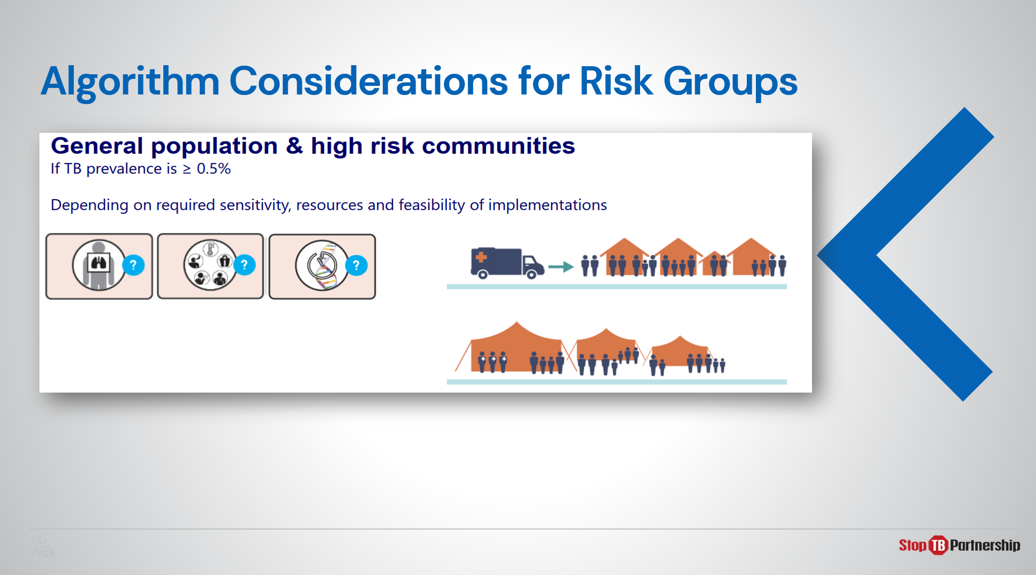
SAY: Lastly, when we consider high risk communities – those with a high TB presence among the general population, we may employ any combination of chest x-ray, symptom screening and molecular diagnostics depending on the required sensitivity and the resources available to feasibly assist the community. In these cases, mobile campaigns and community screening days may be employed.

Summary
Summary | Slide: 32
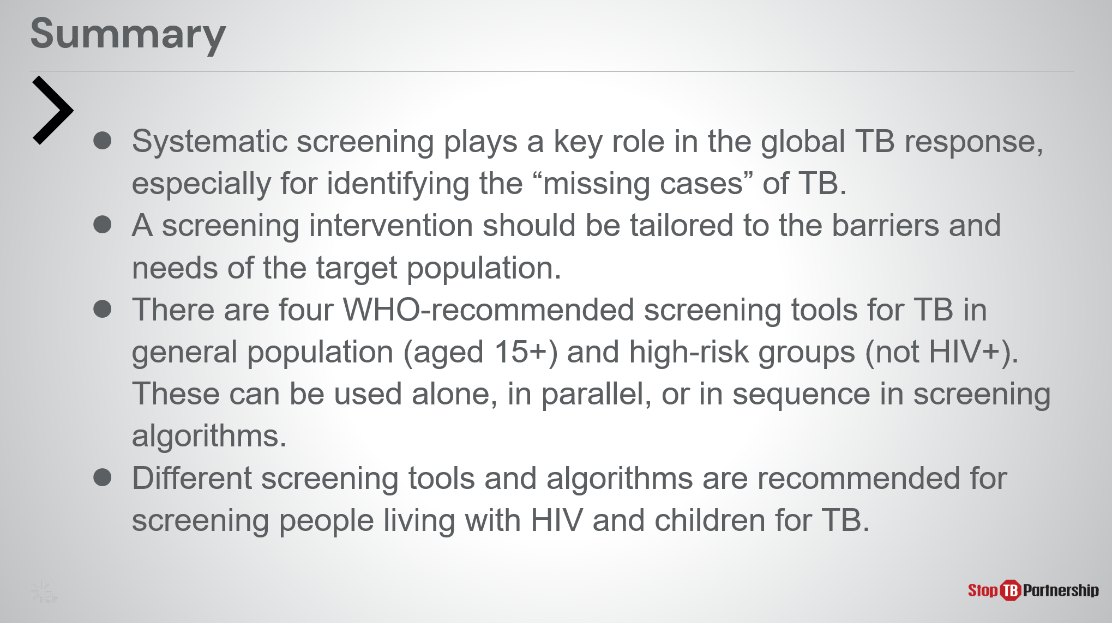
SAY:
- Systematic screening plays a key role in the global TB response, especially for identifying the “missing cases” of TB.
  - The gap is substantial, and further exacerbated by COVID 19. In 2020, we saw more than 4 million missing cases, but even before that - in 2018 and 2019, we saw roughly 3 million missing cases. To close the gap, we will need better screening tools.
- Screening interventions should be tailored.
  - Remember, identifying the target population to be screened is the first step. Once we have identified this target population, we can design a screening intervention that will accommodate that population’s needs and work through the barriers.
- The four WHO-recommended screening tools for TB (symptom screening, chest x-ray, CAD, and rapid molecular diagnostics) can be used alone, in parallel, or in sequence within screening algorithms.
  - These tools are meant for individuals 15 and older, and not intended for those living with HIV.
- Different screening tools and algorithms are recommended for screening people living with HIV and at-risk children.

Module 2: New Tools for TB Screening: Introduction to Computer-Aided Detection (CAD) and Ultra-Portable X-Ray

Target Audience
The target audience for this course is:
  - Program managers
  - NTP

Learning Objectives
Terminal Objective
- At the end of this module, participants should understand the fundamentals of CAD and ultra-portable X-ray devices, particularly those featured in the GDF catalog.

Module Objectives
- By the end of this module, participants should be able to
  - Describe what CAD technology is and how it can be applied in TB screening.
  - Know the key features of the CAD products available from the GDF catalog.
  - Understand what is meant by “ultra-portable X-ray” and the advantages and disadvantages of using it.
  - Detail the components and pricing of the ultra-portable X-ray systems available in the GDF catalog.
  - Understand the different ways CAD and ultra-portable X-ray can be integrated for use in TB screening and triage.

Materials
- Facilitator Guide
- Pens/Pencils

Advance Preparation
- No customization is required

Introduction
Introduction | Slide: 2
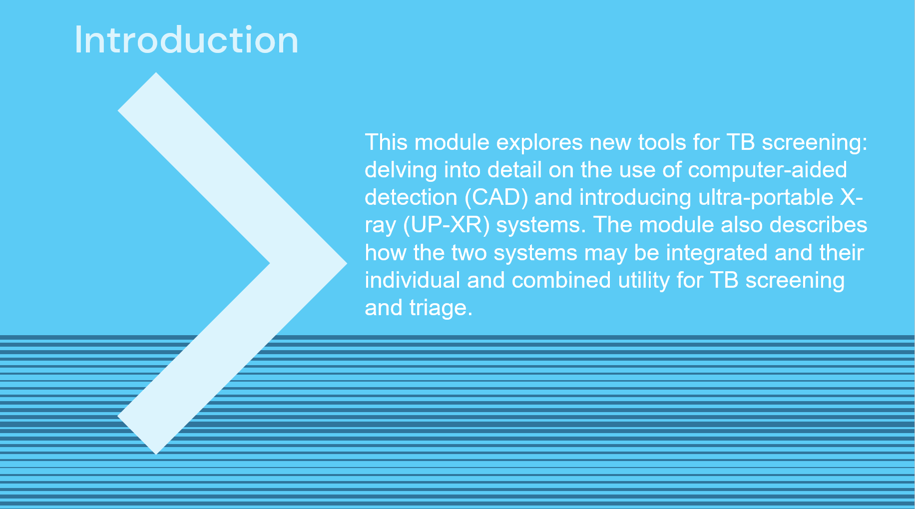
SAY: In this module we will get to grips with how to use the new TB screening tools – CAD and ultra-portable X-ray- with a focus on products available in Stop TB Partnership’s GDF Catalog. The ultimate goal is to provide a foundation of knowledge that we will draw upon in Modules 3-5.

Course Outline | Slide: 3
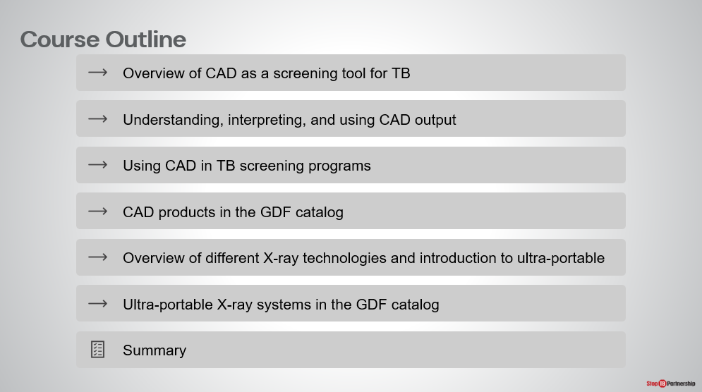
SAY: We will start this module with a focus on CAD technology, how it works, and how to use the CAD output, before looking at the specifics of the CAD product (CAD4TB) that is provided through Stop TB’s GDF Catalog. Next, we will summarize X-ray technology in general before introducing and contextualizing the new ultra-portable X-ray technology. Again, we will narrow our scope to focus on the [either Delft Light/Fujifilm Xair] which this project will be using.

Learning Objectives | Slide: 4
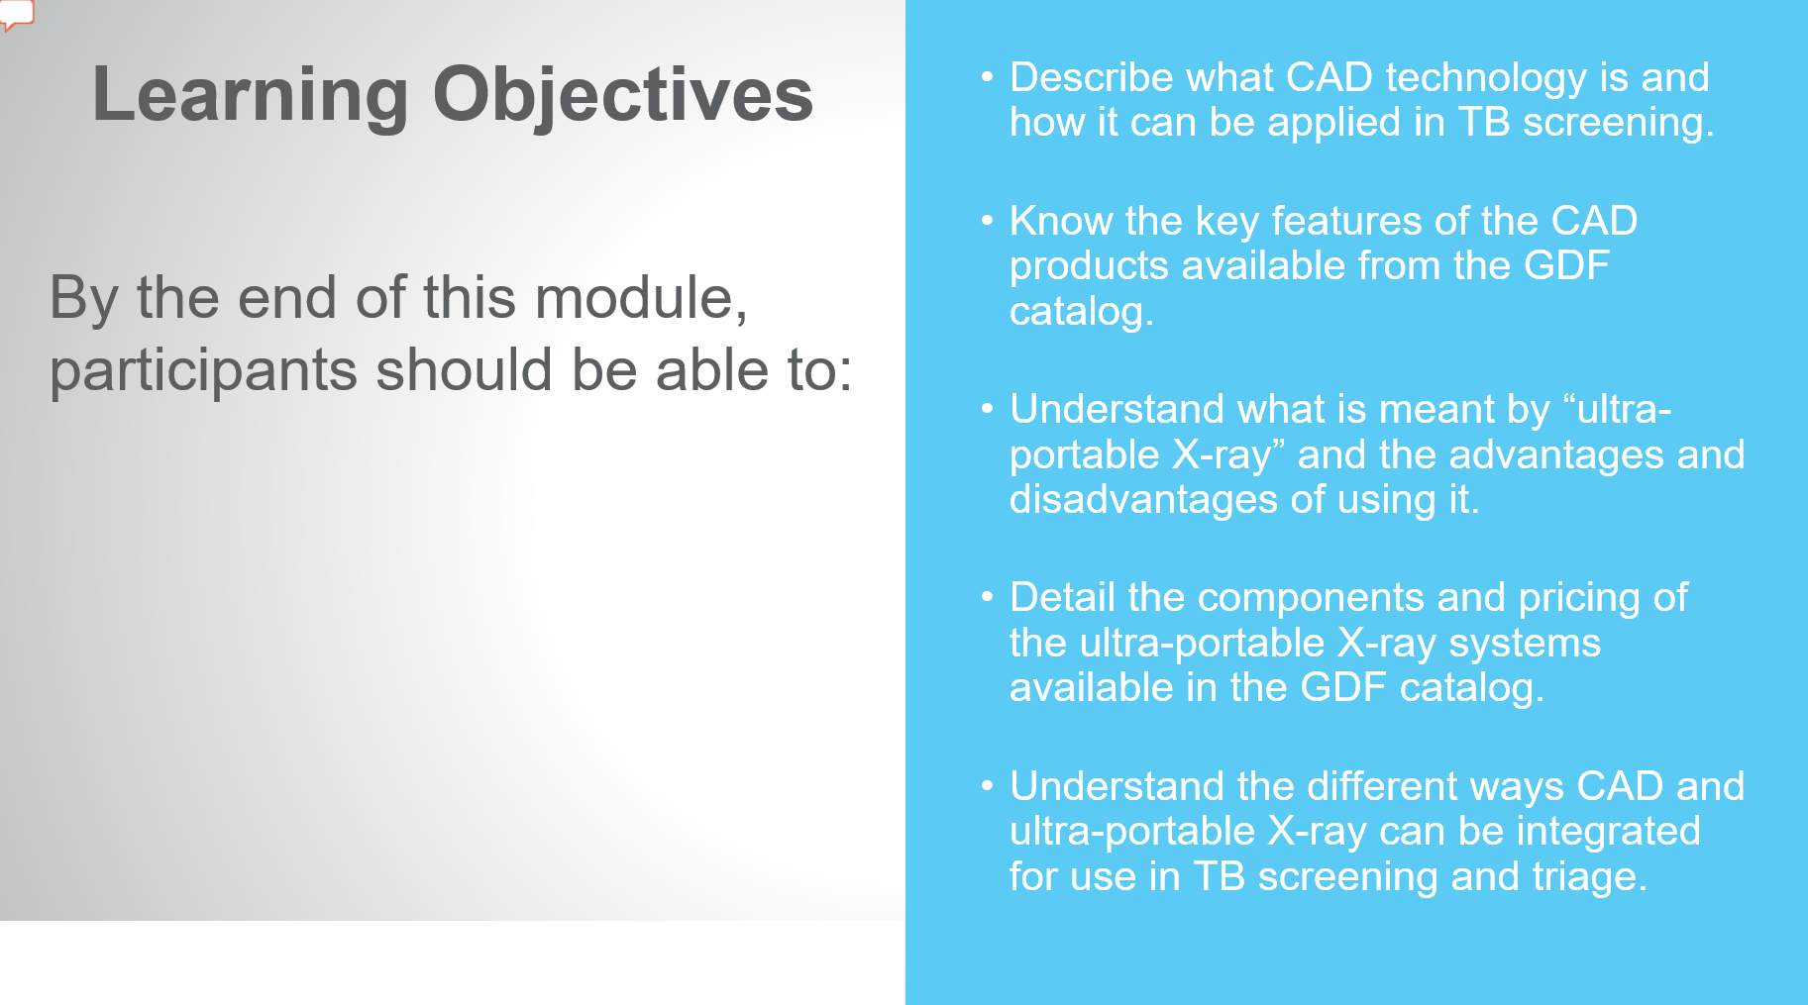
SAY: By the end of this module, you will be able to:
- Describe what CAD technology is and how it can be applied in TB screening
- Know key features of CAD products, particularly those available from the Stop TB’s GDF catalog
- Understand what we mean when we say “ultra-portable X-ray” as well as the advantages and disadvantages of using it.
- Detail the components and pricing of the [Delft Light/ Fujifilm Xair] provided through the GDF catalog
- Understand how CAD and ultra-portable X-ray can be integrated and used together for TB screening and triage.
ASK: Before we briefly recap the relevant content from Module 1, are there any questions?
DO: Allow participants to ask questions and respond appropriately.
Reminder: WHO Guidelines on Systematic Screening | Slide: 5
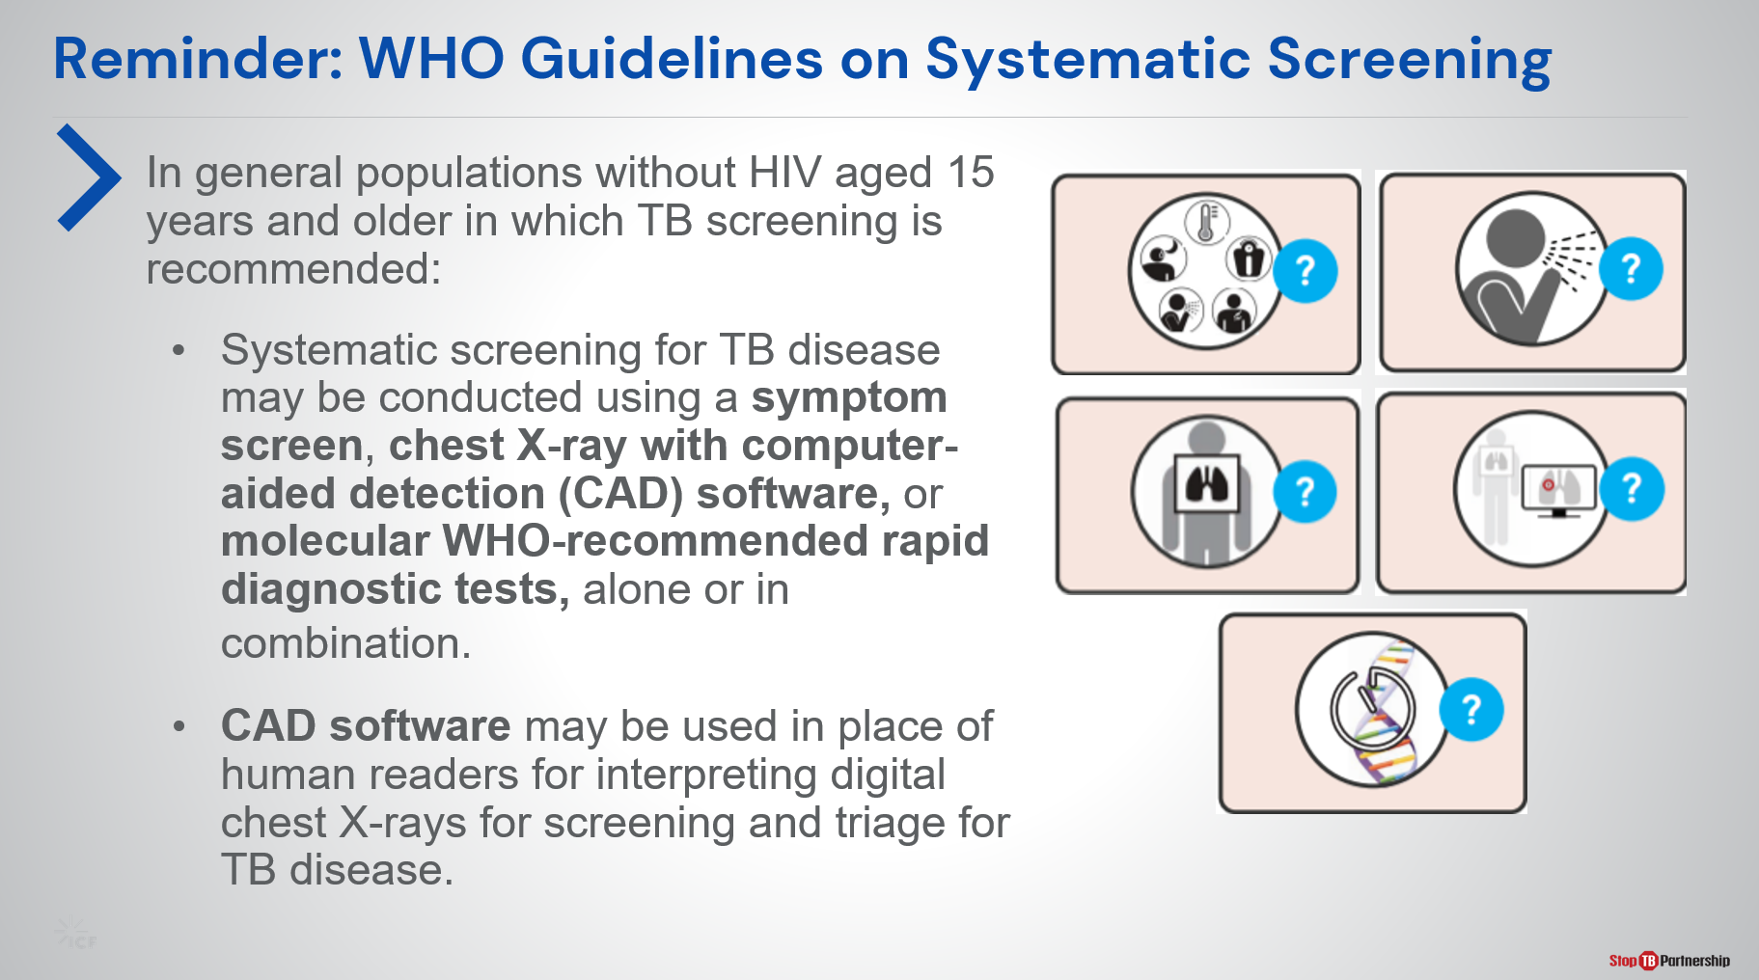
SAY: First, let’s revisit Module 1. Here, we introduced five WHO-recommended screening tools for TB as per the March 2021 TB screening guideline update. You can see that CAD is recommended for the first time alongside symptom screening (any symptom or prolonged cough), chest X-ray, and molecular WHO-recommended rapid diagnostic tests. These may be used to screen for TB alone or in combination.

According to the policy update, CAD can be used in place of human readers for screening chest X-rays for TB in individuals 15 years and older. How exactly this can be done will be explored in this module.

Computer-Aided Detection (CAD) Software for Screening and Triage of TB

Overview of CAD as a Tool to Screen and Triage TB | Slide: 7
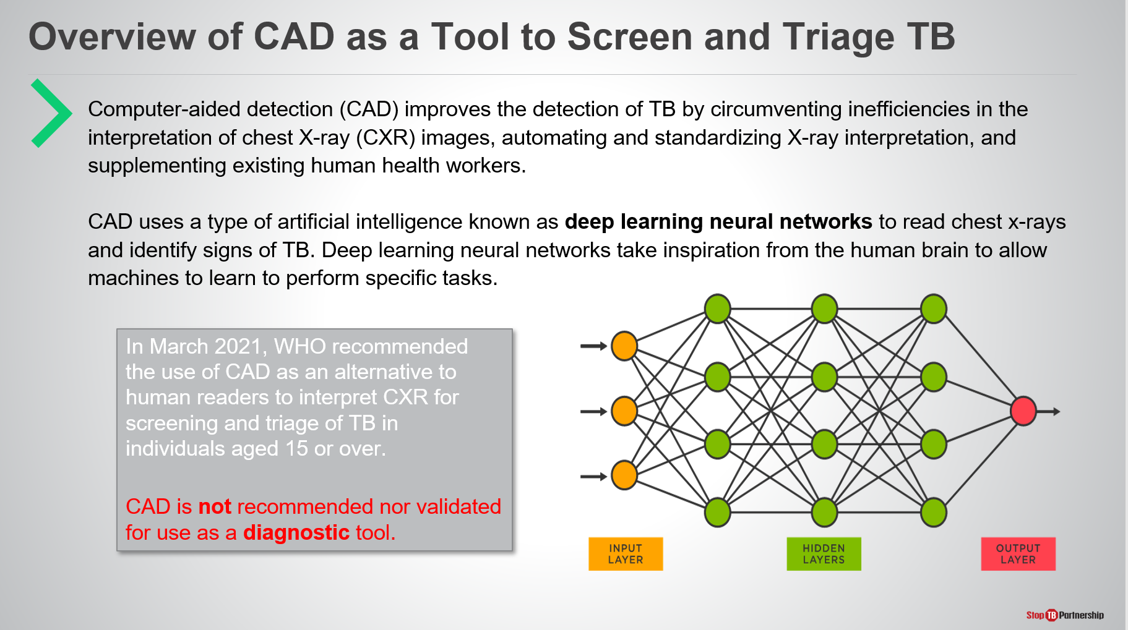
SAY: We will start by understanding the technology behind CAD’s decision – artificial intelligence (AI). Though AI is often the stuff of science fiction, it is increasingly used in today’s world, for example for personalizing music or film recommendations, social media feeds, and increasingly in health care.

The type of AI used in CAD is a called a deep learning neural network.
DO: Direct the audience (through mouse, pointing) to the figure on the slide when talking about deep learning networks.
SAY: This diagram shows us a simplified deep learning neural network. Modelled on those in the human brain, you can see it is structured in layers: the orange layer receives the input – the chest X-ray- the green layers process the input, and provide their collective analysis to the red layer, which generates the output.

The neural network is perfected by training AI on vast quantities of data to perform the desired task, with the neural network evolving during training. For our purpose AI is trained to identify TB in chest X-rays.

Before using CAD, it is essential to know that the CAD result is NOT for diagnosis of TB and individuals identified by CAD as possibly having the disease should receive a diagnostic test.

CAD Output | Slide: 8
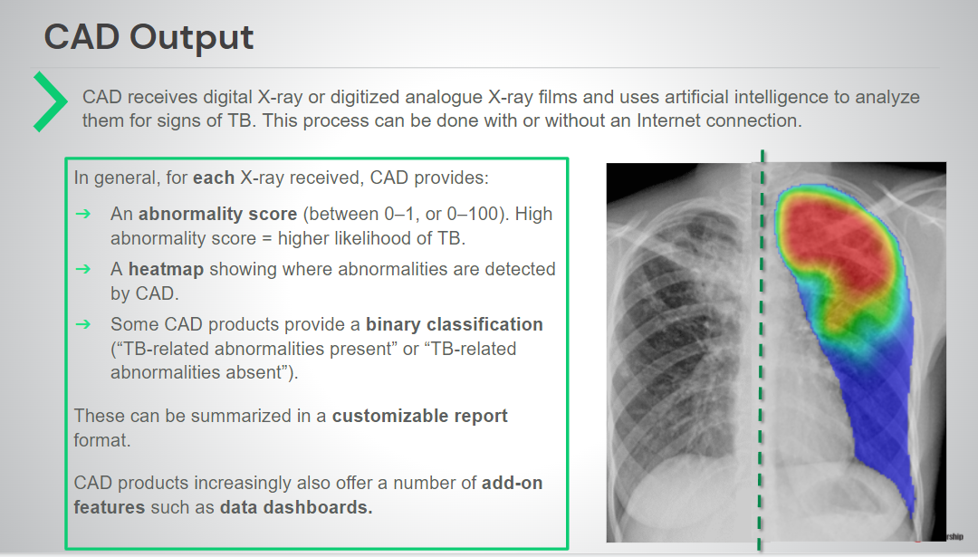
SAY: CAD receives the input- digital X-ray or digitized analog X-ray films- and analyzes them for signs of TB.

For each X-ray image provided, CAD provides:
- An abnormality score (between 0-1 or 0-100) indicating the likelihood of TB presence in the image.
- A heatmap or bounding box diagram showing where abnormalities are detected, if any.
- Some CAD provide a classification “Possibility of TB” or “No TB”

These are often summarized in a customizable radiologist-style report format by the program. In addition to these outputs, the AI analysis is often provided within a package of add-on tools, such as data dashboards.

Detecting Non-TB Abnormalities by CAD | Slide: 0
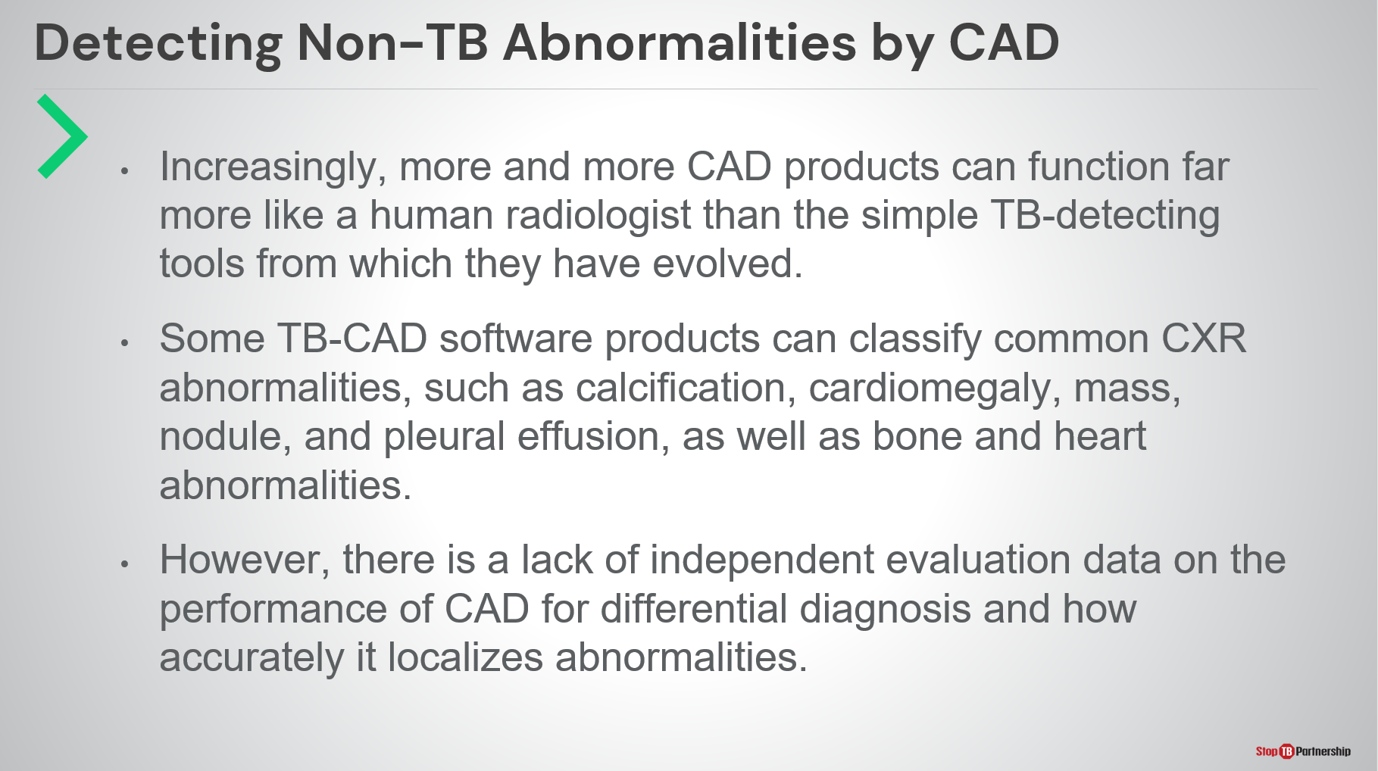
SAY: So far, we have only talked about CAD’s ability to detect TB. Increasingly, CAD products can also detect non-TB lung abnormalities (calcification, cardiomegaly, pleural effusion, for example), bone and heart abnormalities, and non-TB lung diseases (including Covid-19). The range of abnormalities identified depends on the brand and version of the CAD product.

However, CAD has currently only been validated for detecting TB-related abnormalities and its accuracy when detecting other abnormalities and diseases (including Covid-19) remains unknown.

CAD Landscape Analysis | Slide: 10
SAY: The CAD market is rapidly growing. Currently, the website ai4hlth.org identifies 17 different CAD products for TB on the market, 9 with regulatory (CE) approval, and more in development.

Each CAD product has its own selling points but some characteristics common to most products include:
- Suitability for populations over 15 years of age
- Ability to read postero-anterior DICOM images (though antero-posterior images, JPEG, and PNG formats are also widely accepted).
- Abnormality score and heatmap output presented in a radiologist-style report
- Offline and online deployment
- Integration with clinical information systems (like PACS)
- Compatibility with most mainstream X-ray systems

CAD Landscape Analysis | Slide: 11
SAY: However, there is also variation between products. For example, only some products:
- Use local data to tailor their performance to a site.
- Require further training using local data after purchase before on-site installation.
- Identify non-TB abnormalities.

For those curious about the range of CAD products available, visit the website ai4hlth.org run by the Stop TB Partnership and FIND.

Validation of CAD for Interpreting Digital X-ray | Slide: 12
SAY: Next, we will discuss to the accuracy of CAD in identifying TB in chest X-rays.

Preceding the update of the WHO guidelines in 2021, the Guidelines Development Group evaluated three independent evaluations of three different CAD products (CAD4TB, qXR, and Lunit INSIGHT CXR). The results are shown in this table and demonstrate the comparable range in sensitivity and specificity of human readers and CAD software.

It is also important to evaluate CAD in context: trained human readers are not available or in low number in many settings with high TB burden while non-specialist human readers may be used that would not perform as well as the “gold standard” human readers against which CAD is frequently compared.

Based on this, WHO made the decision to recommend CAD in the most recent update of the systematic TB screening guidelines.

Validation of CAD for Interpreting Digital X-ray | Slide: 13
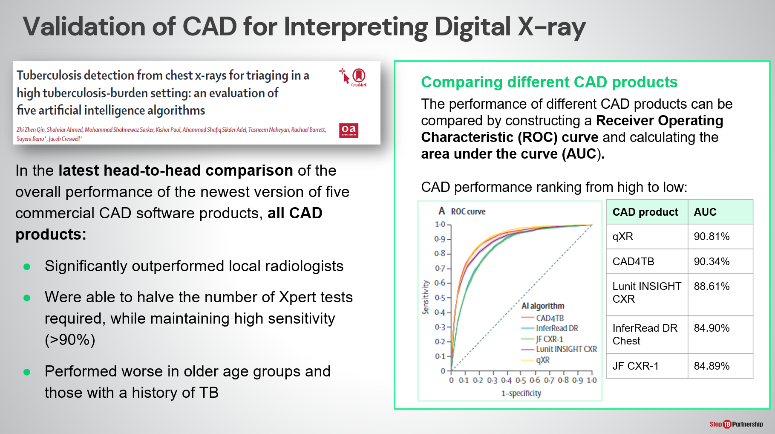
SAY: One of the latest peer-reviewed paper published on Lancet Digital Health evaluated the latest versions of the two CAD products provided through GDF. The evaluation was done in Bangladesh, Dhaka, among people referred by private physicians to test for TB. The prevalence of TB was around 15% - higher than that of a regularly ACF. This study found that CAD:
- Significantly outperformed local radiologists
- Was able to halve the number of confirmatory tests required, while maintaining high sensitivity.
- Performed worse in older age groups and those with a history of TB.

CAD literature also provides insights on how different software perform relative to each other. For example, (shown in the box on the right-hand side) qXR and CAD4TB were the top performing CAD products in this evaluation.
Another insight that can be gleaned from CAD literature is that product performance can vary based on population, epidemiological, and programmatic factors and so results from one evaluation may not hold true for all evaluations and for your prospective implementing population.

Where to Place CAD in the TB Screen Algorithm | Slide: 14
SAY: Given our new knowledge of CAD, we will now move on to discuss how CAD can be integrated with TB screening algorithms.

As previously mentioned, CAD can be used in place of trained human readers according to WHO’s recommendation, but CAD can also be used WITH human readers.
- Alongside human readers, CAD can be useful for helping radiologists optimize their workload and flow, prioritizing follow-up of abnormal images, providing image quality checks, pre-reading and reporting assistance.
- CAD is only recommended to be used in place of trained human readers for individuals aged 15 years and older. Here, it can be used as a rapid screen particularly among asymptomatic individuals without significant risk factors (e.g., in active case finding), or for triage in individuals with symptoms, or risk factors.

Any CAD algorithm used must meet the standard of those evaluated by WHO for the guideline update.

Where to Place CAD in the TB Screen Algorithm | Slide: 15
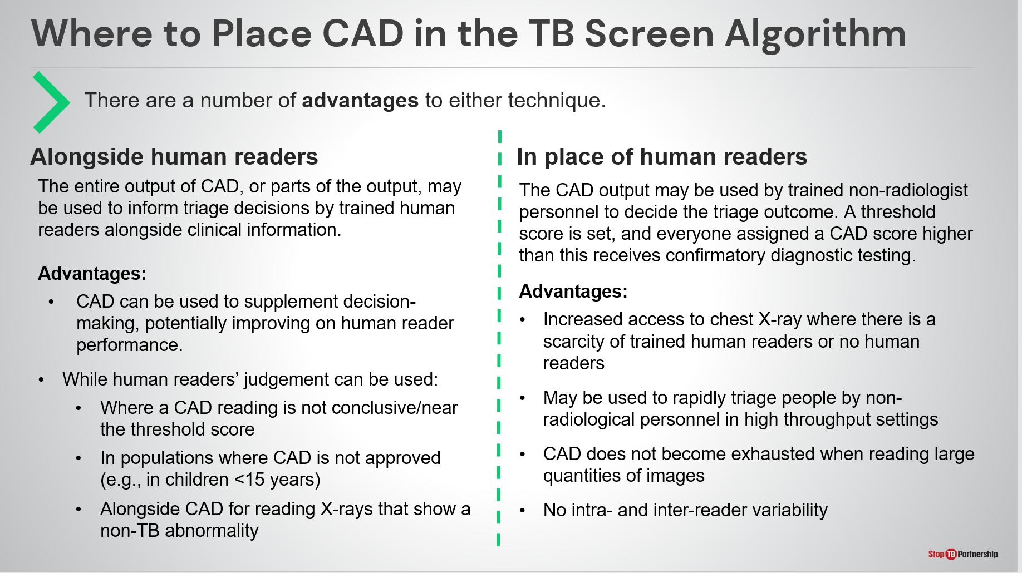
SAY: There are advantages to both approaches.

When used alongside with human readers, CAD outputs can inform the triage decisions of trained human readers, potentially improving upon performance, while the human reader judgement may be helpful to supplement CAD where an output is near the threshold, in children, or for identifying non-TB abnormality.

Meanwhile, when used without experienced human readers, or with non-radiologist personnel, CAD outputs can determine the triage outcome . This approach is particularly helpful where there is a scarcity of trained human readers, or none at all, as well as in high throughput settings.

ASK: With our combined knowledge of [this country’s] current TB recommendations and practices, where are some potential places CAD could supplement our workflows?
DO: Receive answers, encourage note-taking

CAD Products in the GDF Catalogue
CAD4TB | Slide: 17
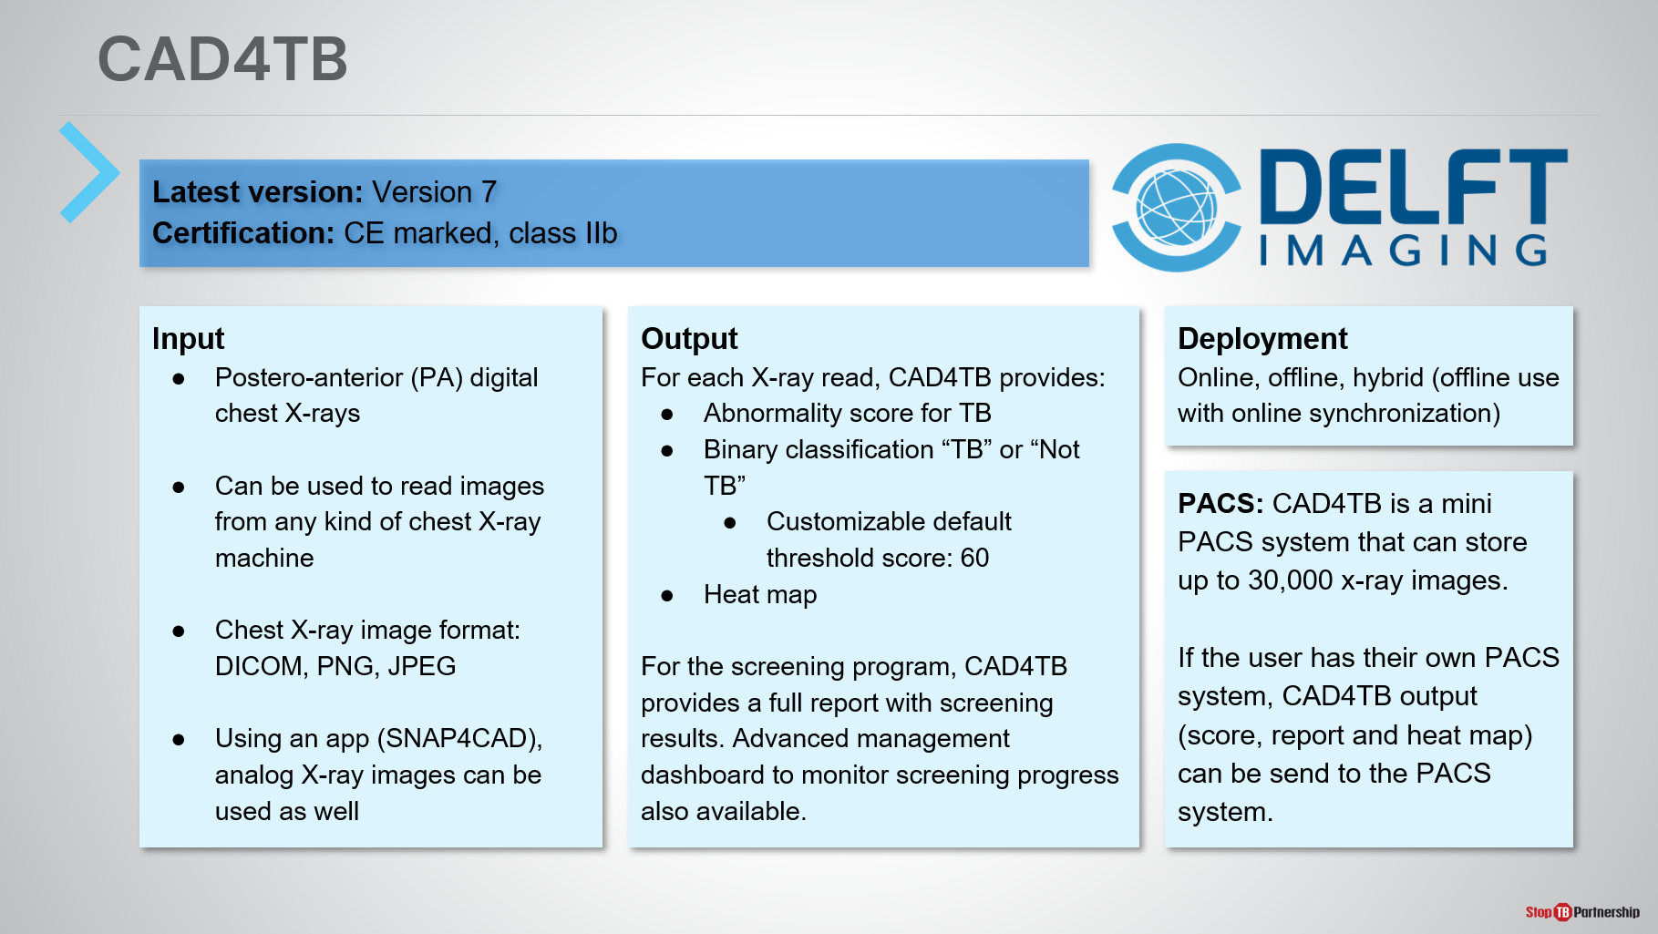
SAY: Now we will stop talking about CAD generally and focus on the products available through Stop TB Partnership’s GDF Catalog. The manufacturer will provide details in their hands-on training so today we will give an overview.

The CAD software provided is CAD4TB by Delft Imaging Systems.
ASK: Does anyone in the room have experience with CAD4TB?
DO: Receive answers and prompt them to provide an overview of where and how they used it.
SAY: The latest version of CAD4TB is version 7 and this is the version procured under this project.

CAD4TB can be used to read chest X-rays from any kind of machine (not just Delft’s own) and reads postero-anterior (PA) digital images in DICOM, JPEG or PNG format. For sites using analog X-ray, an app can be used to take a picture of the film for reading by CAD4TB. This feature exists but not provided through the GDF package.

In terms of output, CAD4TB provides an abnormality score between 0-100 and “No TB” or “Possible TB” classification, as well as a heatmap highlighting areas of abnormality. The threshold score is fully customizable.

CAD4TB can be used online, offline, or in a hybrid mode. Hybrid allows use in areas without internet connection, followed by result synchronization when internet connection is restored.

During installation, CAD4TB can be configured by the manufacturer to integrate with health information systems such as PACS.

Finally, the AI reading is provided within a software package that also includes patient registration, a space to input confirmatory test data, and a program management dashboard.

On subsequent slides we’ll show some brief snippets of the software for the purposes of this training. The manufacturer will provide comprehensive training as part of their training package.

CAD4TB Viewer Window Showing Heatmap and Score | Slide: 18
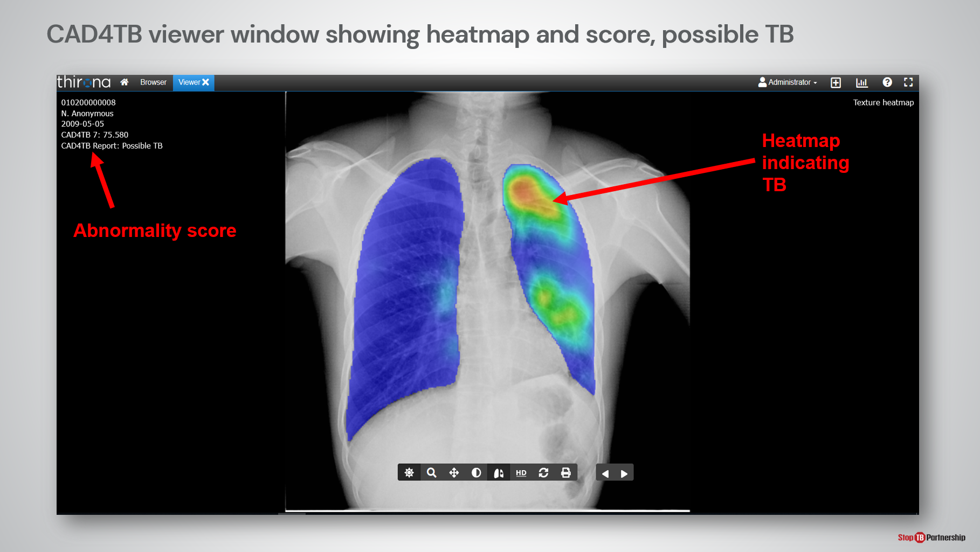
SAY: This is an annotated example of a heatmap showing TB. We can see the abnormality score is much higher in this image than the previous one, the classification by CAD4TB is “Possible TB” and the heatmap shows areas in yellow and orange which indicates abnormality has been detected.

This person should be directed to receive a diagnostic test.

CAD4TB Symptom and GXP Report | Slide: 19
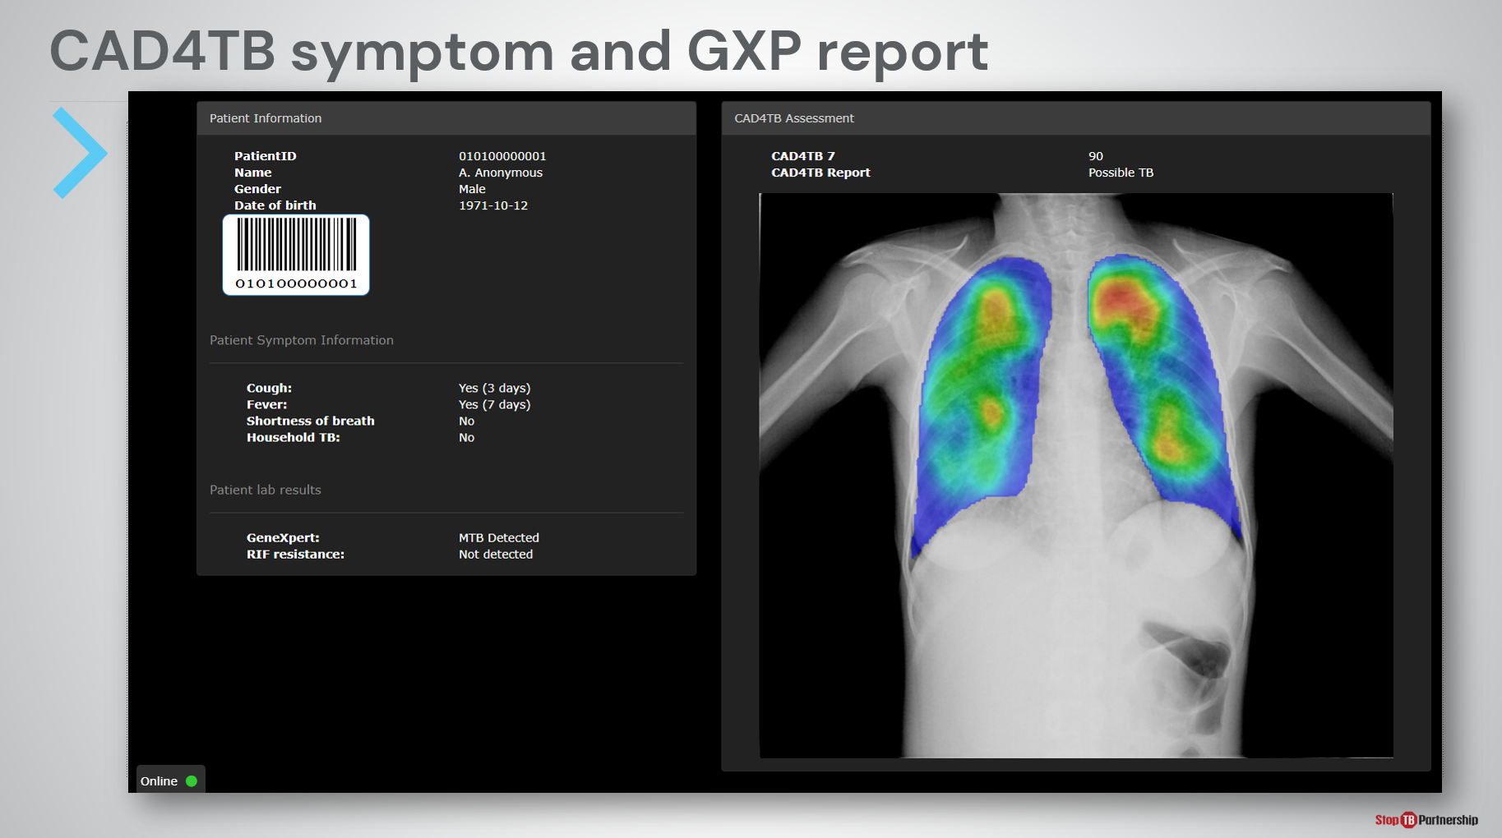
SAY: As mentioned previously, CAD4TB can summarize findings in a radiologist style report.

On the left-hand side “Patient Information” shows information inputted into the CAD4TB system during registration, including patient details and symptoms, as well as confirmatory test results, which can be manually inputted later. The ID and barcode is automatically generated by CAD4TB and can be printed and used with a barcode scanner to link the CAD output with subsequent diagnosis and follow-up.

On the right-hand side “CAD4TB Assessment” shows the 3 CAD outputs: abnormality score, classification, and heatmap.

This report sheet could be printed and kept with paper-based records or stored in electronic health information systems.

CAD4TB Insights Module | Slide: 20
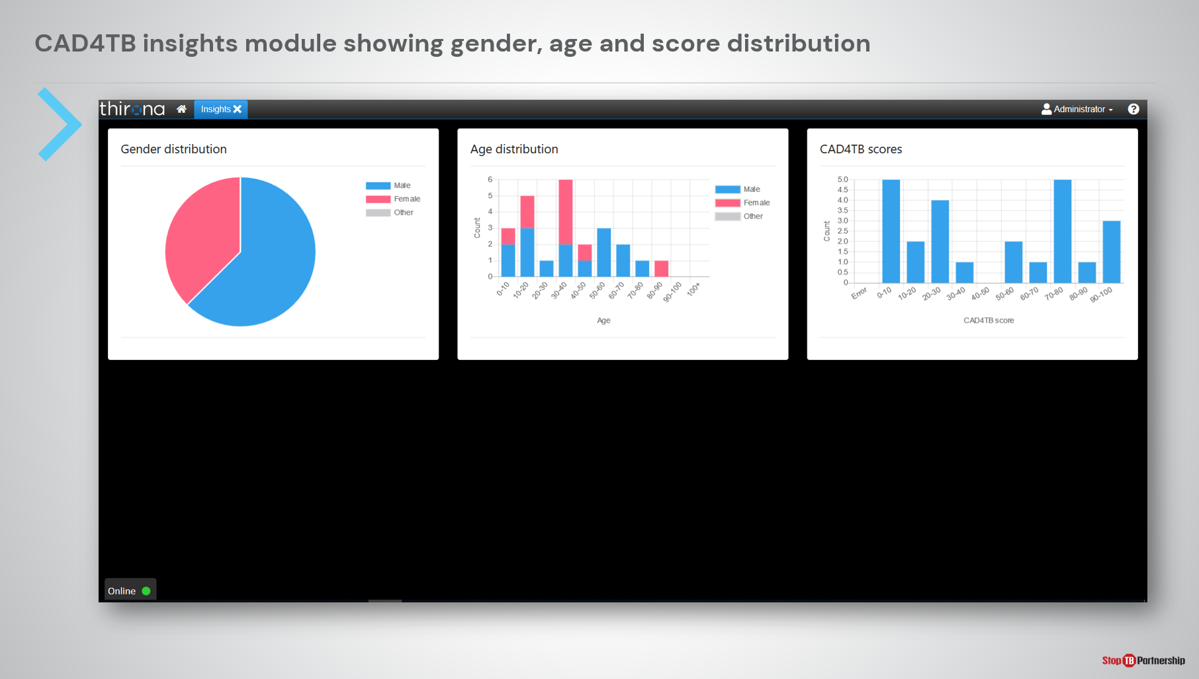
SAY: Finally, new to version 7, is the CAD4TB program management dashboard which displays aggregate data from the screening program, including the gender, age, and CAD4TB abnormality score distributions.

CAD4TB V7 Package and Price | Slide: 21
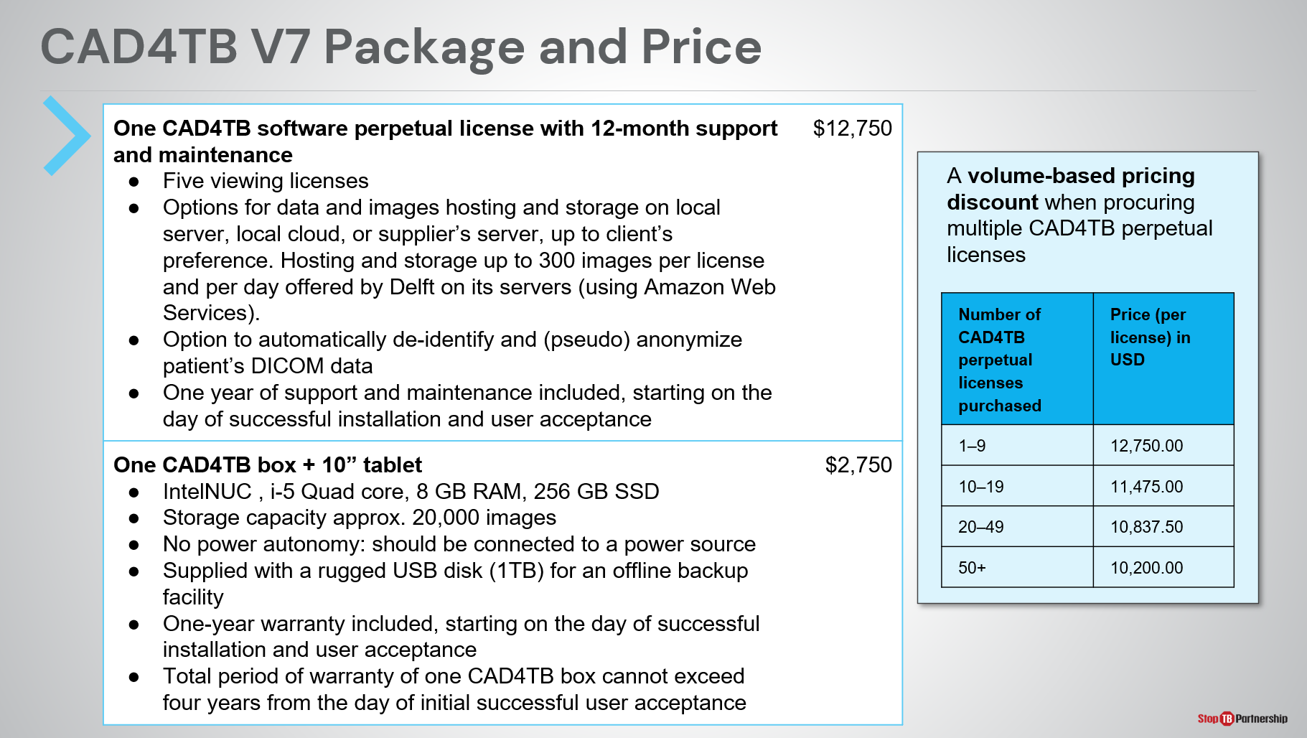
SAY: Now that we’ve got to know the software a little better, this slide shows the price breakdown of CAD4TB if procured through Stop TB Partnership’s GDF catalog.

Key points to note are:
- A perpetual software license costs $12,750, including one year of support and maintenance from Delft.
- For each perpetual license, five additional viewing licenses are included. This means five additional computers can access the software to view the results of CAD4TB analysis.
- To use the software offline is an extra $2,750 because an offline AI box is required
Discounts are available when procuring in volume through GDF and if procured with the Delft Light ultra-portable X-ray system.

CAD4TB V7 Package and Price | Slide: 22
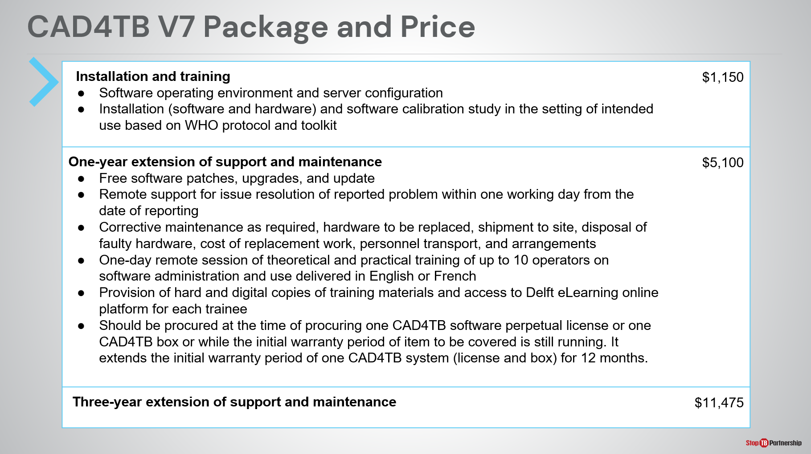
SAY: It is advised to procure one installation and training package alongside the software licenses.

When purchased, support and maintenance is provided for 12 months at no extra cost. One- and three-year support and maintenance extensions can be procured through the GDF catalog, though should be purchased initally or while the initial support and maintenance is still valid. Software updates are included under the support and warranty packages.
ASK: Does anyone have any questions on the pricing structure of CAD4TB through the GDF catalog?
DO: Answer questions appropriately.

InferRead DR Chest | Slide: 23
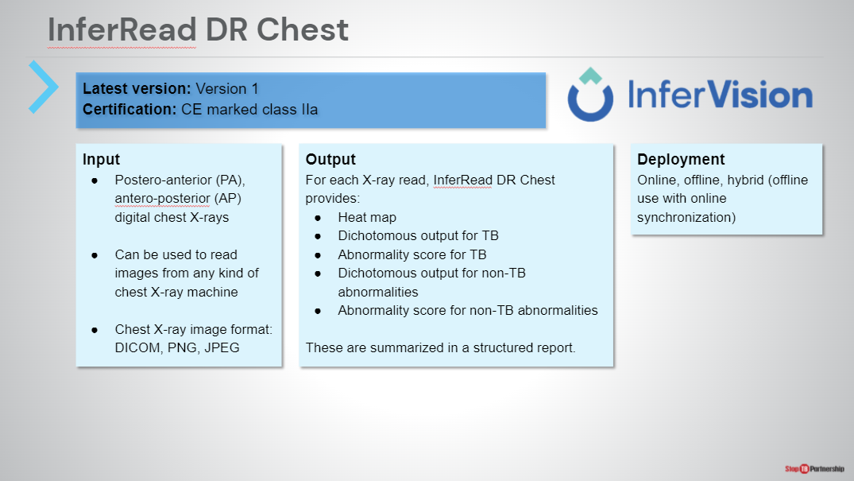
SAY: For a moment, let’s turn our attention to the other CAD software available in Stop TB’s GDF Catalog: InferRead DR Chest by InferVision.

Like CAD4TB, InferRead DR Chest can be used to read images from any brand of X-ray machine and can read inputs in the formats of DICOM, PNG, JPEG. Unlike CAD4TB, the software interprets both postero-anterior and antero-posterior digital chest X-rays.

For each chest X-ray read, InferRead DR Chest provides an abnormality score, bounding box diagram, and classification. However, InferRead DR Chest also provides an indication on the presence or absence of non-TB abnormalities. These are available in a structured report.

InferRead DR Chest can be used online, offline, or in hybrid mode.

Introducing Ultra-Portable X-Ray

Types of X-ray Technology | Slide: 25
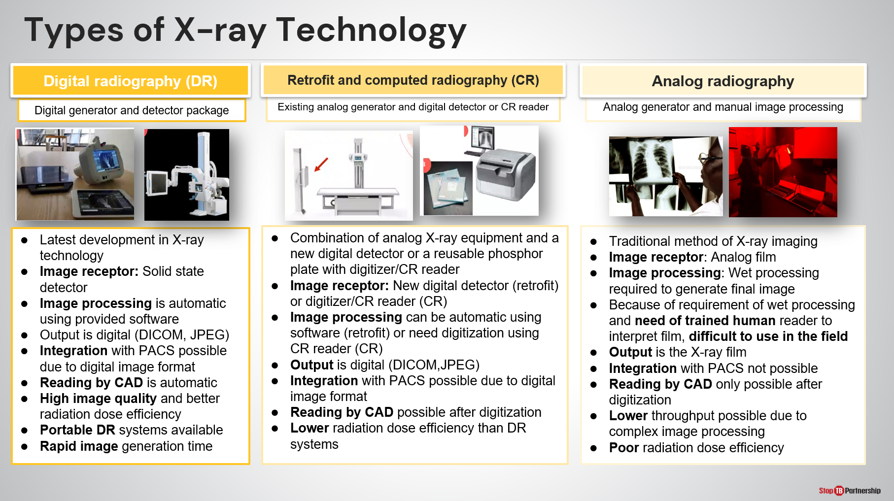
SAY: Taking a break from CAD, we will now move on to discuss the other innovative screening tool provided: ultra-portable X-ray technology. X-ray technology is featured alongside CAD in the WHO recommendations and is widely used for TB screening.

Four different types of X-ray equipment can be used in TB programming: analog, computed, retrofit, and digital. Each has its advantages and disadvantages, though consensus is that digital systems provide rapid, automatic image processing and generation, higher radiation dose efficiency, and can be more portable than computed or analog radiography.

The digital images generated from digital and computed equipment can be automatically inputted into CAD. Digital equipment, however, may not yet be available at all sites and some CAD (CAD4TB included) provide the ability to digitize analog chest X-ray films for reading by AI using a mobile phone app.
ASK: What kind of X-ray equipment is most available in your setting?
DO: Encourage participation and receive answers.

Introducing Ultra-Portable X-Ray (UP-XR) | Slide: 26
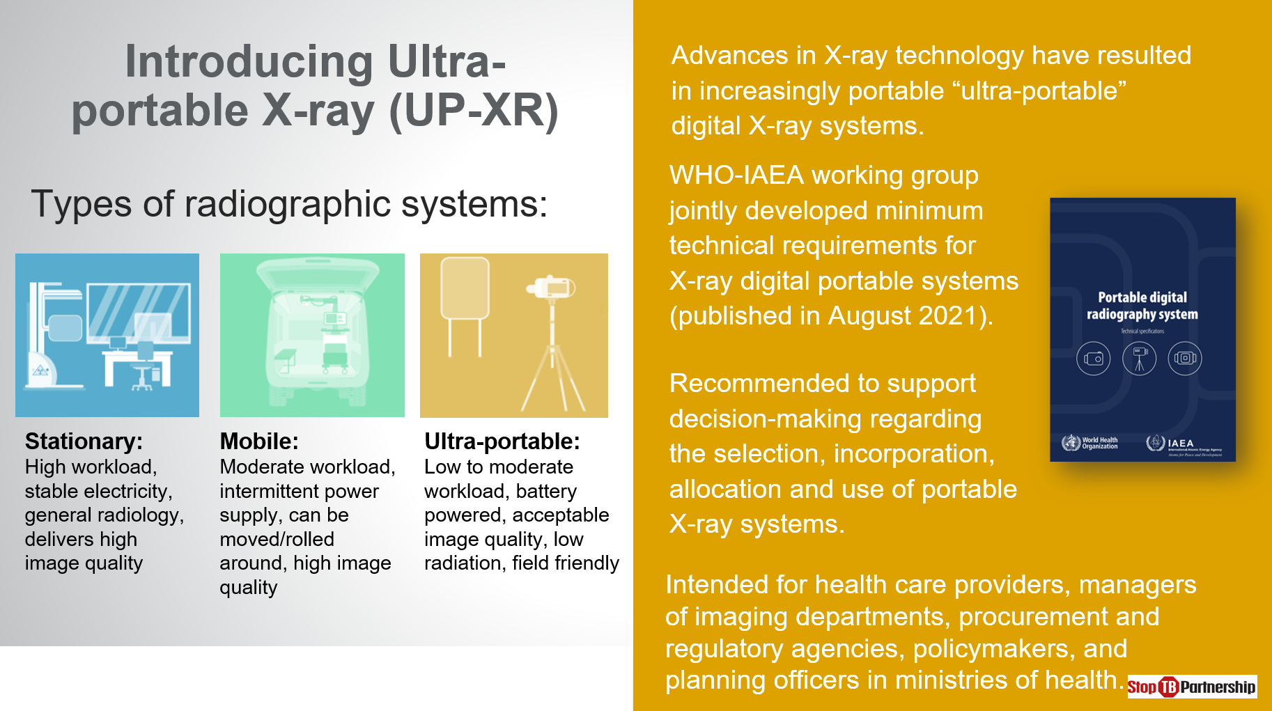
SAY: Digital radiography (DR) systems can be further classified as stationary, mobile, or more-recently ultra-portable.

As the name suggests, stationary X-rays are those that remain in a facility with stable electrical connection and are capable of delivery high quality images and a high workload. Meanwhile, mobile X-rays can be rolled around or transported in vans and are capable of a moderate workload and high image quality, with access to an intermittent electrical connection.

Ultra-portable systems are a new generation of “field friendly” X-ray technology, recognized by WHO and the IAEA as a sub-type of DR system alongside stationary and mobile X-ray. These are battery-powered, lightweight, and can be packaged into a backpack or carry case; they also emit less radiation while producing images of adequate quality. Unlike alternatives, ultra-portable systems are not designed for high workload and have limited exposure capacity without electrical connection.

The portable digital radiography system technical requirements published in August 2021 provide more details to support the selection, allocation, and use of ultra-portable X-ray systems.

Introducing Ultra-Portable X-Ray (UP-XR) | Slide: 27
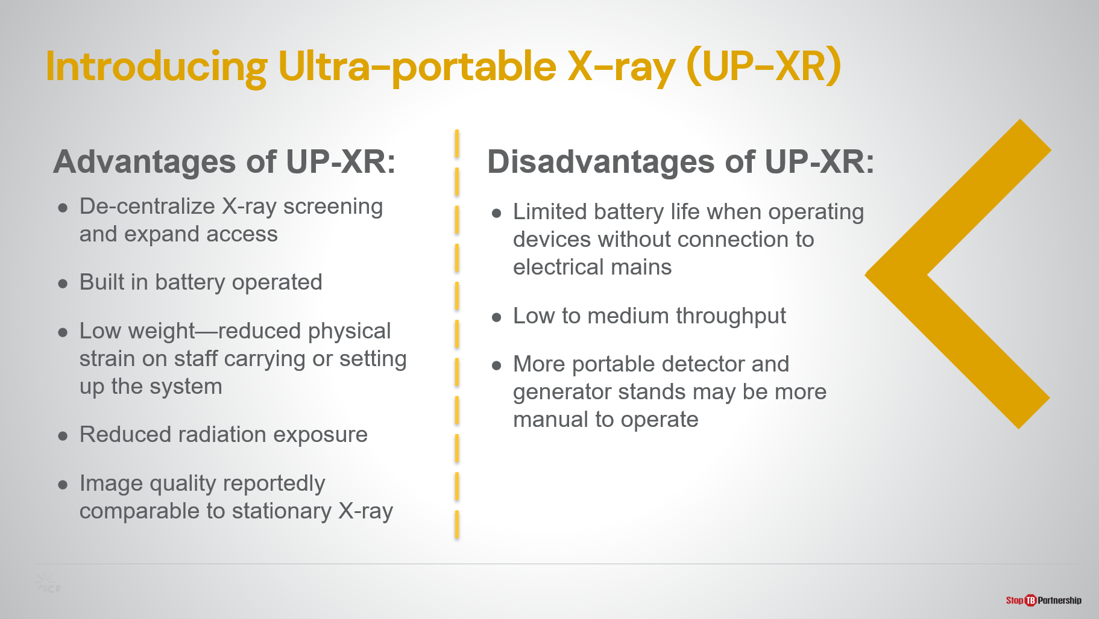
SAY: As with any new tool, there are certain advantages and tradeoffs of using ultra-portable X-ray.

We already touched upon the advantages, ultra-portable X-ray systems:
- Can decentralize X-ray screening and expand access to hard-to-reach populations.
- Have lower weight, reduced radiation exposure, while maintaining image quality similar to stationary systems.

As a consequence of their smaller size, a few compromises are made with ultra-portable X-ray systems including:
- Limited battery life, meaning ultra-portable systems are not suitable for high throughput settings with more than 200 exposures a day.
- More manual operation required of generator and detector stands.

When selecting sites for ultra-portable systems, it will be important to consider both advantages and limitations of the devices.
ASK: Before we continue on to learn more about [Delft Light/ Fujifilm Xair] does anyone have any questions about ultra-portable X-ray systems?
DO: Leave time for respondents to ask questions and provide adequate responses.

Delft Light
Core System | Slide: 29
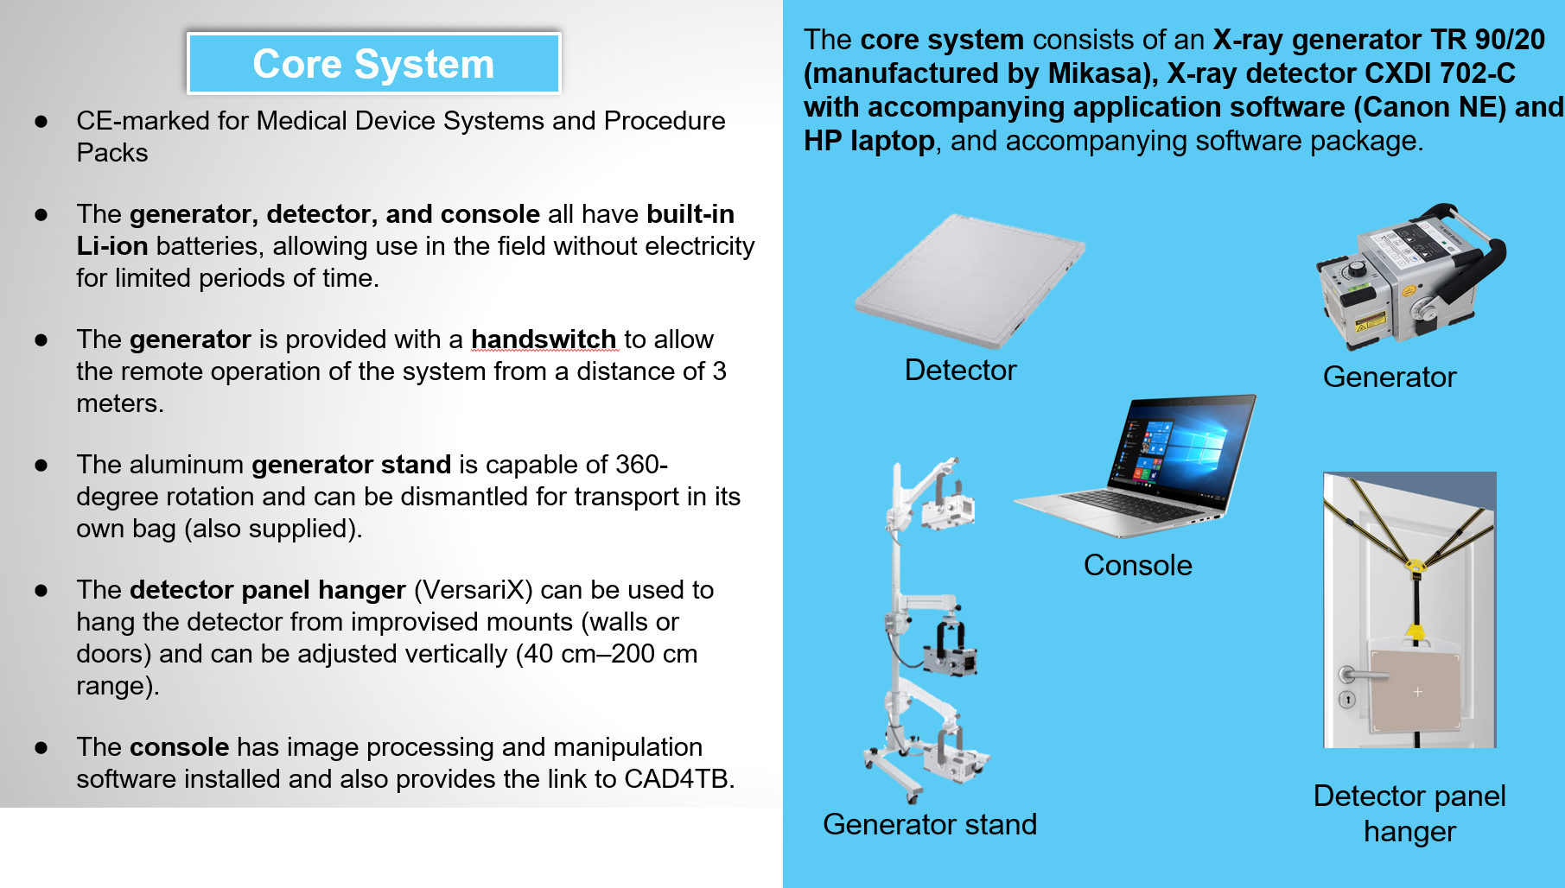
SAY: Now, we will focus on the Delft Light ultra-portable X-ray system which is available through the GDF catalog. The components provided through GDF can be seen on the slide.
- The core system consists of an X-ray generator, detector, and HP laptop. All have built-in lithium-ion batteries to allow for use in settings without electrical power connection.
- Exposures can be taken from a safe distance using the generator hand switch.
- A generator stand is also provided that is capable of 360-degree rotation and can be dismantled for transport in its own bag.
- To position the detector, a panel hanger is provided that can be used to hang the detector from improvised surfaces (walls or doors for example) and can be adjusted vertically.
- The console comes with a software package that allows for chest X-ray image optimization and provides the connection to the AI software.

You will have the opportunity to gain hands-on practice with this equipment during the manufacturer training.
DO: Point out each component while describing them.

Accessories | Slide: 30
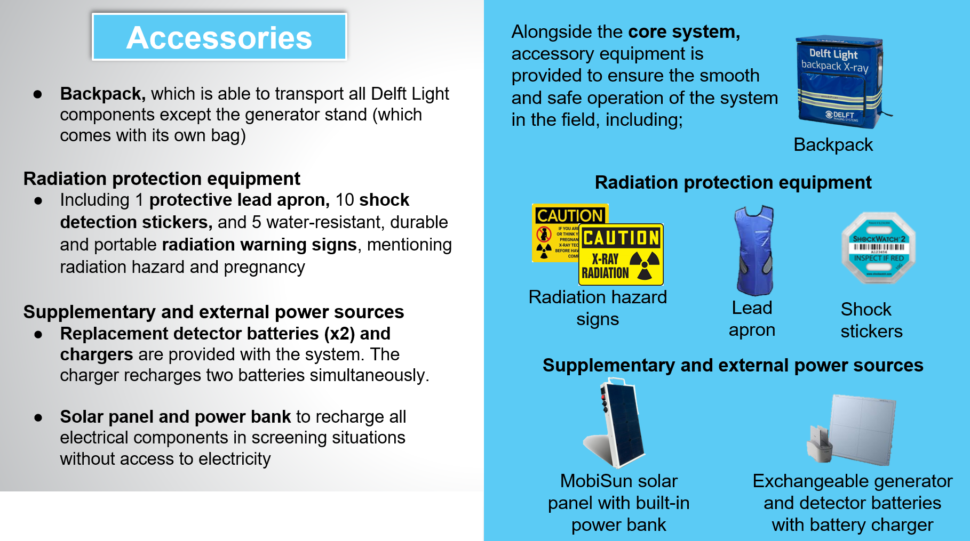
SAY: As well as the core components, several accessories are also provided free of charge when the system is procured through GDF. These include:
- A backpack for packaging up all components except the generator stand which comes with its own bag, for transport.
- Radiation safety equipment: lead apron, shock stickers, hazard signs. These can be used in conjunction with any equipment already available on site.
Supplementary and external power sources to prolong operation in settings without electrical connection. These include one set of replacement detector batteries, with charger, and a combined solar panel/ power bank capable of recharging the generator, detector, or laptop in the field.
DO: Point out each component while describing them.

Delft Light Full Kit—Pricing | Slide: 32
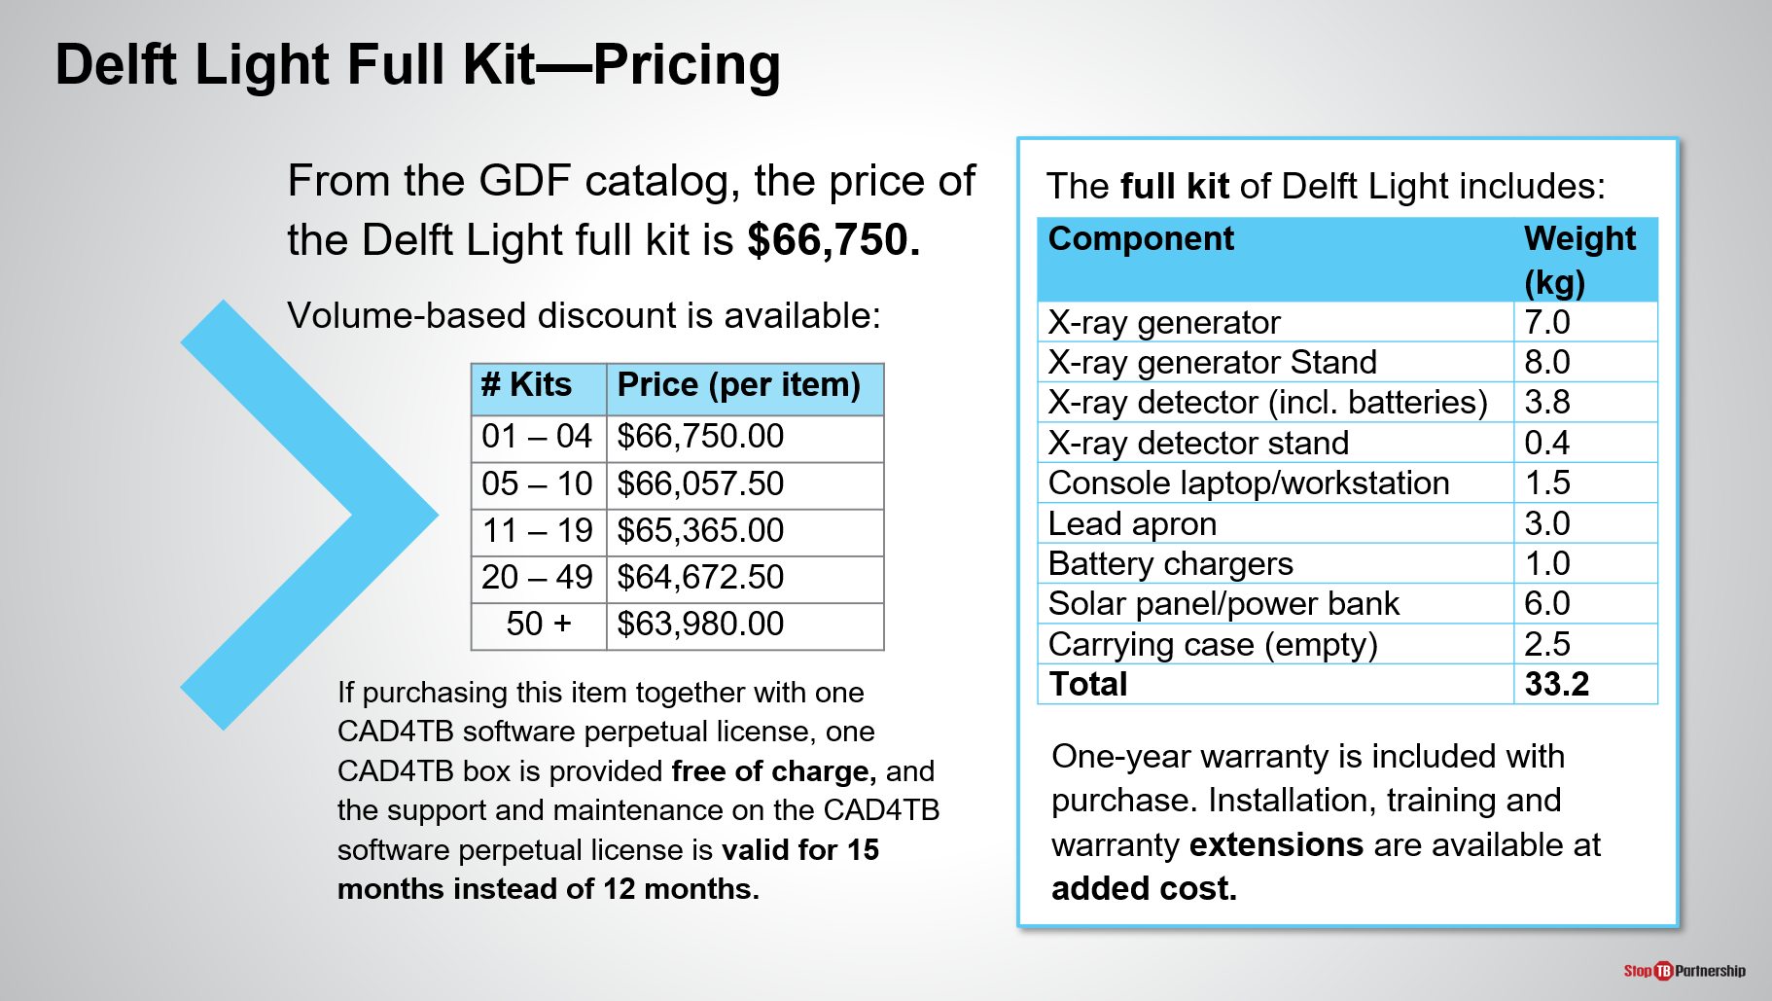
SAY: The price of the Delft Light full kit, including all of the components mentioned, costs $66,750 when procured through GDF with discounts available when procuring in larger quantities. This includes one year warranty, but installation and training, as well as warranty extensions are available at additional cost.

When purchased with the CAD4TB licenses, an offline CAD4TB box is provided free of charge and the support and maintenance package is valid for an extended period of time (15 months rather than usual 12 months).

Delft Light Full Kit—Pricing | Slide: 33
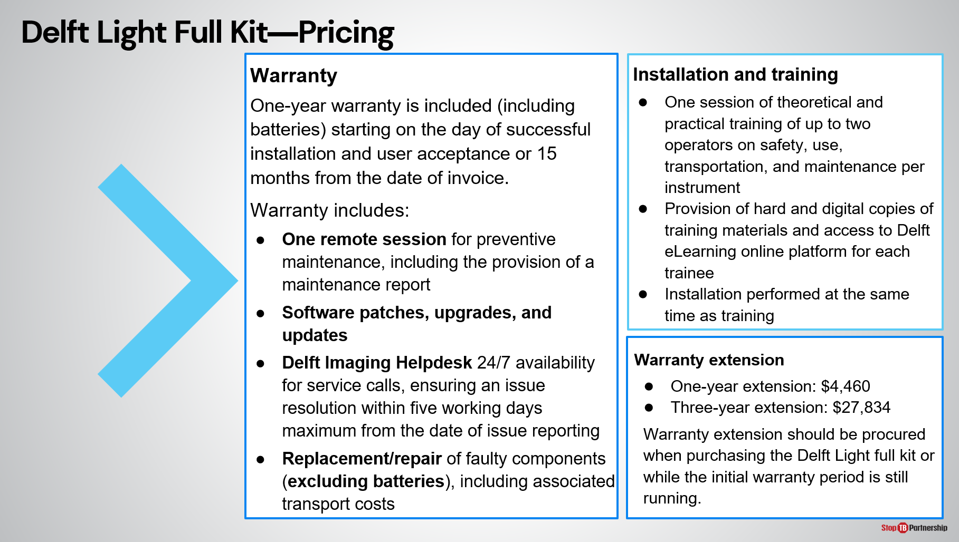
SAY: It is advised to procure the installation and training package when purchasing the Delft Light.

The initial warranty includes remote maintenance sessions, access to the 24/7 Delft Imaging Helpdesk, software patches and updates, as well as part replacement or repair (not including batteries).

The initial warranty period can also be extended by one year (costing $4,460) or three years (costing $27,834). When considering warranty extensions, these should be procured at time of initial purchase or while the initial warranty period is still valid.

Connection with CAD4TB | Slide: 34
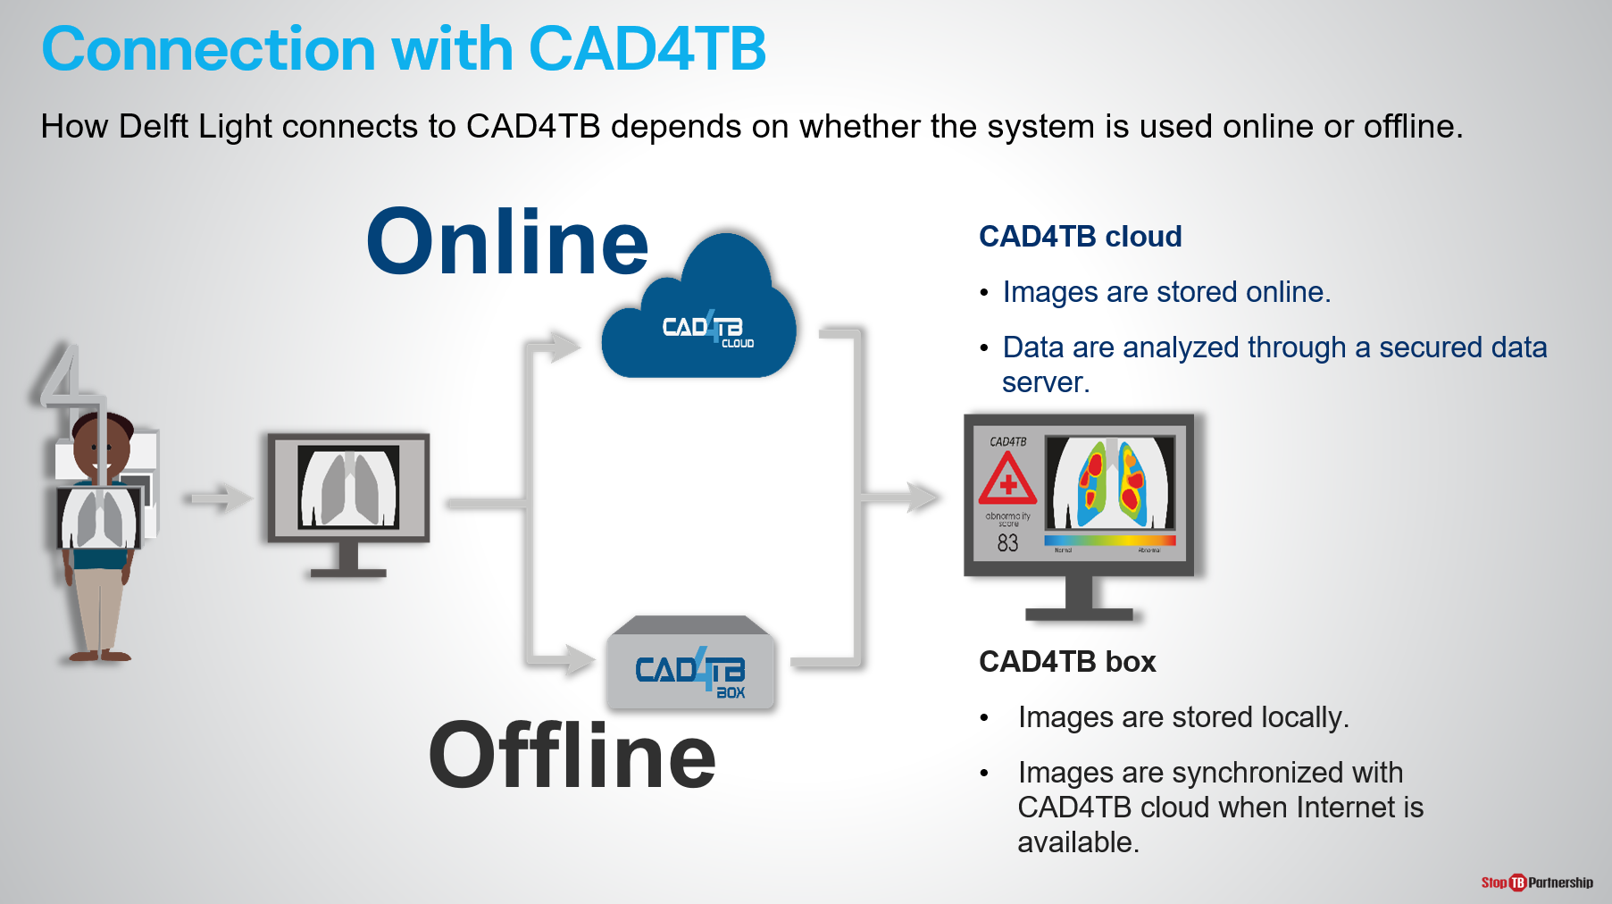
SAY: We will now move on to discuss using the two innovations- CAD and ultra-portable X-ray- together to aid TB screening. For each X-ray exposure taken two different results will be generated: the first is the black and white X-ray from the Delft Light, the second is the output from CAD4TB.

How the Delft Light sends the chest X-ray to the CAD4TB system depends on whether CAD4TB is used online (images analyzed on secure cloud server) or offline (images analyzed on box).

Connection with CAD4TB | Slide: 35
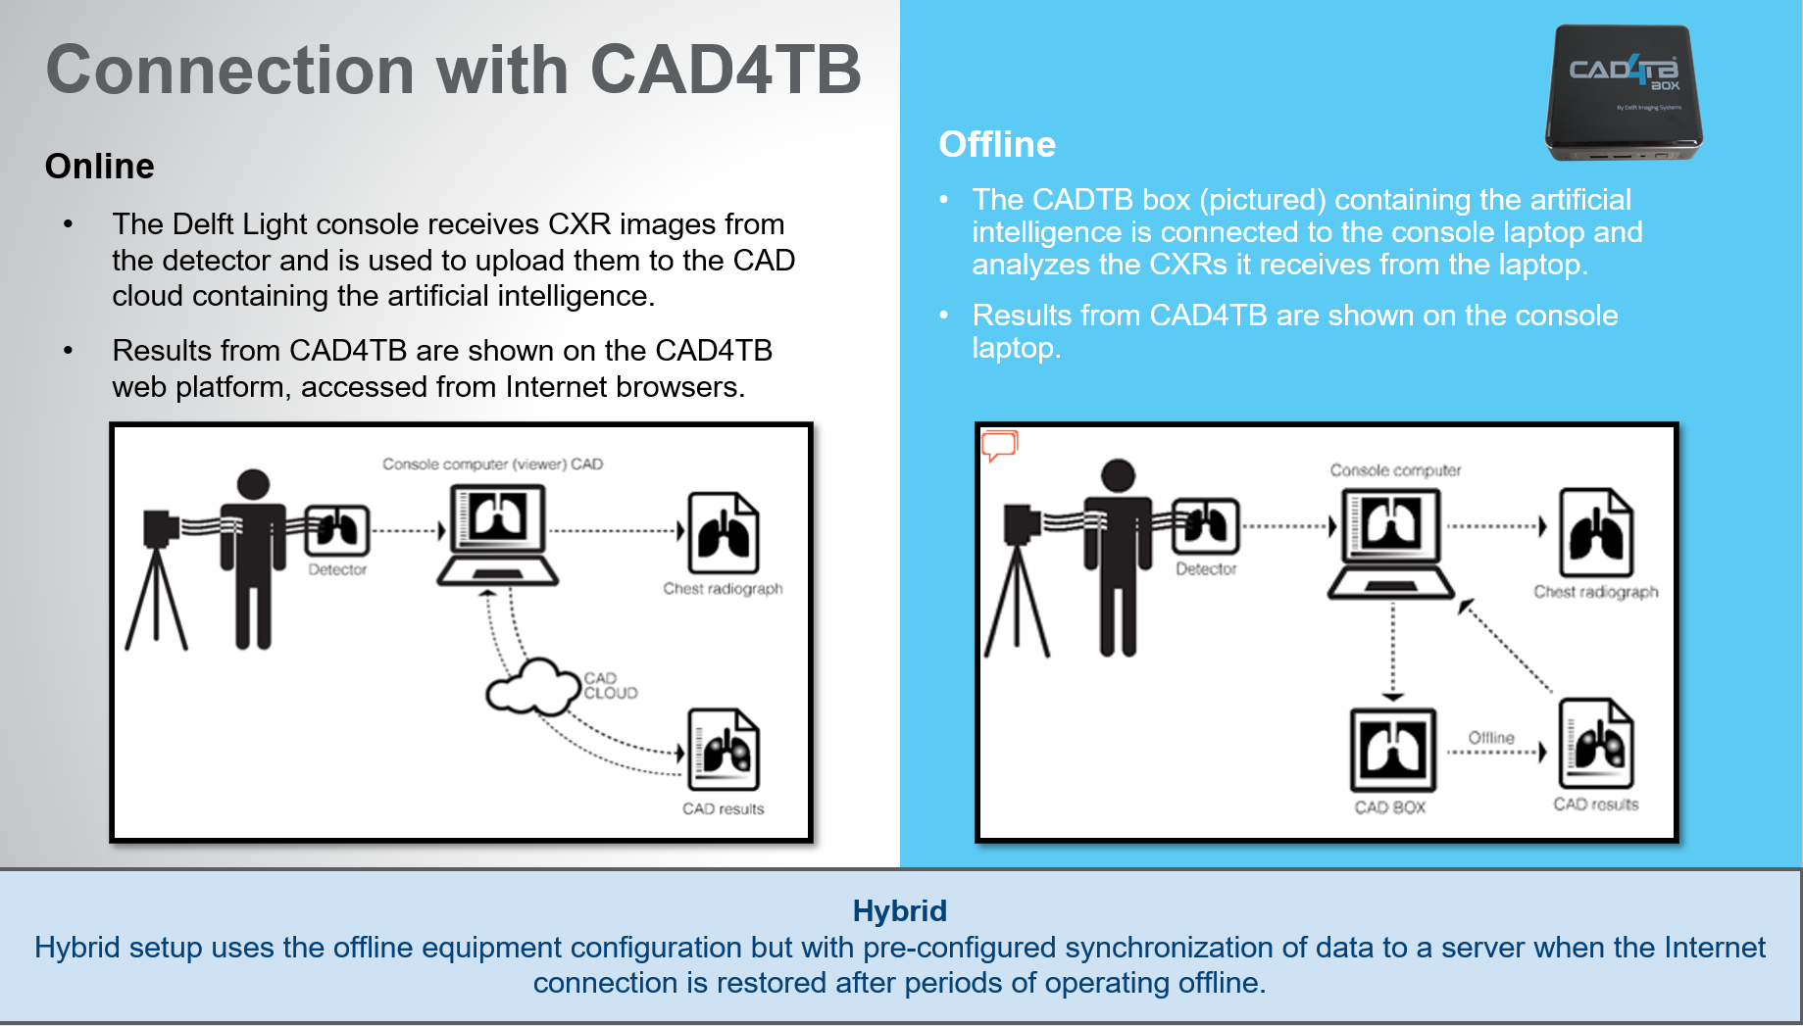
SAY: The schematics on the slide show how the ultra-portable X-ray and CAD systems interact with each other.
- On the left, CAD4TB is being used online. Chest X-ray images taken by the Delft Light are uploaded to the CAD4TB cloud from the console laptop. Both the X-ray image and CAD4TB result can be viewed on the console laptop of the Delft Light.
- If using CAD4TB offline, the offline box containing the AI will be connected to the Delft Light console computer so chest X-ray images can be transferred from the computer to the AI box without internet connection. Both the X-ray image and CAD4TB result can be viewed on the console laptop for the Delft Light.
- Hybrid mode will use the offline equipment configuration.

During the manufacturer training, installation and integration of the two systems will be completed.

CAD and UP-XR | Slide: 36
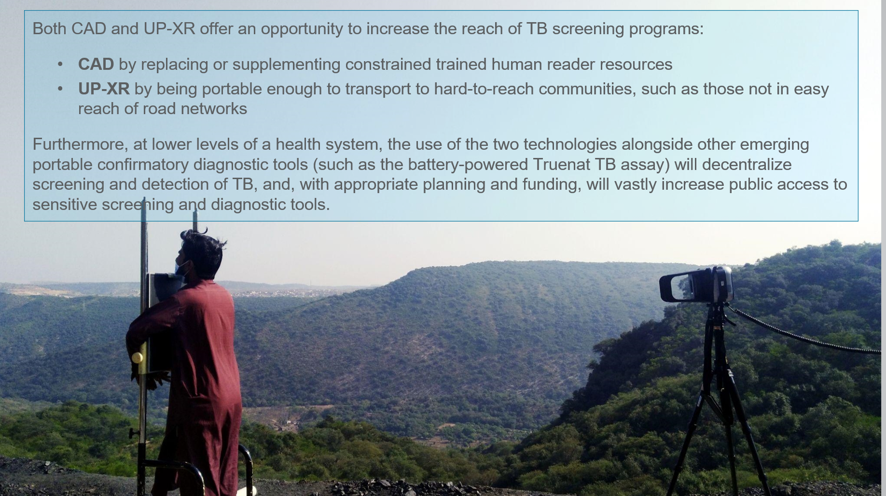
SAY: To conclude this module, together CAD and ultra-portable X-ray can increase the reach of TB screening programs by replacing or supplementing trained human reader resources and by being portable enough to reach hard-to-reach communities.

The use of the two technologies, alongside emerging portable confirmatory diagnostics, could decentralize TB screening and diagnosis. With appropriate planning and funding, these have the potential to vastly increase public access to sensitive screening and diagnostic tools.

Summary

Summary | Slide: 37
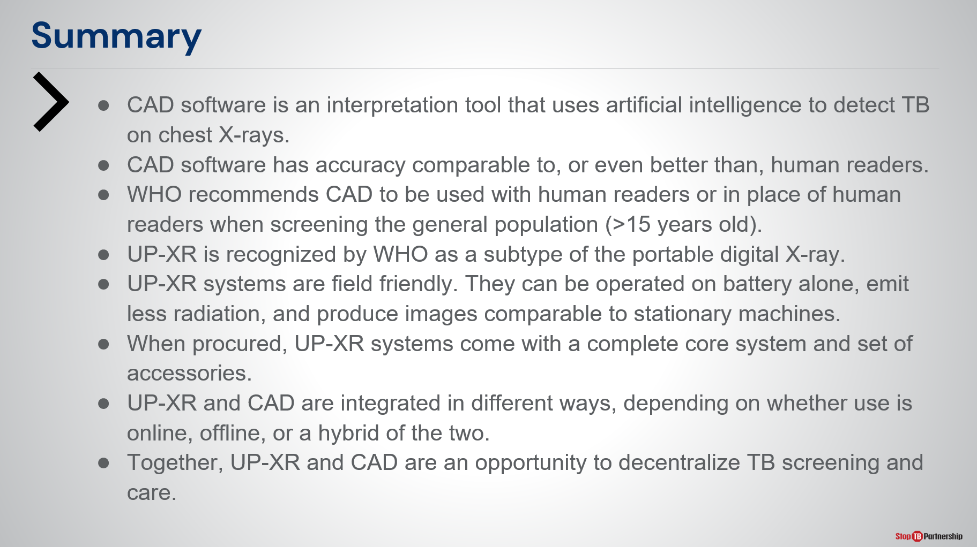
SAY: In summary of this module:
- CAD software is an interpretation tool using AI to detect TB on chest X-rays.
- CAD software has accuracy similar to, or better than, human readers.
- WHO recommends CAD to be used for TB screening and triage in place of human readers for individuals >15 years old.
- Ultra-portable X-ray is a WHO-recognized sub-type of digital X-ray.
- Ultra-portable X-ray systems are “field friendly”: They operate on battery alone, emit less radiation, and produce images of comparable quality to stationary machines.
- Ultra-portable X-ray systems procured from GDF include the core system components and accessories.
- Ultra-portable X-ray and CAD can be integrated in two different ways depending on whether CAD is used online or offline/hybrid.
Together, ultra-portable X-ray and CAD provide an opportunity to decentralize TB screening and care.
ASK: Before we move onto the knowledge check, are there any questions about the content covered in this module?
DO: Receive questions and respond appropriately.

Module 3: Program Planning and Implementation Considerations

Target Audience
The target audience for this course is:

- Program managers and coordinators
- NTP

Learning Objectives
Terminal Objective
- At the end of this module, participants will have a better idea how to best plan and implement an ultra-portable X-ray and CAD program.

Module Objectives
- By the end of this module, participants should be able to
  - Engage key stakeholders from early stages of a CAD and UP-XR program.
  - Perform a tailored situational assessment for a CAD and UP-XR program.
  - Identify suitable sites and prepare for CAD and UP-XR field activities.
  - Understand the human resource requirements of CAD and UP-XR programs.
  - Understand the general screening workflow involving CAD and UP-XR programs.
  - Be aware of key implementation considerations for CAD and UP-XR.
  - Be aware of some challenges and lessons learned from pilot projects

Materials
- Facilitator Guide
- Pens/Pencils

Advance Preparation
- No customization needed

Introduction

Introduction | Slide: 2
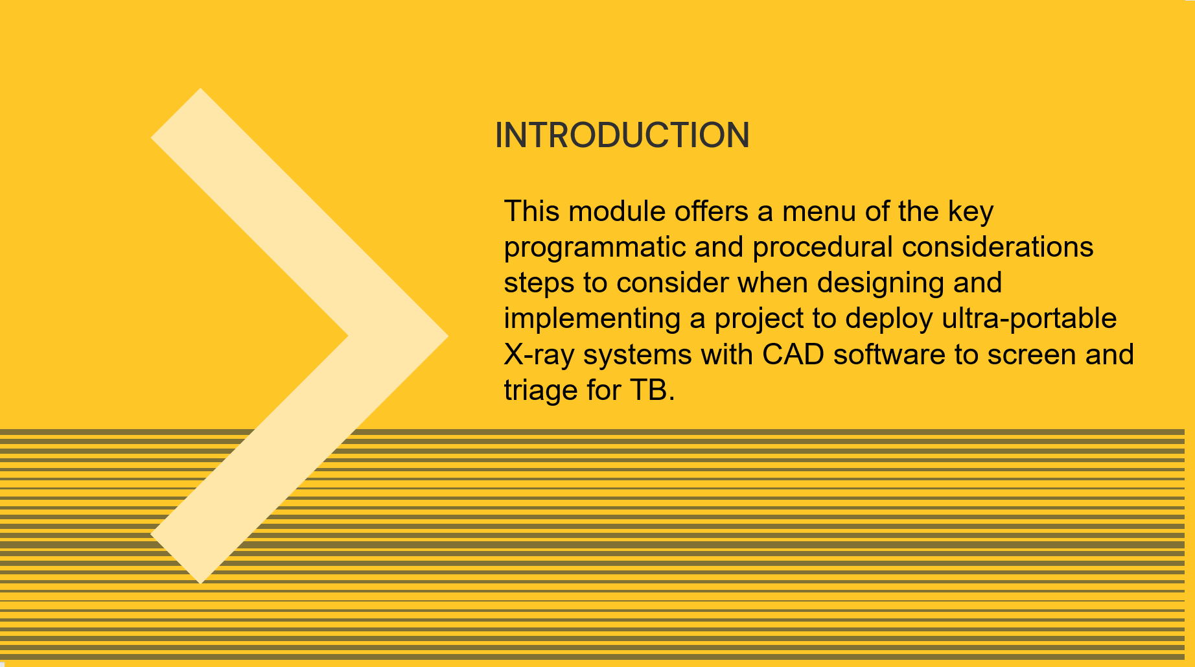
SAY: Now that Module 2 has given us an overview of ultra-portable X-ray and CAD, we will now move on to consider how a program can be designed to facilitate the best use of these two technologies for TB screening and triage.

This module offers a menu of key programmatic and procedural considerations when designing and implementing a project to deploy ultra-portable X-ray systems with CAD.

Outline | Slide: 3
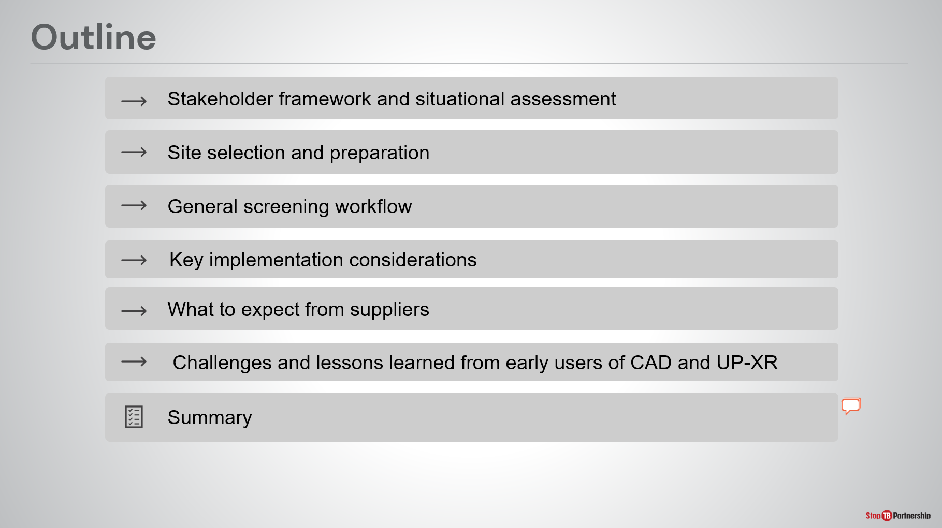
SAY: We will start by understanding the key stakeholders to engage during intervention planning, before moving on to site selection and preparation. A general screening workflow using the two tools will then be described, and we will conclude with key implementation considerations, what to expect from suppliers, and challenges and lessons learned from early users of the tools.

Learning Objectives | Slide: 4
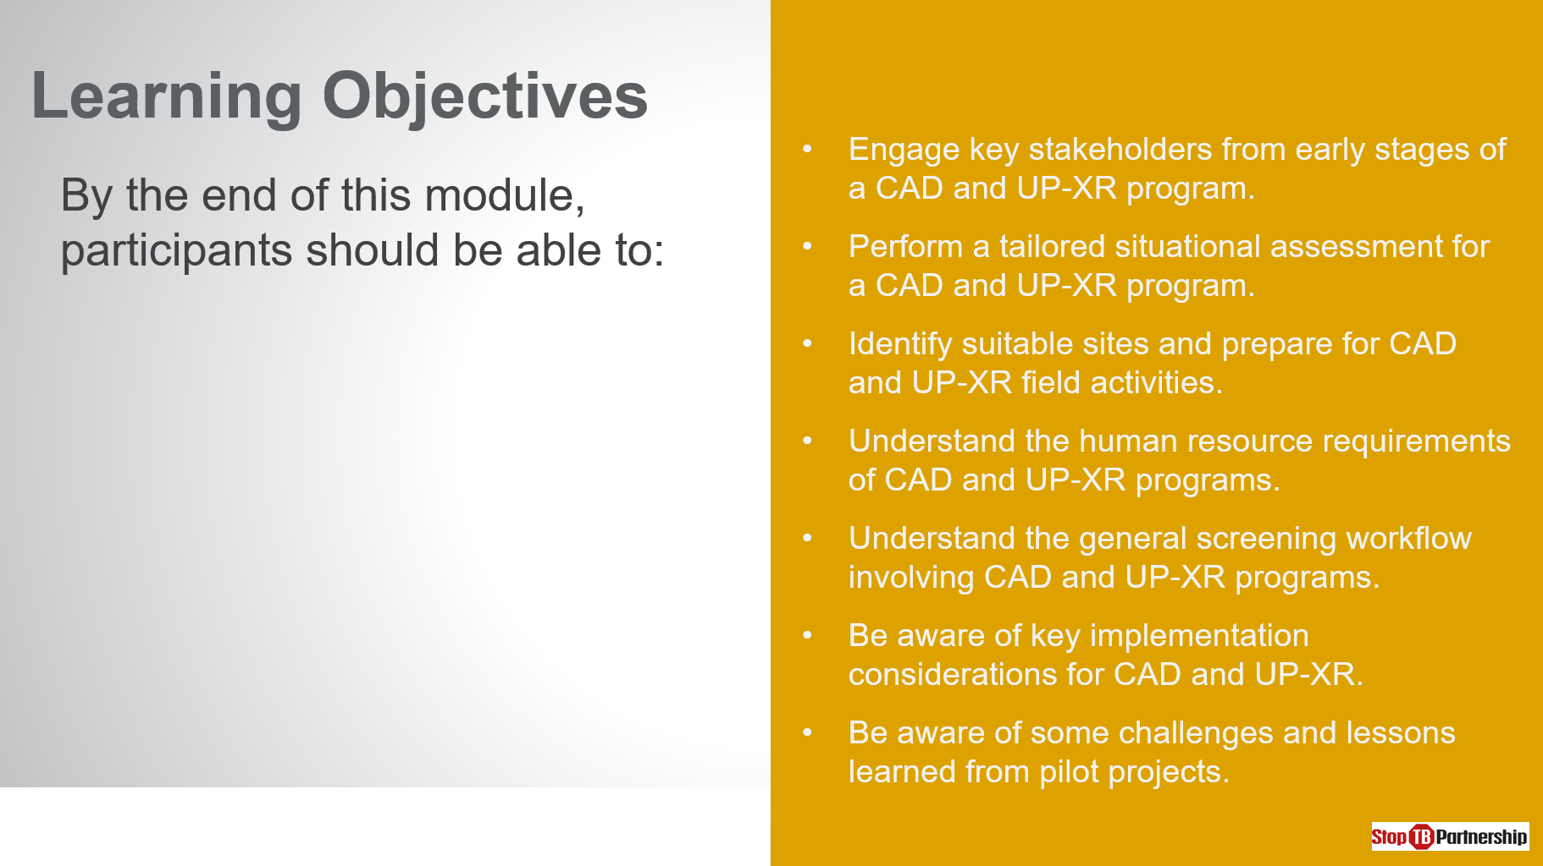
SAY: By the end of this session, you should be able to:
- Engage key stakeholders from early stages of a CAD and ultra-portable X-ray program.
- Perform a tailored situational assessment for the two tools.
- Select and prepare suitable sites for field activities.
- Understand the human resource requirements of using CAD and ultra-portable X-ray.
- Understand the general screening workflow.
- Be aware of key implementation considerations for CAD and ultra-portable X-ray.
- Be aware of some challenges and lessons learned from pilot projects.

We will touch upon a number of tools that can be used to plan implementation, to explore these topics in greater depth and find templates, please consult Stop TB’s practical guide on implementation of CAD and ultra-portable X-ray.

ASK: Before we start, are there any questions about this session?
DO: Allow time for people to ask questions and respond appropriately.

Program Planning and Site Selection and Preparation

Stakeholder Framework | Slide: 6
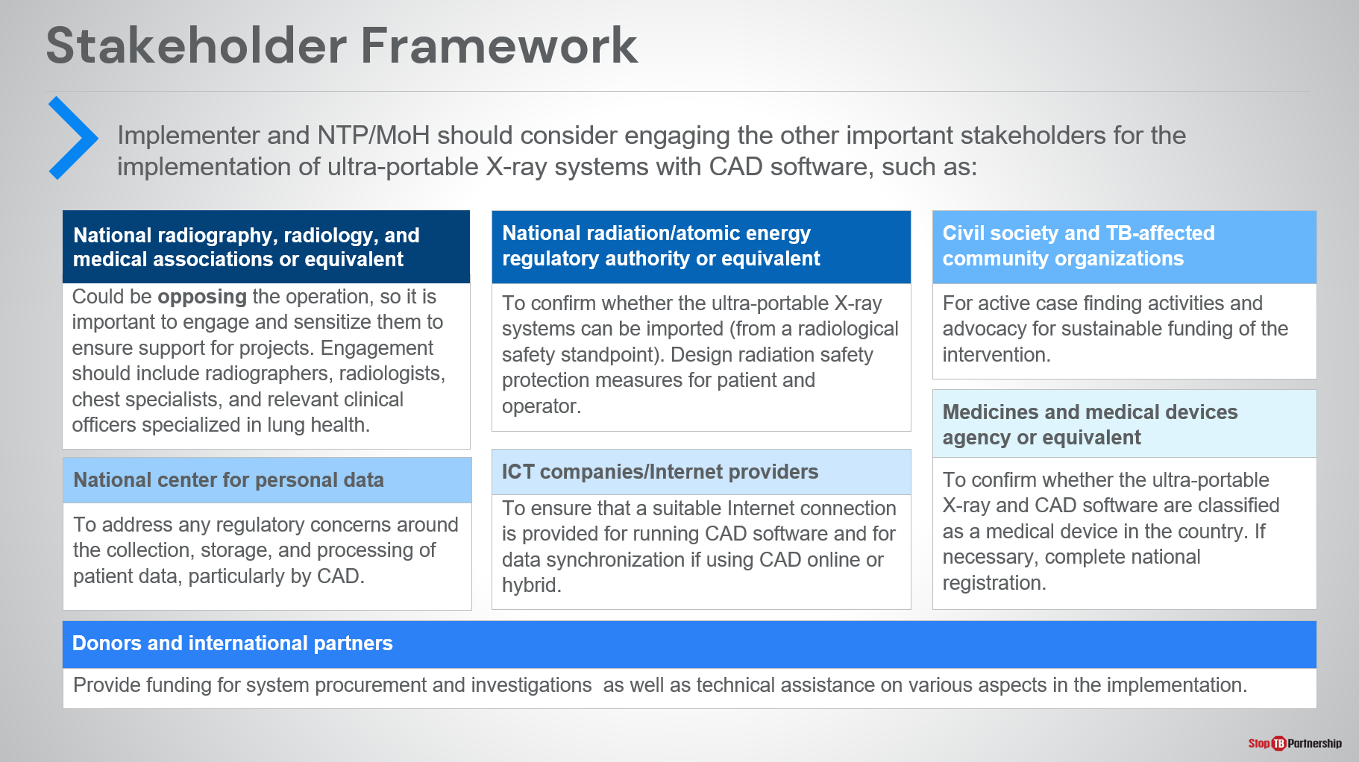
SAY: As with any program, it is important to engage the correct stakeholders early on in implementation.
Because of the nature of the technologies, the following stakeholders should be considered to engage :
- Medicines and medical devices agency- to confirm whether the ultra-portable X-ray and CAD software are classified as medical devices and complete any additional registrations.
- National radiography, radiology and medical associations – these may initially oppose the operation and so it will be important to sensitize them to ensure support for the project.
- National radiation or atomic energy authorities – to support the importation of ultra-portable X-ray devices and identify radiation safety protection measures for patients and operators, especially if using the X-ray systems in the field.
- National center for personal data- to address regulatory concerns about the collection, storage, and processing of patient data by CAD.
- ICT companies and internet providers- to ensure a suitable internet connection is provided if operating CAD online or in hybrid mode.

ASK: Can we suggest the names of any regulatory authorities or any additional stakeholders it may be necessary to engage in [this country]?
DO: Provide time for participants to think and answer the question. Encourage participants to note down the answers provided.

Situational Assessment | Slide: 7
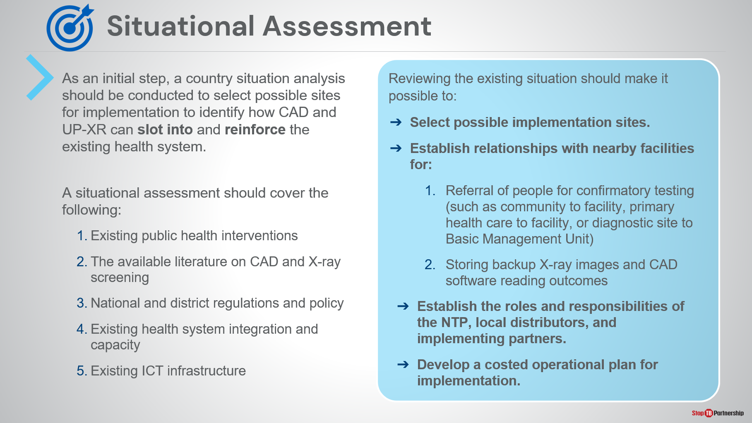
SAY: As a next step we can perform a country situational assessment. The goal of this will be to identify how CAD and ultra-portable X-ray can slot into and reinforce the existing health system in [the country] in a sustainable and scalable way.

A number of things should be covered in a comprehensive situational assessment, these include:
- Existing public health interventions in [the country/region/ target population]
- The available literature on CAD and X-ray screening
- National and district regulations and policy
- Existing health system integration and capacity
- Existing ICT infrastructure.

Ultimately, this information will help us to:
- Select implementation sites
- Establish relationships with nearby facilities to support the intervention through the provision of confirmatory testing or data storage
- Establish roles and responsibilities of involved stakeholders
- Develop a costed operation plan for implementation.

Site Selection and Preparation | Slide: 8
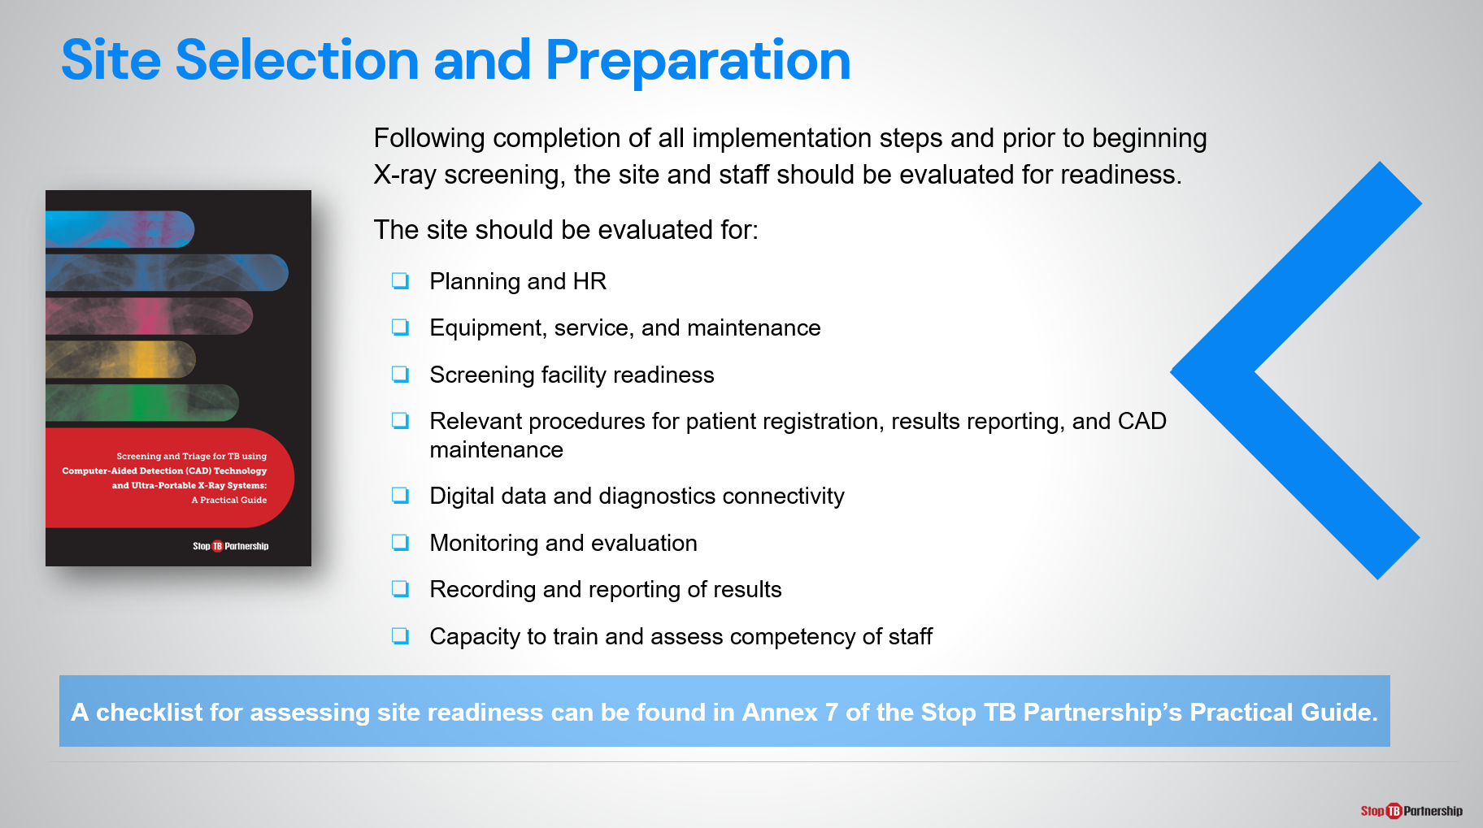
SAY: Moving on, after our situational assessment has helped us to identify possible sites for CAD and ultra-portable X-ray, we need to closer evaluate those sites for their suitability. This could involve assessing the site:
- Planning and HR
- Equipment, service, and maintenance,
- Screening facility readiness
- Relevant procedures for patient registration, results reporting, and CAD maintenance
- Digital data and diagnostics connectivity
- Monitoring and evaluation
- Recording and reporting of results
- Capacity to train and assess staff competency.

Stop TB’s practical guide for implementing CAD and ultra-portable X-ray provides a checklist for site selection and readiness in Annex 6& 7, after the session feel free to look at the guide to delve into this topic further.

Highlighted Considerations for Site Selection and Preparation | Slide: 9
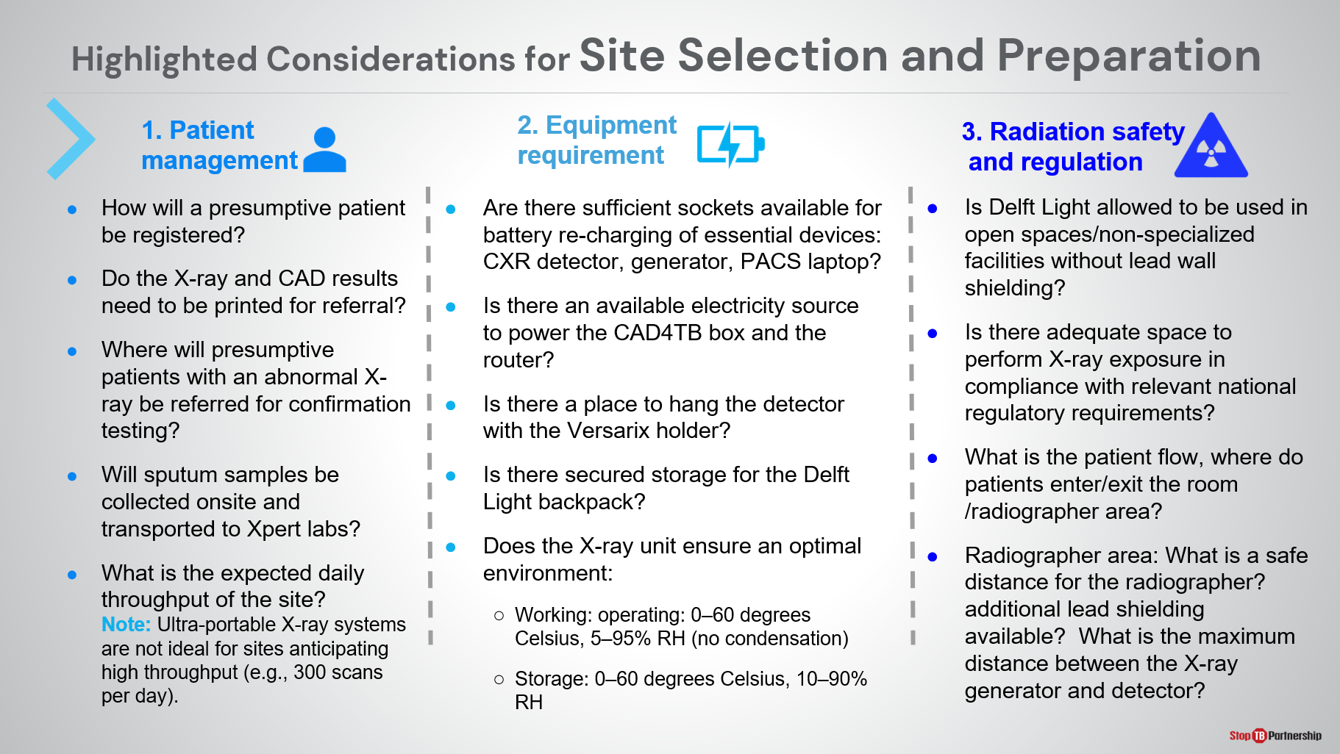
SAY: When selecting a site there are some key considerations particular to CAD and ultra-portable X-ray to be aware of.

The first fall under the topic of patient management:
- Because CAD provides instant results, it will be important to know where presumptive patients with an abnormal X-ray will be referred for confirmatory testing and if sputum samples need to be collected onsite for transport to an Xpert lab.
- If a paper-based patient management system is currently used, does this mean X-ray and CAD results will need to be printed for referral?
- How will presumptive patients be registered?
- What is the expected throughput of the site? Noting that, as discussed in module 2, ultra-portable X-ray systems are not ideal for high throughput sites.

The second are the equipment requirements:
- In terms of electricity- are there sufficient electrical sockets available for re-charging the core X-ray system components (the generator, detector, and laptop)? Is there an electrical source to power the CAD4TB box and router?
- Is there suitable ground for the construction of stands and/or the hanging of the detector panel?
- Is there secure storage for the equipment?
- Are the environmental conditions (heat, humidity) optimal for the X-ray system?

Finally, radiation safety and regulation:
- Is there regulatory approval to use the ultra-portable X-ray in open spaces or non-specialized facilities without lead walls and shielding?
- Is there enough space to set up the X-ray equipment and perform an exposure in compliance with national regulatory requirements? Where do patients enter and exit the room? What is the patient flow?
- Finally, where does the radiographer operate the equipment, and can a safe distance be achieved when taking exposures?

These are just some questions to be answered for each site investigated for suitability.

Human Resources | Slide: 10
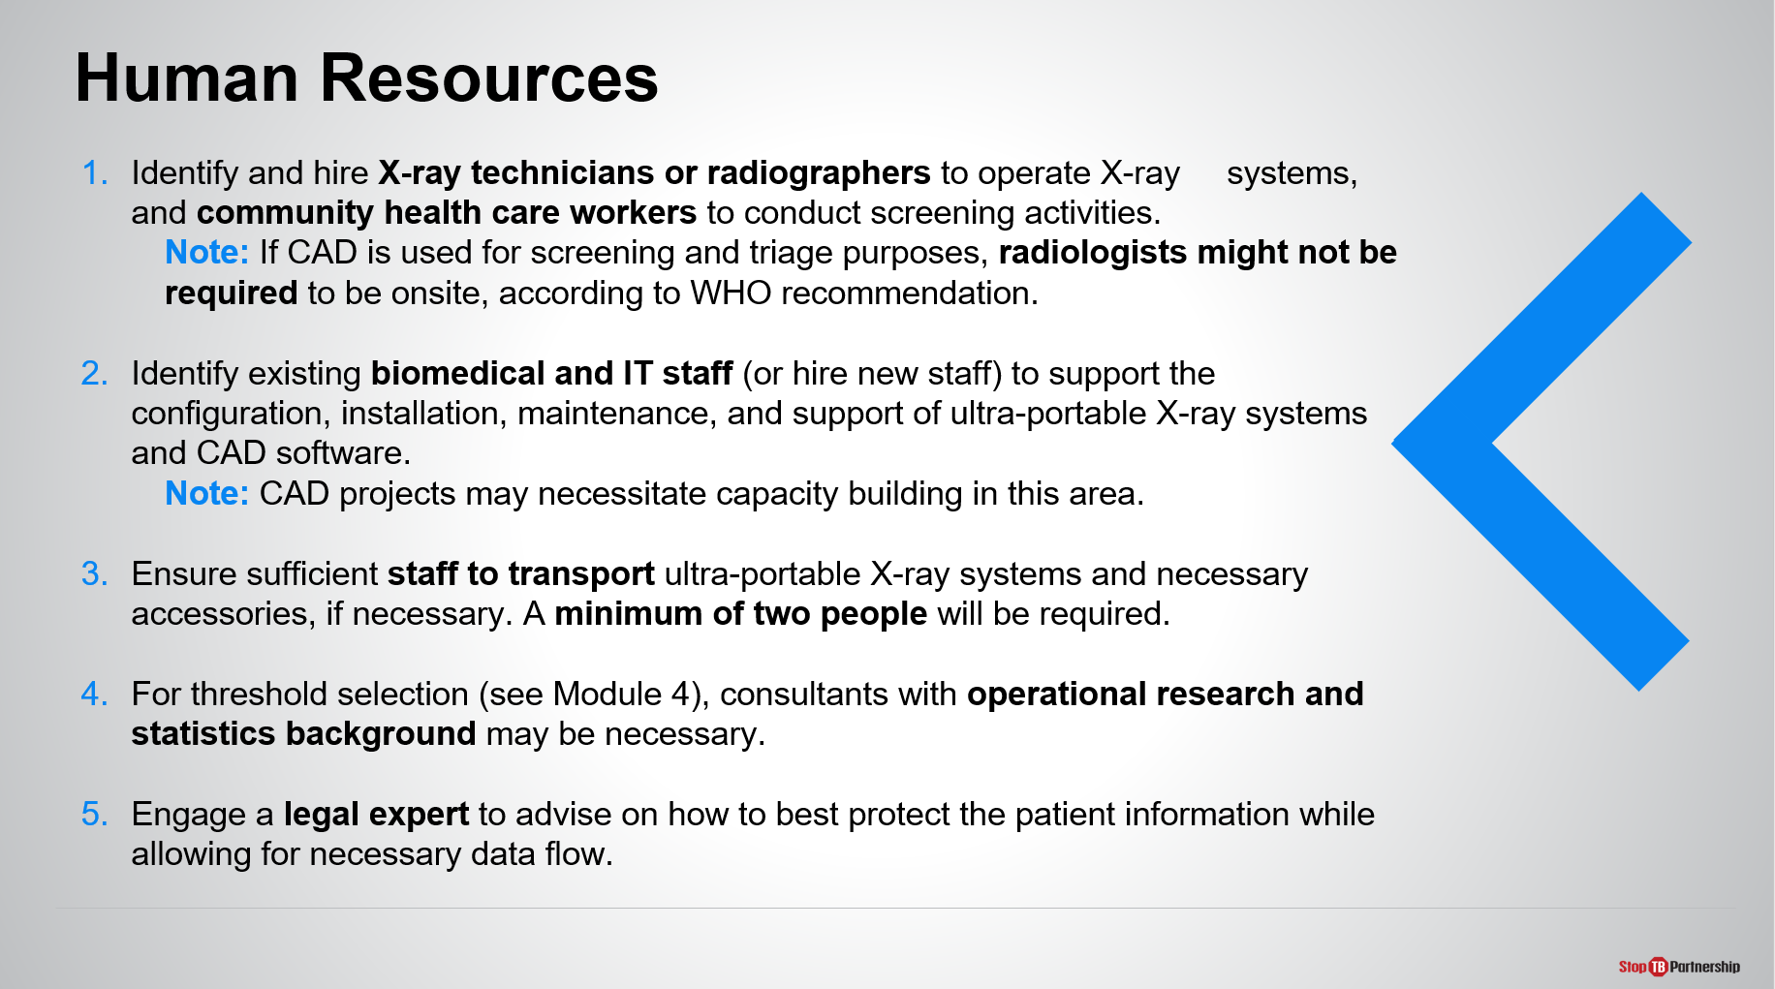
SAY: In addition, CAD and ultra-portable X-ray interventions require a unique blend of expertise:
- Suitable operators for the X-ray equipment (for example X-ray technicians, radiographers) and community health workers to conduct screening activities. Depending on whether CAD is used alone or with human readers, radiologists or other clinicians capable of interpreting X-ray images may also be required on site.
- If sputum samples need to be transported to diagnostic facilities, individuals responsible for this delivery should also be identified.
- Biomedical and IT staff will be needed to support the configuration, installation, and maintenance of the ultra-portable X-ray and CAD systems. To implement and scale up CAD, IT capacity building may be required.
- Staff should also be allocated to transport ultra-portable X-ray systems and necessary accessories. To carry the system by hand, a minimum of two people will be required.
- For CAD threshold selection, consultants with operational research and statistics background may be necessary.
- Finally, a legal expert should be engaged to advise how to best protect patient information during the project, especially if using CAD online.
ASK: Can you think of any other skills or roles that may be required during a CAD and ultra-portable X-ray project?
DO: Receive answers and encourage participants to take notes.

Training and capacity building | Slide: 11
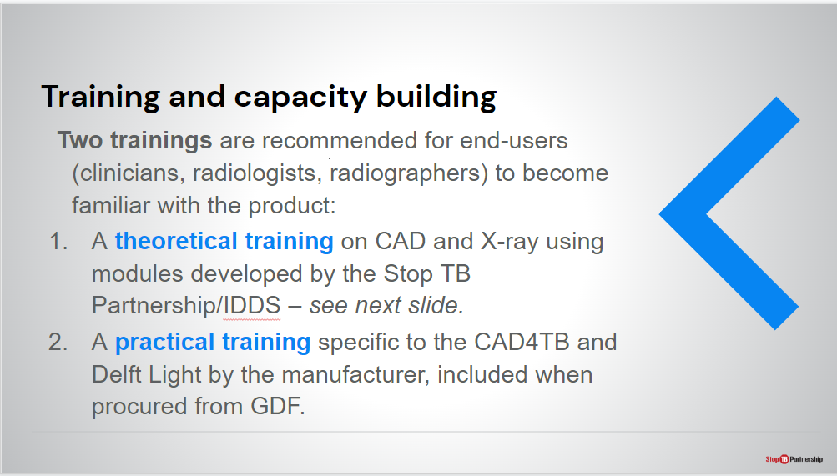
SAY: To build capacity among the end users of these digital tools, including radiographers, Xray technicians and radiologists, two trainings are recommend: a theoretical training explaining the principles of CAD and Xray and practical training run by the manufacturer

Theoretical training for end users | Slide: 12
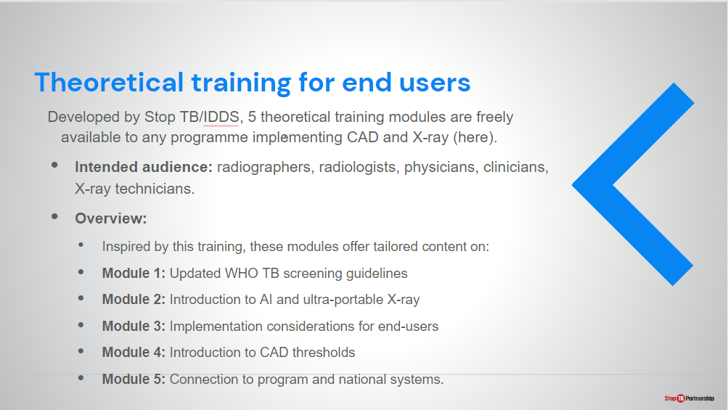
SAY: This is an overview of the theoretical training developed by Stop TB. There are five modules in total. These are:
- Update WHO TB Screening guidelines
- Introduction to AI and Ultra-Portable Xray
- Implementation considerations
- Introduction to CAD thresholds
- Connection to the program and national systems

Theoretical training for end users | Slide: 13
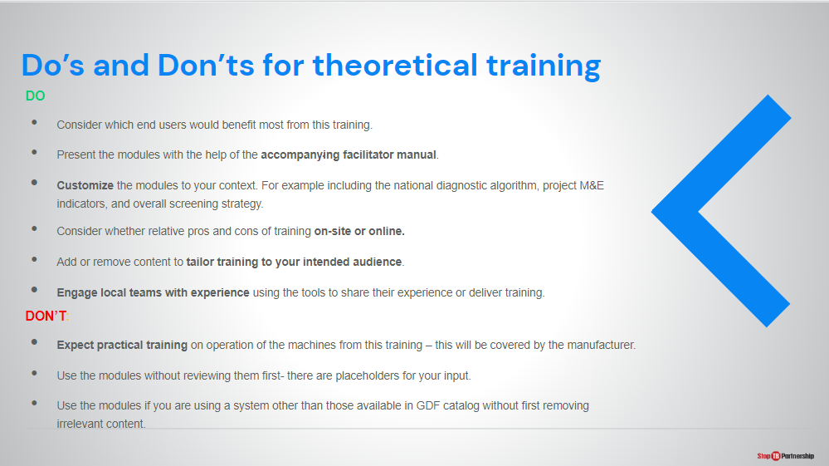
SAY: These are some dos and don’ts to remember when delivering training to end-users
ASK: Are there any other dos or don’ts you would add?

General Screening Workflow | Slide: 14
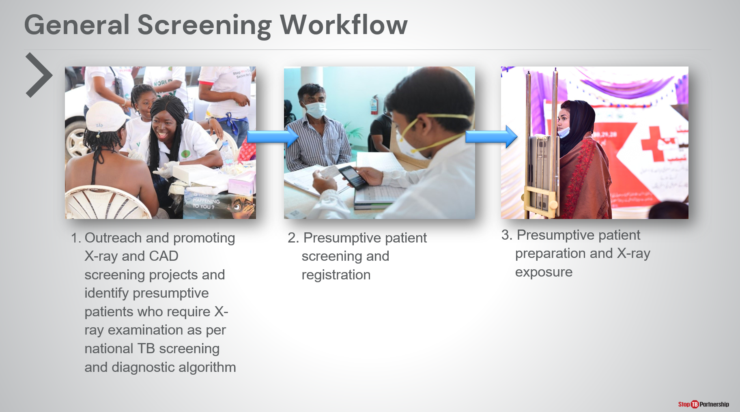
SAY: Now that the sites have been selected and the necessary HR employed, we will take a closer look at the workflow when using CAD and ultra-portable X-ray on site.
- The first step is the outreach and promotion of the X-ray and CAD screening sites in the community, including the identification of presumptive patients for X-ray examination as per [this country]’s national TB screening and diagnostic algorithm.
- Registration of presumptive patients at the screening site.
- Preparation for X-ray exposure and the exposure taken.
ASK:
DO:

General Workflow | Slide: 15
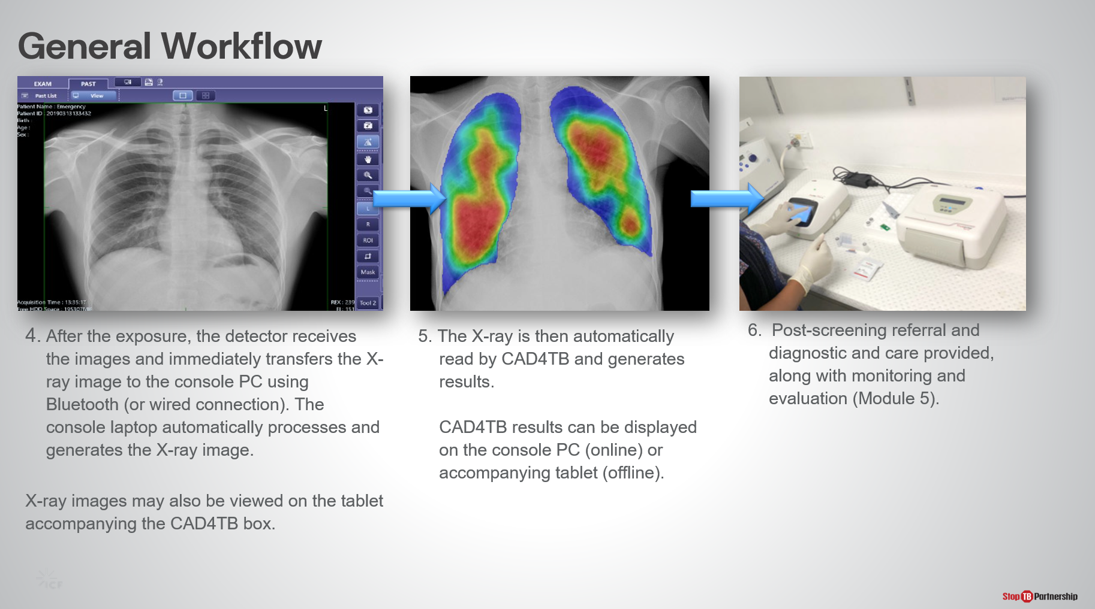
SAY:
Continuing,
- After the exposure is taken, the detector will immediately transfer the chest X-ray to the X-ray consosle laptop using Bluetooth or wired connection. X-ray images can be viewed on the console or the tablet accompanying the CAD4TB box.
- The X-ray is automatically read by CAD4TB to generate the results, which can be viewed either on the web browser or laptop/tablet.
- Depending on whether abnormalities are identified, the patient can then be referred to diagnostic testing and sputum may be collected on-the-spot. Treatment and care can be provided according to the national algorithm.

This provides a general example of the workflow using both CAD and ultra-portable X-ray at screening sites. A step-by-step guide on how to use the software will be provided during the manufacturer training.

Linking this data to national monitoring and evaluation systems will be covered in Module 5.
ASK: Let’s take 5 minutes to discuss how we can adapt this algorithm to incorporate CAD and ultra-portable X-ray screening with our national TB screening and diagnostic algorithm?
DO: Receive answers and encourage discussion.

Implementation Considerations – Delft Light

Electricity and Power | Slide: 17
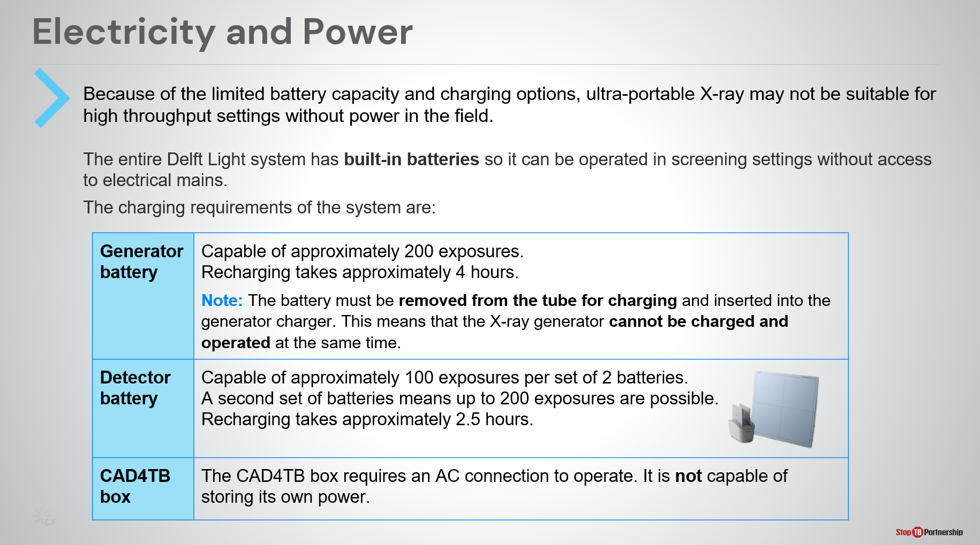
SAY: During the second part of our session, we will discuss some key implementation considerations of CAD and ultra-portable X-ray to keep in mind during program planning.

The first is electricity and power. As mentioned before, operating ultra-portable X-ray devices on battery power may limit the throughput the system is capable of in the field as batteries become flat after a large number of exposures.

- The Delft Light generator battery is capable of approx. 200 exposures without recharging and takes around 4 hours to recharge. Note that the generator cannot be charged and operated at the same time, so while recharging is occurring screening should be paused.
- The Delft Light detector battery is capable of approx. 100 exposures per set of 2 batteries. Recharging batteries takes approx. 2.5 hours. But, a second set of detector batteries is provided with the detector, meaning up to 200 exposures are possible in the field by exchanging the set of batteries.
- The CAD4TB offline box is not capable of storing its own power and must be connected to an AC power source to operate at all times.

Electricity and Power | Slide: 18
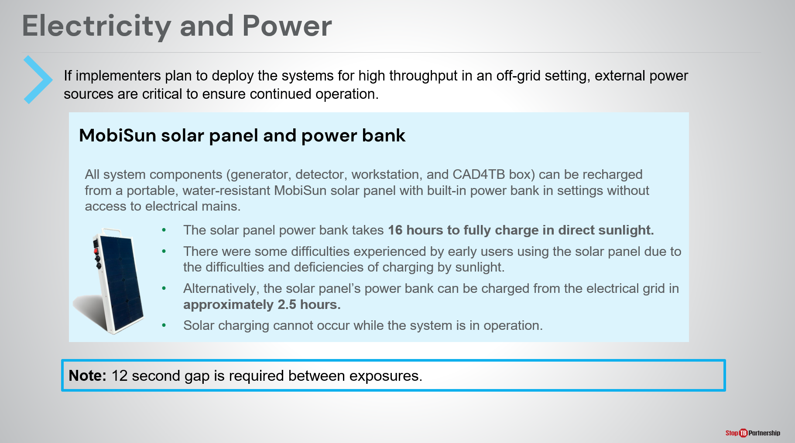
SAY: Because operating on battery power limits the number of exposures the system is capable of in the field, manufacturers have provided innovative ways of recharging the system in situations without access to electrical mains.

For the Delft Light, a water-resistant MobiSun solar panel with built-in power bank is provided that can recharge all system components, including the generator, detector, and console laptop. Solar charging cannot occur while operating the system, meaning a pause in screening will be necessary to recharge the system.

The solar panel itself takes 16 hours to fully charge in direct sunlight, or can be charged through connection to electrical power sources in approximately 2.5 hours.

Because of the limitations of battery power, it is advised not to use ultra-portable X-ray systems at sites with high throughput (greater than 200 exposures per day). A 12 second gap is also required between exposures as per the generator cycle time.

Portability and Setup | Slide: 19
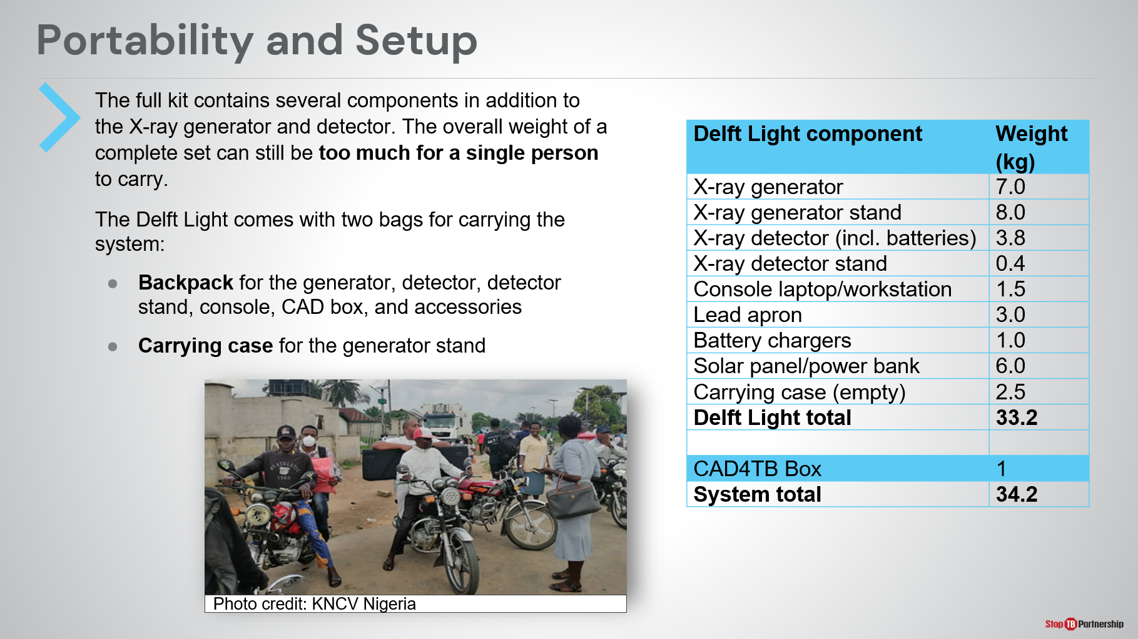
SAY: Another essential consideration is the portability of the system. Although, as the name suggests, “ultra-portable” X-ray systems are easier to transport than alternatives, they are not compact nor light enough to be carried by hand by one person alone.

The entire Delft Light system (including all components listed in the table and the CAD4TB box) weighs just over 34kg and can be packaged into two bags: a backpack and carry case. Some transport solutions include a dividing the components over a small team of people (2 or more) to carry by hand or using motorbikes.

Radiation Safety Policy | Slide: 20
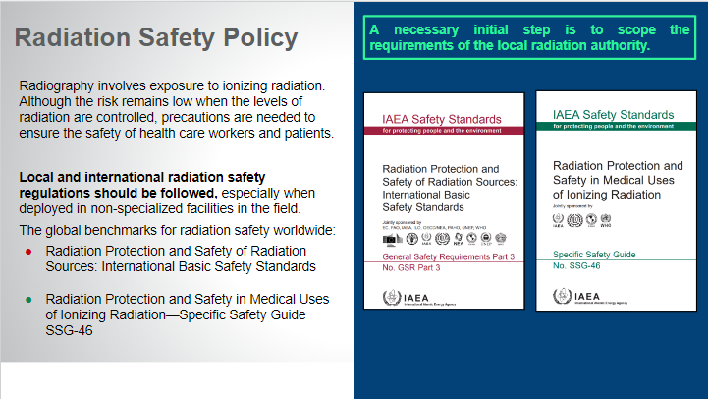
SAY: Radiography involves exposure to ionizing radiation, although this risk is low when appropriate safety measures are in place. When using any radiography equipment, safety of operators and patients is of paramount important.

Local and international radiation safety regulations should always be followed, especially when using ultra-portable X-ray systems that may be deployed in non-specialized facilities or open spaces.

There are two global benchmarks for radiation safety worldwide and it is encouraged to prepare screening sites with these and national guidelines in mind. The guidelines to be consulted include:
- Radiation protection and safety of radiation sources: international basic safety standards.
- Radiation protection and safety in medical uses of ionizing radiation: specific safety guide.

Both can be accessed from these slides which will be shared after the training.

Digital Data—Server and Storage | Slide: 21
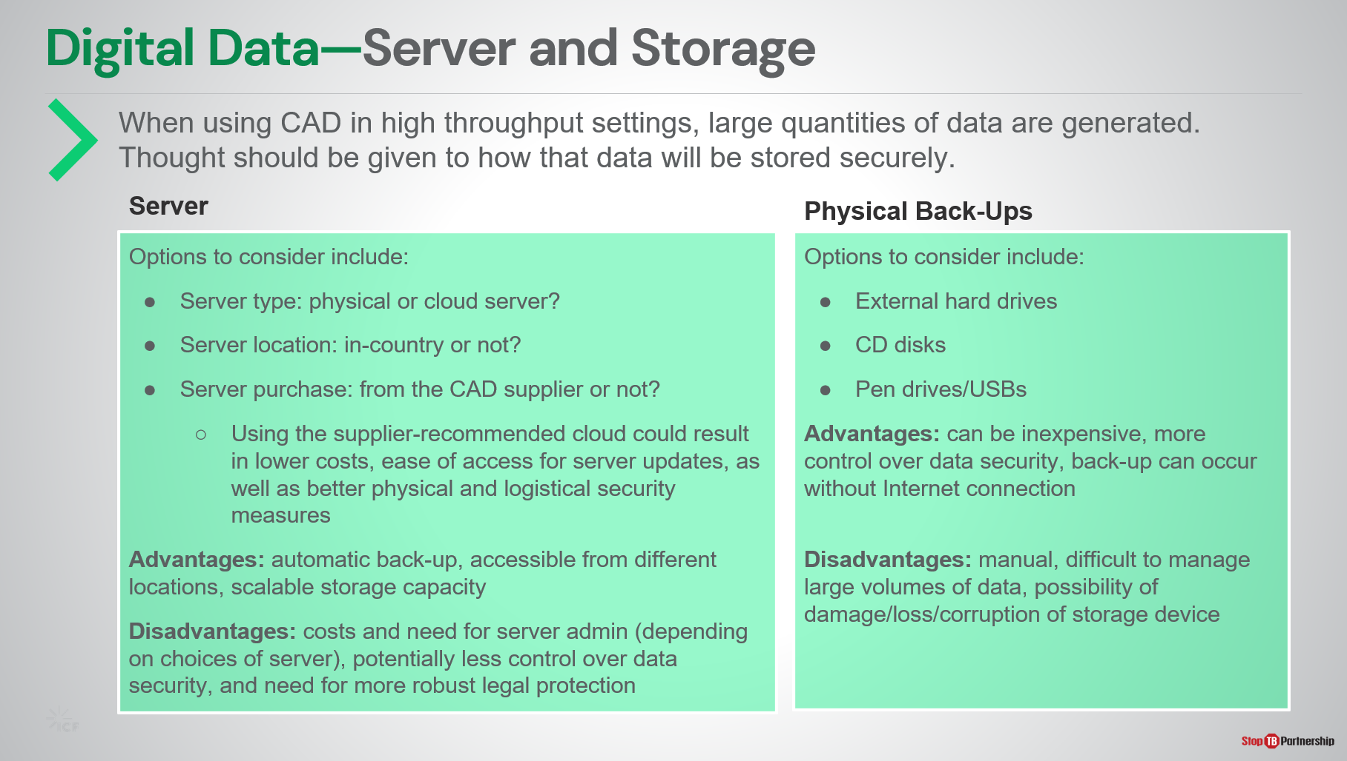
SAY: Moving on, using CAD requires particular attention to how the large quantities of patient data generated will be stored securely. There are two main options, each with advantages and disadvantages.

The first option is to use a server. When considering the use of a server, there are a couple of options:
- Whether to use a physical or cloud server?
- Where to locate the server: in-country or not?
- Where to procure the server from? CAD suppliers often offer to supply a suitable server for added fee.

The advantages of using a server include automatic data back-up if using CAD online or in hybrid mode, and the ability to access data on the server from any location. It is also easier to scale the server storage capacity up or down depending on need. However, this option can be more expensive and could require a dedicated server admin. If a server is located abroad, in the cloud, and/or provided by a third party, it may be more difficult to maintain control over data, requiring robust legal protection.

The second option is to use a physical data storage device. These could be CD disks, external hard drives, or USB devices.

This option is comparably inexpensive, offers greater control over data, and allows for easy back up not requiring internet connection. Its primary downfall is the need to manually manage data back-up, which can be difficult when dealing with large quantities. There is also the possibility of loss, damage, or corruption of the storage device resulting in complete data loss.

Digital Data—Data Privacy and Security | Slide: 22
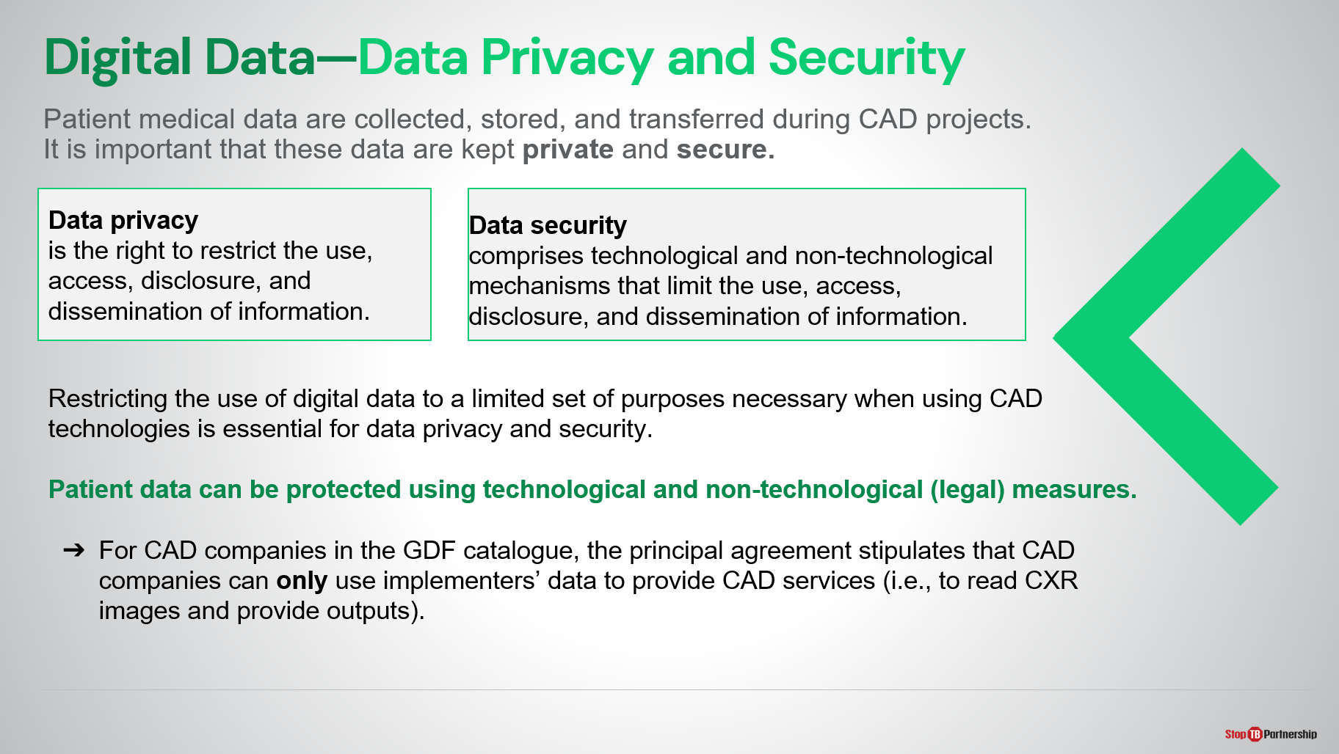
SAY: Using CAD requires collection, storage, and transfer of patient medical data. It is the responsibility of the project to keep patient data private and secure.

First, we will take a look at these two terms:
- Data privacy is the right to restrict the use, access, disclosure and dissemination of information;
- Whereas, data security is the technological and legal mechanisms that limit use, access, disclosure, and dissemination of information.

Employing these two concepts, we can ensure patient data is protected using legal and technological methods.
When procuring from the GDF catalog

Digital Data—Data Privacy and Security | Slide: 23
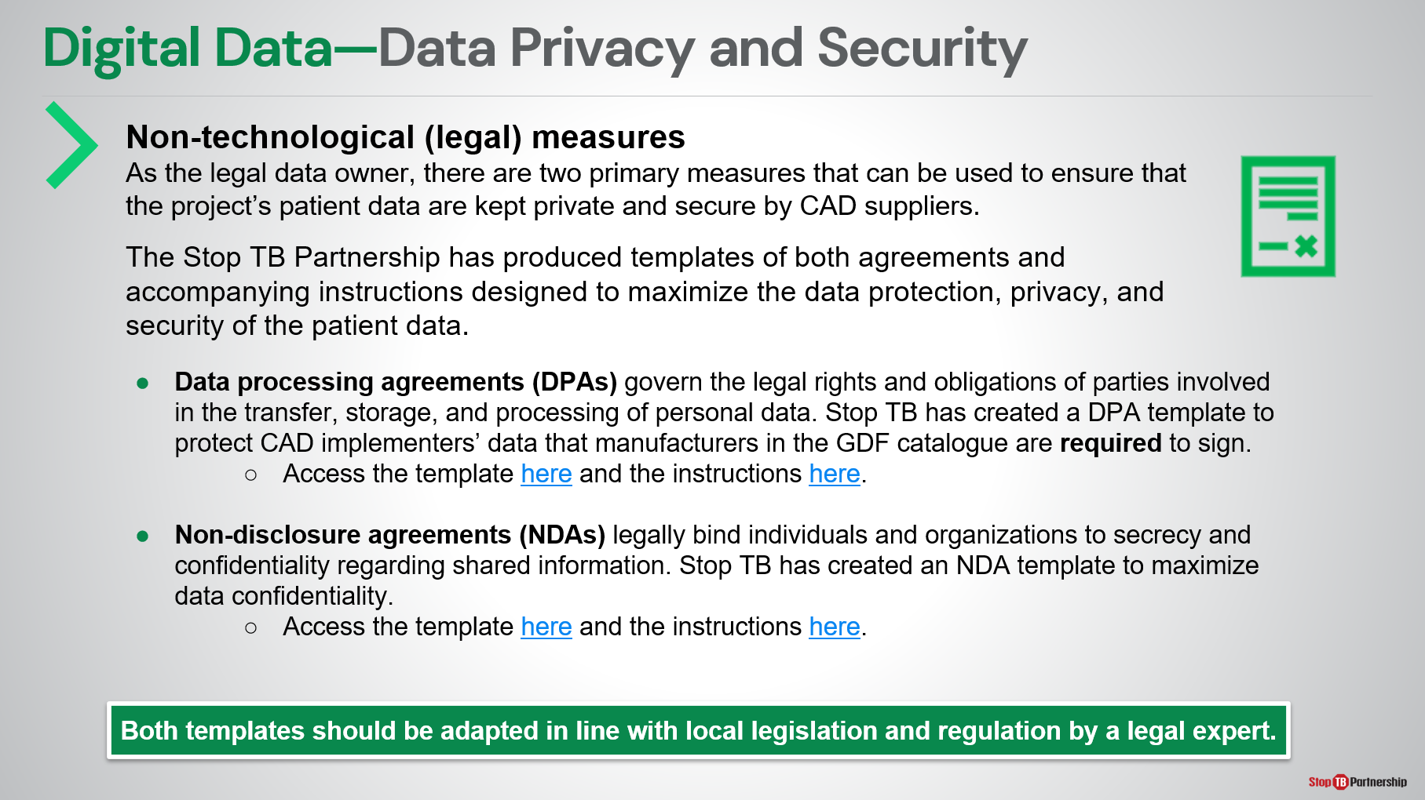
SAY: As the legal data owner, there are two primary methods of legal data protection we can take with a CAD company: data processing agreements and non-disclosure agreements.
- Data processing agreements govern the legal rights and obligations of all parties involved in the transfer, storage, and processing of patient data in a CAD project. CAD suppliers featured in the GDF catalog are obligated to sign a DPA with implementers.
- Non-disclosure agreements legally bind individuals and organizations to secrecy and confidentiality regarding shared information.
A template of both agreements are available from the Stop TB Partnership, as well as instructions on use. To use the template effectively, it is encouraged that a legal expert be engaged to adapt the template in line with local registration in [country of implementation].

Digital Data—Data Privacy and Security | Slide: 24
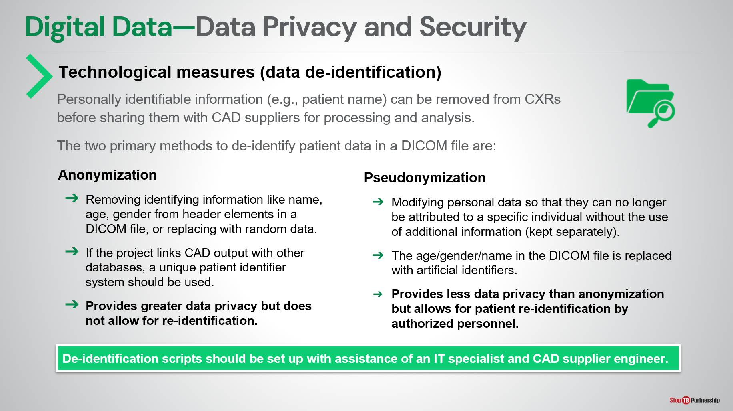
SAY: The other way we can protect patient data is through technological measures – also called data de-identification. This involves removing all identifying information (Name, age, gender, for example) from data shared with CAD manufacturers.

The two primary methods of doing this are called anonymization and pseudonymization.
- Anonymization replaces all identifying information with random data. To link CAD output with other databases, a unique patient identifier could be used. However, re-identification is not possible with anonymized data.
- Pseudonymization modifies all identifying information so it can no longer be traced back to the individual without the use of additional information which is kept separately. Re-identification is possible.

De-identification scripts can be set up with assistance from an IT specialist and CAD supplier engineer.

Further Considerations | Slide: 25
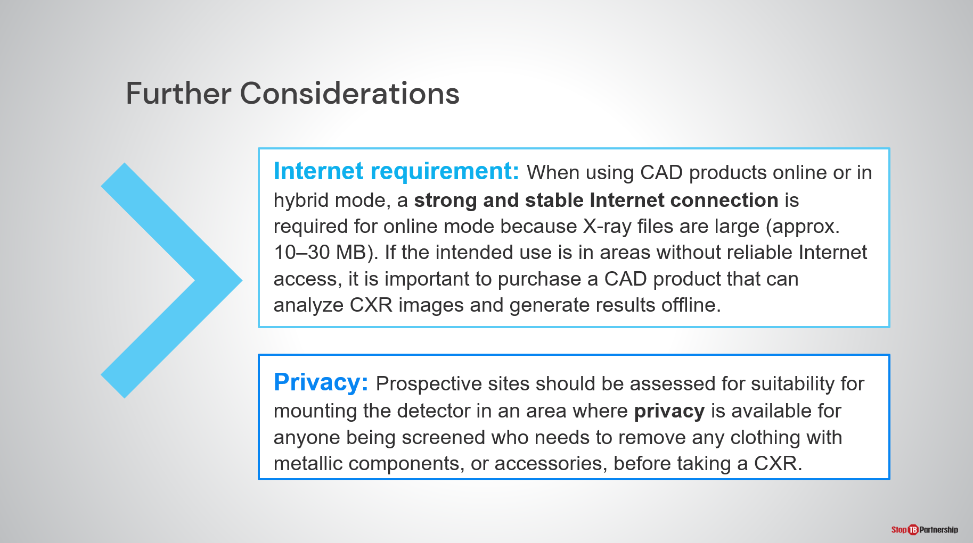
SAY: Briefly, two final considerations when setting up your X-ray and CAD screening site are internet requirement and patient privacy.

When using CAD products online or even in hybrid mode, a strong and stable internet connection is required in order to successfully transfer and process the large X-ray image files. If such a connection is not available, an offline CAD product should be purchased.

Finally, when considering patient flow through the site it is important to ensure a private space is available near the area where the exposures are taken so any clothing or accessories containing metallic components can be removed before taking a CXR.

What to Expect from Suppliers | Slide: 26
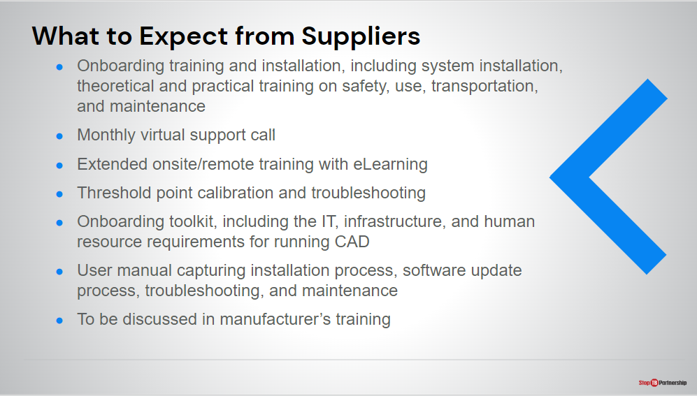
SAY: As we talk about implementation of CAD products, you may be left wondering what is the role of the CAD and X-ray suppliers?

Under the terms negotiated by GDF, the suppliers are expected to provide support with the following:
- Onboarding training and installation. Training and installation occur in the same session. Training is both theoretical and practical, so it is important to have the tools on-hand to get the most out of the training session.
- In addition to onboarding training, Delft also provide additional training through their eLearning platform.
- Delft also provide a monthly virtual support call that project staff can dial into. We hope this will facilitate organizational knowledge sharing and allow for any concerns to be addressed swiftly by the manufacturer.
- The CAD manufacturer also provides some support for the selection of an initial threshold score for operation.
- An onboarding toolkit will also be provided that includes the IT, infrastructure, and human resource requirements for successfully running CAD.
- A user manual for both the CAD and ultra-portable X-ray.

If you have any questions relating to the type or level of service from the manufacturer, these can be answered by the manufacturer themselves during their training sessions.

Challenges and Lessons Learned from Early Users of CAD and UP-XR
Challenges and Lessons Learned | Slide: 28
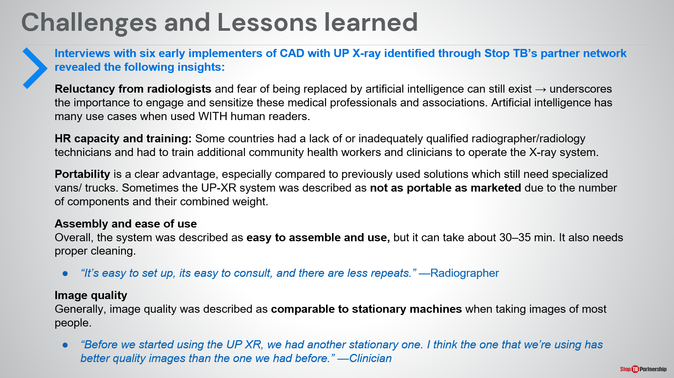
SAY: Lastly, we wanted to share with you the preliminary findings from interviews with implementers of CAD and ultra-portable X-ray in pilot studies. These are related to particular topics as shown on the slide. Direct quotes are in blue:
- Some sites experienced reluctancy from radiologists due to the perception that CAD will replace their role. This underscores the importance of engaging and sensitizing these medical professionals and associations with emphasis on the fact that in many use cases AI is a tool to supplement the work of human readers, rather than replace them.
- Some sites struggled to identify a suitable number of trained operators for the ultra-portable X-ray and so had to train additional community health workers to operate the system.
- Though the ultra-portable devices are easier to transport than their predecessors, especially those systems used in specialized vans/trucks, sometimes sites felt they were not as portable as marketed due to the number of components and their combined weight. A small team of people was still required to transport them.
- Overall, the system was found to be easy to assemble and use.
- And image quality was described as being comparable to stationary devices, even though is sometimes a concern due to the reduced size and power of the generator.

Challenges and Lessons Learned | Slide: 29
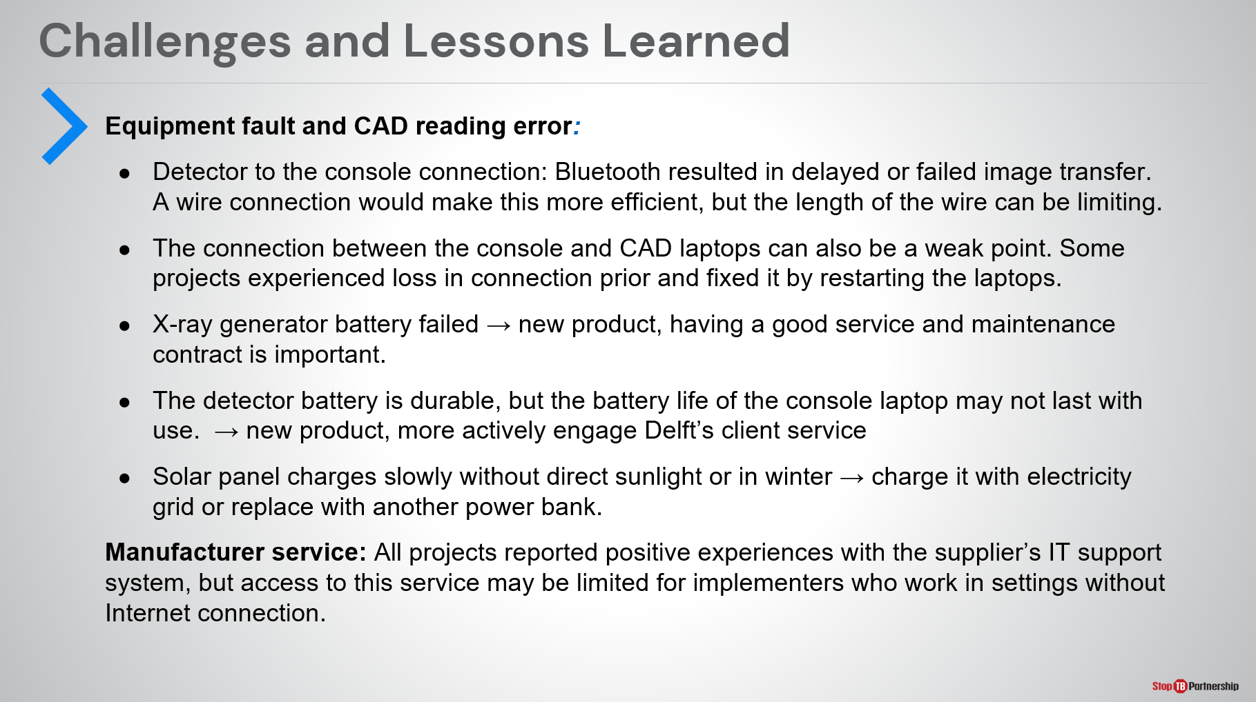
SAY: Early implementers were also asked whether they encountered any equipment fault or reading errors during their pilot projects. Some faults reported included:
- The Bluetooth connection between the detector and computer resulting in delayed or failed image transfer.
- Loss of connection between the X-ray console and CAD laptops
- Failing X-ray generator batteries – though these were quickly replaced thanks to the service and maintenance contract.
- Failing battery life of the battery in the console laptop
- Slow recharging of the solar panel without direct sunlight or in winter- it should be recharged by electricity where possible and could be supplemented with an additional power bank.
In general, experience with manufacturer support and customer service were all good, however access to this service can be limited if work is in a setting with little or no internet connection.

Summary

Summary | Slide: 31
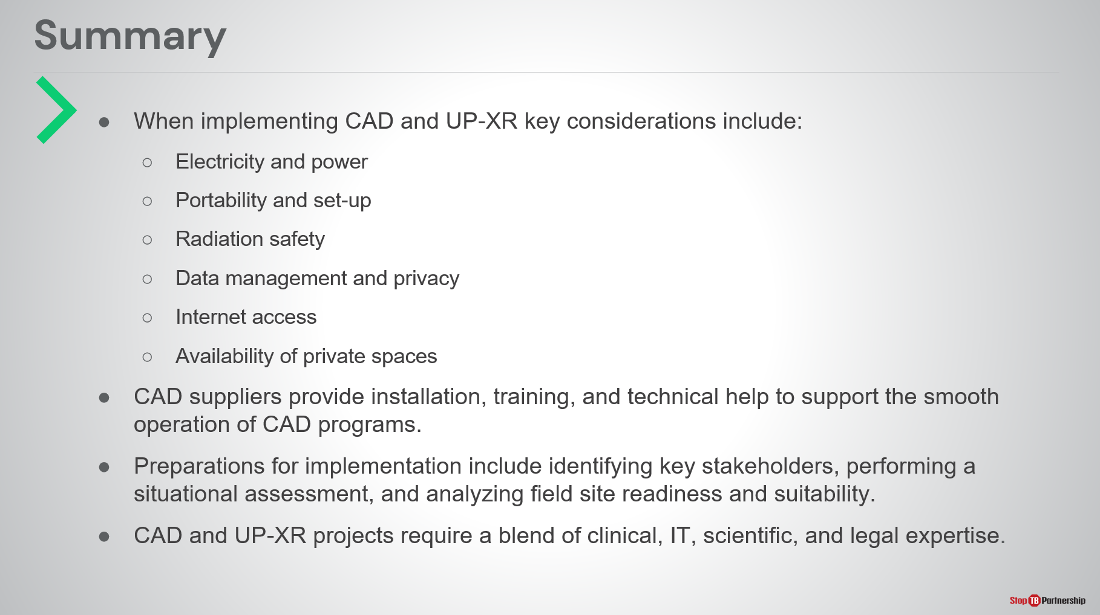
SAY: That concludes the third module of our training summarizing the implementation aspects of ultra-portable X-ray and CAD. To summarize:
- When implementing CAD and ultra-portable X-ray, some key considerations include electricity and power, portability and set-up, radiation safety, data management and privacy, internet access, and the availability of private spaces.
- You should expect CAD suppliers to provide installation, training, and technical help to support the operation of CAD programs.
- Preparations for implementation include identifying key stakeholders, performing a situational assessment, and analyzing field site readiness and suitability.
CAD and ultra-portable X-ray projects require a blend of clinical, IT, scientific, and legal expertise.
ASK: There are no knowledge check questions for this module, are there any questions on the topics covered?
DO: Receive and answer questions appropriately.

Module 4: Introduction to Threshold Selection

Target Audience
The target audience for this course is:
- Program managers and coordinators
- NTP staff

Learning Objectives
Terminal Objective
- At the end of this session, participants should understand the basis behind threshold score selection and what threshold selection strategies may work best in their context.

Module Objectives
- By the end of this module, participants should be able to
  - Understand what a threshold score is and how to set it.
  - Know the effect of changing threshold on key screening targets.
  - Describe why a threshold score needs to be chosen based on the local context.
  - Understand some of the current strategies for adapting and optimizing a threshold in the local context.

Materials
- Facilitator Guide
- Pens/Pencils

Introduction
Course Outline | Slide: 2
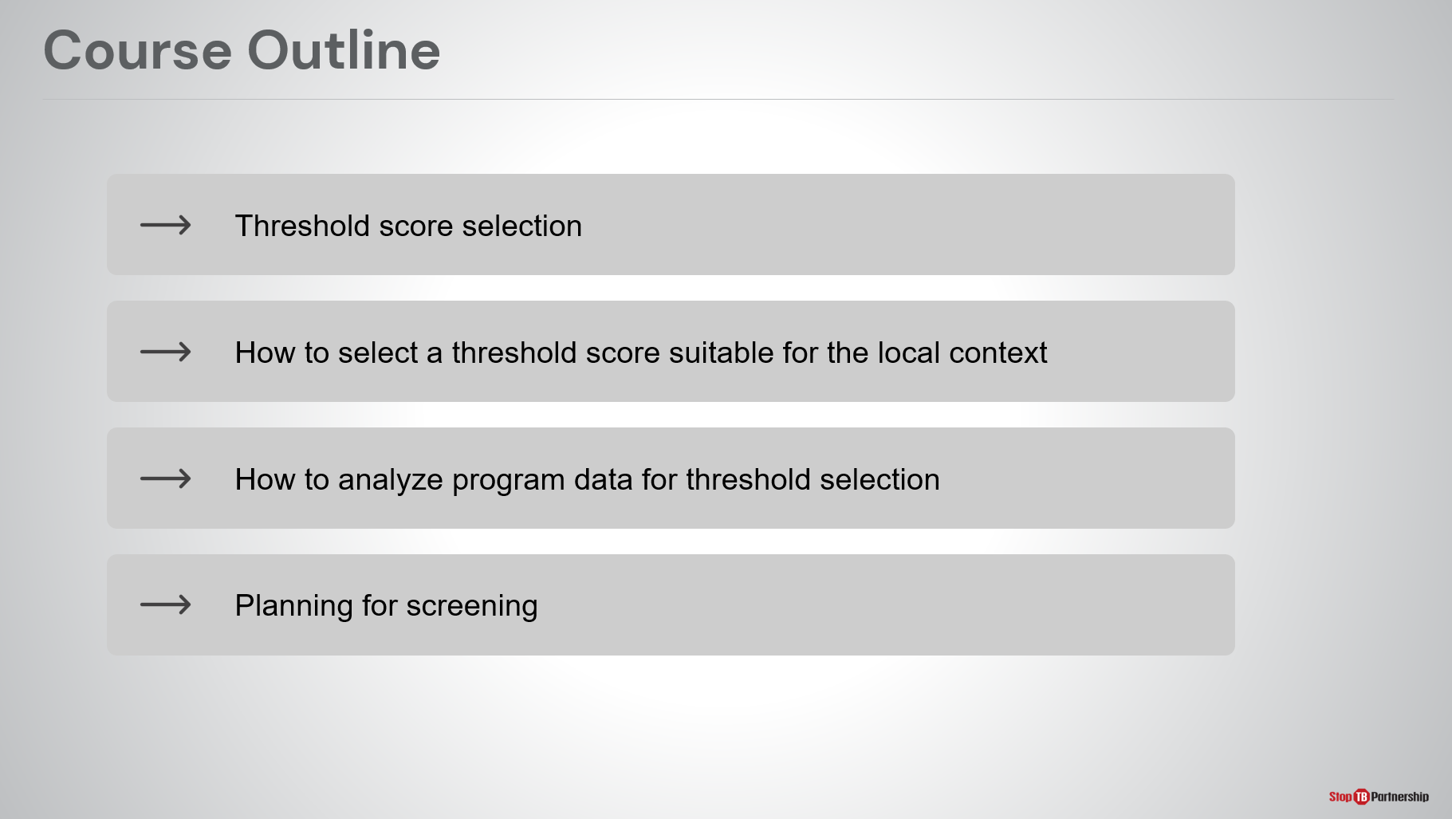
SAY: Our outline for today is threshold score selection, how to select a threshold score suitable for the local context, how to analyze programmatic data for threshold selection, and planning for screening.

Introduction | Slide: 3
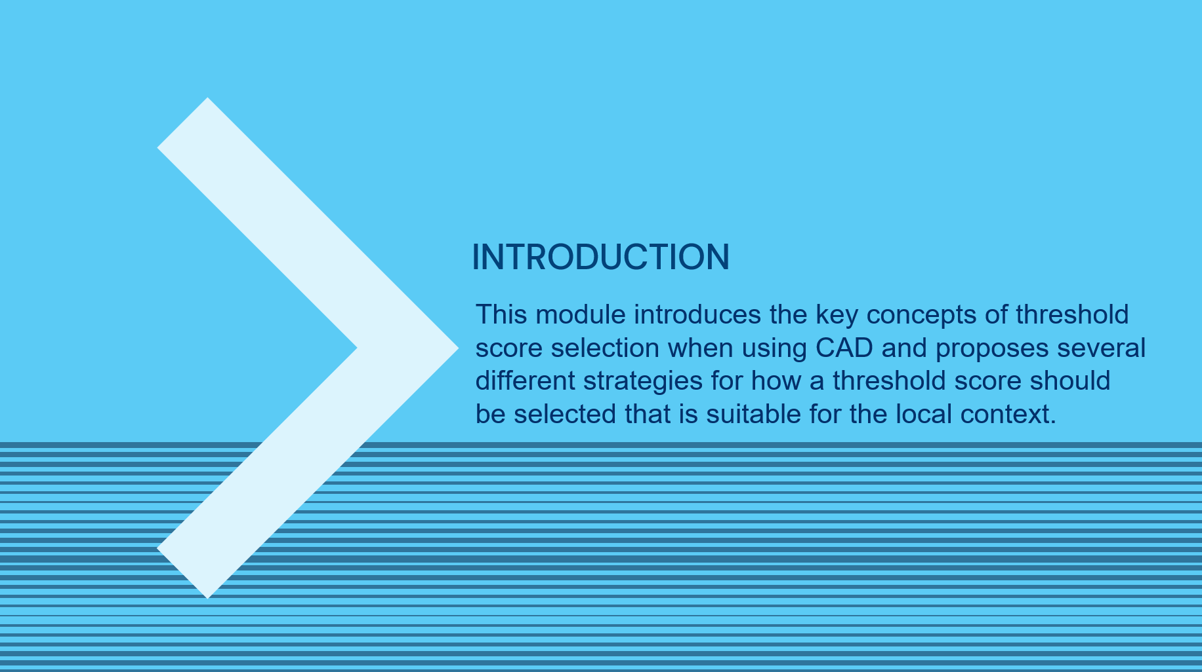
SAY: This module introduces the key concepts of threshold score selection when using computer-aided detection and proposes several different strategies for how a threshold score should be selected that is suitable for the local context.

Learning Objectives | Slide: 4
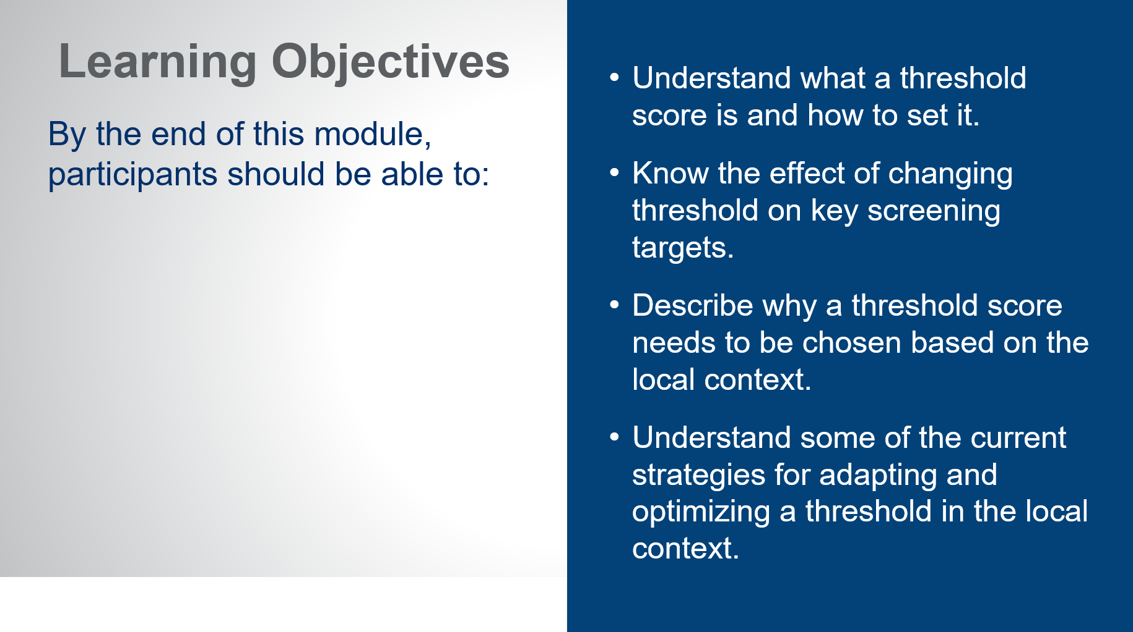
SAY: By the end of this modules, you should be able to:
- Understand what a threshold score is and how to set it.
- Know the effect of changing threshold on key screening targets.
- Describe why a threshold score needs to be chosen based on the local context.
- Understand some of the current strategies for adapting and optimizing a threshold in the local context.

Threshold Score Selection
What is a “Threshold Score”? | Slide: 6
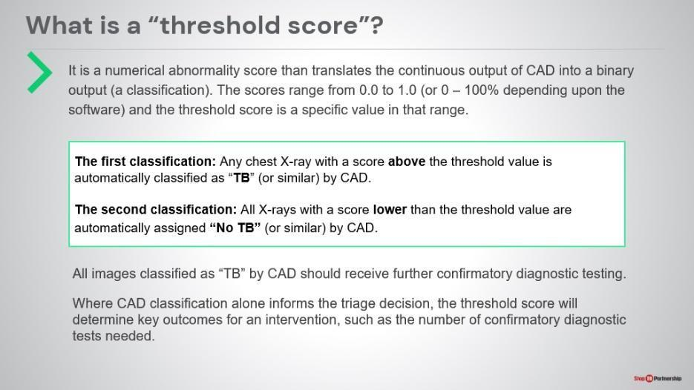
SAY: Let’s start with the basic question: what is a threshold score? It is a value that the CAD system uses (on a scale of Zero to One or Zero to 100 ) to identify what is an abnormal reading based on whether an image has an abnormality score greater or less than the threshold value. Depending on this, the system provides a classification, either:
- “Possibility of TB”: any x-ray with an abnormality score above the threshold value .
OR
- “No TB”: Any x-ray scores lower than the threshold value .
Any images classified as “Possibility of TB” or similar should receive further confirmatory diagnostic testing based on your algorithm, ideally with rapid molecular testing.
Where CAD classification alone informs the triage decision, the threshold score will determine key outcomes for an intervention, such as the number of confirmatory diagnostic tests needed. More on this later.

Basic Concepts in Threshold Selection | Slide: 7
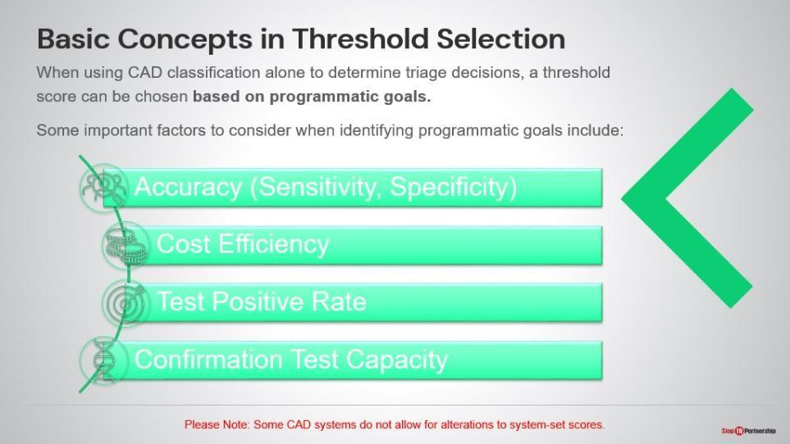
SAY: Let’s understand the basic concepts in threshold selection. When you are using CAD classification alone to determine triage , the threshold should be chosen based on programmatic goals. When identifying programmatic goals, you want to think about the sensitivity of the test, cost efficiency, test positive rate, and critically, your capacity to do confirmation tests. Every image classified as “Possibility of TB” based on your threshold selection should then be immediately referred for confirmatory testing.
ASK: Start to think about what your programmatic goals may be, based on these or other factors. Write down a few ideas.

Impact of Threshold Selection | Slide: 8
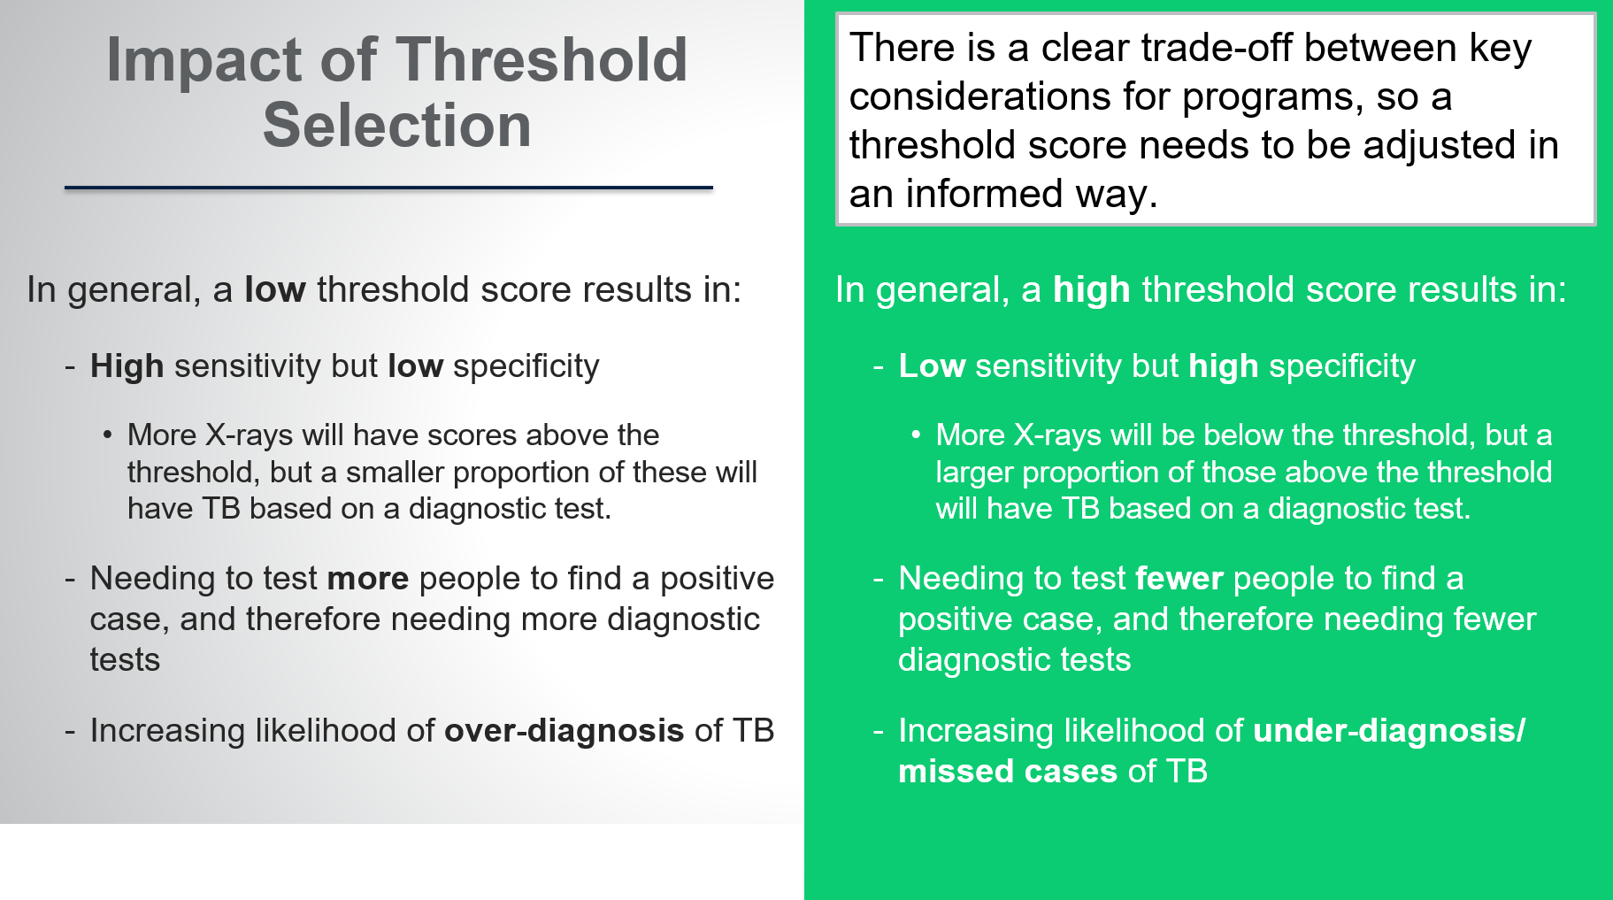
SAY: Let’s talk about the impact of your threshold selection. In general, a low threshold score (for example, 30) results in high sensitivity but low specificity. Since, more X-rays will have scores above the threshold, but a smaller proportion of these will have TB based on a diagnostic test. You will need to test more people to find a positive case and need more diagnostic tests, increasing the likelihood of over-diagnosis, so more false positive tests.

Alternatively, if you set a high threshold score (for example, 80), that leads to low sensitivity – since fewer images will be above this threshold- but high specificity – images above the threshold will be more likely to have TB. Therefore, you will conduct fewer confirmatory tests but that means likely underdiagnosing TB and missing cases.

This creates a clear trade-off between key programmatic considerations, with the most appropriate threshold score likely anywhere between these extremes. You will need think about adjusting your threshold score in an informed way.

ASK: Are you comfortable with more false positives or more false negatives? Why?

Threshold Score Trade-offs in Action | Slide: 9
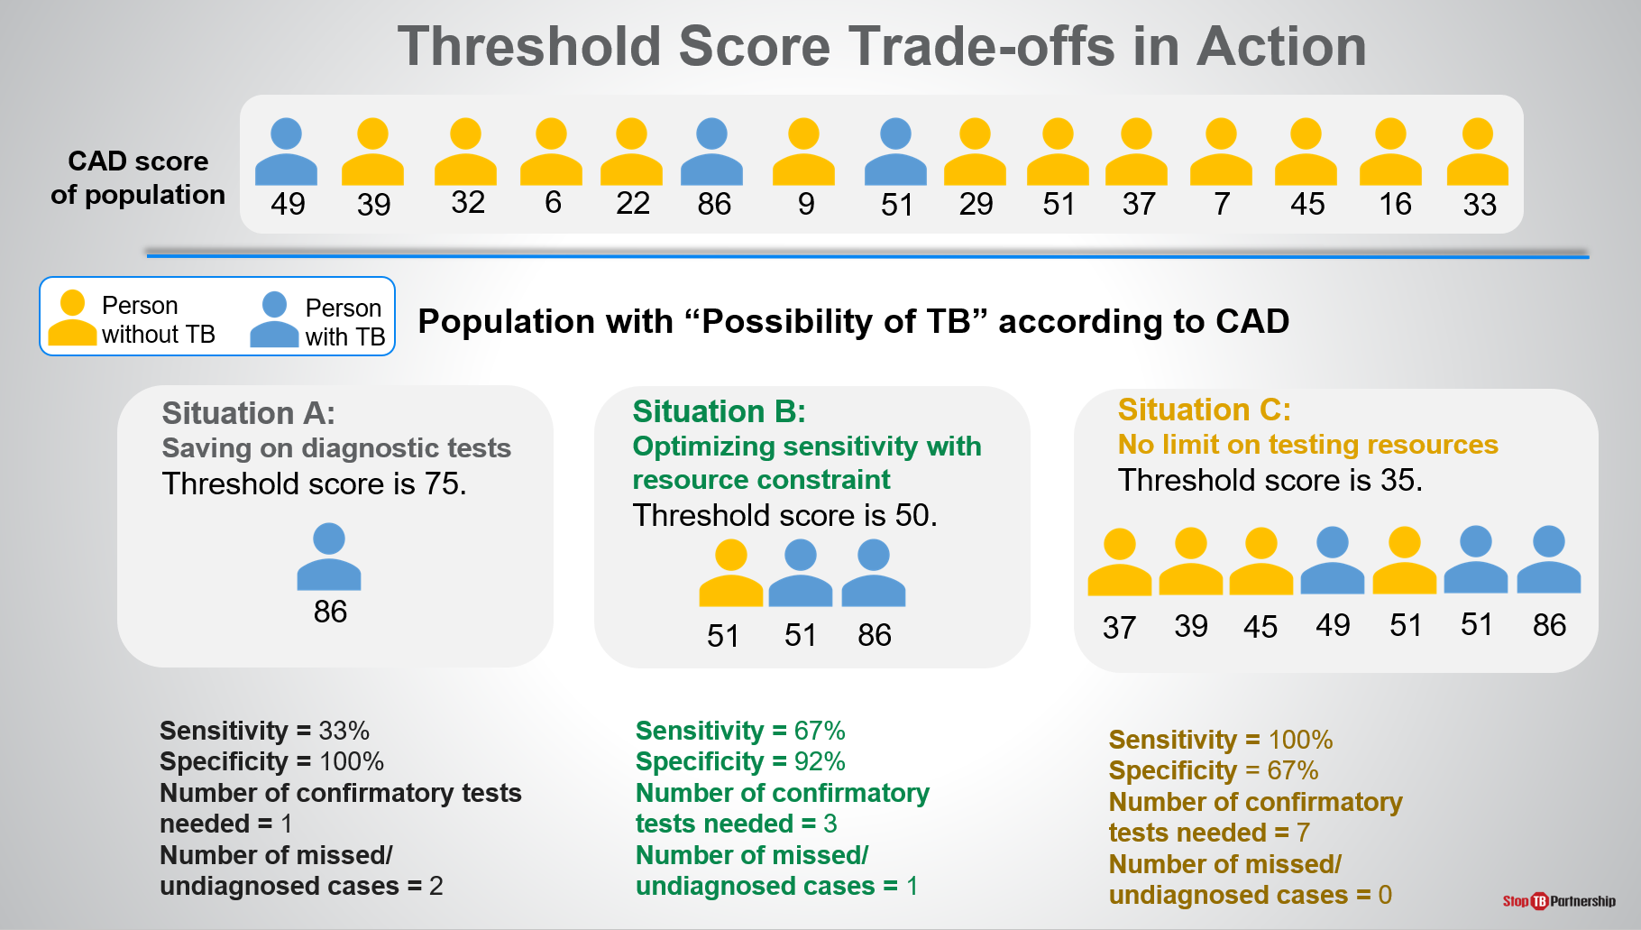
SAY: We can now look at these trade-offs in action using a small hypothetical population . Persons without TB are color-coded in yellow, and persons with TB are color-coded in blue.
- In situation A, what we have done is set our threshold score fairly high at 75. As a result, we only identified 1 person with TB who had an abnormality score of 86 according to CAD. This does result in savings on diagnostic tests. It gives us a fairly low sensitivity at 33% but very high specificity at 100%. Therefore, we need one confirmatory test, but we miss two other TB cases with scores lower than the threshold.
- Let’s say we lower our threshold score to 50 in situation B. We end up with a higher sensitivity and a somewhat lower specificity, identifying two of the possible three TB cases. We need three times as many confirmatory tests as with the threshold set at 75, but we cut the missed cases. .
- In situation C, we really have no limit on our testing resources. We set our threshold low to make sure that we identify as many people with TB as possible. That means that we end up needing seven confirmatory tests. We identified all the people with TB, but we also tested four people that did not have TB, . No missed cases, but higher confirmatory test numbers.

Again, we are trying to figure out what threshold score is most suitable for out context, in line with our testing capacity and prevalence .
ASK: Before we get into specific ways of adjusting your threshold score, which of these situations do you think would make the most sense for your context?

Factors that Influence CAD Performance | Slide: 10
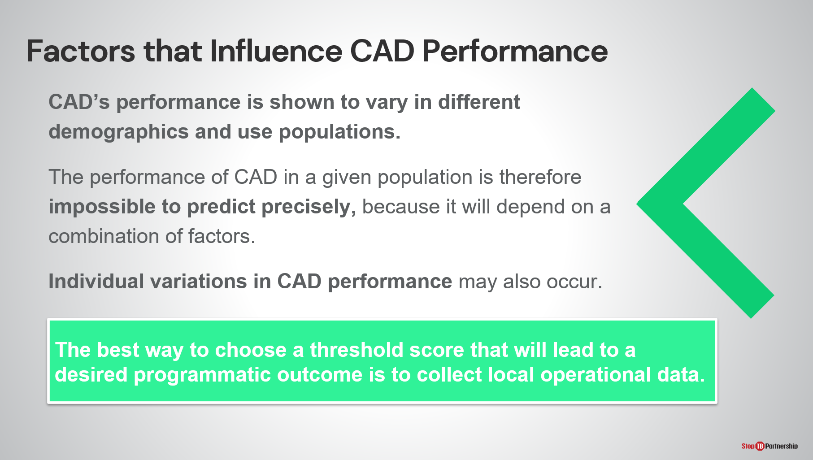
SAY: There are a number of factors that influence CAD performance, and we need to take those factors into account when setting the threshold score. We know this because the CAD performance does vary in different demographics and populations, studies show that CAD is less able to detect TB in older age groups, for example. Although, we don’t have evidence to predict how much certain factors affect the performance of CAD, we do know what are the known influence factors.

Factors that Influence CAD Performance | Slide: 11
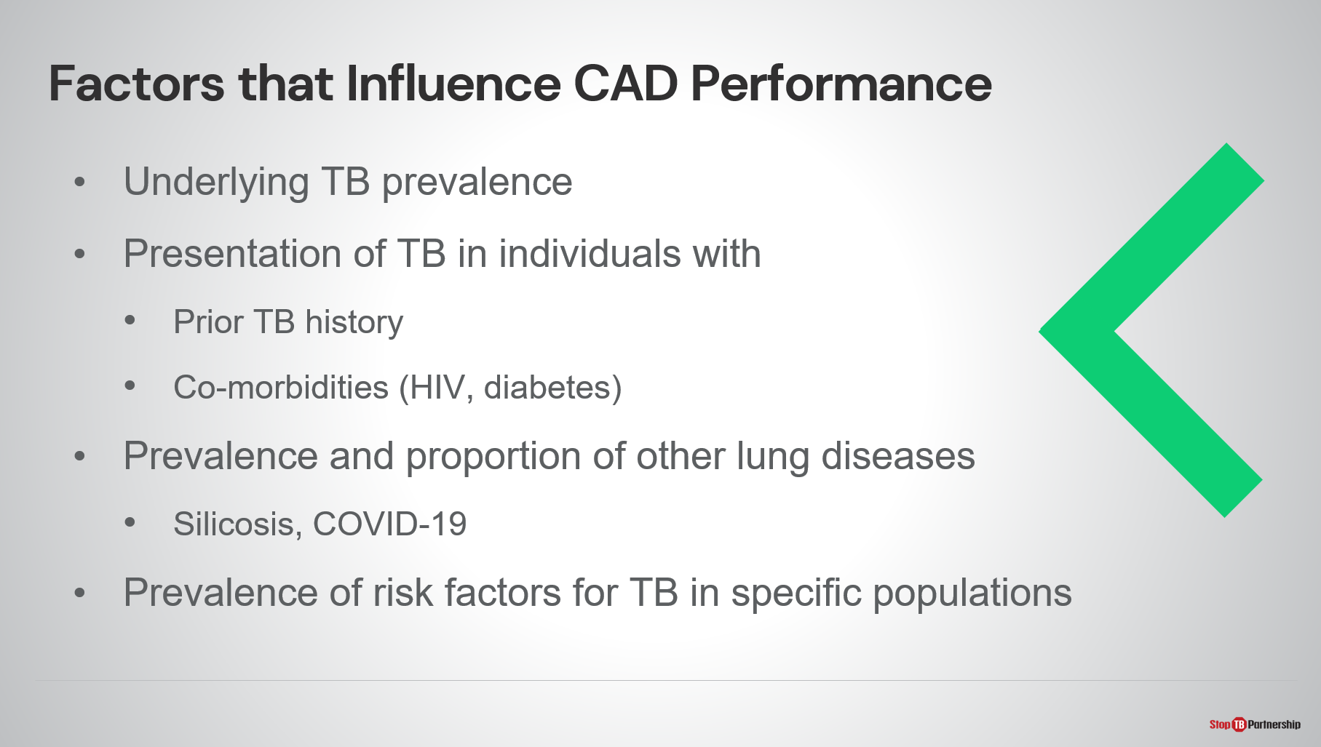
SAY: What affects CAD performance? There is the underlying TB prevalence (how many cases are in the population). There is the presentation of TB in individuals with prior TB history (those with prior TB will often get a false positive result, so we need to be mindful of that) and persons with co-morbidities (may often get missed in an x-ray situation). There’s also the prevalence of other lung diseases (silicosis, COVID-19, pneumonia, and lung cancer). We also need to look at the prevalence of risk factors for TB in specific populations. All these factors can impact CAD performance, so we must take them into account when we set our thresholds.
If we are going to think about choosing our threshold, the best way to do it is to test performance in the target population.

Performance Change between Versions | Slide:12
SAY: Finally, it is also important to know that performance may also vary between different versions of the same product. For example, for CAD4TB, the Delft software product, there has been a significant change in the underlying algorithm between version 6 and version 7. Preliminary results show that version 7 has significantly outperformed version 6 when compared to the reference standard. This tells us that the machine learning is improving over time.

For threshold selection, this means that operating at the same threshold between the two versions would not necessarily produce the same results. As shown in the table, if using a threshold score of 50 with version 6 sensitivity is around 97% and 30% of confirmation tests would be saved. Using the same threshold with version 7 results in lower sensitivity (90%) but higher confirmation test saving.

How to Select a Threshold Score Suitable for the Local Context

How to Choose a Threshold Score | Slide: 14
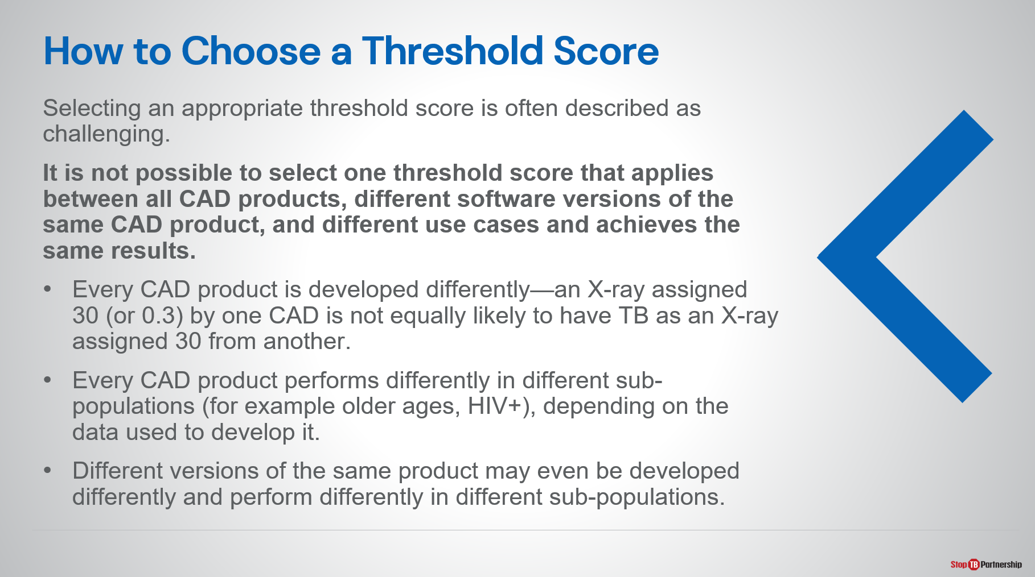
SAY: How are we going to pick the right threshold score for our context?
Start to recognize the question of how we choose a threshold score can be challenging. It because it’s impossible to select one threshold score that will apply to all CAD products because there is no relationship between the scores of different products, and different versions of the same product may also be vastly altered, , and there are also different use cases.

Optional:
  - Every CAD product is developed differently—an X-ray assigned 30 (or 0.3) by one CAD is not equally likely to have TB as an X-ray assigned 30 from another.
  - Every CAD product performs differently in different sub-populations (for example older ages, HIV+), depending on the data used to develop it. CAD is developed by using thousands of x-ray screens (confirmed positive or negative) and learns from them. If these screens come from different populations, the computer will learn based on those populations.
  - Different versions of the same product may even be developed differently and perform differently in different sub-populations. For example, earlier versions may have been developed using smear microscopy for confirmation, which is less sensitive than rapid molecular tests.

How to Choose a Threshold Score | Slide: 15
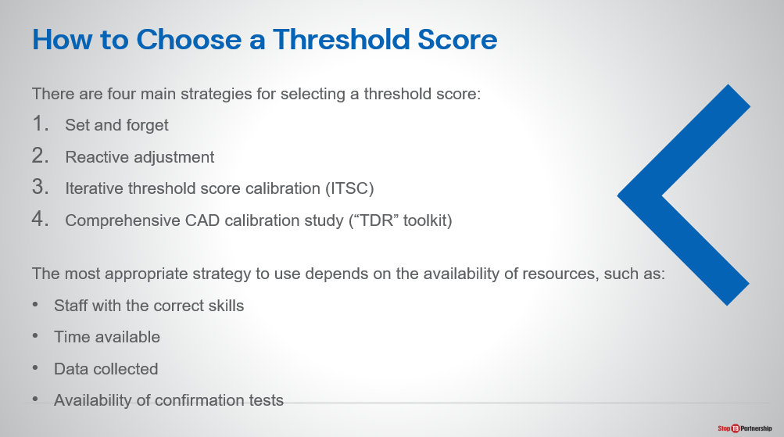
SAY: What we want to offer to you are four main strategies for selecting your threshold score. Again, there is no right answer because there are variations and trade-offs. Some of these strategies may require substantial investment.

Starting with the first one, we have set and forget. Then there is reactive adjustment. We could do an iterative threshold score calibration. Finally, we have comprehensive CAD calibration study, using the WHO-TDR toolkit .

As you think about how you are going to set your threshold score, you need to think about the availability of your resources. You need to make sure you have staff with the correct skills—skills we will discuss. You need to determine the time available and what data can be collected, as well as the availability of the confirmatory tests.

Set and Forget | Slide: 16
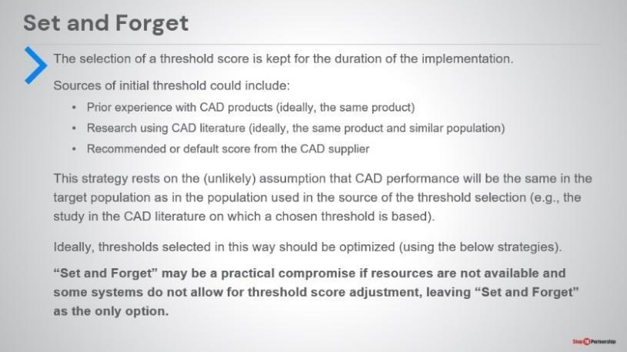
SAY: The first process is called set and forget. This requires bare minimum in terms of resources. You simply set the threshold score, and it continues for the duration of the implementation. In terms of selecting a threshold: you may use the default threshold recommended by the manufacturer , you may do desk research to look at how this product has been used with similar populations, your national TB program may recommend a threshold, or you may use your own experience with CAD products. This strategy assumes that CAD performance will be the same in the target population as in the population used in the source of the threshold selection. This is unlikely but this is a practical compromise. You do not have to do additional studies or pre-work as compared to the strategies that I will explain next..

Shortcomings in CAD Literature | Slide: 17
SAY: When reviewing literature to find the performance of CAD, we must also be aware of the limitations of the current literature on the tool:
- Literature is frequently outdated as new versions of CAD software are rapidly available and can have entirely different underlying AI meaning literature referring to older versions are no longer relevant.
- How accurate CAD is at detecting non-TB abnormalities is still largely unknown.
- Most studies use the same method – the area under the receiver operating characteristic curve- to measure CAD performance. More implementation-relevant measures are needed.
- How well CAD performs in children and TB key populations still needs to be investigated.
- More validations need to be conducted that are not co-authored by manufacturers themselves.

Reactive Adjustment | Slide: 18
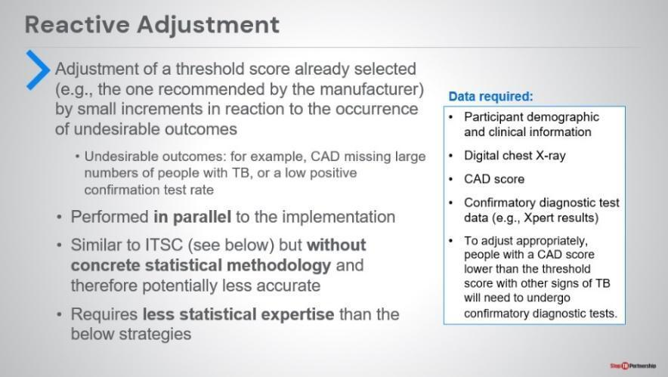
SAY: You can also use a reactive adjustment—that is a continual adjustment of the threshold score . You do it in small increments in reaction to the occurrence of undesirable outcomes. For instance, if you are missing the case finding target, you may lower the score and monitor any improvement. . This can be performed in parallel to the implementation.
It does not have the same concrete statistical methodology as compared to the methods that will be discussed next, which means it may potentially be less accurate. However, you must also keep in mind that it requires less analytic expertise, so it may be simpler to perform in certain settings.
The data required includes participant demographic and clinical information, digital x-ray data, CAD score, and the confirmatory diagnostic results.

Iterative Threshold Score Calibration | Slide: 19
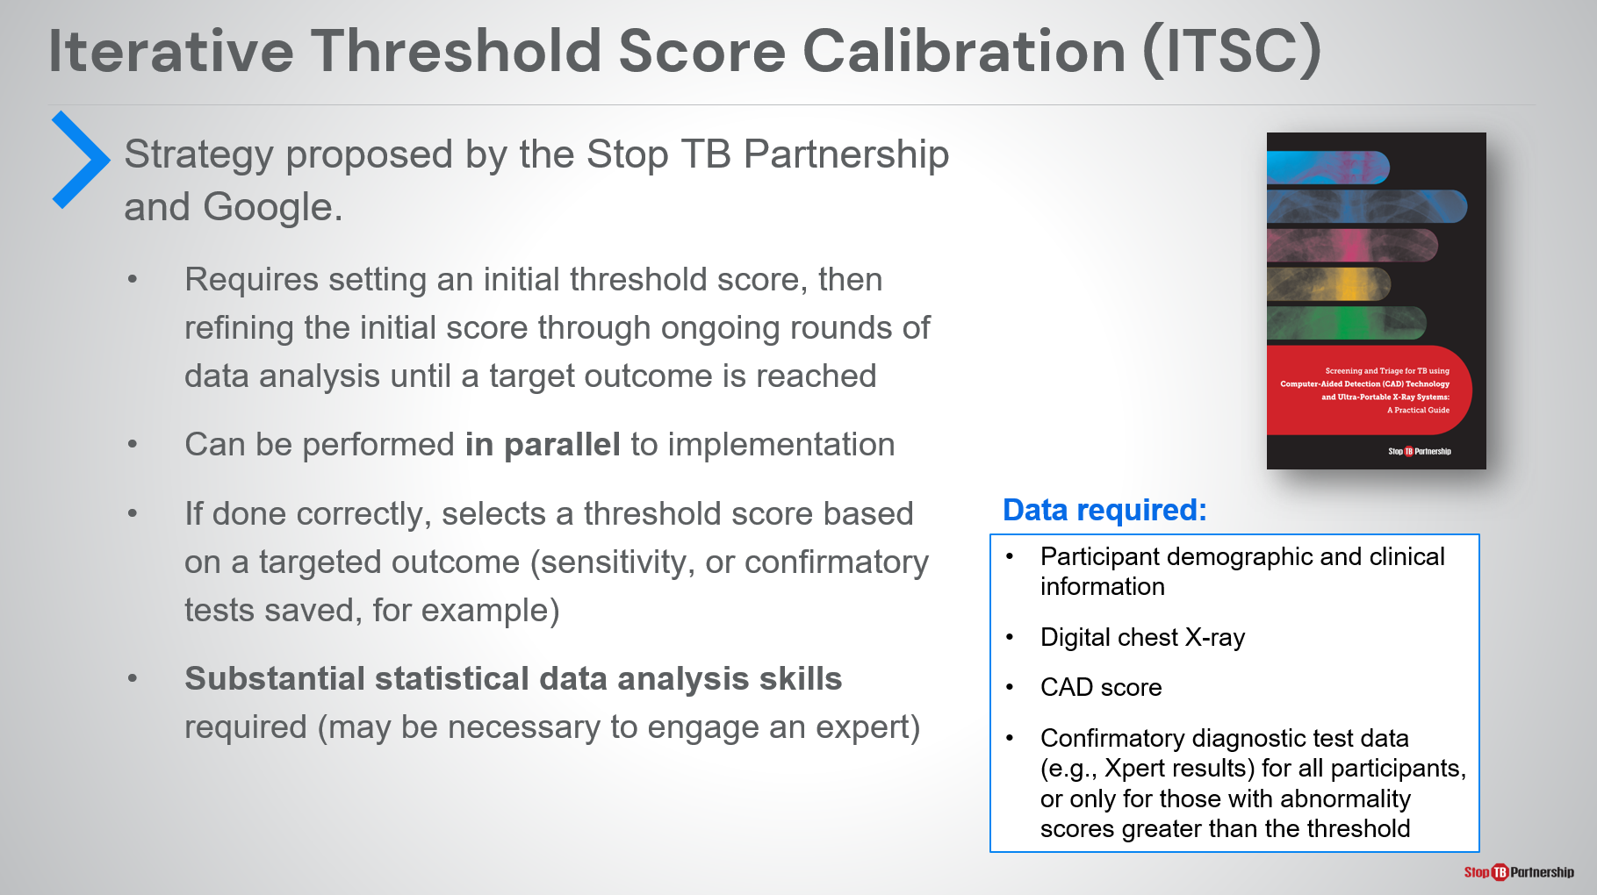
SAY: Next, we have the iterative threshold score calibration, which was proposed by the Stop TB Partnership working with Google. What you do is set an initial threshold score and decide on the target outcome (for example, Xpert testing rate, Xpert positive rate, sensitivity, or confirmatory tests saved ), and then you refine the threshold score as you undergo rounds of data analysis. This is done in parallel to implementation, so you can go ahead and use the CAD score for screening purposes while you optimize the threshold. . Iterative threshold score calibration has a comprehensive statistical methodology behind it, unlike both other methods discussed so far. The downside of this is that it does require substantial data analysis skills. Do not sell this part short, and be prepared to engage an expert to review the data as it comes in.
The data you need include participant demographic and clinical information, digital x-rays, CAD score, and the results of the confirmatory tests for all participants or only for those with abnormality results greater than the threshold (depending on the goal).
More details about this strategy can be found in Stop TB Partnership’s Practical Guide on implementing CAD and ultra-portable X-ray.
ASK: Ask participants to think about why iterative threshold score calibration may be beneficial as compared to other methods discussed so far.

Comprehensive CAD Calibration Study | Slide: 20
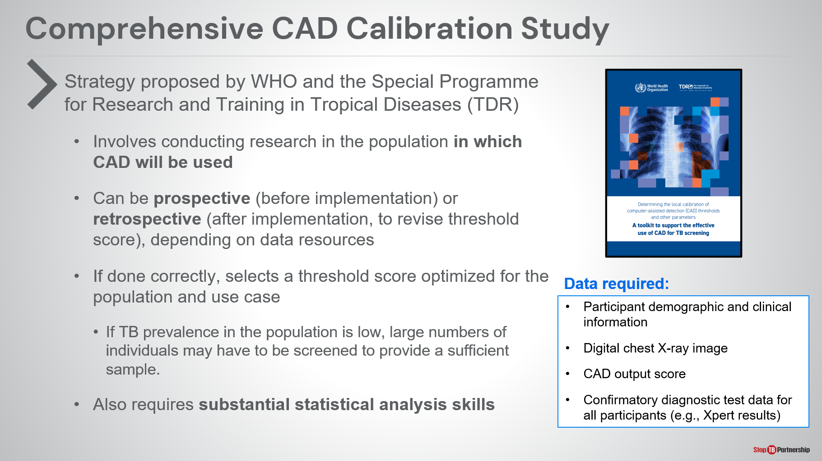
SAY: Finally, we have the comprehensive CAD calibration study. The World Health Organization and the Special Programme for Research and Training in Tropical Diseases issued a toolkit to support the effective use of CAD screening. This involves conducting research in the population in which CAD will be used. It can be done as a prospective study (before implementation) or as a retrospective study (after implementation). This should depend on your data resources. If done correctly, this calibration study selects a threshold score optimized for your population and use case (for instance, passive or active case finding). Remember, if TB prevalence in the population is low, large numbers of individuals may have to be screened to provide a sufficient sample to make this study. When you do this study, it also requires substantial statistical analysis skills, so you are able to accurately understand and interpret what the data are telling you. The data required include participant demographic and clinical information, the digital images themselves, the CAD output score, and confirmatory diagnoses for all participants.

ASK: Ask participants to think about if they would have the necessary resources to run this type of study.

Comprehensive CAD Calibration Study | Slide: 21
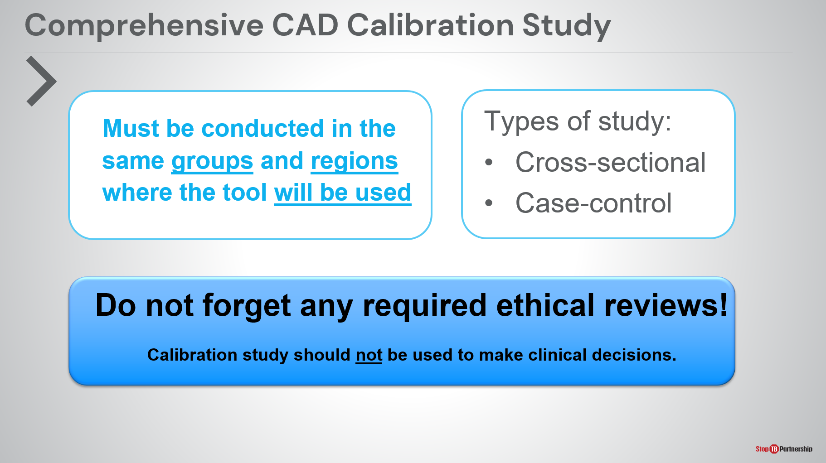
SAY: The important thing to note when designing a calibration study, participants must be draw from the same group and in the same region where the tool will be used. Otherwise, you are mixing apples and oranges.
You can look at two types of studies: cross-sectional study or case-control study. We will get to both of those.
What’s more, the calibration study should not be used to make clinical decisions. This is happening at the same time as you would do routine programmatic study. Make sure you are not using this as a part of your clinical decision-making.
You will need to get any required ethical reviews for a study as these do involve human subjects.

Comprehensive CAD Calibration Study: Cross-Sectional Study | Slide: 22
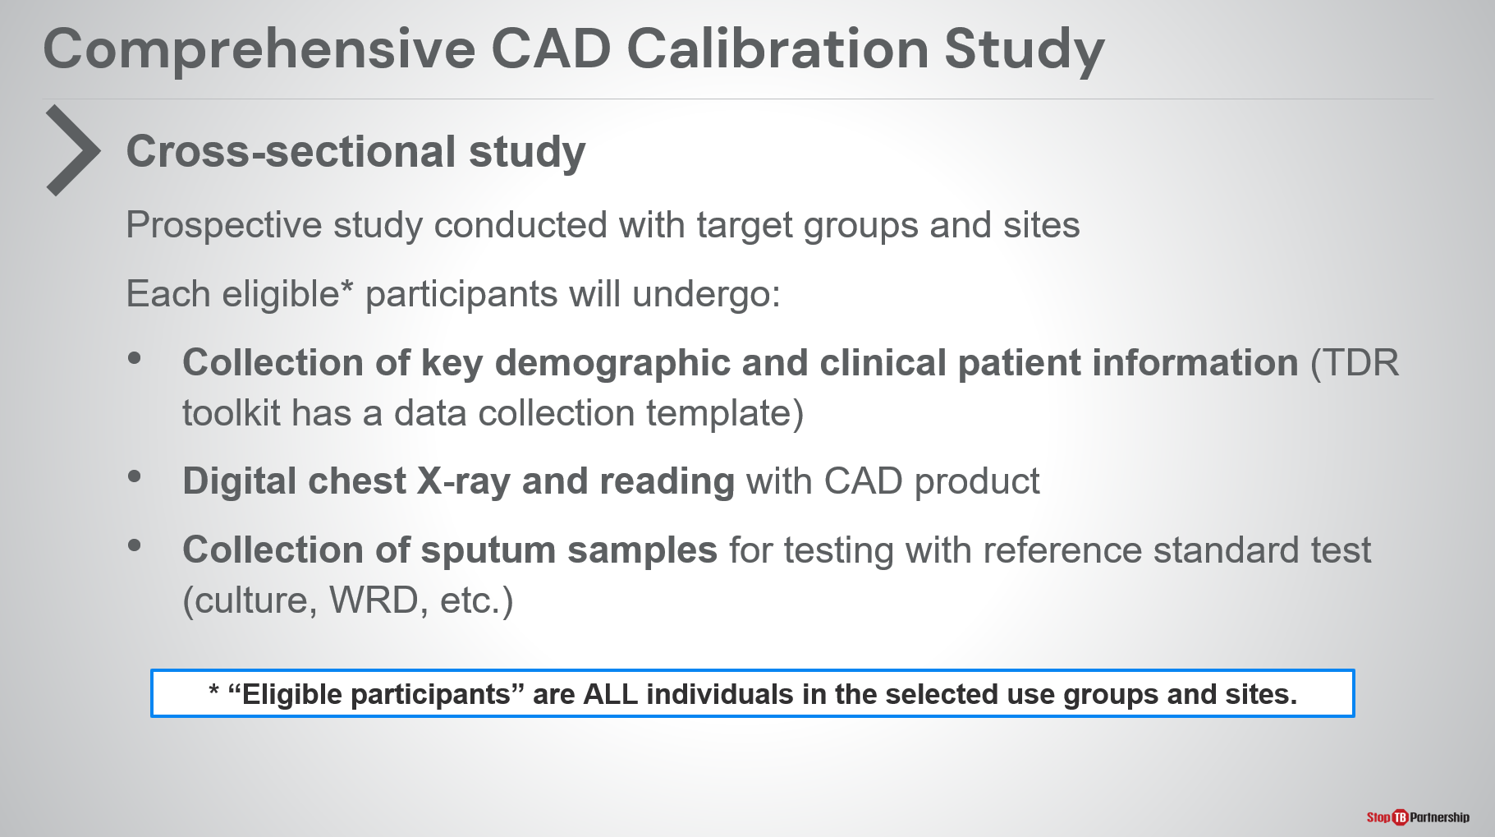
SAY: Starting with a cross-sectional study, you look at a prospective study conducted within target group and geographical setting. For each eligible participant (all individuals in selected use group and site), you must collect key demographic and clinical patient information. The TDR toolkit has a data collection template that you may use.
You must take a digital x-ray reading using the CAD product as well as collection of sputum samples for testing with reference tests, whether that is culture or a WHO-recommended rapid diagnostic tests.
Remember, we are not using these x-rays or sputum samples for our clinical decision-making. Instead, what we are doing is we are continuing on the standard clinical decision-making and doing these other tests in parallel.

Comprehensive CAD Calibration Study: Cross-Sectional Study | Slide: 23
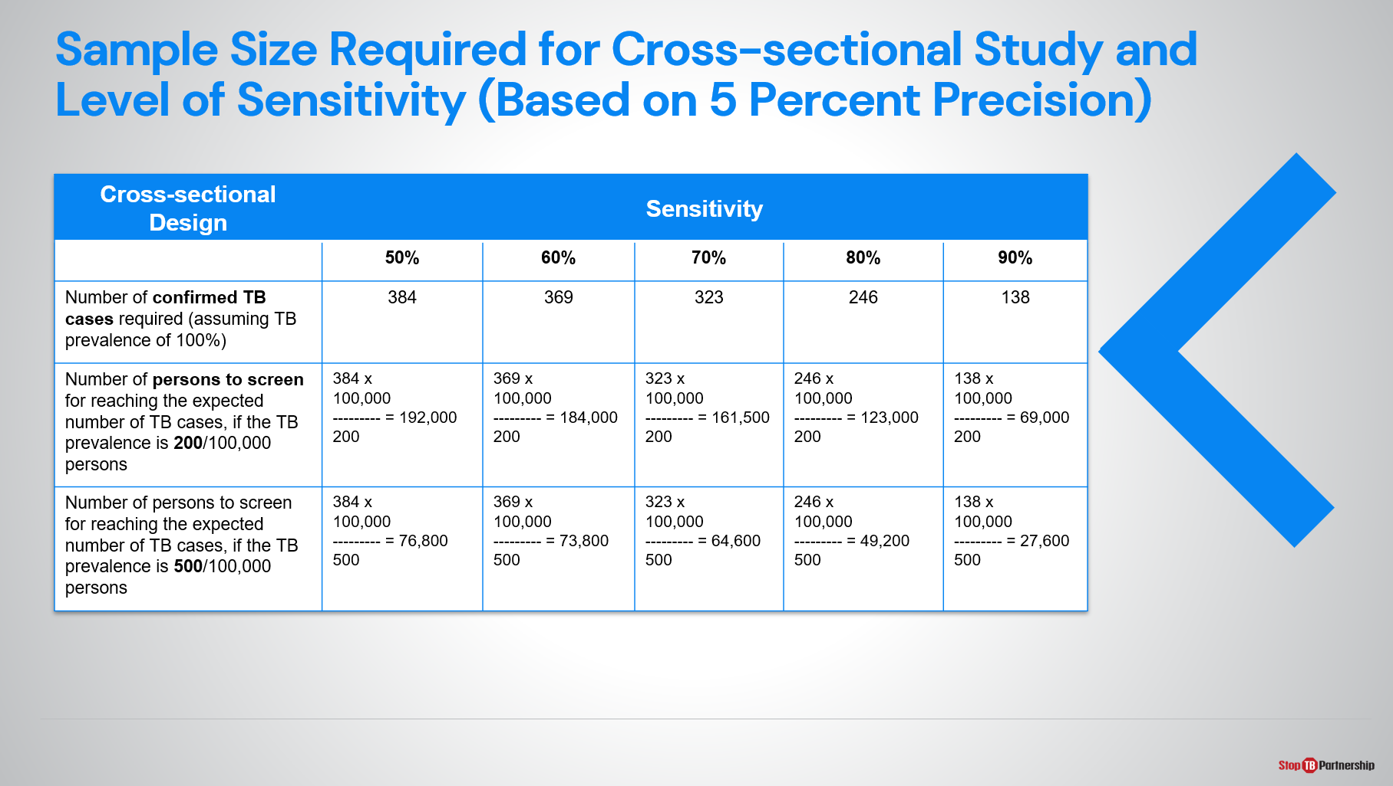
SAY: Now the thing to remember is that a rather substantial sample size is required for a cross-sectional study. We need to attain a certain number of confirmed TB cases. Here we offer a sliding scale. Lower sensitivity requires additional cases, and higher sensitivity requires fewer cases. As we go through this, low sensitivity requires a substantial number of persons to be screened, and the number of persons you need to screen depends on the prevalence within the target group. If it is 200 per 100,000, you are going to need to screen many more people. If the prevalence is 500 per 100,000, you will need to screen fewer people. We are still talking about screening tens of thousands of individuals.
For example, using this table from the TDR toolkit, if we wanted to select a threshold score to obtain 90% sensitivity according to CAD we would have to include 138 TB cases in our study sample. If the estimated TB prevalence in the target population is 200 per 100,000, this would mean screening 69,000 people.

Comprehensive CAD Calibration Study: Case-Control Study | Slide: 24
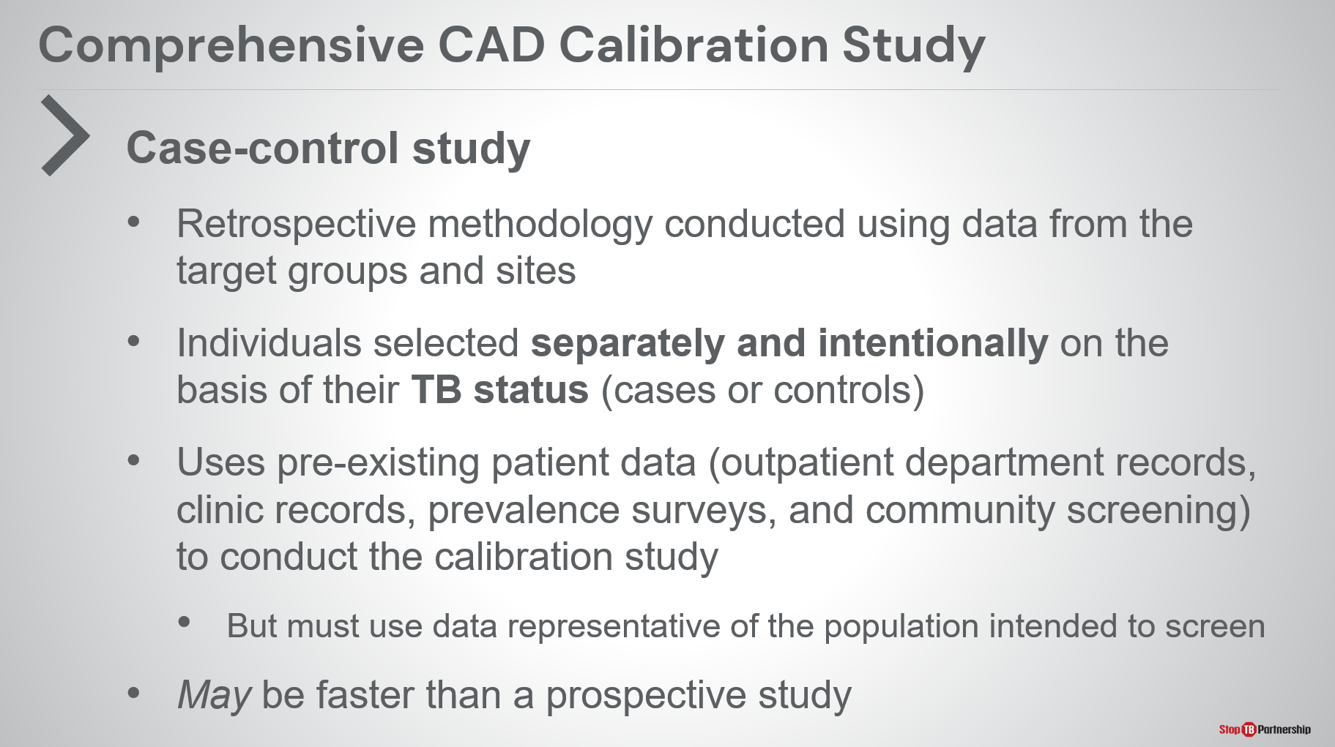
SAY: In a case control study, you are looking at more of a retrospective methodology, using data from target groups and target sites. You are selecting individuals separately and intentionally based on their TB status: persons with confirmed TB and controls (negative TB).
You are able to use pre-existing patient data (outpatient department records, clinic records, prevalence surveys, and community screening). These can all be used for the calibration study, but data must be representative of the population intended to be screened.
This may be faster than a prospective study as you will not have to screen tens of thousands of people, but you should not underestimate the resources and skills needed.

Comprehensive CAD Calibration Study: Case-Control Study | Slide: 25
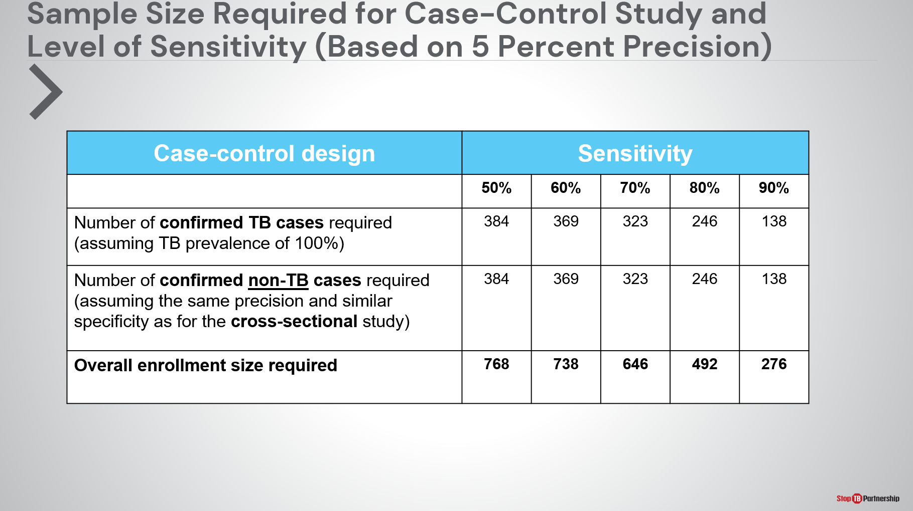
SAY: Again, we need the same number of confirmed TB cases as for the cross-sectional study. We must also identify an equivalent number of non-TB cases. This can take a long time because you have to go back through all the clinical records. In a prospective study, you just start screening people until you hit the right numbers. In a retrospective study, you have to dig through clinical records. Even though the overall enrollment size is lower, do not think this automatically means faster.

Comprehensive CAD Calibration Study | Slide: 26
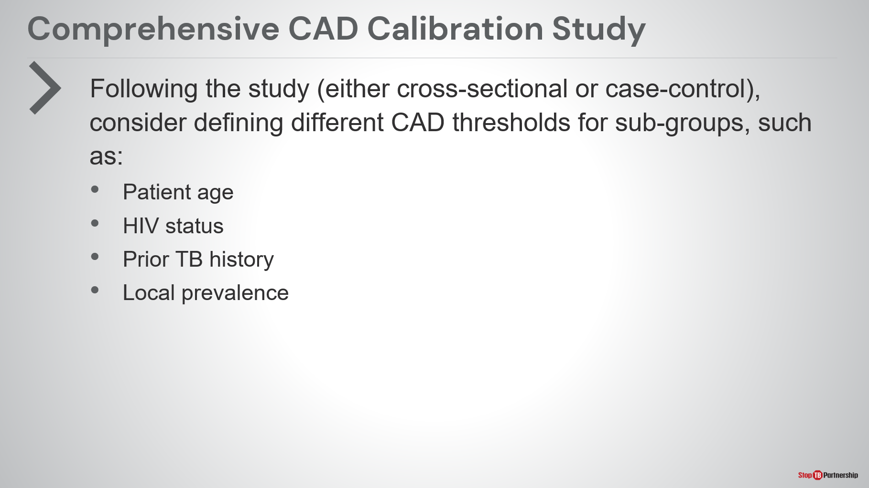
SAY: When thinking through your study, we may have different sub-groups or target populations. If time and resources allow, consider defining different thresholds for some sub-groups to ensure an equal sensitivity of CAD. That may be determined by a separate study (cross-sectional or case-control) or prior experience.
Some of these sub-groups may include: patient age (young, middle, or old), HIV status (positive or negative), prior TB history, and local prevalence in the region (if you have a high prevalence setting, you may want to set the threshold slightly lower; if you are looking at a low prevalence setting, maybe set it higher)
ASK: What may be your target population or populations for your screening program?

Comprehensive CAD Calibration Study: Compare Study Designs | Slide: 27
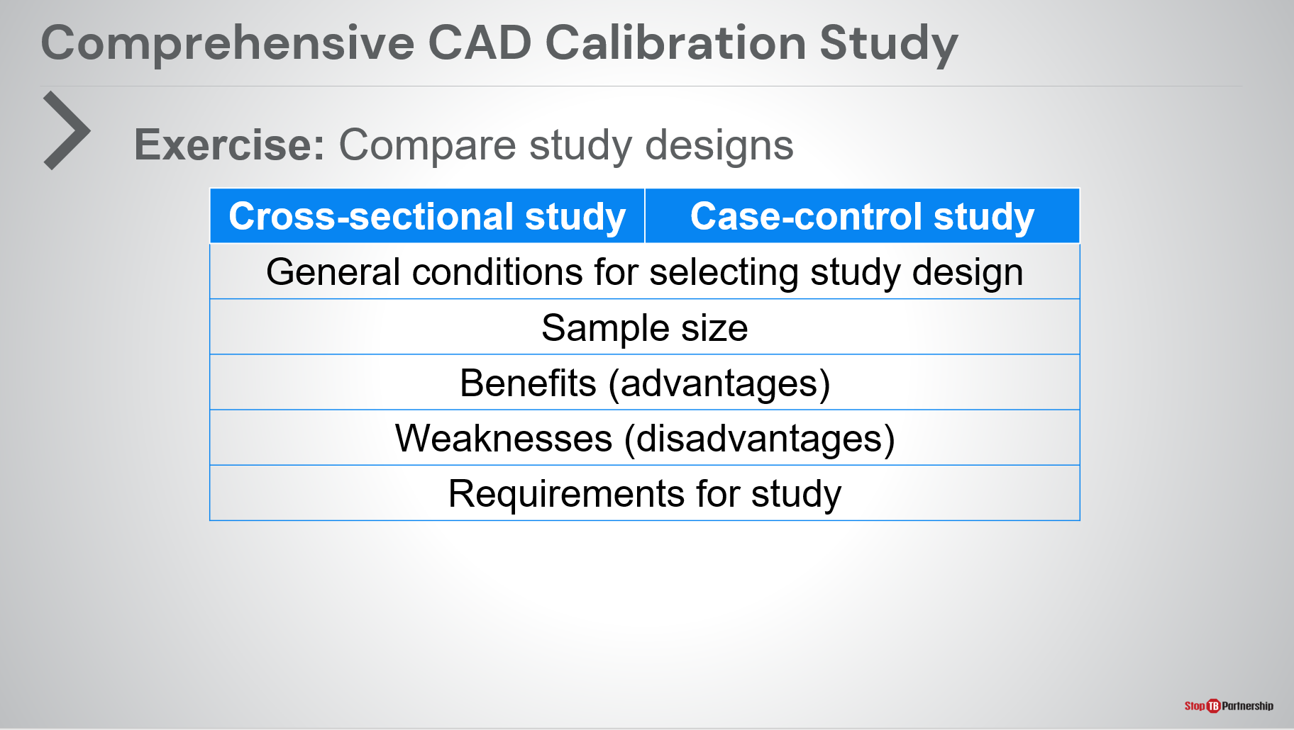
ASK: I’d like you all to take a moment to compare the study designs (cross-sectional versus case-control). Think about the general conditions for selecting study design. Look at your sample size. Think of the benefits and weaknesses of each one as we are making trade-offs with these decisions. Think about the requirements for your study. I’ll pause and ask you to take five minutes to discuss this with your neighbors.
ASK: [after about five minutes of discussion]: What did you discover as you thought through these study designs? Did anything strike you? Is there anything that you want to share?

Threshold Score Selection Strategy | Slide: 28
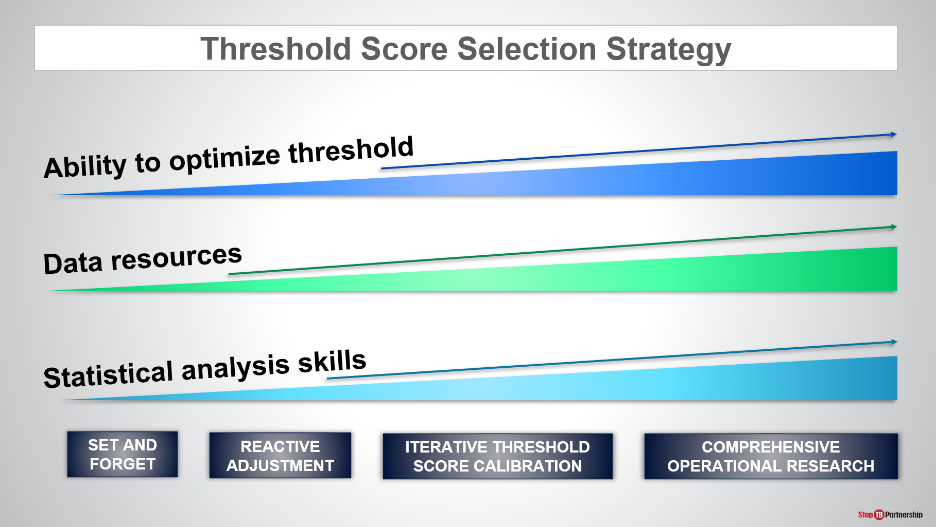
SAY: Keep in mind that as we increase the complexity of the threshold selection strategy, it does require additional data resources and analytical skills. At the same time, it does allow you to better optimize the threshold. There are clear benefits to using a strategy like comprehensive operational research, but that comes at programmatic costs for data collection, data review, and the time required to conduct the tests.
ASK: What would be your primary consideration in deciding a threshold score selection strategy?

How to Analyze Program Data for Threshold Selection Optimization
Data Analysis for Threshold Optimization | Slide: 31
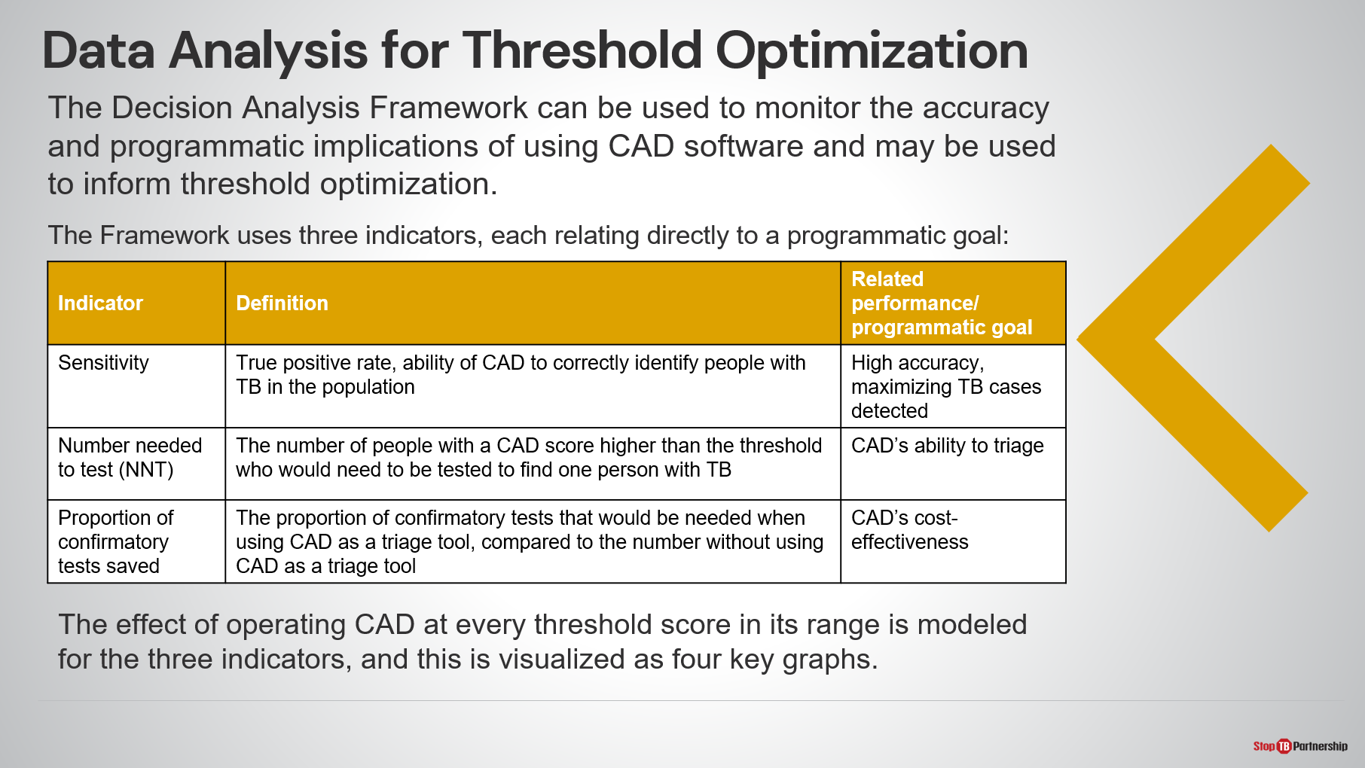
SAY: Next, we will talk about how to use programmatic data for threshold selection optimization and the decision analysis framework. This can be used to monitor the accuracy and programmatic implications of using CAD software. These implications will then inform your threshold optimization. This framework starts with three indicators, each relating to a specific programmatic goal.
- The first is sensitivity, which is the true positivity rate or the ability of CAD to correctly identify people with TB in the population. This leads to high accuracy and maximizes the TB cases that are detected.
- We can also look at the number needed to test, which is the number of people with a CAD score higher than your threshold who would need to be tested to find one person with TB. This helps us identify CAD’s ability to triage and be used as a triage test for TB.
- Lastly, we have proportion of confirmatory tests saved, which is the number of tests that would be needed when using CAD as a triage tool as compared to the number without using CAD as a triage tool. This demonstrates CAD’s cost-effectiveness.
The effect of operating CAD at every threshold score in its range is modeled for the three indicators, and this is visualized as four key graphs.

Data Analysis for Threshold Optimization—Example | Slide: 32
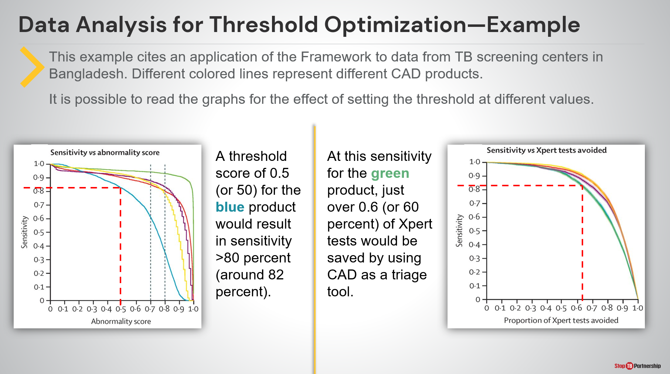
SAY: Let’s start with an example, which cites an application of the framework to data from TB screening centers in Bangladesh. The different colored lines represent different CAD products. It is possible to read the graphs for the effect of setting the threshold at different values.
For instance, the graph on the left shows that if we set a threshold of 0.5 (or 50) for the blue product. That results in a sensitivity of around 80 percent. At this sensitivity for the green product, just over 60 percent of Xpert tests would be saved by using CAD as a triage tool, as shown by the graph on the right.

Data Analysis for Threshold Optimization—Example | Slide: 33
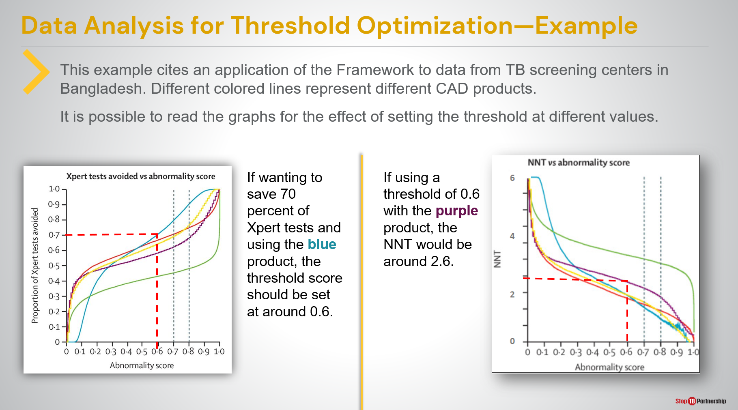
SAY: Continuing with the same example, we are reading the graphs to see the effect of setting the threshold to different values.
For example, if we want to save 70% of Xpert tests, using the blue product, we want to set the threshold score around 0.6 or 60 (see the graph on the left). If using a threshold of 0.6 with the purple product, the number needed to test would be around 2.6 (see the graph on the right).

Exercise—Selecting Thresholds in Line with Programmatic Goals | Slide: 34
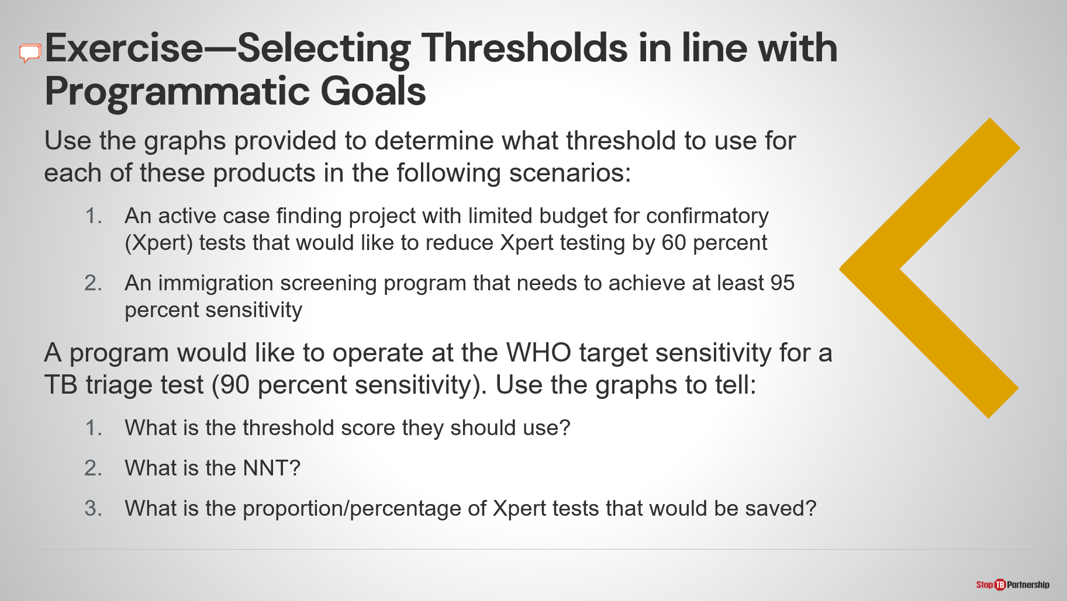
SAY/ASK: Let’s reflect back on the same graphs and think about some exercises that help us understand what we are talking about. We want to select thresholds in line with our programmatic goals. You can refer back to those graphs to determine what threshold to use for each of these products in the following scenarios.
- What threshold would we use for an active case finding project with limited budget for confirmatory tests that would like to reduce Xpert testing by 60 percent?
- What threshold would we want to use for an immigration screening program that needs to achieve at least 95 percent sensitivity?
We will pause here while you think about those first two questions.
DO: Go back to slides with the graphs. Allow participants time to discuss.
SAY: Another exercise: a program would like to operate at the WHO target sensitivity for a TB triage test (90 percent sensitivity). Use those graphs to determine what is the threshold score that they should use, what is the number needed to test, and what is the proportion of Xpert tests that would be saved.
DO: Go back to slides with the graphs. Allow participants time to discuss.

Planning for Screening

Start How You Want to End | Slide: 36
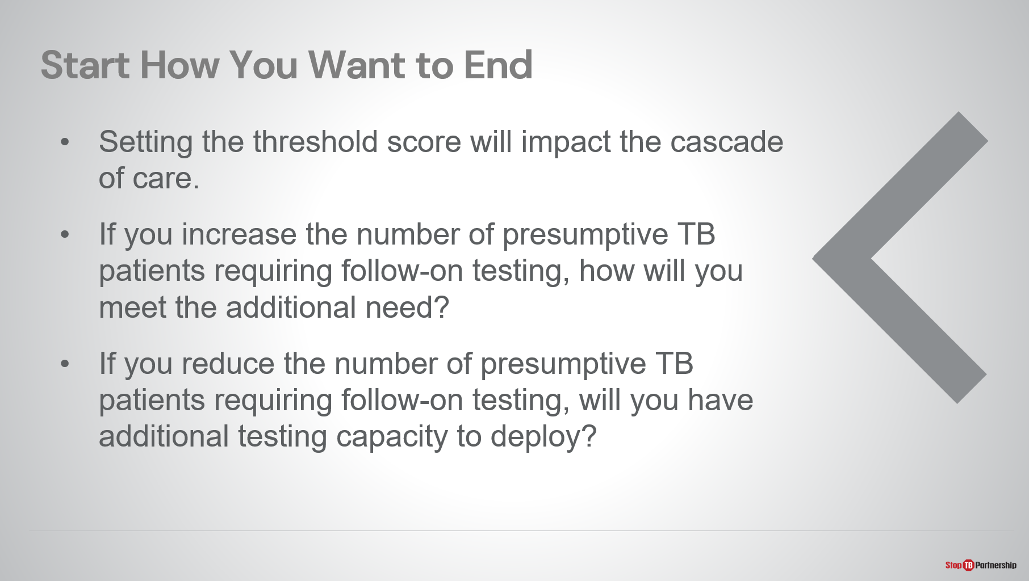
SAY: Let’s think about how we are planning for our screening program and how we are going to use our CAD software. As we know in a good programmatic design, we always want to start how we want to end. Setting your threshold score will impact the cascade of care.
- Therefore, if you increase the number of presumptive TB patients requiring follow-on testing, how will you meet the additional need?
- If we are doing a large screening campaign and we have a very targeted threshold score, we want to be sure that we have the confirmatory tests that we need and that we have targeted our threshold score for the number of confirmatory tests that we have available to us.
- If you reduce the number of presumptive TB patients requiring follow-on testing, does that give you additional testing capacity that should be deployed elsewhere?
We need to keep these ideas in mind, ensuring that we have the cascade of care. Not only thinking about follow-on testing, but if we increase the number of persons with a positive follow-on test, do we have the treatment capacity to take care of all those people?

Start How You Want to End | Slide: 37
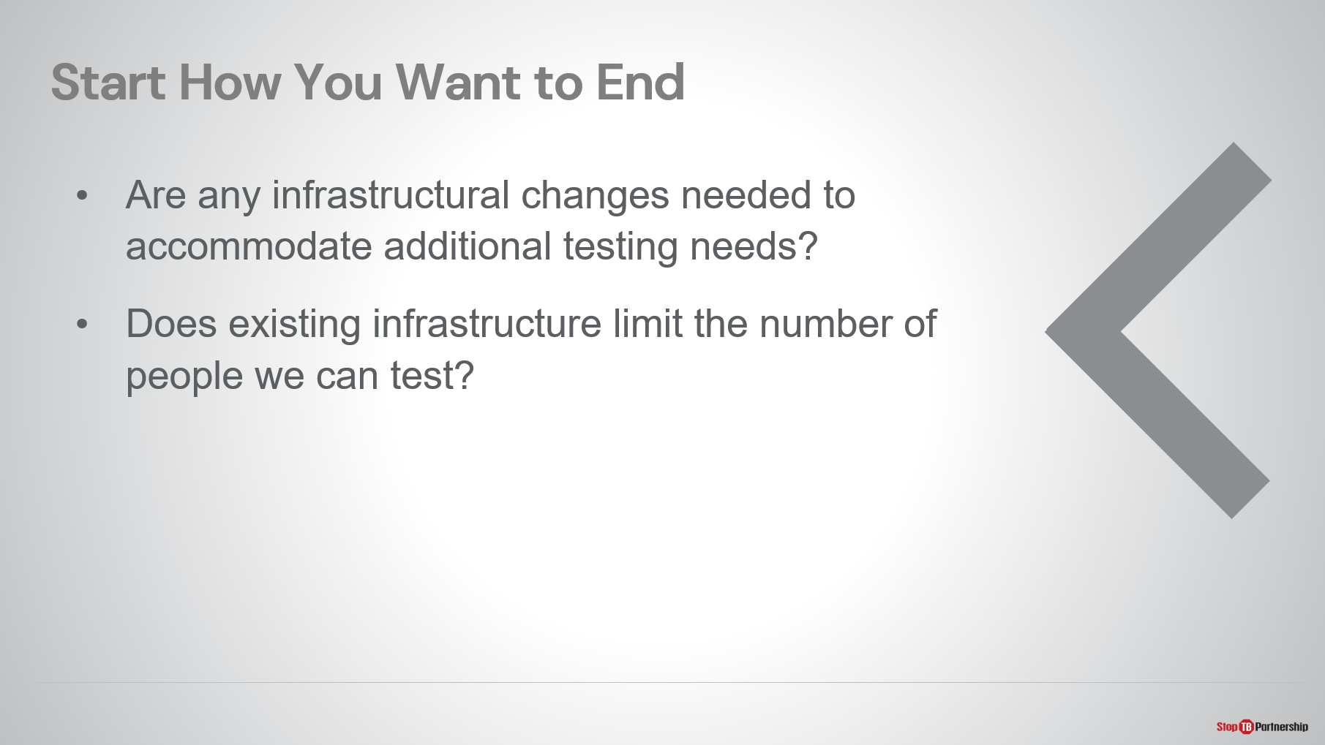
SAY: Are any infrastructural changes needed to accommodate additional testing needs? For instance, if we are reliant on Gene Xpert and we now have many more confirmatory tests needed, do we need to increase the number of Xpert sites?
Similarly, does existing infrastructure limit the number of people we can test? If we only have so many Xpert instruments and they are at full utilization rate, how can we offer additional confirmatory testing?
ASK: What are key questions that you will need to answer when planning your screening program? Write down a few of these questions to help you continue thinking about this.

You Can Revisit the Threshold Score | Slide: 38
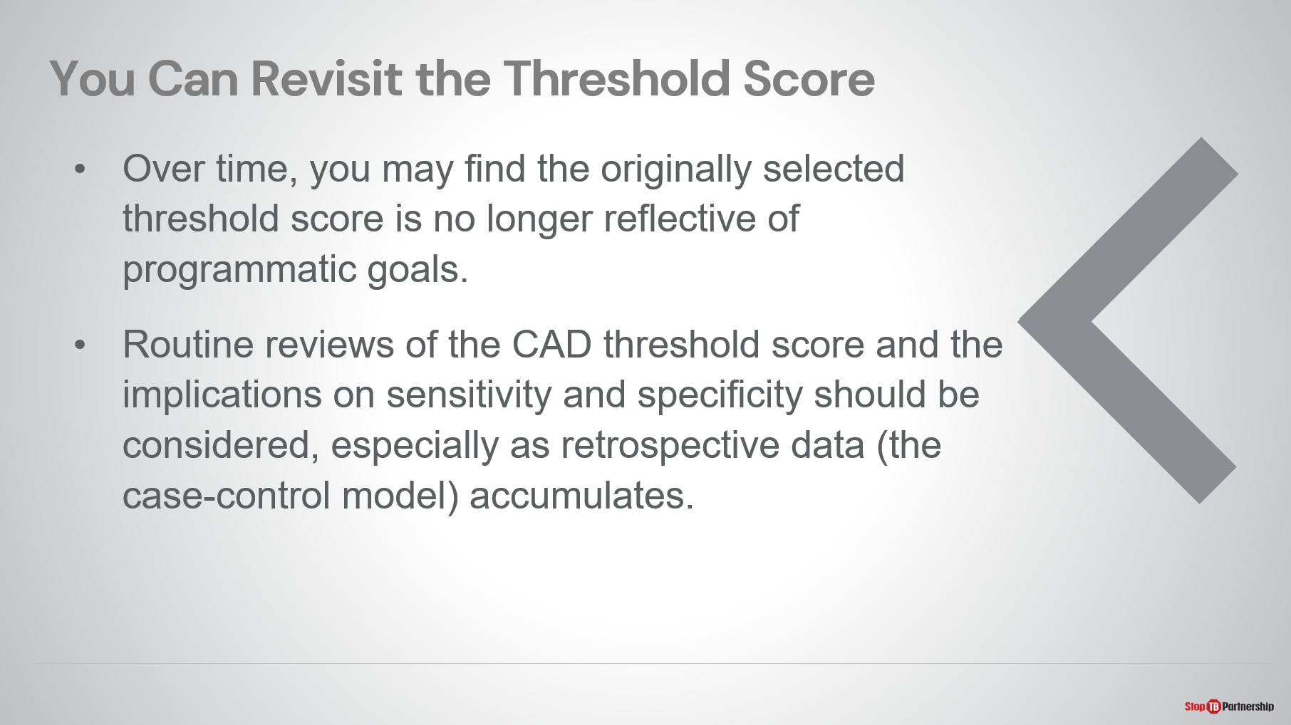
SAY: Remember, we can always revisit the threshold score. We talked about the reactive adjustment method , where over time, you may find that your original threshold score is no longer reflective of your programmatic goals. We want to be sure that we are constantly checking our assumptions and reviewing the outcomes of our testing strategy.
Routine reviews of the CAD threshold score and the implications on sensitivity and specificity should be considered, especially as retrospective data accumulates. In other words, as you are doing implementation, you can still conduct case-control models.

Summary

Summary | Slide: 39
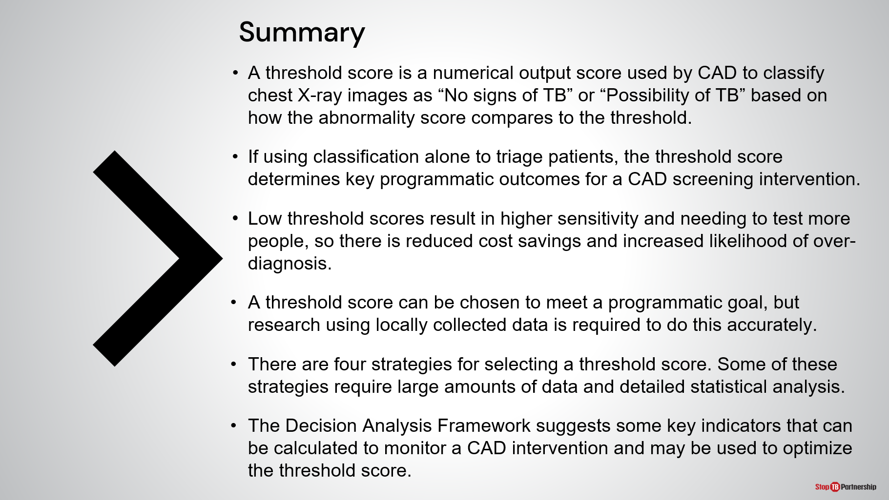
SAY: I’d like to try and summarize here for us all:
- First, a threshold score is a numerical output score used by CAD to classify chest X-ray images as “No signs of TB” or “Possibility of TB” based on how the abnormality score compares to the threshold.
- If using classification alone to triage patients, the threshold score will determine key programmatic outcomes for a CAD screening intervention.
- Lower threshold scores result in higher sensitivity and needing to test more people, so there is reduced cost savings and increased likelihood of over-diagnosis. (Low threshold scores mean more false positives.)
- A threshold score can and should be chosen to meet a programmatic goal, but research using locally collected data from the target population is required to do this accurately.
- We have presented to you four strategies for selecting a threshold score. Some of these strategies require large amounts of data and detailed statistical analysis. Do not be frightened by these needs but understand that there are trade-offs that are made.
- Finally, you may use the Decision Analysis Framework, which suggests some key indicators that can be calculated to monitor a CAD intervention and may be used to adjust the threshold score over time.
ASK: Any questions or topics you need a few more minutes with?
DO: Allow participants time to think and respond.

Module 5: Monitoring & Evaluation for CAD-enabled digital X-ray as part of TB screening​

Target Audience
The target audience for this course is:
- P rogram managers, coordinators

Learning Objectives
Terminal Objective
- At the end of this session, participants should understand how CAD-enabled X-ray can fit within their national monitoring and evaluation systems.

Module Objectives
- By the end of this module, participants should be able to
  - Describe how to integrate CAD-enabled X-ray into the diagnostic algorithm.
  - Describe monitoring & evaluation requirement for a CAD-enabled X-ray system.
  - Select indicators to use when establishing a screening program using CAD-enabled X-ray.
  - Describe how they would do these in their own country.

Materials
- Facilitator Guide
- Pens/Pencils

Introduction

Introduction | Slide: 2
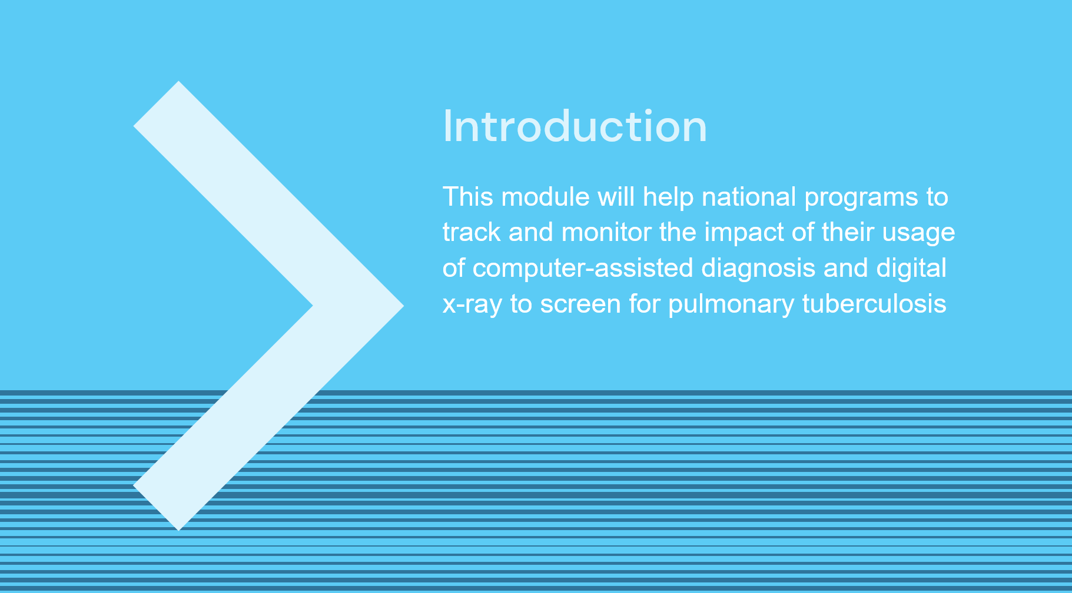
SAY: In this module, we will discuss how national programs can track and monitor the impact of their usage of computer-assisted detection and ultra-portable digital x-ray to screen for pulmonary tuberculosis.

Course Outline | Slide: 3
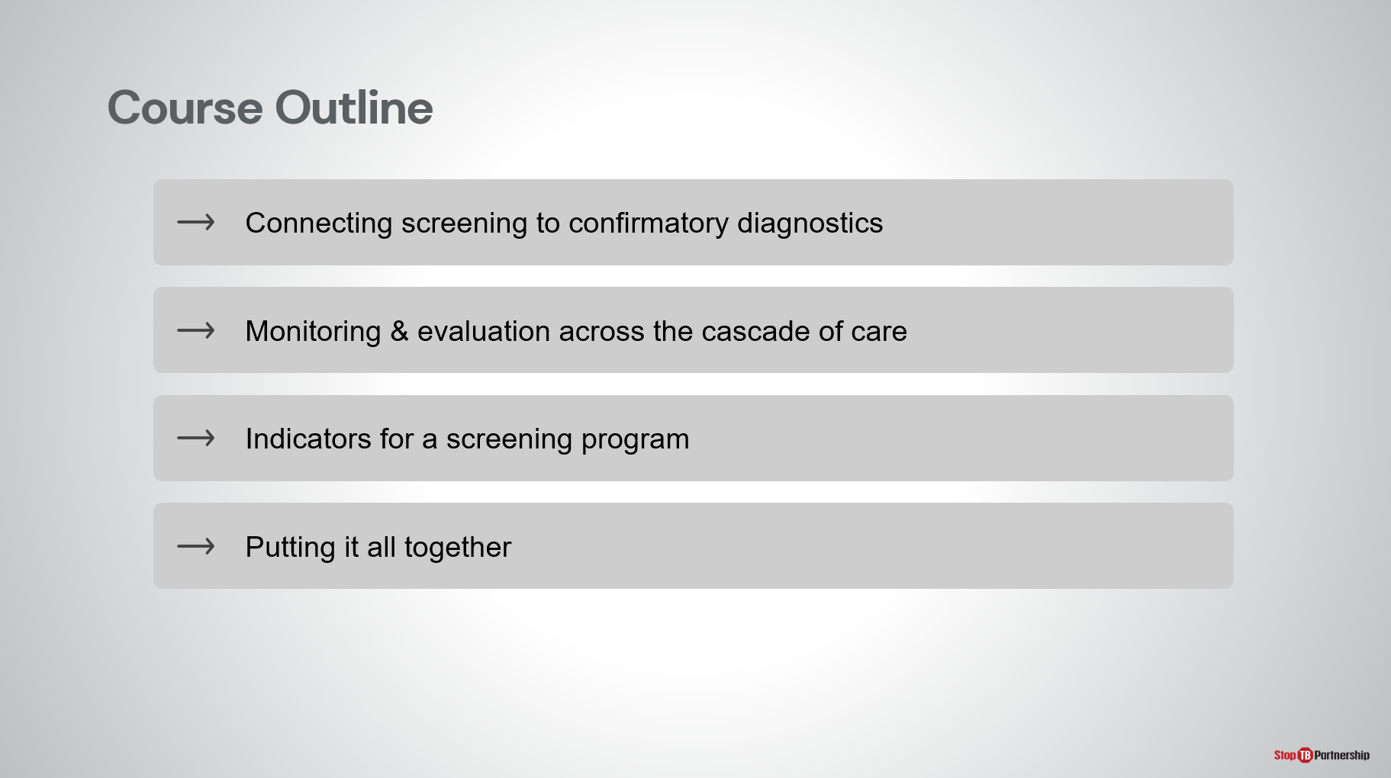
SAY: Our course outline consists of, first, connecting screening to confirmatory diagnosis; second, monitoring and evaluation across the cascade of care; next, the right indicators for a screening program that uses these tools; and finally, putting it all together with a team exercise.

Learning Objectives | Slide: 4
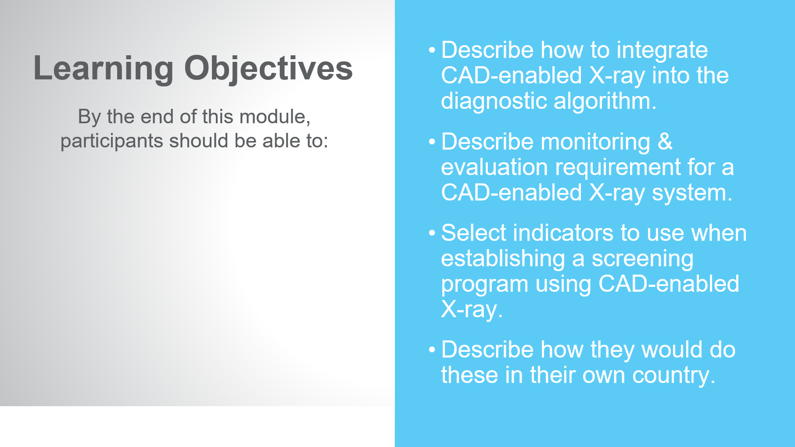
SAY: By the end of this modules, you should be able to:
- Describe how to integrate CAD-enabled X-ray into the diagnostic algorithm.
- Describe monitoring & evaluation requirement for a CAD-enabled X-ray system.
- Select indicators that you would use when establishing a screening program using CAD-enabled X-ray.
- Finally, describe how you would do these in your country.

Reminder: WHO Guidelines on Systematic Screening | Slide: 5
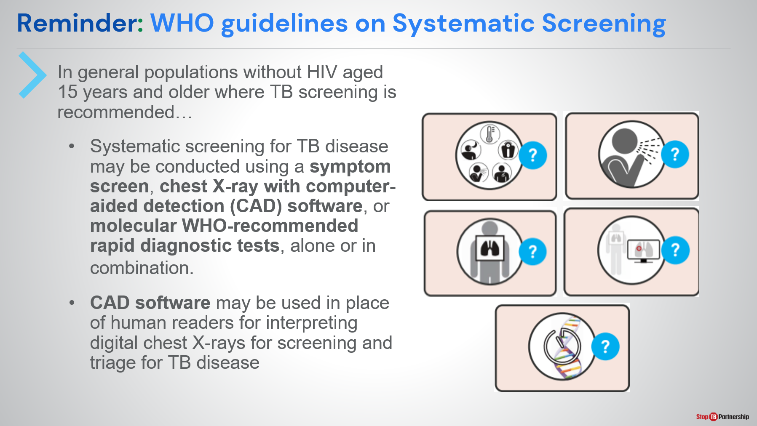
SAY: Let’s go back and review. Remember, WHO guidelines on systematic screening: in general populations without HIV aged 15 years and older, where TB screening is recommended:
- Systematic screening for TB disease may be conducted using a symptom screen, chest X-ray with computer-aided detection software, or molecular WHO-recommended rapid diagnostic tests, alone or in combination, through parallel or sequential screening techniques
- CAD software may be used in place of (or to augment) human readers for interpreting digital chest X-rays for screening and triage for TB disease

Connecting CAD-Enabled X-Ray to Confirmatory Diagnosis

Reminder: How is CAD-Enabled X-Ray being Used? | Slide: 7
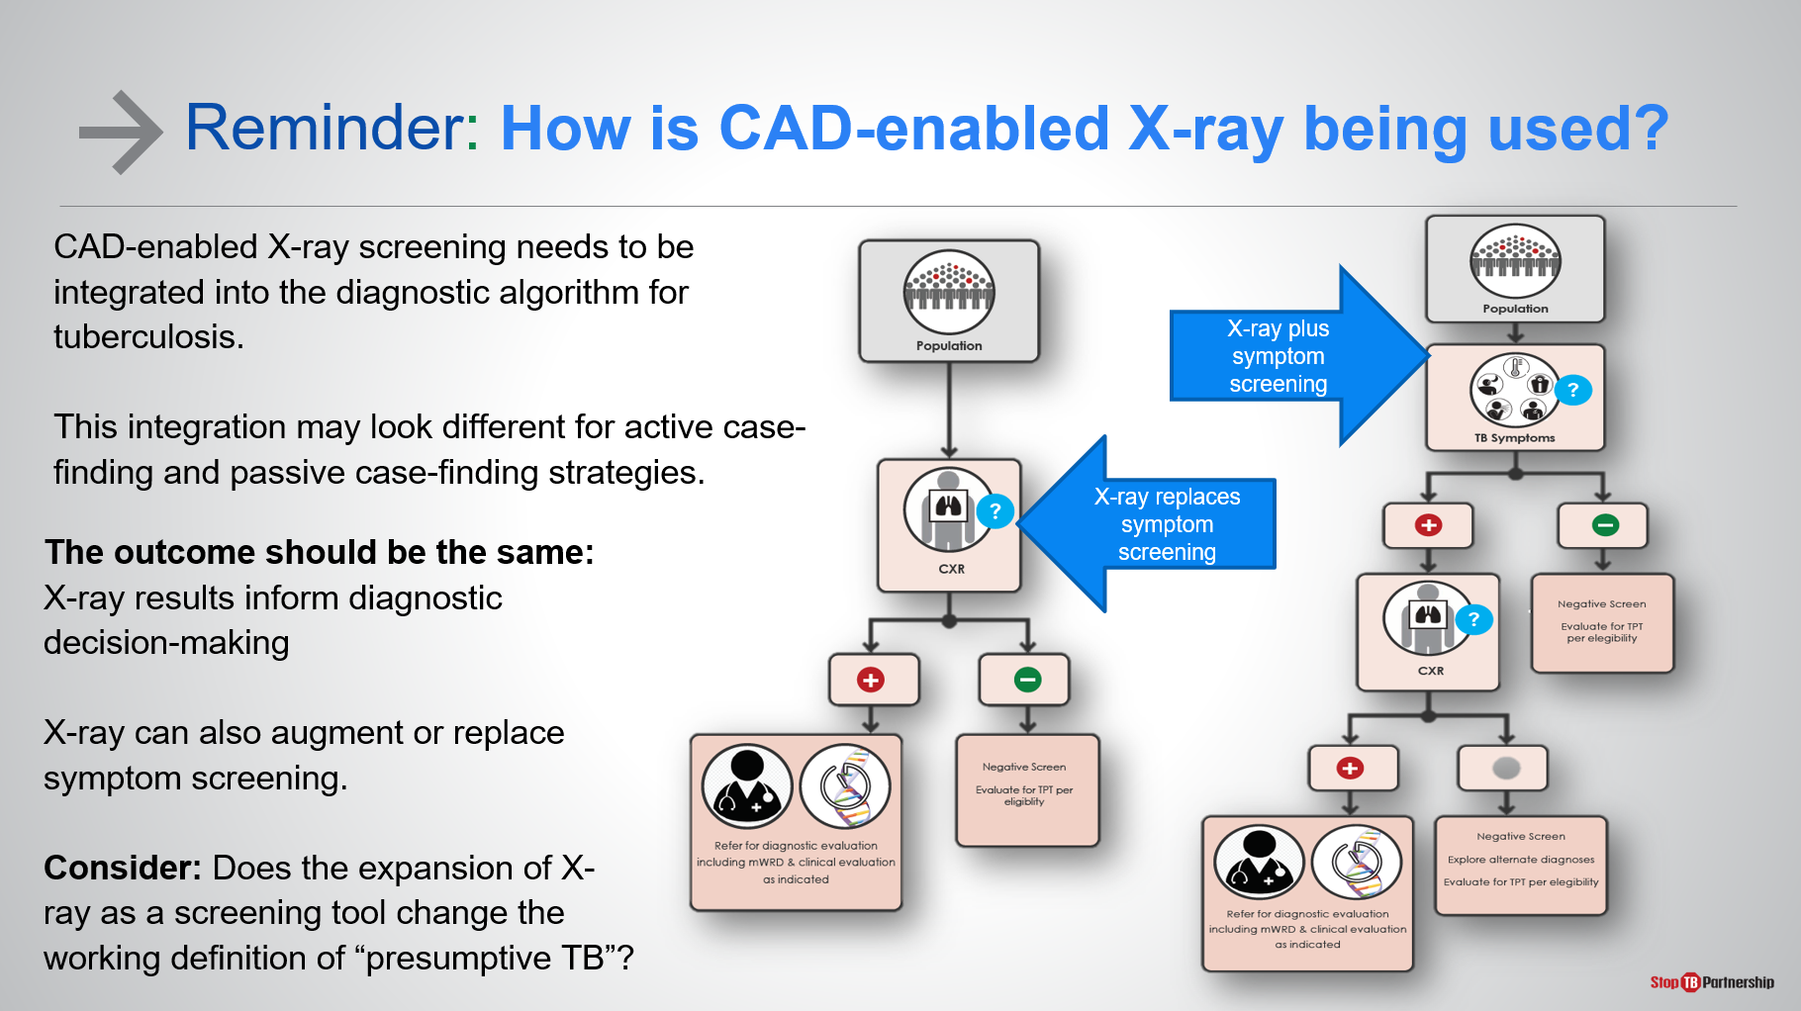
SAY: Let’s talk about how we are going to connect CAD-enabled x-ray to confirmatory diagnosis. Starting with, how are we using CAD-enabled x-ray? Let’s be sure that we have integrated it into the diagnostic algorithm. We spoke earlier in module one about the algorithms and how this new technology would fit into use with symptom screening or replacement of symptom screening. Know that the integration may look different whether we are talking about active case-finding or passive case-finding. However, the outcome should be the same, and that is the x-ray results informing diagnostic decision-making. X-ray can also augment or replace symptom screening. Often times, symptom screening has been shown to be less effective in prevalence surveys, where we have seen 50 percent to 70 percent of persons with confirmed TB are actually asymptomatic.
ASK: Consider whether the expansion of x-ray as a screening tool changes the working definition of presumptive TB. If your current definition of presumptive TB is based only on symptomology, then using an x-ray as a screening technique, does that change what we think of as presumptive TB?

CAD-Enabled X-Ray Results Lead to Confirmatory Testing | Slide: 8
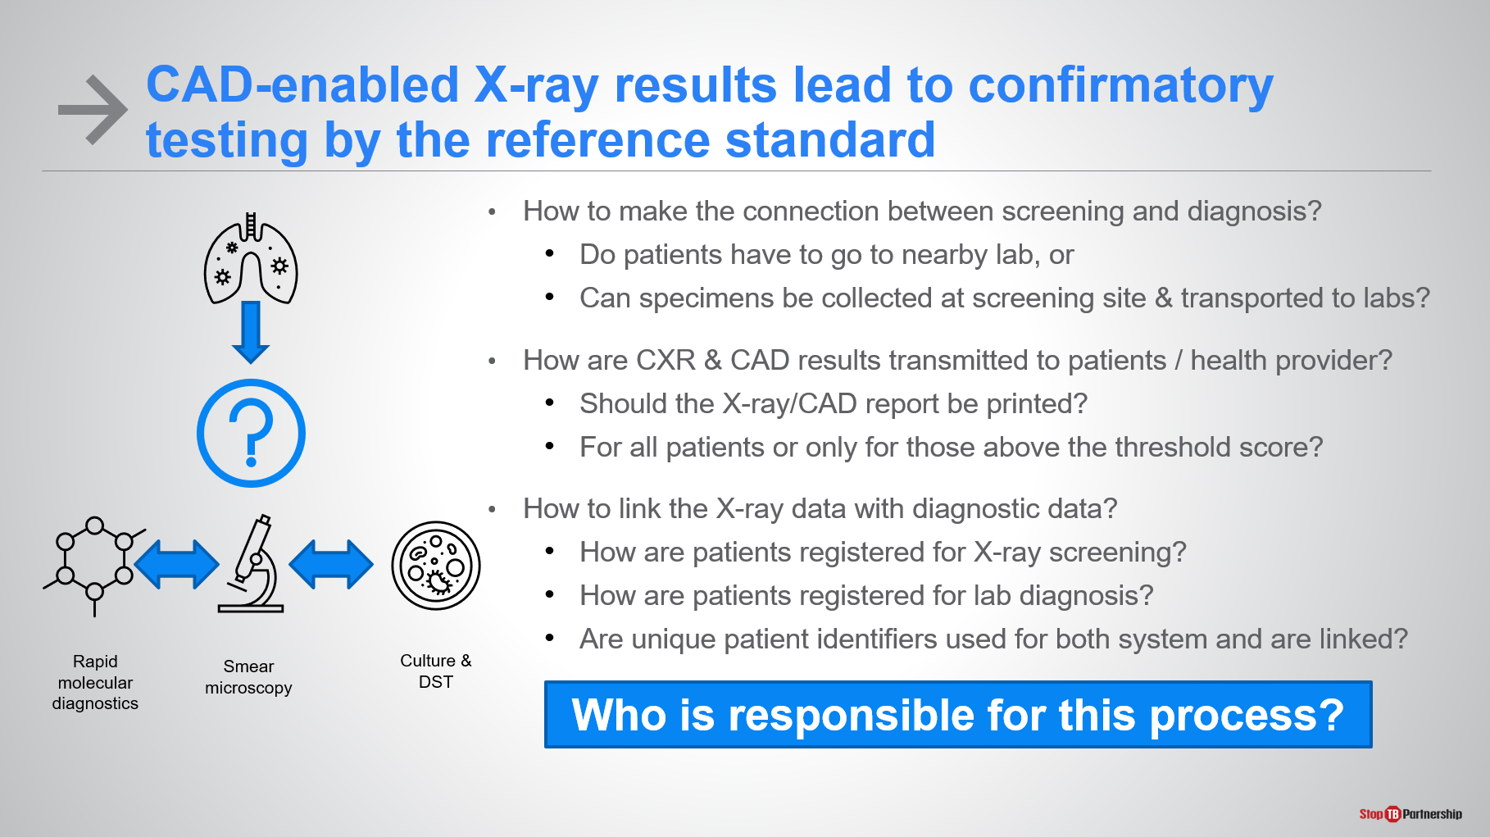
SAY: The most important thing is that any CAD-enabled x-ray result that is suggestive of TB symptoms needs to lead to confirmatory testing by the reference standard. Then how do we make the connection between screening and diagnosis? If someone is presenting at a healthcare clinic that has both x-ray and confirmatory testing, they can do both in a single stop. If this is not the case, do patients that get an x-ray suggestive of TB have to make the trip to a nearby lab for confirmatory testing, or can we collect the sputum specimens at the screening site to be transported to the lab for confirmatory testing?
Once we’ve done that part (the test to wherever the laboratory is), how are we getting those results transmitted back to the patient and to the provider? Do we need a printed x-ray or CAD report? Do we only want x-ray reports for patients above the threshold, or for all patients?
In addition, how are we linking our x-ray data with diagnostic data? Are patients registered for x-ray screening? Are patients registered for lab diagnosis? How do we go from one to the other? Do we have unique patient identifiers for both the X-ray/CAD system and all diagnostics?
Lastly, I can’t stress this enough: who is responsible for this process? How does this work when a patient gets an x-ray presumptive of TB, and how do they get to the point where they are able to access confirmatory testing? If they do not close that loop, how do we ensure that the loop is closed? How do we ensure that someone with an x-ray suggestive of TB (whether CAD-read or radiologist-read) gets to confirmatory diagnosis?
ASK: Start to think about how these systems for getting the patient from screening to confirmatory testing are already set up for your program? Will it need to be changed with the introduction of CAD? Write down a few notes.

Setting up an M&E System for CAD
What is Needed for an M&E System for CAD? | Slide: 10
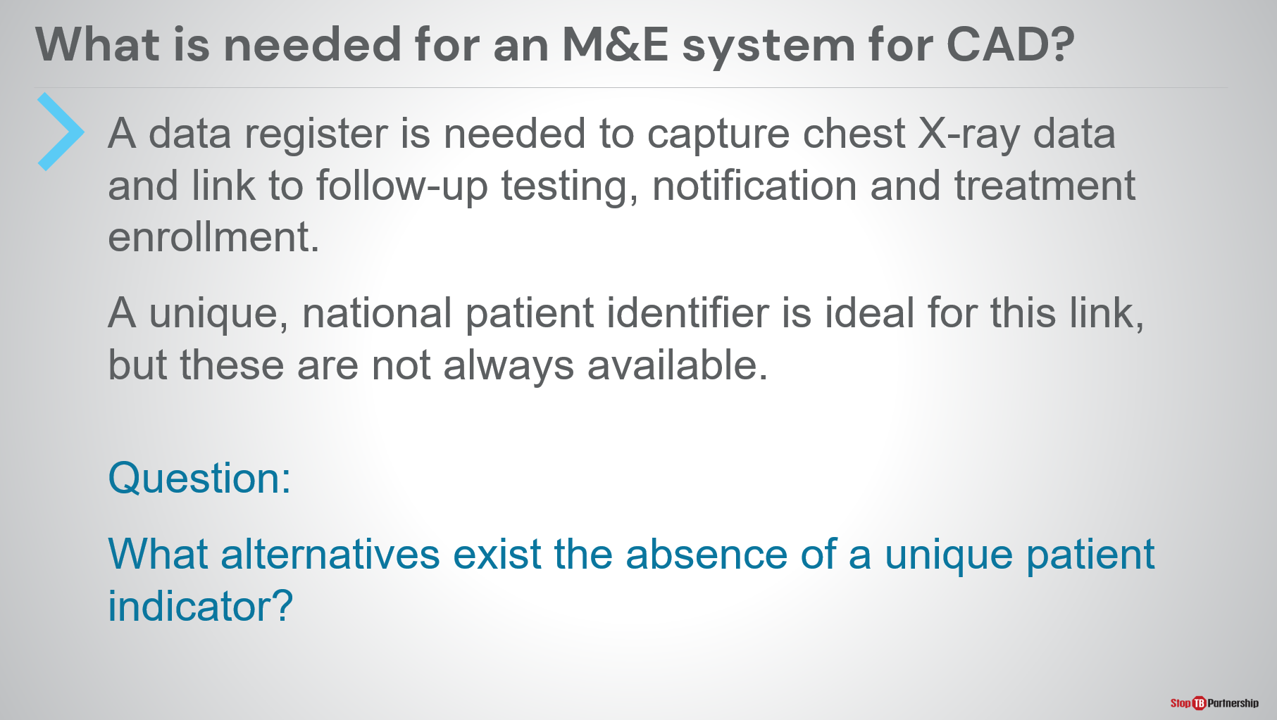
SAY: Let’s think about how we are going to set up an M&E system for CAD . First, what do we need? We need a data register, so that we can capture the x-ray data that allows us to link for follow-up testing, notification, and treatment enrollment. In an ideal situation, all patients would have a national unique identifier, an electronic medical record, or something similar, but these are not always available.
ASK: In the absence of a unique patient identifier, what alternatives exist? What do you use? How do we make sure that we have a unique identifier for our patients with x-ray that ensures that we are able to link them to follow-up testing, notification, and treatment?

Linking to National M&E Systems | Slide: 11
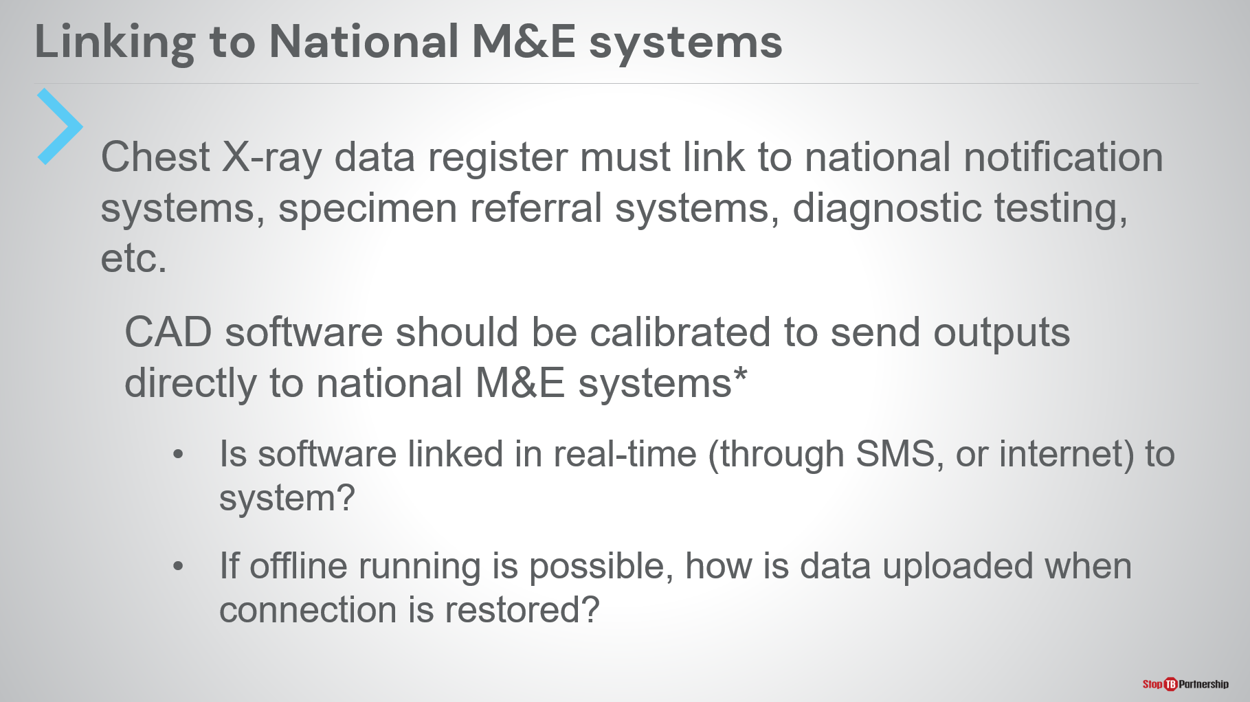
SAY: We need to link these to national M&E systems. CAD software is a new system in most countries; however, we do often have existing screening registers and existing national M&E systems. We need to think about how we move from existing screening registers to existing M&E systems. We should not be trying to reinvent things. We should consider that x-ray is a screening tool, and we already know ways to integrate screening into national M&E systems.
I ask that we think about: can we take a chest x-ray data register (all x-rays have a unique identifier) and link those to national notification systems, specimen referral systems (so that patients do not have to leave their homes and specimens can be collected from them at their homes), and for diagnostic testing. We want to close the loop from x-ray to specimen to diagnostic testing.
Ideally, CAD software should be calibrated to send outputs directly to national M&E systems. If that is the case, is software linked in real-time through SMS or internet to the national M&E system? If we are looking at offline running, how do we move the data once the connection is restored? For example, if an x-ray campaign is happening in a remote location with no internet coverage, how do we transmit data once the system comes back into an area with coverage? How do we transmit data in a way that reduces coding errors? We want to ensure to minimize the amount of data re-entry that happens.

Selecting Indicators for a Chest X-Ray/CAD Screening Program
Cascade of Care—Indicators | Slide: 13
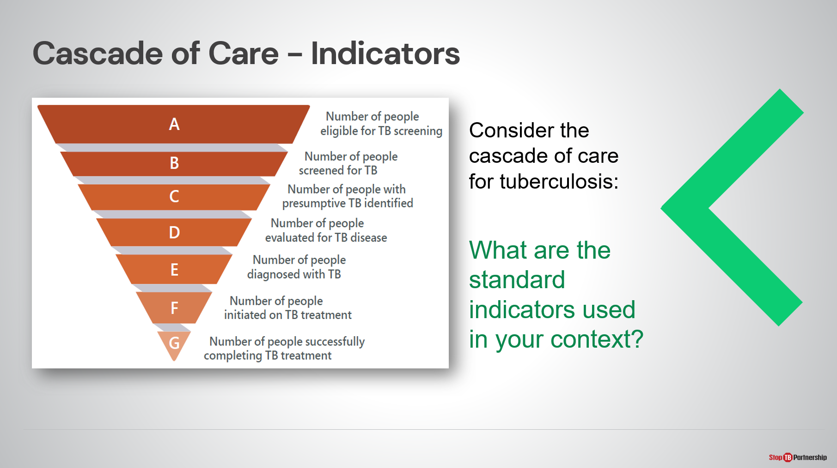
SAY: When we think about our M&E system, we also have to think about one step below that. What are our indicators that we need? How do we determine the correct indicators for chest x-ray and CAD screening program?
Let’s start with the cascade of care for tuberculosis. Think about the standard indicators used in your country. We can start with number of people eligible for screening, then number of people screened, number of people with presumptive TB, number of people evaluated for TB disease, number of people diagnosed with TB, number of people initiated on TB treatment, and number of people that successfully complete treatment.
At each stage, we are reducing the total population. Ideally, some of these would be fairly similar, such as the number of people diagnosed with TB would be the same as the number of people started on TB treatment. The number of people with presumptive TB would be the same as the number of people evaluated for TB disease. The number of people initiated on treatment would be the same as the number of people completing treatment. So the pyramid should not be taken as literal but should be taken as descending steps in the process.
ASK: Think about your indicators: how do you track each of these in your systems?
SAY: How do we get points A, B, and C integrated for CAD-enabled x-ray? How do we identify the number of people eligible for screening by CAD-enabled x-ray? How do we calculate the number of people screened? How do we ensure that people with presumptive TB are processed for evaluation?

Calculations from the Indicators for Each Screened Group | Slide: 14
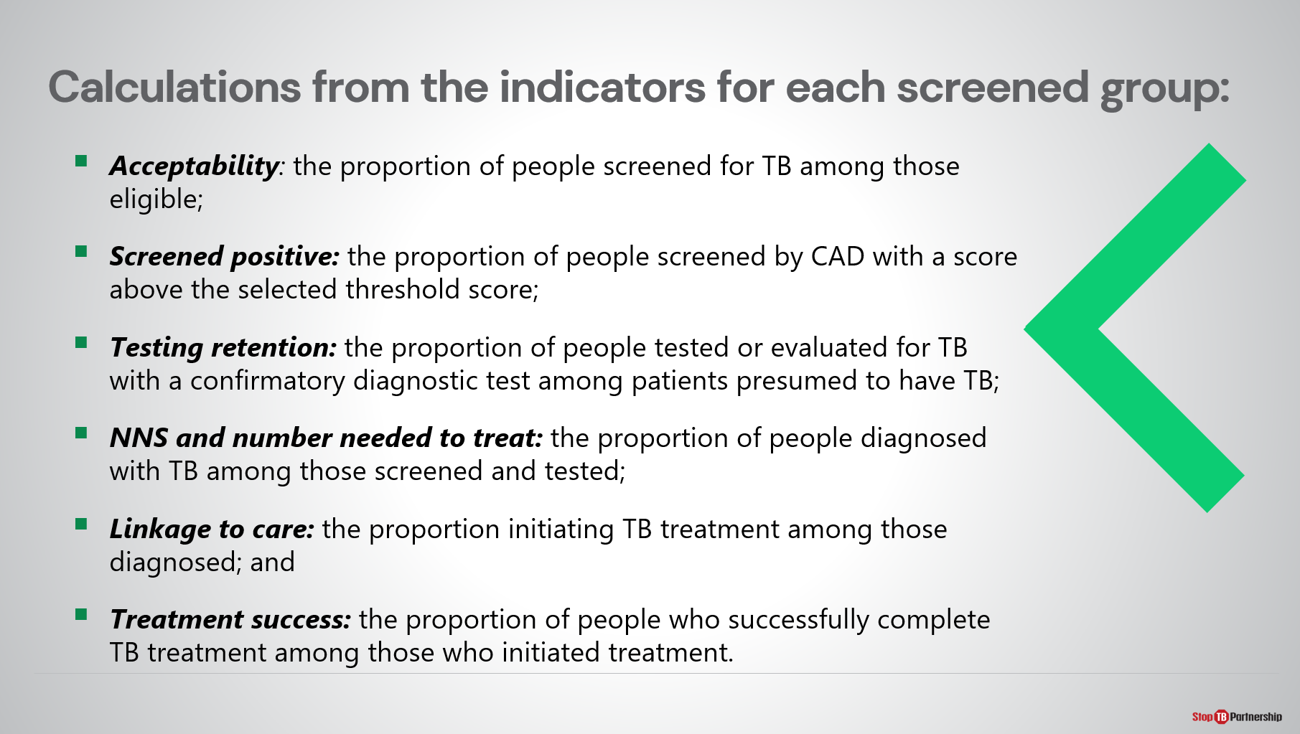
SAY: Calculations from the indicators for each group are:
- Acceptability: of the people eligible for screening, how many are screened
- Screened positive: proportion of people screened by CAD with a score above the selected threshold score
- Testing retention: the proportion of people tested or evaluated for TB with a confirmatory diagnostic test among patients presumed to have TB (we could also think about loss to follow up); it is our responsibility as TB program managers to retain patients in our system
- Number needed to screen and number needed to treat: the proportion of people diagnosed with TB among those screened and tested
- Linkage to care: enrollment in treatment; we don’t want to lose patients between confirmatory diagnosis and treatment enrollment
- Treatment success: if we are using bacteriological confirmation, this is treatment cure; the proportion of people who successfully complete TB treatment among those who initiated treatment.

Questions to Ask | Slide: 15
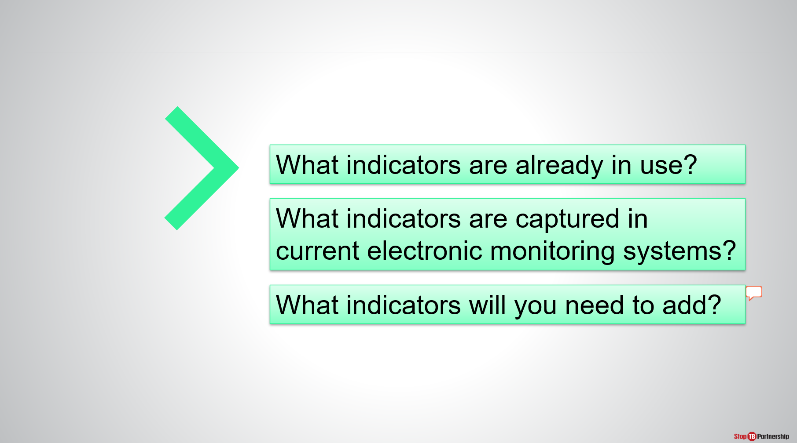
ASK: Again, I ask you, what indicators are already in use? How are you capturing those in your current electronic monitoring systems? As you roll out CAD-enabled x-ray, what indicators will you need to add to the current systems? If you need to add indicators, what are the infrastructure requirements to do so?
Write down some notes [can ask for people to share if there is time].

Selecting Indicators for a Screening Program | Slide: 16
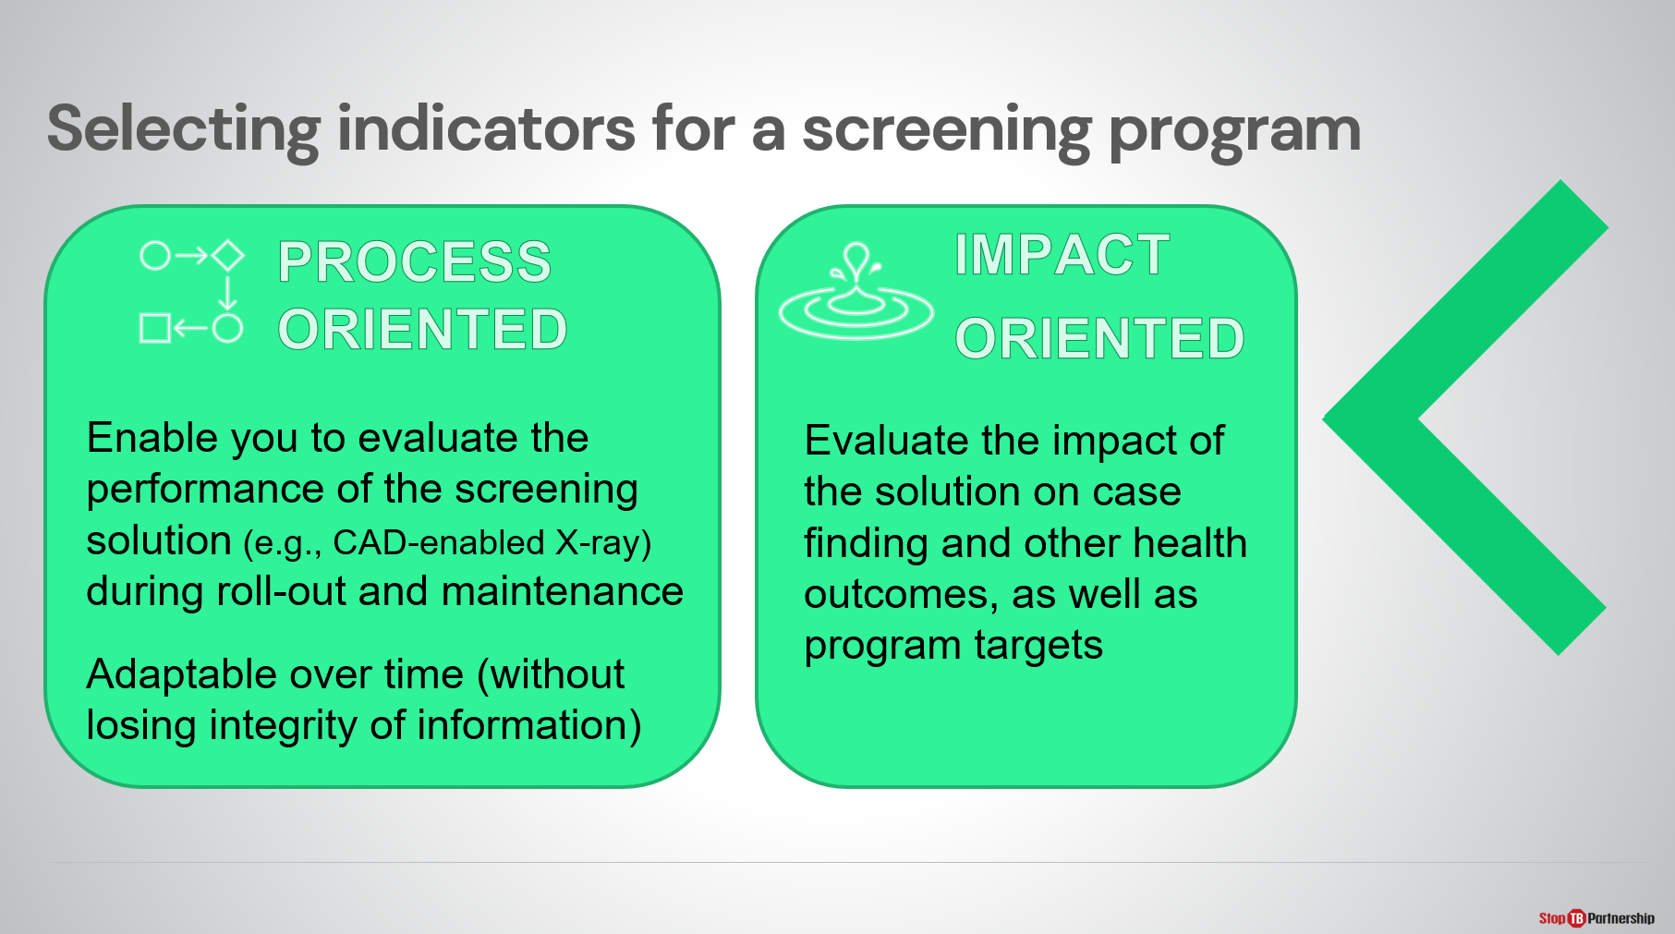
SAY: When you are selecting your indicators for a screening program, I want you to think about two separate kinds of indicators. There are process indicators, which allow you to evaluate the performance of the screening solution during roll-out and maintenance. For example: how many people are you screening, how fast are you screening, what proportion are being screened positive, what proportion are being screened negative? The process-oriented indicators should be adaptable over time. This allows us to maintain the integrity of data but also ensure that as our processes are updated, we can capture this data as it evolves.
We also need to think beyond process to think about impact. How does CAD-enabled x-ray improve our downstream data? How does CAD-enabled x-ray help us achieve a greater cure rate or a greater cure number? If we are improving our screening capacity, we should be improving our number of confirmatory tests, which will then increase the number of people that could be cured with adequate treatment.

Proposed Indicators for Monitoring the Performance of CAD Technology | Slide: 17
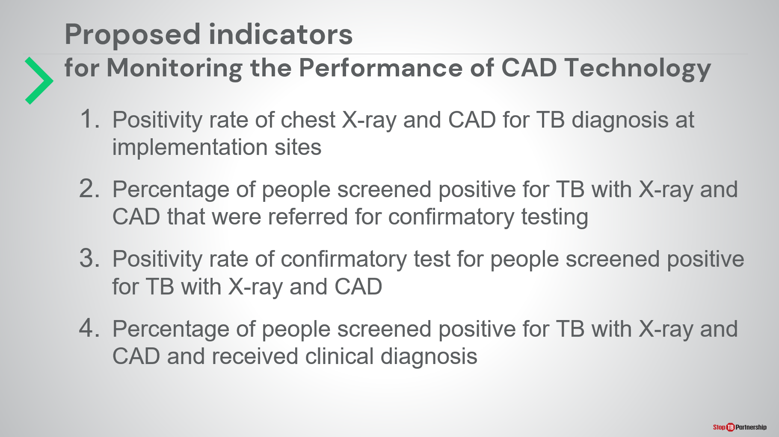
SAY: I’ve asked you to think about these indicators, but let me propose a few that might come in handy:
- First, positivity rate of chest X-ray and CAD for TB diagnosis at implementation sites (of the number of people that are screened, how many have presumptive TB and need to be referred)
- Then, percentage of people screened positive for TB with X-ray and CAD that were referred for confirmatory testing
- Positivity rate of confirmatory test for people screened positive for TB with X-ray and CAD (of the people who screened positive, how many are confirmed to have TB)
- Percentage of people screened positive for TB with X-ray and CAD and received clinical diagnosis (we want to think about this as well; we also have to remember that GeneXpert and microscopy don’t rule out TB in some populations, so we have to make sure that patients are also clinically evaluated)

Practicalities of Introduction of CAD-Enabled X-Ray

Where to Place CAD in the TB Screen Algorithm | Slide: 18
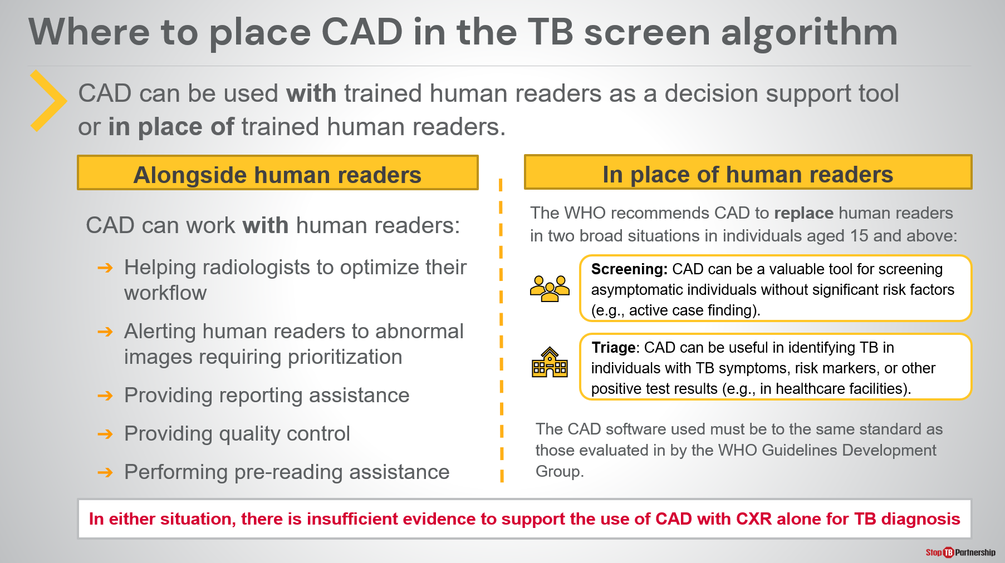
SAY: I’d like us now to take a minute and think about a team exercise. Think about the practicalities of introducing CAD-enabled x-ray. Again, let us think about where we place CAD in the TB screening algorithm. CAD can be used with trained human readers or in the place of human readers. If we want to use it as decision support tool, where are human readers located? How would they be used—would human readers or AI be used first? CAD can work with human readers to: help radiologists to optimize their workflow, alert human readers to abnormal images requiring prioritization, provide reporting assistance, provide quality control, and perform pre-reading assistance.
We can also use CAD in the place of human readers. The WHO recommends this in two situations: screening for asymptomatic individuals without significant risk factors, in other words, active case-finding campaigns. We can also use it as triage: identifying TB in individuals with TB symptoms, risk markers, or other positive test results. We should also think about it in place of human readers in places where there are no radiologists and no clinicians that are trained in reading radiographs.
In either situation, there is insufficient evident to support the use of CAD with chest x-ray along for TB diagnosis. The CAD software used must be to the same standard as those evaluated in by the WHO Guidelines Development Group. We have some limitations on how we might use this, but we also have clear guidance as a part of the WHO comprehensive screening guidelines.

Where to Place CAD in the TB Screen Algorithm | Slide: 19
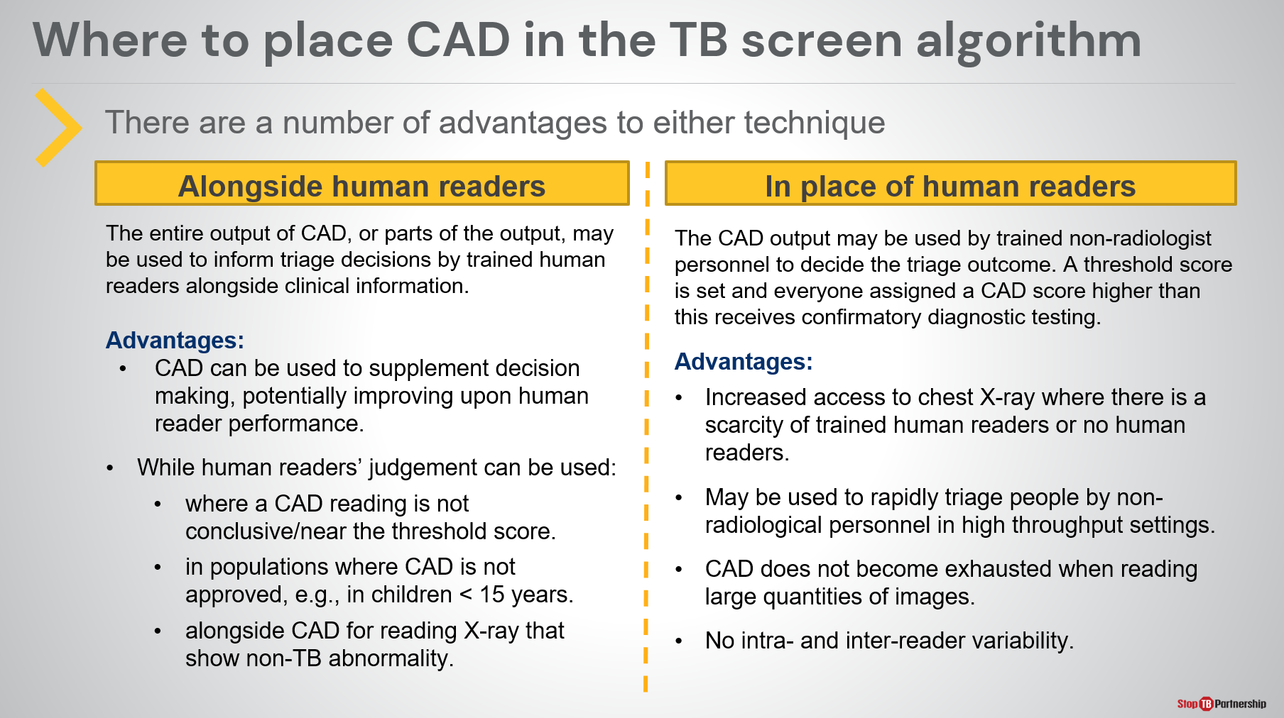
SAY: Remember that there are advantages to both techniques. Alongside human readers, the entire output of CAD, or parts of the output, may be used to inform triage decisions by trained human readers alongside clinical information.
CAD can give us a result in one minute and can be used to supplement decision making. While human readers’ judgement can be used: where a CAD reading is not conclusive or near the threshold score; in populations where CAD is not approved, such as children under 15 years old; and alongside CAD for reading X-ray that show non-TB abnormality.
In the absence or in place of radiologists, CAD outputs can be used to decide triage outcomes. A threshold score is set and everyone assigned a CAD score higher than this receives confirmatory diagnostic testing. In this case, we need to be consistent, so that everyone above the threshold gets confirmatory diagnosis and everyone below the threshold does not. The advantages to this are: increased access to chest X-ray where there is a scarcity of trained human readers or no human readers, may be used to rapidly triage people by non-radiological personnel in high throughput settings, CAD does not get tired when reading large quantities of images as a radiologist might, and there is no intra- and inter-reader variability .

Closure

Ask Yourself | Slide: 20
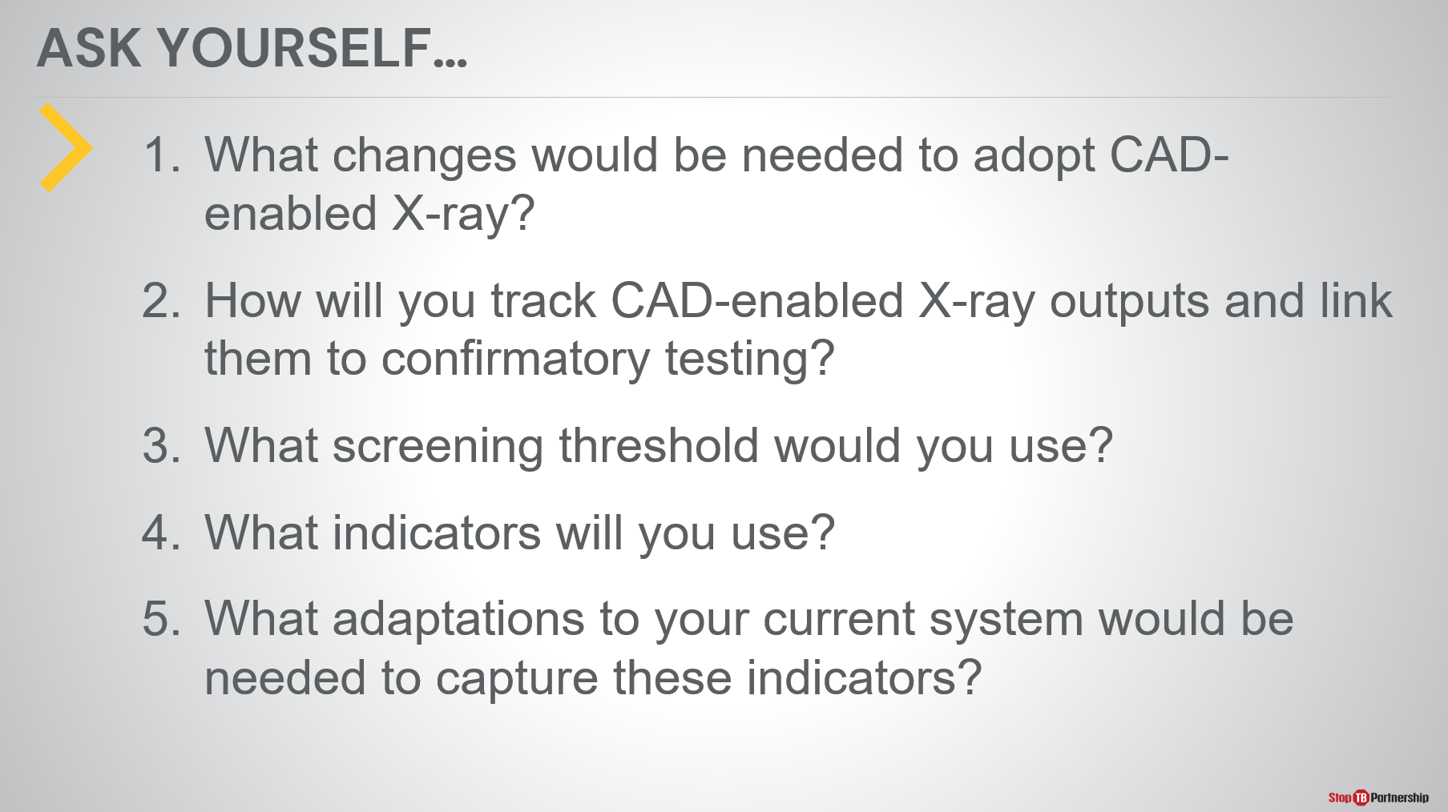
ASK: As we go through this exercise, I’d like you to ask yourself the following questions:
- What changes would be needed to adopt CAD-enabled X-ray?
- How will you track CAD-enabled X-ray outputs and link them to confirmatory testing?
- What screening threshold would you use? What would you recommend?
- What indicators will you use to monitor the outcomes in terms of both process and impact?
- What adaptations to your current national M&E system would be needed to capture these indicators?

Ask Yourself | Slide: 21
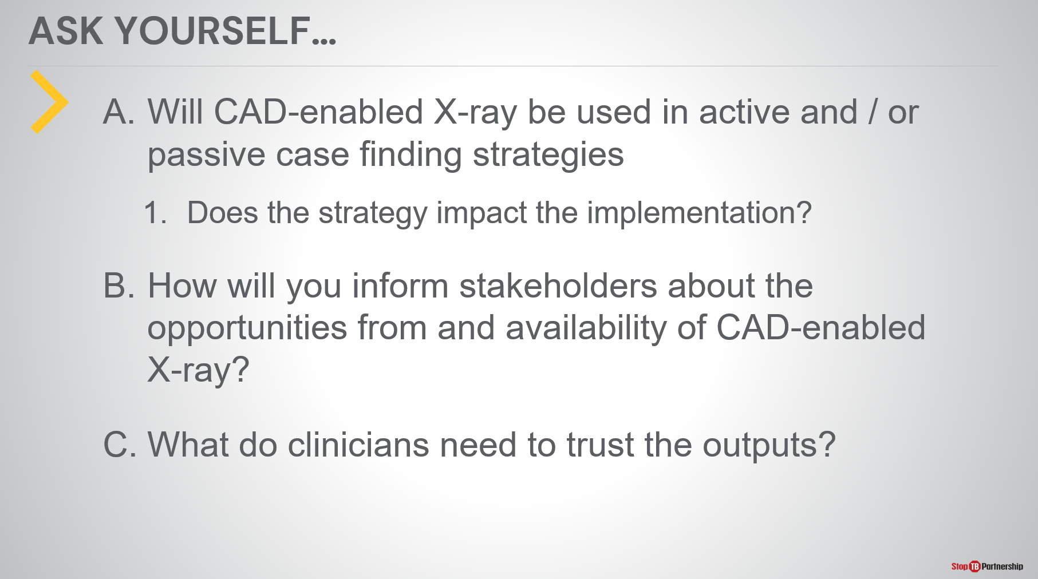
ASK: Also ask yourself:
- Will CAD-enabled X-ray be used in active and / or passive case finding strategies? Does the strategy impact the implementation?
- How will you inform stakeholders about the opportunities from and availability of CAD-enabled X-ray? This training session is an excellent starting point, but there are going to be many other users out there that will benefit from this, technicians that may want to use this, and patients that would like to see this in their communities.
- We also need to consider the clinicians. Are clinicians knowledgeable about referring patients for CAD-enabled x-ray? When clinicians get results from CAD-enabled x-ray, will they trust that? Will they look at that to make proper referrals? If we need to make education, how would we do so?

Closure | Slide: 22
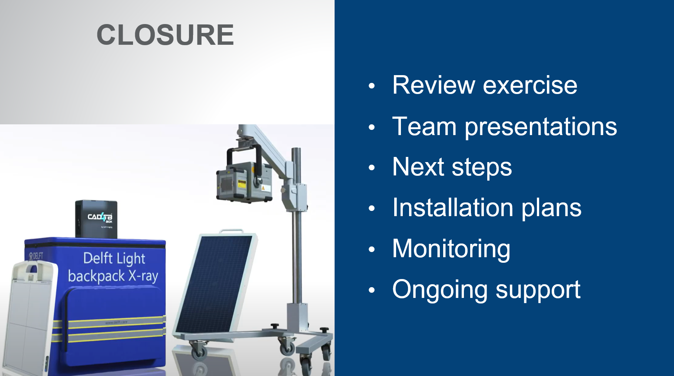
SAY: We are about to close, but first we are going to break up into teams to review this exercise. We will then do team presentations, and we will come back at that point. Thank you.
DO: Split participants into small teams to work through these questions.
SAY: [following the exercise]: Welcome back from the exercise. I hope you found the process helpful and thought-provoking as you considered the practicalities of introducing CAD-enabled x-ray in your country. The exercise asked several questions [can return to the previous two slides to show the questions]:
- What changes would be needed to adopt CAD-enabled X-ray?
- How will you track CAD-enabled X-ray outputs and link them to confirmatory testing?
- What screening threshold would you use? How would you decide the threshold?
- What indicators will you use to track the process and outputs of the implementation?
- What adaptations to your current national M&E system would be needed to capture these indicators?
- What is the use case? Will CAD-enabled X-ray be used in active and / or passive case finding strategies? Does the strategy impact the implementation?
- How will you inform stakeholders about the opportunities from and availability of CAD-enabled X-ray? We need to think about communities, radiologists, and clinicians. How will results be interpreted and used?
- How will we ensure that clinicians are aware of and accepting of the technology? We are used to working with human readers, and we are asking people to take the step of accepting a computerized result. What information do we need to share to ensure that people are comfortable and trusting of the software.
I’m looking forward to hearing the outcomes of these exercises and hope these exercises will inform how we proceed with use of this technology. Thank you.
DO: Ask participants to share what they discussed in their groups as a wrap-up to the training.

